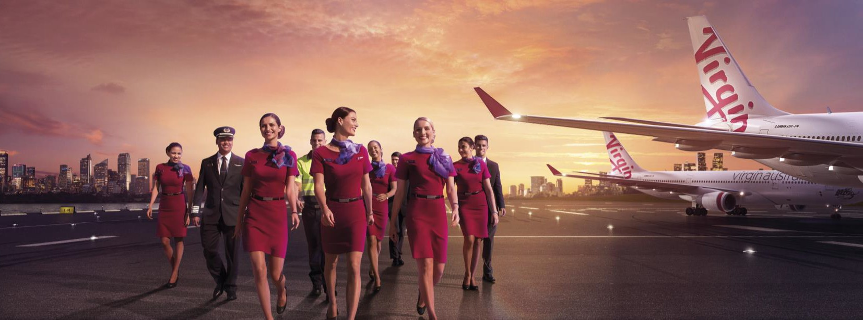
Virgin Australia
Position Description

Position Snapshot
Position Title: Crew Training Instructor
Business / Division / Department: VAA
Location: Brisbane based, may be required to work and/or be based at other locations
Reports to: Leader Crew Training
Direct Reports: NA
Classification: 1D
Employment: Fulltime
Date: February 2019

Overall Impact Statement
We are passionate about Championing Better and believe who you are and how you show up is as important as what you do.
The objective of the Crew Training Instructor role is to develop courseware and training delivery for Cabin Crew and Flight Crew to ensure all regulatory and company requirements are met.
To create an environment where safety and guest care training is developed and delivered to the highest standard

Organisation Context
Virgin Australia Group is a major Australian airline group which includes Tigerair and operates domestic and international regular passenger services, charter and cargo services and the loyalty program Velocity Frequent Flyer. It is proud of its reputation for exceptional customer service.

The Group employs around 10,000 team members in Australia, New Zealand, the United States and the United Kingdom. We pride ourselves on recruiting the right people into the right roles and we’re always looking for team members in all specialties to join our award winning team.

Virgin Australia Group team members are passionate believers in better. When we live our shared values, we can do things that most people would think impossible.

As a result, every person that we come into contact with; our guests, our customers, our colleagues and the community will feel and experience better outcomes, based on the interactions we have with them.

Key Accountabilities
General Functions
- To research, plan, develop and execute dynamic and innovative training programs, develop training content to align with learning outcomes and deliver all training as scheduled
- Oversee and mentor adhoc instructors through instructor development processes
- Ability to work in cohesive team environment, supporting each other to achieve departmental goals
- Offer ideas and creative solutions to improve departmental processes or polices
Regulatory Requirements
- Conduct Initial Training, Interim Proficiency Checks and SEP recurrency program as required
- Assess crew for competency as per CASA and Company standards
- Ensure training documentation is completed accurately and efficiently, and disseminated to key stakeholders and meets all company and regulatory requirements
- Thorough knowledge of CASA and regulatory requirements and ensure knowledge and skills are proficient to maintain CAO 20.11 approval
Training
- Maintain broad knowledge and understanding of Cabin Crew and Flight Crew training, including current challenges and processes through regular engagement and operational exposure
- Ensure training documentation is approved, version controlled, current , updated, recorded to comply with Document control procedures in the Document Control Register, and updated in accordance with document change management procedures
- Utilise highly developed facilitation skills to deliver training programs
Qualifications
- Maintain currency as cabin crewmember, and Fly when required to maintain curreny and ensure all company and CASA requirements are maintained

Key Requirements
Essential | Desirable
- Certificate IV – Workplace Training and Assessment or Relevant Tertiary Qualification with experience in course development, delivery and assessment  - Ad hoc instructor position within Virgin Australia, or proven training background  - Previous experience as cabin crew  - Expert knowledge of CASA regulations and requirements  - Experience in managing high volume, high variance activity with short turnaround times  - Excellent interpersonal skills and demonstrated ability to build collaborative relationships with internal and external stakeholders, and the ability to focus on what is best for business | - Intermediate computer literacy skills  - Previously held CAO 20.11 Approval  - Experience within an aviation training environment

Virgin Australia Leadership Standards
Standard | Level 1 Behavioural Descriptors
Passionately VA | - Displays a passion for delighting both internal and external customers  - Seeks to understand customer needs by actively listening to their thoughts and concerns  - Embraces diversity and is responsive to different experiences, perspectives, values and beliefs  - Is curious and continuously looks for ways to learn and improve  - Knows, understands and follows standard operating procedures  - Is authentic and honest, can admit to making mistakes
Desire to be Better | - Strives to improve experiences for internal and external customers  - Has a curious mind towards identifying opportunities and finding ways to be better  - Demonstrates a high level of personal motivation to learn and develop  - Resourceful and creative with coming up with solutions  - Identifies and contributes ideas for improvement  - Identifies, addresses and reports safety hazards
Collaborates | - Displays passion for sharing knowledge and ideas  - Voices opinions and new ideas freely  - Respects differences and seeks to understand diverse perspectives  - Works constructively in and across teams, viewing every interaction as an opportunity to collaborate  - Is curious and open-minded to new ideas, perspectives and approaches  - Clarifies own understanding and embraces alternate view  - Challenges behaviours that compromise safety
Inspires Team | - Welcomes change and remains positive in the face of ambiguity  - Seeks information to understand change and impacts  - Demonstrates a change mindset, flexibility and openness  - Understands the need for VA Group to be innovative and drive business improvement  - Seeks to understand Virgin Australia’s strategy and how they can contribute  - Demonstrates forward-thinking and awareness of immediate consequences of actions ensuring safe outcomes
Creates Future | - Welcomes change and remains positive in the face of ambiguity  - Seeks information to understand change and impacts  - Demonstrates a change mindset, flexibility and openness  - Understands the need for VA Group to be innovative and drive business improvement  - Seeks to understand Virgin Australia’s strategy and how they can contribute  - Demonstrates forward-thinking and awareness of immediate consequences of actions ensuring safe outcomes
Drives Results | - Plans work to deliver within expected timeframes  - Shows energy, enthusiasm and initiative for achieving own goals  - Follows through on commitments to both internal and external customers  - Seeks guidance and support to address obstacles and achieve set goals  - Integrates feedback and takes responsibility for achieving own goals  - Delivers outcomes within standards operating procedures

Values

