Statement of duties
Position Title | Executive Services Officer
Position Number | 523618
Division/Branch/Section | Office of the Chief Executive Officer, Corporate  Governance and Executive Services
Award/Agreement | Health and Human Services (Tasmanian State Service)
Classification | General Stream Band 3
Position Status* | Permanent
Position Type* | Full-time
Location | South
Reports to | Manager – Office of the Chief Executive Officer
Check Type | Annulled
Check Frequency | Pre-employment
* The above details in relation to Position Status and Position Type may be different when this position is advertised – please refer to the advertisement for vacancy details.
About Us
Homes Tasmania is established under the Homes Tasmania Act 2022 and commenced on 1 December 2022.
Homes Tasmania is building homes and creating opportunities for Tasmanians by delivering the Government’s 10-year, $1.5 billion plan to provide 10 000 new social and affordable homes by 2032.
We work with government, industry, the private sector, and the social housing and homelessness sector to improve the housing market and provide more housing opportunities for people in need.
Through the work of Homes Tasmania, Tasmanians will benefit from a resilient and diverse housing market that allows them to continue to improve their housing situation and the opportunities that better housing makes possible.

Our Purpose
The purpose of Homes Tasmania is to provide housing and housing assistance to eligible Tasmanians and to strategically manage and develop housing across Tasmania, giving consideration to the requirements of the complete housing continuum and to best meet the needs of all Tasmanians, both now and into the future.

Our Board
Homes Tasmania is governed by a skills-based Board, appointed by the Minister for Housing. The Board is established under the Homes Tasmania Act 2022.
The Board oversees how Homes Tasmania exercises its functions and powers, to ensure it meets the requirements of the Homes Tasmania Act 2022 including the Ministerial Statement of Expectations.

Our Organisation
Office of the Chief Executive Officer
The office comprises:
- executive services who support the Homes Tasmania Board and coordinate requests between Homes Tasmania and the Minister’s office
- governance services who coordinate Homes Tasmania’s statutory reporting obligations including its risk and audit programs
- communications and media who is responsible for public communications, media, public relations and stakeholder engagement strategy for Homes Tasmania.
- human resource related activity, establishment management, recruitment services, onboarding and staff movements including the provision of advice, development and maintenance of frameworks, systems, processes and resources to support Homes Tasmania in meeting health, safety and wellbeing responsibilities.
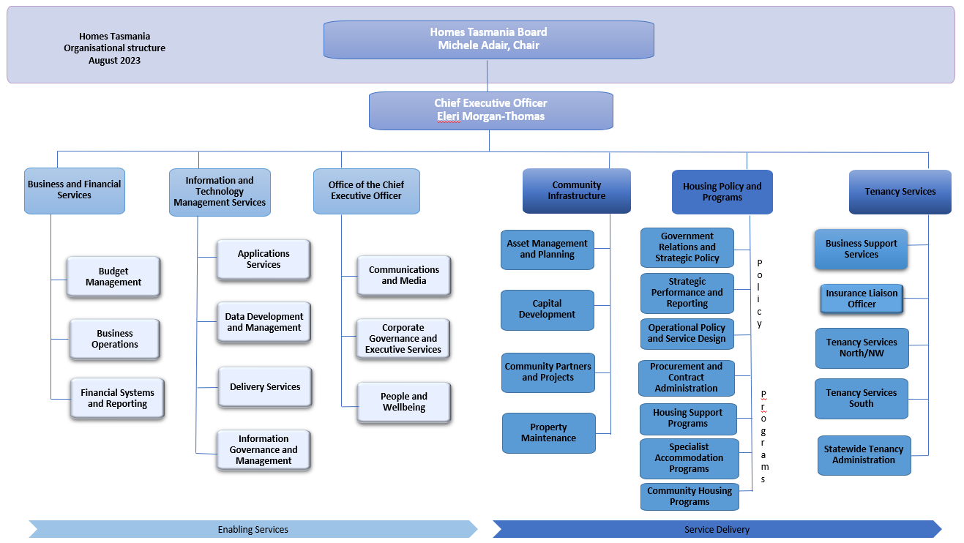
Primary Purpose
Under the general direction of the Manager, the Executive Services Officer will be responsible for supporting and providing executive support to the Chief Executive Officer. The officer will also:
- Assist in the coordination and management of the flow of information and requests between Homes Tasmania, Office of the CEO and Ministers Offices.
- Assist with the coordination of internal communications.
Primary Duties
- Provide executive support to the CEO including the following tasks -
- calendar, email and message management and triage
- organise meetings, including preparation, approvals, travel arrangements and distribution of papers
- action received correspondence via post, email, and online enquiries
- maintain the flow of communications and correspondence between the CEO, Homes Tasmania executive management, Minister’s Office, Office of the CEO, corporate units and external stakeholders
- use of standard office management support tools and business information systems.
- Provide a quality customer related service to stakeholders, including the ensuring sensitive and confidential handling of enquiries/matters.
- Assist in the preparation of documentation and correspondence and undertake general administrative and clerical duties.
- Actively participate in and contribute to Homes Tasmania’s commitment to being a healthy, safe, inclusive and wellbeing focused organisation.
- The incumbent can expect to be allocated duties, not specifically mentioned in this document, that are within the capacity, qualifications and experience normally expected from persons occupying positions at this classification level.

Level of Responsibility, Direction and Supervision
Under the general direction and supervision of the Manager, the Executive Services Officer will:
- Ensure that all work undertaken is aligned with and upholds Homes Tasmania values including a commitment to participate in building an inclusive workplace and workforce for Homes Tasmania.
- Exercise considerable initiative and a high level of judgment and discretion, with the ability to work independently on a day-to-day basis with reference to established procedures.
- Perform work which involves highly confidential matters and liaise with business units, corporate units, the Minister’s Office, and relevant stakeholders.
- Operate and support a broad range of information systems, applications and tools used by Homes Tasmania.
Essential Requirements
Registration/licences that are essential requirements of this role must remain current and valid at all times whilst employed in this role and the status of these may be checked at any time during employment. It is the employee’s responsibility to ensure that registration/licences remain current and to advise the Employer if their circumstances change. This includes notifying the Employer of any new criminal convictions and/or if a registration/licence is revoked, cancelled or has its conditions altered.
The Head of the State Service has determined that the person nominated for this job is to satisfy a pre-employment check before taking up the appointment, on promotion or transfer. The following checks are to be conducted:
- Conviction checks in the following areas:
    - crimes of violence
    - sex related offences
    - serious drug offences
    - crimes involving dishonesty
    - serious traffic offences (if Driver’s Licence is an essential requirement)
- Proof of identification check
- Disciplinary action in previous employment check.

Selection Criteria
- Demonstrated high level executive and administration support skills, including demonstrated experience in supporting senior executive/senior managers and committees.
- Effective high level written and oral communication skills, with the ability to provide quality customer services with courtesy and discretion.
- Demonstrated capacity to operate proficiently in a technological environment, including a high level of skills in the use of computer applications, especially Microsoft Office packages, and the ability to learn other computer applications required by the business unit.
- Sound teamwork skills, with the ability to liaise and maintain effective relationships with a range of stakeholders and customers, including the ability to obtain cooperation and assistance from people within and outside Homes Tasmania.
- Proven capacity to work under pressure in an environment of competing priorities and to meet identified timeframes.
- Ability to use problem solving skills, initiative, flexibility, sound judgment, and discretion including the ability to interpret and analyse information and recommend or decide upon appropriate action.
Values and Behaviours
We are a values-based organisation. Our aim is to attract, recruit and retain people who uphold our values and are committed to building a strong values-based culture. Our values and behaviours reflect what we consider to be important.
State Service Principles and Code of Conduct: The minimum responsibilities required of officers and employees of the State Service are contained in the State Service Act 2000. The State Service Principles at Sections 7 and 8 outline both the way that employment is managed in the State Service and the standards expected of those who work in the State Service. The Code of Conduct at Section 9 reinforces and upholds the Principles by establishing standards of behaviour and conduct that apply to all employees and officers, including Heads of Agencies. Officers and employees who are found to have breached the Code of Conduct may have sanctions imposed.
The State Service Act 2000 and the Employment Directions can be found on the State Service Management Office’s website at http://www.dpac.tas.gov.au/divisions/ssmo
Delegations: This position may exercise delegations in accordance with a range of Acts, Regulations, Awards, administrative authorities and functional arrangements mandated by Statutory office holders including the Secretary. The relevant manager can provide details to the occupant of delegations applicable to this position. Homes Tasmania has a zero tolerance in relation to fraud and in exercising any delegations attached to this role the occupant is responsible for the detection and prevention of fraud, misappropriation and other irregularities.
Records and Confidentiality: Officers and employees of Homes Tasmania are responsible and accountable for making and maintaining proper records, including using relevant information management systems. Confidentiality must be always maintained and information must not be accessed or destroyed without proper authority.
Smoke-free: Homes Tasmania is a smoke-free work environment. Smoking is prohibited in all State Government workplaces, including vehicles and vessels.
Health, Safety and Wellbeing: Homes Tasmania values and is committed to ensuring the health, safety, and wellbeing of our people. We aspire to zero harm, strive for continuous improvement in the prevention of incidents, injuries and illness and prioritise health, safety and wellbeing within our operating environment. Officers and employees of Homes Tasmania are responsible for compliance with the Work Health and Safety Act (Tas) 2012 and other relevant legislation, regulations, standards, and codes of practice, together with the authority’s health and safety policies, procedures, and practices.

