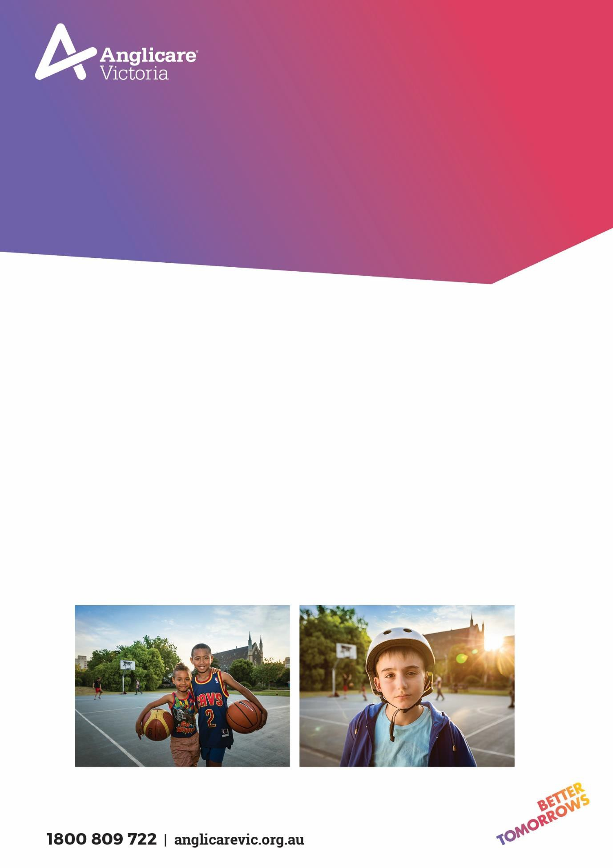
CASE MANAGER/ PLACEMENT & SUPPORT POSITION - HOME BASED CARE
FOSTER CARE PROGRAM SOUTHERN

At Anglicare Victoria our focus is on transforming the futures of children, young people, families and adults. Our work is based on three guiding pillars: Prevent, Protect and Empower.

We strive to create an environment where employees feel valued and rewarded.

At Anglicare Victoria we care about our employees in the same way that we care about our clients. We support and encourage our employees with a wide range of professional and personal opportunities to strengthen their overall well-being.

By living the Anglicare Victoria values and actively fostering fairness, equality, diversity and inclusion, our people make Anglicare Victoria a truly great place to work.

Page 1

Position details

Position | Case Manager/Placement & Support – Foster Care
Program | Southern Foster Care
Classification | SCHADS Award Level 5 (Social Worker Class 2)  (Classification will be dependent on qualification and years of experience within the relevant field consistent with the SCHADS Award)
Hours | Part Time
Hours per week | 30.4 Hours
Duration | 7 Months
Fixed term end date | 3rd of March 2023
Location | Southern Region, Dandenong Office
Reporting Relationship | Recruitment, Training & Retention Team Leader
Effective date | August 2022

Page 2

Overview of program
Anglicare Victoria provides foster care for children and young people who are temporarily unable to live at home. Anglicare Victoria is the State’s largest provider of foster care and plays a vital role in protecting children and young people by ensuring they have a safe, stable and nurturing home while their family cannot care for them.
Our Southern Foster Care program provides Complex, Intensive and General Home Based Care for children and young people aged between 0 and 18 years. Children enter foster care for a number of reasons, most being placed in out of home care following Child Protection intervention and can stay with our carers for as short as one night or for several years.

Position Objectives

Field enquiries from prospective volunteers, and to assist prospective and accredited volunteers with training and development.
Receive and respond to all enquiries and referrals from DHHS and volunteers.
Manage the volunteer pool for the purposes of providing support, supervision and compliance with program standards
Management of data requirements regarding placement and volunteers.
To provide children and young people with family based placements that will support their development and maintain them in a safe and secure environment.
To provide complex Home Based Care case management services to children, young people, their carers and their families. This involves co-ordination of support services as well as direct casework.
To ensure that placement goals established with the child, the child’s family, the caregiver family, and the case manager are achieved.
To ensure that practice procedures, as documented in program Referral Guidelines, Practice and Policy Manuals, including Department of Families, Fairness and Housing minimum Out of Home Care Standards are followed.

Page 3

Key responsibilities
The key responsibilities are as follows but are not limited to:

 | Develop and participate in recruitment activities including fielding and lodging enquiries from prospective volunteers.
2. | Organise and facilitate information sessions and training for prospective and existing volunteers, which may result in afterhours work.
3. | Develop and participate in support and retention activities for volunteers
4. | To liaise between the service user family, caregiver family and the referring worker providing consultation, advice, support, supervision, direction and management regarding the child’s placement to maintain a quality service.
5. | Undertake reviews of volunteers suitability and eligibility for ongoing accreditation
6. | To provide complex case management and support to carers and children in Out of Home Care placements.
7. | Receive and manage referrals from the community, the DFFH services and internal placement changes
8. | Maintain accurate and up to date file notes, and provide other reports in relation to placements where necessary; for example, Crisis Management Plans, Case Plan Reports, Court Reports, Post Placement Reports and Best Interest Plans. Reporting includes the use of various internal and external platforms and interfaces.

Page 4

Key Selection Criteria

Role specific requirements

A relevant tertiary qualification in Social Work, Psychology, Early Childhood Specialist and/or related behavioural sciences at degree level with proven experience; or associate diploma level with substantial experience in the relevant service stream.
Demonstrated case work experience in foster care, other out of home care programs, family services or within the community services sector, including knowledge and experience of assessment intervention strategies.

Demonstrated understanding of the Department of Families, Fairness and Housing, with a particular emphasis on the Child Protection function, and the ability to develop strong working relationships within the protective services field.
Highly effective communication, negotiation, advocacy and report writing skills.
Demonstrated ability to work under pressure, manage competing demands and respond in a crisis situation.
Staff must hold a valid WWCC and current driver’s licence at all times and undergo a Criminal Records Check prior to employment. Subsequently, staff must report any criminal charges or court appearances.

Child Safety
AV is committed to protecting children and young people from all forms of harm and abuse. As an employee you are required to report any concerns raised by, or on behalf of, children and young people in accordance with mandatory reporting, reportable conduct and incident management procedures. Everyone at AV has a role to play in keeping children and young people safe.

Occupational Health & Safety (OHS)
Anglicare Victoria is committed to ensuring the health and safety of its employees and any other individuals present in our workplaces.
In achieving and maintaining workplace health and safety, Anglicare Victoria will apply best practice in OHS in accordance with statutory obligations at all times.
All Anglicare Victoria employees, contractors and volunteers are required to:
- take reasonable care for their own health and safety and for that of others in the workplace by working in accordance with legislative requirements and the company’s OHS policies and procedures
- take reasonable care their actions or omissions do not adversely affect the health and safety of themselves and others
- cooperate with any reasonable directions, policies and procedures relating to health and safety in the workplace
- report all injuries, illness or ‘near misses’ to their Supervisor or Manager
- participate in relevant health and safety training based on roles and responsibilities
- as required, participate in the development and implementation of specific OHS hazard and risk management strategies
In addition to the above, positions with supervision or management responsibility are required to ensure a safe and healthy work environment for all employees, clients, contractors and visitors. This can be achieved by ensuring all people are aware of and have access to OHS policies, procedures, training and reporting systems.
Cultural Safety in the Workplace
Anglicare Victoria recognises the important and unique contribution Aboriginal and Torres Strait Islander employees make by bringing their unique skills, knowledge and experience to the workplace. They also contribute important insight into how Anglicare Victoria can provide for and engage with Indigenous clients and communities more effectively.
Our Reconciliation Action Plan (RAP) and Workforce Strategy outlines Anglicare Victoria’s commitment to leading and facilitating sustainable employment, training, retention and career development opportunities for Aboriginal and Torres Strait Islanders people.

Conditions of employment
- Salary and conditions are in accordance with the Social, Community, Home Care and Disability Services Industry Award (SCHADS) 2010. Salary packaging is offered with this position.
- All offers of employment at Anglicare Victoria are subject to a six month probationary period. The staff member will be asked to participate in an annual performance review linked to objectives set out for the position.
- All offers of employment are subject to a satisfactory Criminal History Check and an Employment Working with Children Check prior to commencement.
- A current Victorian Driver’s license is essential.
- In line with Anglicare Victoria’s Covid 19 Vaccination Policy all staff, students and volunteers are required to provide evidence of full vaccination against Covid-19 or provide a valid medical exemption. This requirement may be amended from time to time in line with Anglicare Victoria Policy or as directed by Chief Health Officer.
Acceptance of Position Description requirements

To be signed upon appointment

Employee
Name:
Signature:
Date:

Page 5

