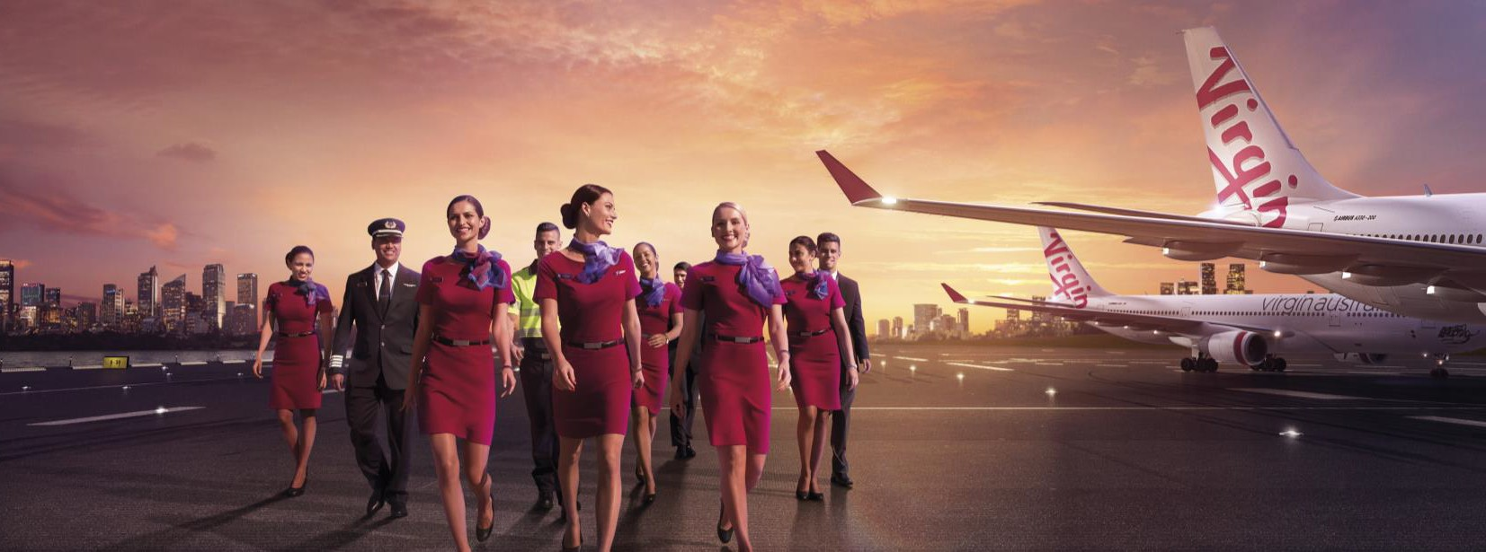
Virgin Australia
Position Description

Position Snapshot
Position Title:
Customer Strategy & Innovation Advisor
Business / Division / Department:
Brand, Marketing & Public Affairs
Location: Brisbane
Reports to: Customer Strategy & Innovation Specialist
Direct Reports: 0
Classification: 1
Employment: Fulltime
Date: 4 February 2019

Overall Impact Statement
The objective of the Customer Strategy & Innovation Advisor role is to influence brand, product, service, marketing and customer leaders to drive improved branded customer experience, customer acquisition & loyalty.
The role achieves this through:
- Analysing trends, competitor behaviour & insights to help define what customers value.
- Supporting the successful roll out of the Customer Centricity Transformation program by documenting current state processes, identifying improvements and documenting future state and plans to successful implement the change.
- Support in the development of customer experience initiatives that will drive customer value.

Organisation Context
Virgin Australia Group is a major Australian airline group which includes Tigerair and operates domestic and international regular passenger services, charter and cargo services and the loyalty program Velocity Frequent Flyer. It is proud of its reputation for customer service.

The Group employs around 10,000 team members in Australia, New Zealand, & the United States. We pride ourselves on recruiting the right people into the right roles and we’re always looking for team members in all specialties to join our award-winning team.

Virgin Australia Group team members are passionate believers in better. When we live our shared values, we can do things that most people would think impossible.

As a result, every person that we come into contact with; our guests, our customers, our colleagues and the community will feel and experience better outcomes, based on the interactions we have with them.

Key Accountabilities
- Analysing trends, competitor behaviour & insights to help define what customers value.
- A credible source of context of the broader societal issues & trends impacting people, travellers and brand expectations.
- Assist in designing, delivering, analysing and reporting trend and competitor research.

- Supporting the successful roll out of the Customer Centricity Transformation program.
- Document current state processes, identify improvements and document future state and plans to successfully implement the change.
- Assist with the development of future business requirements and improvement possibilities.
- Drive the implementation of new process and change.

- Support in the development of customer experience initiatives that will drive customer value.
- Innovative thinking that continues to challenge and deliver the unexpected to the market and surprise and delight our guests.
- Support in the delivery of compelling customer value propositions and innovations.
- Cost benefit analysis of customer experience initiatives to prove customer value and commercial return.
- Facilitate MVP trials of customer experience initiatives as required.

Key Requirements
 | Essential | Desirable
Knowledge | - Knowledge and leadership experience in best practice innovation tools and techniques.  - Knowledge and understanding about business processes.  - Demonstrated understanding of market research and analytics processes. | - Aviation sector understanding.  - Best practice innovation methodologies.
Qualifications | - Degree qualification in Business, Marketing, Psychology, Statistics or related discipline.
Skills | - A positive disposition and ability to relate well with others.  - Demonstrated ability to influence and engage internal teams.  - Strong written, numeric and verbal communication skills.  - Strong planning and organisational skills.  - Good presentation skills.  - Flexible, responsive and can handle pressure. | - Ability to think strategically and implement initiatives in a way that deliver upon business outcomes.  - Facilitation skills.
Experience | - 2+ years’ experience in an analytically orientated work environment.  - Experience in operating with a level of autonomy, structuring work effectively and coping with conflicting and changing demands.  - Demonstrated experience in being proactive and taking initiative.  - Experience working with agencies, including creating briefs, crafting reports and preparing presentations. | - Aviation sector experience.  - Business analyst experience.  - Product development experience.

Virgin Australia Leadership Standards
Standard | Level 1 Behavioural Descriptors
Passionately VA | - Displays a passion for delighting both internal and external customers  - Seeks to understand customer needs by actively listening to their thoughts and concerns  - Embraces diversity and is responsive to different experiences, perspectives, values and beliefs  - Is curious and continuously looks for ways to learn and improve  - Knows, understands and follows standard operating procedures  - Is authentic and honest, can admit to making mistakes
Desire to be Better | - Strives to improve experiences for internal and external customers  - Has a curious mind towards identifying opportunities and finding ways to be better  - Demonstrates a high level of personal motivation to learn and develop  - Resourceful and creative with coming up with solutions  - Identifies and contributes ideas for improvement  - Identifies, addresses and reports safety hazards
Collaborates | - Displays passion for sharing knowledge and ideas  - Voices opinions and new ideas freely  - Respects differences and seeks to understand diverse perspectives  - Works constructively in and across teams, viewing every interaction as an opportunity to collaborate  - Is curious and open-minded to new ideas, perspectives and approaches  - Clarifies own understanding and embraces alternate view  - Challenges behaviours that compromise safety
Inspires Team | - Participates in 2-way conversations, listening and discussing issues thoughtfully and openly  - Understands and values the skills, knowledge and experiences that others bring  - Engages with others, clearly conveying information and facts  - Actively seeks to provide suggestions on how to be a better team  - Informs team about work and progress  - Understands personal obligations with respect to following standard operating procedures
Creates Future | - Welcomes change and remains positive in the face of ambiguity  - Seeks information to understand change and impacts  - Demonstrates a change mindset, flexibility and openness  - Understands the need for VA Group to be innovative and drive business improvement  - Seeks to understand Virgin Australia’s strategy and how they can contribute  - Demonstrates forward-thinking and awareness of immediate consequences of actions ensuring safe outcomes
Drives Results | - Plans work to deliver within expected timeframes  - Shows energy, enthusiasm and initiative for achieving own goals  - Follows through on commitments to both internal and external customers  - Seeks guidance and support to address obstacles and achieve set goals  - Integrates feedback and takes responsibility for achieving own goals  - Delivers outcomes within standard operating procedures

