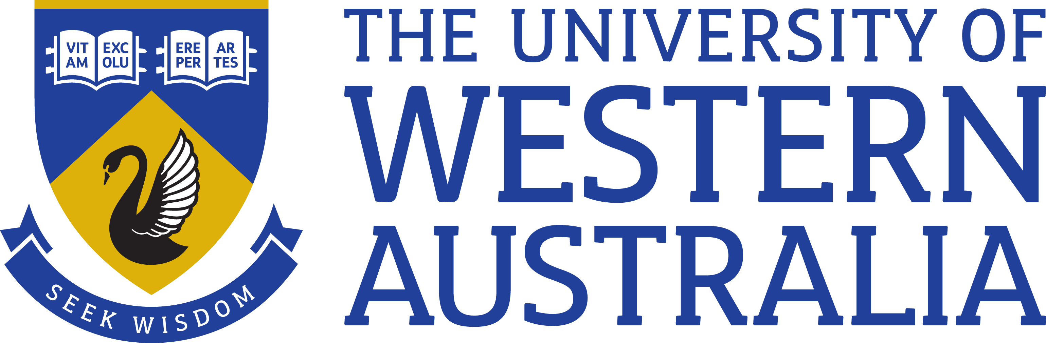

Position Title: Senior Educational Adviser
Position Classification: Level 7
Position Number: 316816
Faculty/Office: Deputy Vice-Chancellor (Education)
School/Division:
Centre/Section: Educational Enhancement Unit (EEU)
Supervisor Title: Associate Director, (Educational Innovation Strategy)
Supervisor Position Number: 316813
Your work area
The Educational Enhancement Unit enables innovation and excellence in teaching and learning across UWA that leads to an improved learning experience and better educational outcomes. The unit supports the implementation of the University’s Education strategy, through the provision of hands-on support to academic staff, facilitating collaboration and sharing of best practice, harnessing pedagogical expertise and working closely with academic leaders to drive a consistent strategy of educational enhancement.

Reporting Structure

Reports to: Associate Director, (Education Innovation Strategy)

Your role
As the appointee you will work, under broad direction, to provide key strategic planning advice and direction to drive education innovation and enhancement across the University.
Key responsibilities
Initiate and work collaboratively to facilitate the development of the education innovation strategy across multiple horizons (to meet present and future needs)

Develop and manage strategic University-wide projects to drive education innovation in accordance with the strategy

Report on Faculty and University-wide performance and strategy implementation against targets

Coordinate scholarships and awards programs in accordance with the strategy

Apply an extensive and in-depth knowledge to support the Associate Director in the development of the communication strategy for the educational enhancement function

Other duties as directed

Your specific work capabilities (selection criteria)
A bachelor level qualification or equivalent or higher with extensive experience in educational design in higher education
Demonstrated understanding of contemporary pedagogical theories and practices in higher education
Demonstrated ability to undertake research, analysis and report writing to support strategic decision making
Experience presenting and reporting on the outcomes of research and evaluation in an educational context

Excellent interpersonal, written and oral communication skills including the demonstrated ability to work with a variety of stakeholders at all levels to provide effective leadership in higher education
Demonstrated ability to think creatively and work positively and collaboratively in a complex environment
Excellent organisational and project management skills, including the ability to work independently, prioritise work, meet deadlines and agreed outcomes and plan and implement new initiatives
Commitment to continuous learning and a scholarly and professional approach to work
Special Requirements (selection criteria)
There are no special requirements
Compliance

Workplace Health and Safety
All supervising staff are required to undertake effective measures to ensure compliance with the Occupational Safety and Health Act 1984 and related University requirements (including Safety, Health and Wellbeing Objectives and Targets).
All staff must comply with requirements of the Occupational Safety and Health Act and all reasonable directives given in relation to health and safety at work, to ensure compliance with University and Legislative health and safety requirements.
Details of the safety obligations can be accessed at http://www.safety.uwa.edu.au

Equity and Diversity
All staff members are required to comply with the University’s Code of Ethics and Code of Conduct and Equity and Diversity principles. Details of the University policies on these can be accessed at http://www.hr.uwa.edu.au/publications/code_of_ethics, http://www.equity.uwa.edu.au

