Position Number(s) | 003208/004772/004293/003865/003796/001289/005274/  005279/000232/004577/003897/003974/001380/002861/  004156/002355/002961/000099/000036/002264/002332/  002339/002669/002397/002597/001346/000335/002926/  002927/003015/000233/000338/003110/003232/003806/  001778/002904/004036/004665/004075/003883/002865/  003057/001308/001836/004044/004088/004124/004195/  004223/003664/003913/003920/004599/005237/002555/  003855/002583/001211/003798/004325/002617/004292/  003799/003724/003526/003663/002863/004053/001394/  001304/000986/001229/001294/001297/001299/001352/  001405/001149/001173/001212/001213/001019/001194/  001214/001355/001360/001335/001378/002646/002846/  004202/005817/005902/006178/003219/003582 | Manager’s Role Title | District Leader
Business Group | Customer Delivery | Manager Once Removed | Manager Networks
Level of Work | VI SA Water Hierarchy Level | Direct Report’s Role Title(s) | Not applicable

Purpose (Unique value add)
Contribute to the efficient achievement of regional performance targets for customer satisfaction, safety, environment and water quality, by carrying out field based preventative, corrective maintenance and emergency response activities.

Objectives
The objectives (maximum 6) of this role are to:
- Regularly take charge of the preparation, on-site control, quality and completion of specific jobs and/or work programs through allocation and determination of work priorities.
- Responsible for field control of water supply and sewerage functions in a district.
- Influence and contribute to technical on the job decisions.
- Assist in the training of Network Operators and ensure the quality of work of other Network Operators.
- Lead role in on-site field/water emergency response.
- Make in the field decisions affecting service continuity.

Shared Organisational Goals
As a member of the Customer Delivery Group you are collectively accountable for delivering our goals and objectives.

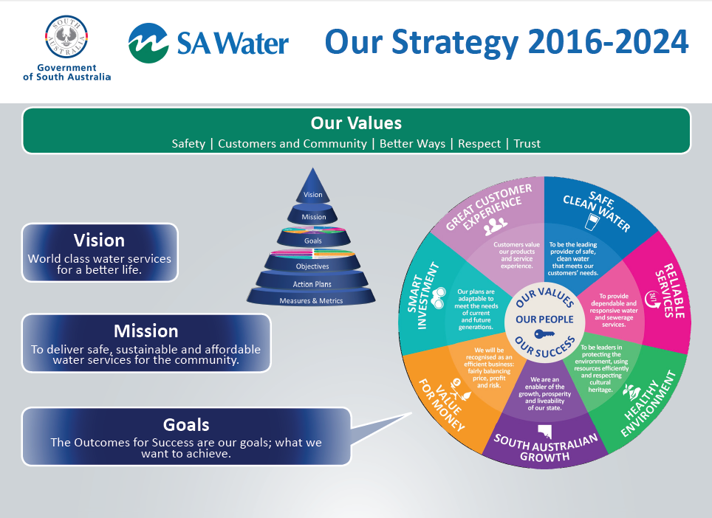
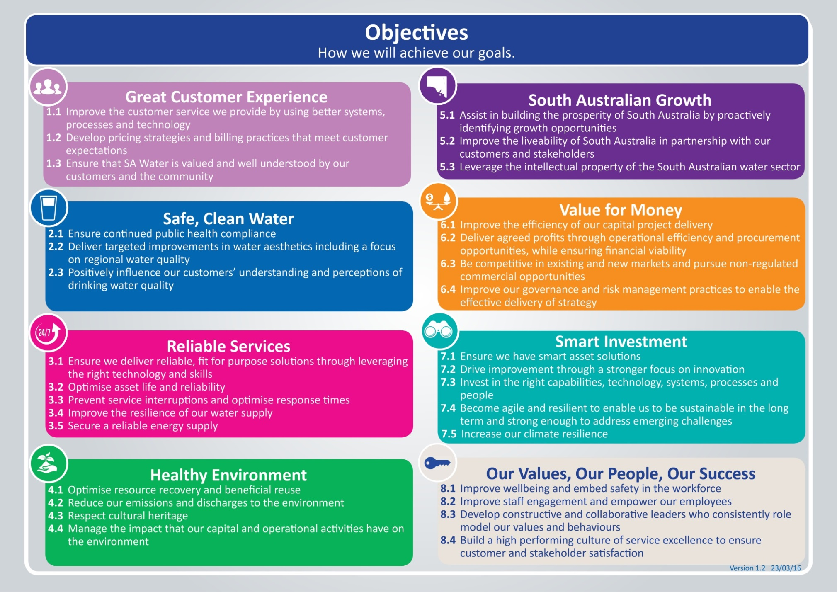

Key Accountabilities
Select relevant objectives from section 1.3 of this PD: Our Strategy 2016-2024 (also available on the AquaNet) and add them to the table as key accountabilities.
The key accountabilities (minimum 4 and maximum 6 including the mandatory ones), of this role are:
Key Accountabilities | Output/Measures
Mandatory accountability:  Contribute effectively to the team ensuring efforts are aligned toward achieving team goals | - Implement the direction set by your people leader.  - Complete specific tasks allocated.  - Collaborate effectively to ensure team goals are achieved by providing input into decision making and problem solving.  - Actively contribute to creating a culture of service excellence.
Mandatory accountability:  Put safety above all else | - Be aware of and apply roles and responsibilities in accordance with WHS Roles and Responsibilities Procedure.  - Take responsibility for the safety and wellbeing of yourself and others including your own fitness for work (e.g. under the influence of drugs, alcohol and/or fatigue).
Achieving standards and timeframes | - Compete all relevant tasks and activities to the required standard and timeframe.
Compliance with systems | - Utilise and comply with all relevant electronic/paper systems, processes and procedures.
Utilisation of resources | - Use and maintain all relevant tools, materials, equipment and vehicles appropriately.
Customer service | - Communication occurs between customers and colleagues to ensure the best outcome.  - Maintain a high level of service that meets customer’s expectations.  - Customer issues are resolved in a timely manner.

Behavioural Competencies
Uphold SA Water’s Values:
- Put safety above all else
- Act in the best interests of customer and the community
- Seek and apply better ways
- Respect our people
- Be trustworthy

Behavioural Competencies | Behavioural Expectations
Customer Focus | - Anticipates needs of customer and follows through.  - Makes decisions that take into account value for customer.  - Speaks up and identifies problems arising.
Collaborate for Success | - Works co-operatively with others to achieve the best outcomes.  - Maintains effective working relationships with others in the team and across the business.  - Treats people in an honest, courteous and respectful manner.
Self-Management | - Focuses on delivering services despite challenges.  - Presents ideas clearly and concisely.  - Is responsive to the changing needs of our customers and business by adapting to change.
Achieve Results | - Takes personal responsibility for mistakes and learns from them.  - Looks for ways to continually improve and finds better ways.  - Focuses on achieving outcomes using good judgement and quick decisions that lead to business success.
Safety Culture | - Puts safety first when making decisions.  - Adheres to safety processes and procedures and reports when things are ‘not right’.  - Openly communicates ways of improving safety.

Knowledge, Skills and Experience

Foundation knowledge, skills, experience and qualifications | Essential or Desirable
Certificate 2 in Water Operations | Desirable
Driver’s Licence | Essential
White Card | Essential
Work Zone Traffic Management | Essential
Skilled in the use and maintenance of hand and power tools, small machinery and various static and mobile vehicles, plant and machinery | Desirable
Understanding of operation and maintenance of water and wastewater systems | Desirable
Knowledge of OHS&W, Water Quality and Environmental procedures | Desirable
Ability to do basic calculations | Desirable
Communication skills – written and verbal (complete routine forms) | Desirable
Basic computer skills including data entry | Desirable
Ability in using data capture equipment | Desirable
Experience in civil construction | Desirable

Key Stakeholder Relationships
- SA Water management
- Contractors
- SA Water customers (i.e. general public)
- Workshops

Special Conditions
- Flexible hours and some after hours as required, some intra and interstate travel.
- On call

Template: Position Description - Level 6/7 Employee Version 3.01 22/11/16 -Document ID: SAWT-HR-0025

