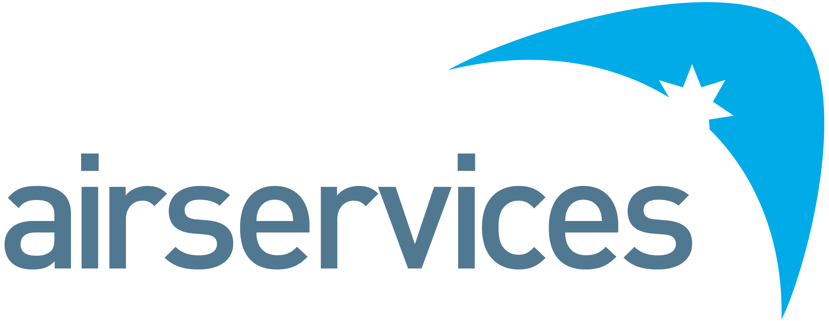
OneSKY Support System Engineer
Position Detail
Reports To | OneSKY Technical Lead – Support System | Group | OneSKY Joint Program
Budget Accountability | Nil | Location | MEL
Delegations:  - Administrative  - Financial | Nil | Reports:  - Direct  - Total | -

Organisational Environment
Airservices is a government-owned organisation providing safe, secure, efficient, and environmentally responsible services to the aviation industry. Each year we manage over four million aircraft movements carrying more than 140 million passengers and provide air navigation services across eleven per cent of the world’s airspace.
Airservices has two major operating centres in Melbourne and Brisbane and a corporate office in Canberra. We operate 29 air traffic control towers at international and regional airports, and provide aviation rescue fire-fighting services at 26 Australian airports.
The Royal Australian Air Force is charged with providing Air and Space Power to the Australian Government to achieve its national security outcomes. Within the Royal Australian Air Force, Number 44 Wing is charged with providing Air Traffic Control services, operating twelve air traffic control towers and nine approach control facilities across Australia as well as providing tactical battlefield airspace control from deployed locations.
The OneSKY Australia Program is responsible for the planning, development, and implementation of Airservices next generation services including the future Civil-Military Air Traffic Management System (CMATS), Airservices Defence OneSKY Towers (ADOT) and Bypass Voice Communication System (BVCS), where CMATS and ADOT are a joint activity with the Department of Defence.
The OneSKY Program is enabling the fundamental organisational and industry transformation required to maximise the benefits and value of the future system as expected by Airservices and Defence customers and stakeholders.
The OneSKY Joint Program Engineering Team is part of the OneSKY Joint Program Team (JPT) and is responsible for the Engineering delivery of CMATS, ADOT and BVCS projects within OneSKY.
Primary Purpose of Position
The purpose of the OneSKY Support System Engineer is to provide System Engineering expertise to ensure that the Support System Design and Verification outcomes, as planned and delivered by the Contractor(s), achieve the Airservices and Defence technical requirements as defined in the appropriate Acquisition Contract. This in turn supports Design Acceptance of the new systems for Airservices and Defence.
The work-focus areas align with the specific Project milestones: Design, V&V, and Acceptance.
The OneSKY Support System Engineer will build their subject matter expertise over time across the major functions of the applicable Project’s Support System. They understand or build their understanding, of the functions from a Capability Baseline and Functional Baseline perspective.
The OneSKY Support System Engineer must become familiar with technical issues that arise and escalate them as appropriate through the proper channels.
You will support the analysis, compilation, and collation of compliance evidence against the Support System technical baselines, and against engineering-related entry, conduct, and exit criteria for Program milestones.
You will form an integral part of the OneSKY CMATS Joint Program Team; adopt a system wide approach and will support Safety, Security and Human Factors in delivering and maintaining high quality artefacts to support the Defence design acceptance strategy and Airservices record of Safety, Environmental, WHS, Risk, and Compliance excellence.
Accountabilities and Responsibilities
Position-specific:
- Work in the OneSKY CMATS Joint Program Engineering Team to:
  - Review Project documents, and act as Review Lead (as applicable) for Contractor deliverable documents (focussing on the Support System); and deliver these reviews against Project milestones (including contractual milestones), including milestone criteria
  - Ensure the technical correctness, integrity, and consistency of the applicable contractor specifications
  - Ensure the Contractor’s design and implementation are compliant with specified requirements
  - Provide engineering advice and support to the Technical Lead – Support System
  - Participate in workshops, working groups, and Contractor-conducted formal events
  - Support the collation and delivery of AV&V outcomes in a timely manner to support the Commissioning process
- Work with the Technical Lead – Support System to:
  - Report progress against assigned tasks
  - Escalate issues and risks
  - Confirm priorities
- Work with the Contractor in a collaborative and supportive way
- The OneSKY Support System Engineer has the support of:
  - The Technical Lead – Support System
  - OneSKY CMATS Joint Program Engineering Manager
  - Project Managers
  - OneSKY Project Engineers
  - OneSKY Design Acceptance Team
People:
- Be part of a high-performance team with an emphasis on an accountable performance culture
- Develop and maintain a highly effective working relationship within the OneSKY Program and other internal and external stakeholders to ensure open and transparent communication and resolution of technical issues
- Contribute to the development of project and program engineering staff through mentoring and advocating and effectively application of sound Systems Engineering process to achieve project objectives.
Systems, Safety and Reporting Compliance
- Demonstrate behaviours consistent with enterprise strategies, and perform duties in accordance with work health and safety accountability requirements
Key Performance Indicators
Efficient, Effective and Accountable
- Builds and maintains effective relationships at working levels
- Takes responsibility for actions, outcomes, and people
- Achievement of OneSKY Program objectives
People and Safety
- Effective engagement
- Training and development
- Compliance with regulatory standards, safety, risk, environmental and any other standards.
Key Relationships
As a Support System Engineer:
- The Technical Lead – Support System
- OneSKY Joint Program Engineering Team
- OneSKY Project Managers
- OneSKY Design Acceptance Team
- OneSKY teammates
- OneSKY stakeholders.
Skills and Competencies
- Required to:
  - Hold tertiary qualification in Engineering or commensurately experienced
  - Be eligible for registration at the chartered level by a recognised professional body
  - Be eligible for registration as a Professional Engineer in relevant area of engineering in accordance with relevant legislation e.g. Professional Engineer Queensland (RPEQ)
- Required to be able to:
  - Understand systems engineering processes
  - Speak to engineering issues to engineering audiences
  - Develop and present innovative solutions
- Preference to have experience in the Air Traffic Control, Airport Tower Control systems or similar engineering fields. Required level of experience is dependent on the specific role.
Security Clearance
- May be required to hold an Australian Government security clearance up to Negative Vetting Level 1 [SECRET]
Performance Standards and Behaviours
As a member of the OneSKY program, Airservices or Defence, you will consistently demonstrate performance standards and behaviours that meet Airservices Code of Conduct or similar. This includes:
- Treating everyone with dignity, respect, and courtesy
- Acting with honesty and integrity
- Acting ethically and with care and diligence
- Complying with all OneSKY organisations’ policies and procedures, and applicable Australian laws
- Disclosing and taking reasonable steps to avoid any actual, potential, or perceived conflict of interest
- Behaving in a way that upholds our vision, mission, and values, and promotes the good reputation of the OneSKY program and the organisations the program represents.

