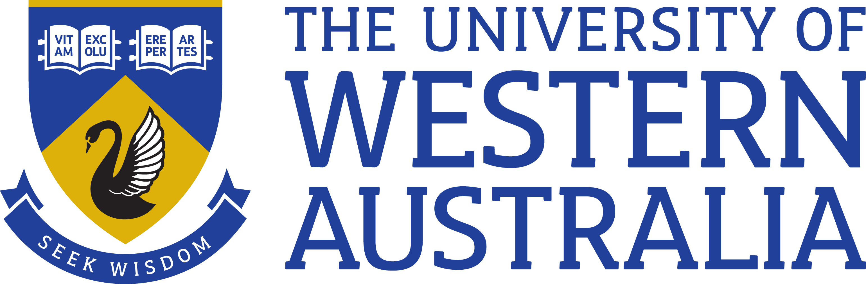

Position Title: Senior Lecturer (SIMS)
Position Classification: Level C/D
Position Number: xxxxxx
Faculty/Office: Deputy Vice Chancellor (Research)
School/Division: Research Infrastructure Centre
Centre/Section: Centre for Microscopy, Characterisation and Analysis
Supervisor Title: Director
Supervisor Position Number: 307221
Your work area
The Centre for Microscopy, Characterisation and Analysis (CMCA) comprises ~35 academic, research, technical and administrative staff supporting a diverse range of instrument platforms including secondary ion mass spectrometry (SIMS), electron microscopy and microanalysis, optical, confocal, and multiphoton microscopy, flow cytometry, NMR, X-ray diffraction, biological and molecular mass spectrometry, small animal imaging, scanning probe microscopy, and micro-CT. The CMCA’s mission is to enable research excellence by providing access to world-class scientific infrastructure and expertise in characterisation to researchers and industry.
The CMCA’s Ion Probe Facility is one of the best-equipped SIMS facilities in the world, housing three state-of-the-art instruments – a CAMECA IMS 1280 large-geometry ion probe, and two CAMECA NanoSIMS 50s. The IMS 1280 is a flagship of the Australian Microscopy & Microanalysis Research Facility (AMMRF) and plays a crucial role in the geochemical workflow of minerals analysis in Australia. The lab also supports the activities of the International Atomic Energy Agency (IAEA) by providing isotopic analyses for nuclear safeguards. The IMS1280 was recently upgraded with a Hyperion RF plasma ion source for the generation of O- primary ions. The Facility is supported by other geoscience-based analytical techniques such as SEM, EPMA and XRD, and is closely linked to UWA’s LA-ICPMS facility.
For further information, please contact Professor Matt Kilburn matt.kilburn@uwa.edu.au
Reporting Structure
Direct Report: Director, CMCA
Teams: SIMS Technique Group, Geoscience Application Group
Role statement
As an expert in stable and/or radiogenic isotopes systems relevant to geoscience, you will undertake academic leadership and management of the CAMECA IMS1280 laboratory, maintaining the Facility’s position at the forefront of geochemical analysis within Australia. You will initiate and conduct collaborative research with a broad range of users, locally, nationally and internationally. You will be responsible for the day-to-day management of the IMS1280 laboratory, overseeing and coordinating user training and maintenance of the Facility. You will take responsibility for the quality of data produced in the laboratory, and oversee quality control procedures in the acquisition, processing and interpretation of data by users and technical staff. You will perform the full range of academic activities, including individual and collaborative research, teaching and training, and student supervision. As part of the SIMS Technique Group and the Geoscience Application Group, you will contribute to the provision of support to researchers making use of cognate capabilities, such as LA-ICPMS, NanoSIMS, SEM and EPMA, leading to high impact research outcomes. As academic leader, you will represent the facility locally, nationally and internationally, and be the main point of contact for users and stakeholder who support the Facility’s activities.
Key responsibilities
Take responsibility for the management of the CAMECA IMS1280 laboratory as a user facility, maintaining the schedule and monitoring the scientific quality, outputs and usage of the facility;
Initiate and undertake an independent research program utilising SIMS and engage in collaborative research projects within the University and across the wider research community;
Provide academic and technical expertise to users in all areas of SIMS including experiment design, sample prep, data acquisition, statistical evaluation and interpretation;
Take responsibility for maintenance, care, and security of the laboratory, coordinating routine maintenance, troubleshooting and repair;
Direct and supervise postgraduate research projects;
Engage in the teaching and demonstration of the principles of SIMS to HDR, Honours, and undergraduate students – from first principles to advanced concepts;
Supervise a Senior Research Officer involved in the day-to-day operation of the Facility, and provide mentorship to other academic and professional staff;
Provide support to the SIMS Technique Group, in maintaining current knowledge of developments in SIMS, and engaging in strategic planning regarding future upgrades and acquisitions;
Coordinate experimental development and implementation of new methodologies, using the new ion source;
Coordinate or contribute to competitive funding applications, including applications for new instrumentation and ancillary facilities;
Promote the Ion Probe Facility and help to coordinate its national roles engaging with stakeholders (for example, AMMRF, AuScope, IAEA,) and leading researchers to ensure outstanding collaborative outcomes;
Other duties as required.
Your specific work capabilities (selection criteria)
Essential:
PhD in a relevant field (Geoscience, Chemistry, Physics);
Demonstrated knowledge and experience with Secondary Ion Mass Spectrometry (SIMS); experience with large-geometry ion probes would be a distinct advantage;
Substantial research experience in stable and/or radiogenic isotope systems relevant to geoscience.
Demonstrated ability to carry out independent research, and willingness to participate in collaborative research;
Ability and willingness to direct and maintain a multi-user SIMS facility;
Demonstrated ability to attract research funding through competitive grant applications;
Excellent written and verbal communication skills, and the ability to work effectively as part of a dynamic, multidisciplinary team;
Excellent organisational skills and demonstrated ability to set priorities and to meet deadlines.
Desirable:
Experience with CAMECA IMS1280 ion probe;
Experience in a range of in situ analysis techniques, e.g. LA-ICPMS, EPMA, SEM;
Experience in computer programming and statistical evaluation of data.
Compliance
Workplace Health and Safety
All supervising staff are required to undertake effective measures to ensure compliance with the Occupational Safety and Health Act 1984 and related University requirements (including Safety, Health and Wellbeing Objectives and Targets).
All staff must comply with requirements of the Occupational Safety and Health Act and all reasonable directives given in relation to health and safety at work, to ensure compliance with University and Legislative health and safety requirements.
Details of the safety obligations can be accessed at http://www.safety.uwa.edu.au
Equity and Diversity
All staff members are required to comply with the University’s Code of Ethics and Code of Conduct and Equity and Diversity principles Details of the University policies on these can be accessed at http://www.hr.uwa.edu.au/publications/code_of_ethics, http://www.equity.uwa.edu.au

