Faculty / Division: DVCA
School / Unit: Student Lifecycle
Position Level: Level 5
Position Number:
Position Title: Administrative Officer, Student Records
Date Written: April 2018

ORGANISATIONAL ENVIRONMENT
UNSW is currently implementing a ten year strategy to 2025 and our ambition for the next decade is nothing less than to establish UNSW as Australia’s global university. We aspire to this in the belief that a great university, which is a global leader in discovery, innovation, impact, education and thought leadership, can make an enormous difference to the lives of people in Australia and around the world.
Following extensive consultation in 2015, we identified three strategic priority areas. Firstly, a drive for academic excellence in research and education. Universities are often classified as ‘research intensive’ or ‘teaching intensive’. UNSW is proud to be an exemplar of both. We are amongst a limited group of universities worldwide capable of delivering research excellence alongside the highest quality education on a large scale. Secondly, a passion for social engagement, which improves lives through advancing equality, diversity, open debate and economic progress. Thirdly, a commitment to achieving global impact through sharing our capability in research and education in the highest quality partnerships with institutions in both developed and emerging societies. We regard the interplay of academic excellence, social engagement and global impact as the hallmarks of a great forward-looking 21st century university.
To achieve this ambition we are attracting the very best academic and professional staff to play leadership roles in our organisation.

UNSW BEHAVIOURS
UNSW recognises the role of employees in driving a high performance culture. The behavioural expectations for UNSW are below.

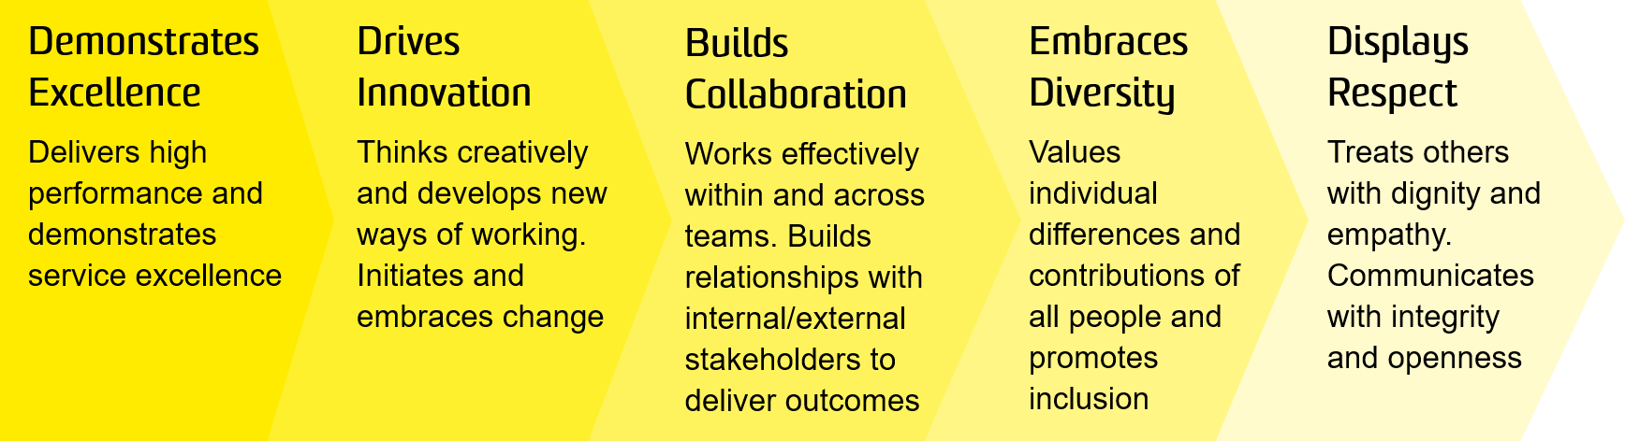

OVERVIEW OF RELEVANT AREA AND POSITION SUMMARY
The Student Services and Systems (SSaS) portfolio, within the Division of the Deputy Vice-Chancellor (Academic), has responsibility for a broad range of student services that cover the whole student lifecycle from recruitment to graduation. The Student Lifecycle team play a key role in ensuring that students progress seamlessly through the milestone events of their UNSW academic career and is responsible for delivering trusted advice to both students and staff, ensuring that policies and procedures are easy to understand and applied consistently and fairly.
The Administrative Officer, Student Records will undertake core business processes within the Student Lifecycle but will primarily focus on enrolment, progression, data verification and the central management of student records.
The role of Administrative Officer, Student Records reports to the Manager, Student Records. As this is a new role in a newly formed service of the University, direct reporting relationships are still under consideration and will be developed during 2018.

RESPONSIBILITIES
Specific responsibilities for this role include:
Operational Support
- Be the contact for and have responsibility for all aspects of maintaining undergraduate, postgraduate coursework and non-award student academic records for one or more Faculties.
- Provide advice to staff and students on policies and procedures relating to the student lifecycle.
- Provide verification of qualifications to third parties
- Produce academic transcripts on request for current and past students.
- Manage work to ensure a cooperative and effective working environment that contributes to positive internal and external working relationships.

General
- Undertake the full range of administrative activities and undertake other duties as required as commensurate with the role within a positive services-based culture, using UNSW values: Excellence, Innovation, Collaboration, Diversity and Respect.
- Contribute to the review, evaluation and update of local procedures in consultation with Manager.
- Cooperate with all health and safety policies and procedures of the university and take all reasonable care to ensure that your actions or omissions do not impact on the health and safety of yourself or others.

SELECTION CRITERIA
- A relevant Tertiary qualification with relevant experience or an equivalent level of knowledge gained through other education, training and/or experience.
- Demonstrated experience in and a proven commitment to, customer service.
- Excellent oral and written communication skills, with the ability to liaise at all levels and with people from diverse backgrounds and cultures.
- Proven ability to work in a high volume, process driven administrative environment with variable workflow patterns.
- Excellent organisational skills, with proven experience of meeting deadlines.
- Demonstrated ability to work accurately and with attention to detail.
- Demonstrated ability to effectively solve problem/enquiries and work with limited supervision
- Demonstrated experience of interpreting and applying policy and procedure documents.
- Demonstrated experience in the use of standard office desktop software such as email, word processing, spreadsheets and internet applications for researching and preparing reports, statistics and other documents.
- Knowledge of health and safety responsibilities and commitment to attending relevant health and safety training.
It is not the intention of the position description to limit the scope or accountabilities of the position but to highlight the most important aspects of the position. The aspects mentioned above may be altered in accordance with the changing requirements of the role.

