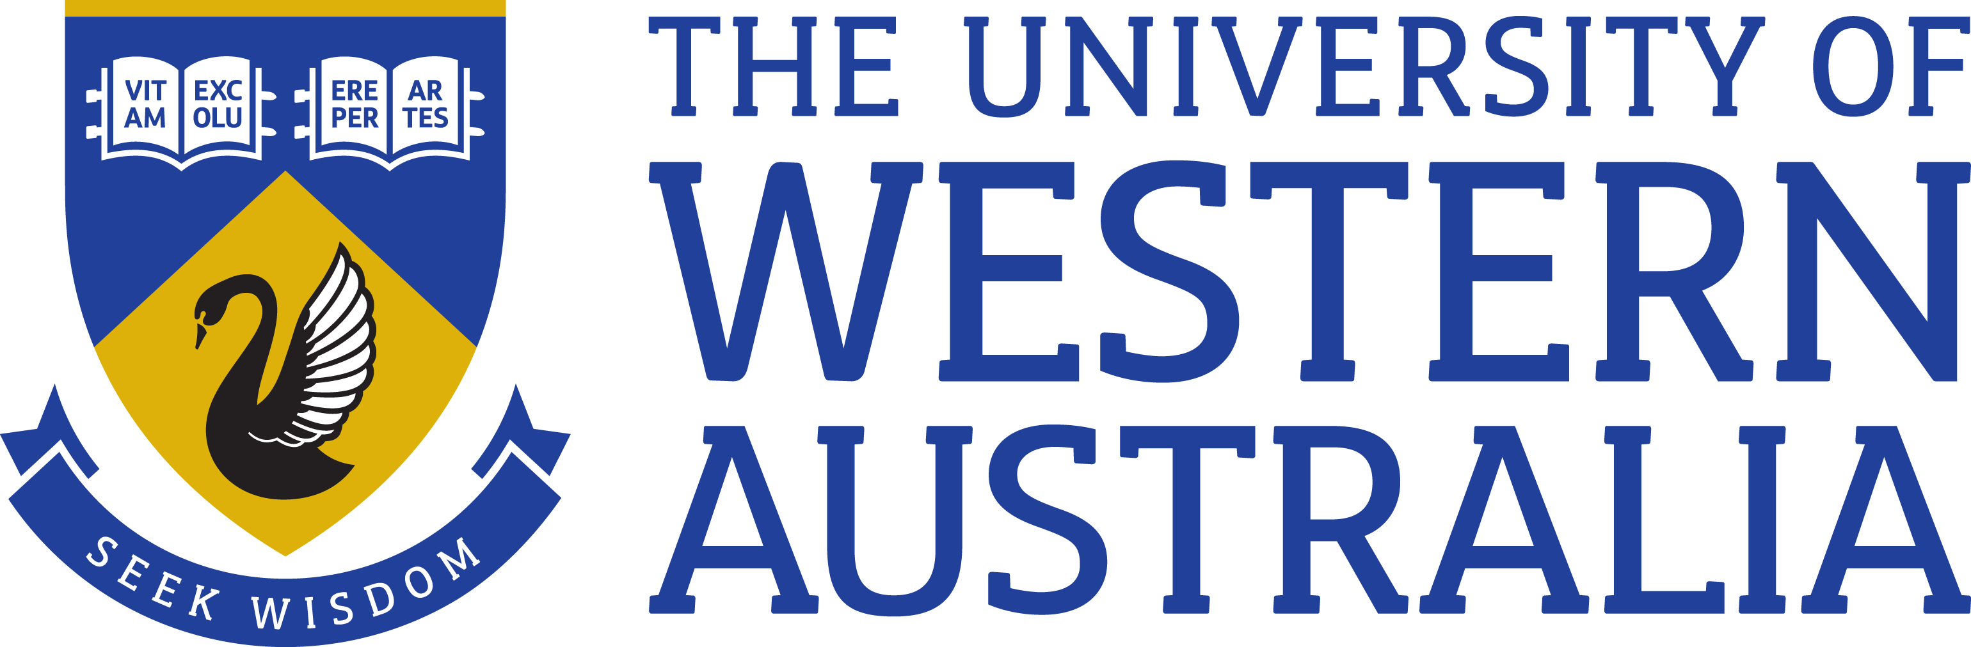

Position Title: Technical Manager, Platform and Storage
Position Classification: Level 9
Position Number: 315596
Faculty/Office: Information Technology
School/Division: Central Unit
Centre/Section: Infrastructure and Platform Services
Supervisor Title: Associate Director, Infrastructure and Platform Services
Supervisor Position Number: 315588

Your work area

UWA is making significant investments in the Information and Technology Services to enable its strategic direction and goals. UWA is also looking to utilise technology advancements to expand its services and create new and innovative teaching and research models.
Robust, flexible, integrated and agile enterprise architecture, information and technology services are vital to enabling the university strategic objectives.
Reporting Structure

Repors To: Associate Director, Infrastructure and Platform Services

Direct Reports: Platform & Storage Specialists

Your role

The Technical Manager, Platform and Storage is responsible for providing leadership and strategic direction for storage, computing and infrastructure software platform services. This includes the development, operation, maintenance and support of these services, the implementation of best practices, project planning and management leading to the deployment of new services.
Key responsibilities

- Lead the Platform and Storage Team to provide support, monitoring and maintenance of the storage, computing and infrastructure software platforms to Service Level Agreement Levels.

- Research, analyse and make recommendations for future storage, computing and infrastructure software platform requirements across the University.

- Champion the design of the platform & storage services through working with internal teams and external providers.

- Follow the appropriate IT policies and processes to ensure efficient and effective delivery of platform & storage operations.

- Manage the delivery, escalation and close out of requests, incidents and problem management for the platform and storage services.

- Ensure data recoverability by implementing a schedule of system backups and archive operations along with regular testing of data recovery and backups.

- Ensure the documention of technical configuration, problems, error messages, troubleshooting steps and action plans are kept up to date, contributing to the technical knowledge base.

- Lead and motivate the Platform and Storage Team to maximise potential and ensure clarity of roles and expectations.

- Recruit appropriate talent, effectively manage and develop employees through communication, appraisals, objective setting, performance management, mentoring and training to bridge skills gaps.

- Embed a culture of service excellence, innovation and continuous improvement founded on cohesiveness, team work and flexibility.

- Other duties as directed.

Your specific work capabilities (selection criteria)

- Relevant University degree or equivalent.

- ITIL Certification or demonstrated experience in ITIL processes

- Extensive experience in designing, supporting, monitoring and maintaining platform and storage services in large and complex organisations.

- Highly developed skills in managing technical teams and external service providers.

- Superior analytical and problem solving skills, and the ability to interpret needs and recommend appropriate solutions within a changing environment.

- Highly developed written and verbal communication skills.

- Demonstrated proven ability to communicate with substantial influence, establish positive stakeholder relationships and negotiate competing priorities whilst always remaining fully customer focused.

- Working knowledge of the Higher Education sector is desirable.

Special Requirements

Some after hours and weekend work may be required.

Compliance

Workplace Health and Safety

All supervising staff are required to undertake effective measures to ensure compliance with the Occupational Safety and Health Act 1984 and related University requirements (including Safety, Health and Wellbeing Objectives and Targets).

All staff must comply with requirements of the Occupational Safety and Health Act and all reasonable directives given in relation to health and safety at work, to ensure compliance with University and Legislative health and safety requirements.
Details of the safety obligations can be accessed at http://www.safety.uwa.edu.au

Equity and Diversity

All staff members are required to comply with the University’s Code of Ethics and Code of Conduct and Equity and Diversity principles. Details of the University policies on these can be accessed at http://www.hr.uwa.edu.au/publications/code_of_ethics, http://www.equity.uwa.edu.au

