Faculty / Division: UNSW Law
School / Unit: UNSW Law
Position Level: 7
Position Number: XXXXXX
Position Title: International Development Coordinator (Law)
Date Written: July 2018

ORGANISATIONAL ENVIRONMENT
UNSW is currently implementing a ten year strategy to 2025 and our ambition for the next decade is nothing less than to establish UNSW as Australia’s global university. We aspire to this in the belief that a great university, which is a global leader in discovery, innovation, impact, education and thought leadership, can make an enormous difference to the lives of people in Australia and around the world.
Following extensive consultation in 2015, we identified three strategic priority areas. Firstly, a drive for academic excellence in research and education. Universities are often classified as ‘research intensive’ or ‘teaching intensive’. UNSW is proud to be an exemplar of both. We are amongst a limited group of universities worldwide capable of delivering research excellence alongside the highest quality education on a large scale. Secondly, a passion for social engagement, which improves lives through advancing equality, diversity, open debate and economic progress. Thirdly, a commitment to achieving global impact through sharing our capability in research and education in the highest quality partnerships with institutions in both developed and emerging societies. We regard the interplay of academic excellence, social engagement and global impact as the hallmarks of a great forward-looking 21st century university.
To achieve this ambition we are attracting the very best academic and professional staff to play leadership roles in our organisation.

UNSW BEHAVIOURS
UNSW recognises the role of employees in driving a high performance culture. The behavioural expectations for UNSW are below.
Please refer to the UNSW Behavioural Indicators for the expectations of your career level (level 7).

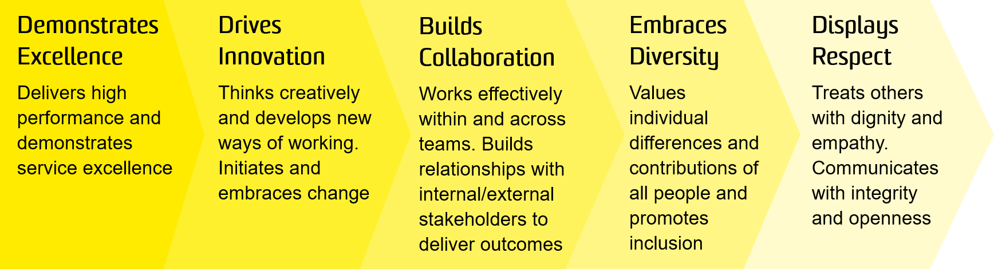

OVERVIEW OF RELEVANT AREA AND POSITION SUMMARY
Ranked 16th in the world (QS 2018), UNSW Law is Australia’s leader in progressive and rigorous legal education and research. Inspired by principles of justice, UNSW Law through its teaching, research and community outreach, promotes a holistic understanding of law and its role in society. UNSW Law includes more than 90 academics, many of whom are leaders in their areas of research interest. The Faculty’s research is organised around a range of centres and disciplinary clusters.
The International Development Coordinator will play a key role in supporting UNSW Law’s strategic objectives in relation to Academic Excellence in Education and Global Impact. The position is responsible for supporting the development of activities and priorities around international engagement, particularly around recruitment of high quality and diverse students into the LLB, JD, LLM and PhD programs and the development of key international relationships.
The position will be integrated into the Law Faculty, with significant involvement with the Law Faculty’s international operations, particularly in relation to the activities of the Dean of Law, the Associate Dean (International & External Engagement), Director of Postgraduate Studies (International), and Business Partner (External Relations), as well as our South East Asia specialist. The position will also work closely with the Head of School and Associate Dean (Education) as well as the Offshore Recruitment team within the Division of External Relations (DEx) to facilitate the necessary collaboration between the Faculty and the International Office to ensure the strategic goals of the Faculty and University are met.
The International Development Coordinator will report to the Faculty Executive Director with a dotted line report to the Associate Dean (International & External Engagement).
Other Relationships
Within the Law Faculty, the role will work closely with the Head of School, the Associate Dean (Education), Director of Postgraduate Studies (International) and members of the Faculty’s International Committee. Within DEx, the role will work closely with the Business Partner (External Relations), the International Office, UNSW Global, and specific country/region-liaison officers.

SPECIFIC RESPONSIBILITIES
Specific responsibilities for this role include:
- Support UNSW Law’s international engagement work, particularly in relation to student recruitment and strategic institutional relationships.
- Develop strong working relationships with the offshore region specialists in the Future Student Marketing team to develop strong insights and knowledge that can be used to further support and formulate Law’s own international recruitment strategy, ensuring it is based on factual insights and demand driven.
- Develop and maintain a portfolio of key international relationships (including universities, high schools, agents, scholarship bodies, government bodies) both on campus and overseas.
- Establish best-practice systems, procedures and guidelines to facilitate the administration of international development mobility in the Faculty.
- Provide advice to the ADI on international marketing opportunities, strategies, and student related issues.
- Work with colleagues in DEx to ensure UNSW Law is appropriately represented at key University international events as planned by DEx each year.
- Represent UNSW Law at key international student recruitment, including education exhibitions and promotional functions, both domestic and abroad, including reporting back on missions to ADI.
- Liaise with the Future Students Marketing Coordinator in the Faculty to develop geo-targeted high-quality Law-specific materials (hard copy and digital, including videos) for deployment in the recruitment of high quality and diverse international students at international and domestic events and other activities.
- Liaise with International Office and country/region liaison officers to assist with organising international travel and itineraries of Law Faculty members engaging in international recruitment and key institutional relationship-building activities.
- Coordinate tours, presentations and meetings for visiting staff from international partner universities and other organisations, including government
- In collaboration with the Global Partnerships Team in the Division of External Relations, provide training to overseas agents, representatives and groups who deal with prospective international students, including monitoring compliance with legislative obligations and managing issues as they arise.
- Provide ADI and Faculty Leadership Group with timely relevant data on trends in international marketing, recruitment, mobility and issues affecting their portfolios.
- Provide ADI and Faculty Leadership Group with changes to policies, procedures, standards and laws that might impact Law’s international activities.

SELECTION CRITERIA
- Relevant tertiary qualifications (such as Law, Business, Accounting, Administration, Marketing).
- Minimum three years proven working experience in international marketing, student recruitment, preferably in a Law, Business or HASS field and/or in a complex large education environment.
- Proven track record in a performance-orientated and outcomes-driven marketing environment, with an excellent knowledge of marketing techniques.
- Demonstrated ability to work with a high level of autonomy, and a highly developed sense of initiative and responsibility, to manage competing priorities under pressure.
- Demonstrated ability to interpret and communicate complex policies, and ability to draft and write reports or correspondence to communicate complex issues.
- Demonstrated high level of analytical and problem solving skills with the ability and experience to contribute to strategic plan implementation.
- Demonstrated experience in developing and maintaining business relationships and the ability to liaise and negotiate with a wide and diverse range of clients.
- Demonstrated superior written and interpersonal communication skills, including the ability to relate effectively across diverse cultures and preferably to speak languages other than English.
- Flexibility to undertake international travel and engagement.
- Knowledge of health and safety responsibilities and commitment to attending relevant health and safety training.

PRE-EMPLOYMENT CHECKS
- Verification of Qualifications
- Criminal Record Check
- Working with children check
It is not the intention of the position description to limit the scope or accountabilities of the position but to highlight the most important aspects of the position. The aspects mentioned above may be altered in accordance with the changing requirements of the role.

