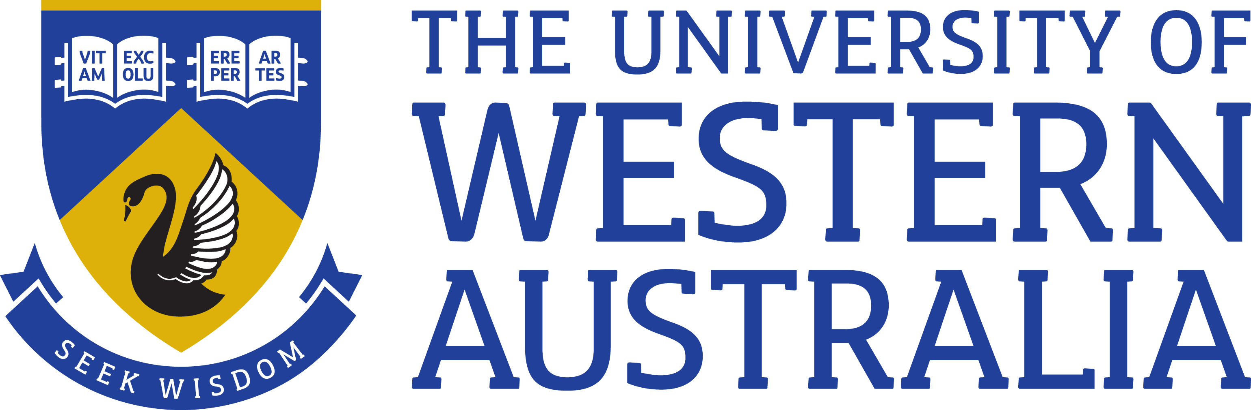

Position Title: Research Associate/ Research Fellow 1
Position Classification: Level A/ Level B
Position Number: NEW
Faculty: Faculty of Engineering and Mathematical Sciences
School: School of Engineering
Department: Department of Chemical Engineering
Supervisor Title: Professor
Supervisor Position Number: 308999
Your work area
The School of Engineering is renowned for its award-winning researchers, teachers and facilities. It is a multidisciplinary school offering education and research in a number of engineering disciplines. This includes civil, environmental, mining, chemical, mechanical, electrical and electronic engineering. Successful applicants will work in the Fluid Science and Resources Research Group (https://www.fsr.ecm.uwa.edu.au/) which primarily conducts research across the oil and gas industry. The relevant theme to these positions focusses on rock core analysis for oil&gas reservoir evaluation.

Reporting Structure

Reports to: Professor Mike Johns.

Your role
As the appointee you will, under limited direction of the Professors, participate in and coordinate the experimental, analytical and other research work required by the project “Experimental Studies of EGR/EOR from tight Carbonates and Tight Formations”. This is a collaboration between UWA and King Fahd University of Petroleum and Minerals in Dhahran, Saudi Arabia. The project will consider the characterization of carbonates and shale rocks, predominately using NMR techniques, as required to better understand EGR and EOR processes. This will involve the application of in-situ NMR measurements during relevant core flooding processes at reservoir conditions. The appointee will have the opportunity to spend two extended periods of time at the extremely well equipped KFUPM College of Petroleum Engineering & Geosciences (CPG) as part of the collaboration.
The position is for a duration of 2 years with a strong possibility of extension to a third year.

Key responsibilities
Conduct high quality research on the project

Publication of research papers and presentations at international conferences and workshops

Work collaboratively with other researchers and students engaged in the research team

Provide management and logistical assistance regards the collaboration with KFUPM.

Assist in the supervision of undergraduate, Masters and PhD students.
Participate in the research group’s activities and contribute to/organize group projects, meetings and workshops.

Contribute to UWA teaching activities where possible.

Other duties as directed.

Your specific work capabilities (selection criteria)
A PhD in a relevant field.
Strong track record of research publication relative to opportunity.
Extensive knowledge of and experience in applied Nuclear Magnetic Resonance (NMR), in particular relaxometry and self-diffusion measurements.
Experience applying NMR to characterise porous media, in particular rock cores, would be desirable.
Highly developed written and verbal communication skills in the preparation of high-quality reports, presentations and publications.
An ability and willingness to direct and supervise students.
Highly developed organisational skills and demonstrated ability to set priorities, meet deadlines and conduct research.

Special Requirements

Significant Overseas Travel

Compliance

Workplace Health and Safety
All supervising staff are required to undertake effective measures to ensure compliance with the Occupational Safety and Health Act 1984 and related University requirements (including Safety, Health and Wellbeing Objectives and Targets).
All staff must comply with requirements of the Occupational Safety and Health Act and all reasonable directives given in relation to health and safety at work, to ensure compliance with University and Legislative health and safety requirements.
Details of the safety obligations can be accessed at http://www.safety.uwa.edu.au

Equity and Diversity
All staff members are required to comply with the University’s Code of Ethics and Code of Conduct and Equity and Diversity principles. Details of the University policies on these can be accessed at http://www.hr.uwa.edu.au/publications/code_of_ethics, http://www.equity.uwa.edu.au

