Position Description

Deputy Director, Operations (Facilities and Services)
Position No: | 50142946
Business Unit: | Chief Operating Officer
Division: | Net Zero | Facilities, Assets and Services
Department:  Classification Level: | Facilities, Assets and Services Management  ESMC1
Employment Type: | Full Time, Fixed Term
Campus Location: | Melbourne (Bundoora)
Other Benefits: | http://www.latrobe.edu.au/jobs/working/benefits
Further information about:

La Trobe University - http://www.latrobe.edu.au/about
Infrastructure and Operations - https://www.latrobe.edu.au/io

Position Context/Purpose

The Deputy Director, Operations (Facilities and Services) leads and directs the strategic delivery of facilities maintenance and operations services associated with buildings, facilities and grounds operations and the Service Desk to effectively support the achievement of University goals.

A key element of this role is the leadership of contracted partnerships that deliver security, traffic, parking, cleaning, waste, porterage, electrical, hydraulic, building fabric, lifts, fire and life safety, and mechanical plant functions.

Duties at this level will include:

- Understand, investigate and aligns Departmental activities with strategic priorities and objectives to develop plans that address both current and future requirements for the efficient provision of facilities maintenance and operations services of the University. This involves the high level management of contracted partnerships and staff performance (associated with operational excellence targets, financial targets, safety standards, and customer satisfaction).
- Ensures high quality service delivery by championing continuous improvement strategies, aligning operations with leading practice, maintains a strong focus on quality control and promotes a proactive approach to all client issues.
- Manage, monitor, measure and report the performance of contracted partnerships in accordance with agreed key performance indicators and benchmarks. Specifically related to contracts across metropolitan and regional sites that oversee maintenance, cleaning and waste, security, and legislative life safety maintenance.
- Manages a resource budget ($25m p.a.), subject to executive oversight, determines how to achieve results and substantially influences the allocation of resources. Ensures all activities are in accordance with the financial plan, compliant to University financial procedures, and monitors the impact on spend of all decisions.
- Responsible for the procurement of all operations related services and disciplines ensuring these align with the University approach of valuing the client, problem solving and completing complex tasks within reasonable timeframes. This includes approaching all procurements and negotiations with a strong grasp of the key issues, whilst understanding the desired objectives and associated strengths and weaknesses. Encourages debate and identifies common ground to facilitate agreement and acceptance of mutually beneficial solutions.
- Builds and sustains relationships with a network of key people internally and externally. Recognises shared agendas and works toward mutually beneficial outcomes. Anticipates and is responsive to internal and external client needs.
- This position deputises for the Director Facilities, Assets and Services in their absence.
- This position has University wide responsibilities and is required to travel to other campuses and sites. There is an expectation of responding to a reasonable number of out-of-hours phone calls and associated site attendance, as needed.
- Other duties as directed, commensurate with the scope and classification of the position.
Essential Criteria
Skills and knowledge required for the position
- Ability to direct, lead and control the work of other managers. Extensive knowledge and skills and many years of relevant experience in the Australian University sector, or a breadth of professional experience in industry; would commonly have achieved second or further degree level qualifications.
- Extensive knowledge and skills and many years of relevant experience in the Australian University sector, or a breadth of professional experience in industry; would commonly have achieved second or further degree level qualifications.
- Specialised facilities knowledge of complex methods and techniques within hard and soft services e.g. mechanical plant services, automation control systems, building fabric, security, cleaning and landscaping.
- Highly developed communication skills with an ability to lead and motivate others, to resolve conflicts and to confer with peers in other higher education organisations, to determine best practice approaches in program/service delivery.
- Demonstrated ability to build and sustain collaborative relationships across the University, develop partnerships with diverse groups and individuals and actively guide the development of others.
- Proven ability in provision of a high level of customer service to a wide variety of stakeholders and leadership of a team with a client focussed approach to services delivery.
- Demonstrated knowledge and understanding of the legislative and statutory requirements relevant to and impacting on facilities management activities.
- Ability to demonstrate drive and integrity through a strong commitment to actions and taking responsibility for role modelling the professional behaviours important to the University.
- Ability to support shared purpose, think strategically and harness information and opportunities to reinforce the vision for the future of the University.

Capabilities required to be successful in the position
- Ability to collaborate effectively across functions, tailor communication in a way that is meaningful to the audience and contribute to a safe, inclusive, high-performing culture – consistently modelling accountability, connectedness, innovation and care.
- Ability to operationalise strategy, adapt quickly to disruption and actively contribute to a healthy culture to successfully navigate change – implementing recommended improvements to organisational practice.
- Ability to inspire and motivate others towards shared objectives, actively facilitate communication and two-way feedback across the University and create a safe, inclusive, high-performing team culture – consistently modelling and enabling accountability, connection, innovation and care.
- Demonstrated creative, critical and systems thinking, ability to promote a culture of innovation across La Trobe – encouraging and enabling the generation of new ideas, demonstrating a willingness to experiment, and taking calculated risks to solve organisational problems and support the University’s strategic and cultural priorities.

Essential Compliance Requirements

To hold this La Trobe University position the occupant must:

- hold, or be willing to undertake and pass, a Victorian Working With Children Check; AND
- take personal accountability to comply with all University policies, procedures and legislative or regulatory obligations; including but not limited to TEQSA and the Higher Education Threshold Standards.
- Current Victorian driver licence with 'Car' listed under licence type.

Other Information

The position description is indicative of the initial expectation of the role and subject to changes to University goals and priorities, activities or focus of the job.

Position Flexibility

We offer flexible work arrangements that can assist you in balancing your work and other responsibilities.
This role leads a team who work on campus. It is anticipated that this role will therefore work on campus at least nine days per fortnight, or as required.

Why La Trobe:

- Develop your career at an innovative, global university where you’ll collaborate with community and industry to create impact.
- Enjoy working on our inspiring and stunning campuses – the perfect hub for industry, students and academics
- Help transform the lives of students, partners and communities now and in the future

This is more than just a job. Working at La Trobe offers opportunities to demonstrate excellence and transform lives.

Here, you’ll join exceptional people, partners and communities, who power our operations with ambition and purpose.

Our success can be attributed to its strong sense of community. We have a long-standing commitment to diversity, inclusion and social justice; we are committed to providing a workplace where all staff feel valued, respected and supported to achieve their full potential. We strive to build a workplace where all employees of diverse backgrounds, abilities, experiences, sexuality, gender, religion and age are welcome, valued, respected and one that is representative of our community. We demonstrate our cultural qualities by holding ourselves accountable and creating a culture of trust and innovation while genuinely caring for one another.

La Trobe’s Cultural Qualities:

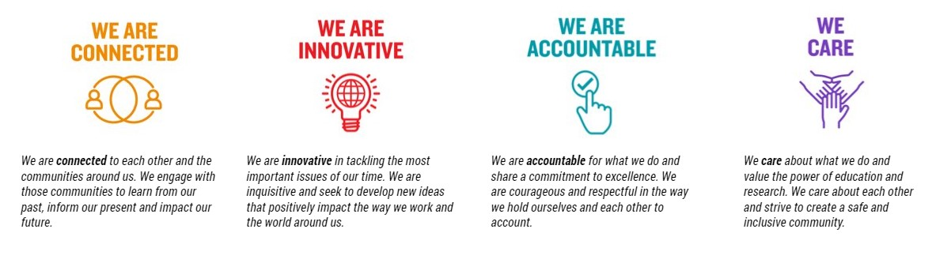

For Human Resource Use Only
Initials: Date:

