Faculty / Division: UNSW Law
School / Unit: Research Support
Position Level: Level 8
Position Number: XXXXXX
Position Title: Research Manager
Date Written: May 2018

ORGANISATIONAL ENVIRONMENT
UNSW is currently implementing a ten year strategy to 2025 and our ambition for the next decade is nothing less than to establish UNSW as Australia’s global university. We aspire to this in the belief that a great university, which is a global leader in discovery, innovation, impact, education and thought leadership, can make an enormous difference to the lives of people in Australia and around the world.
Following extensive consultation in 2015, we identified three strategic priority areas. Firstly, a drive for academic excellence in research and education. Universities are often classified as ‘research intensive’ or ‘teaching intensive’. UNSW is proud to be an exemplar of both. We are amongst a limited group of universities worldwide capable of delivering research excellence alongside the highest quality education on a large scale. Secondly, a passion for social engagement, which improves lives through advancing equality, diversity, open debate and economic progress. Thirdly, a commitment to achieving global impact through sharing our capability in research and education in the highest quality partnerships with institutions in both developed and emerging societies. We regard the interplay of academic excellence, social engagement and global impact as the hallmarks of a great forward-looking 21st century university.
To achieve this ambition we are attracting the very best academic and professional staff to play leadership roles in our organisation.

UNSW BEHAVIOURS
UNSW recognises the role of employees in driving a high performance culture. The behavioural expectations for UNSW are below.
Please refer to the UNSW Behavioural Indicators for the expectations of your career level (level 8).

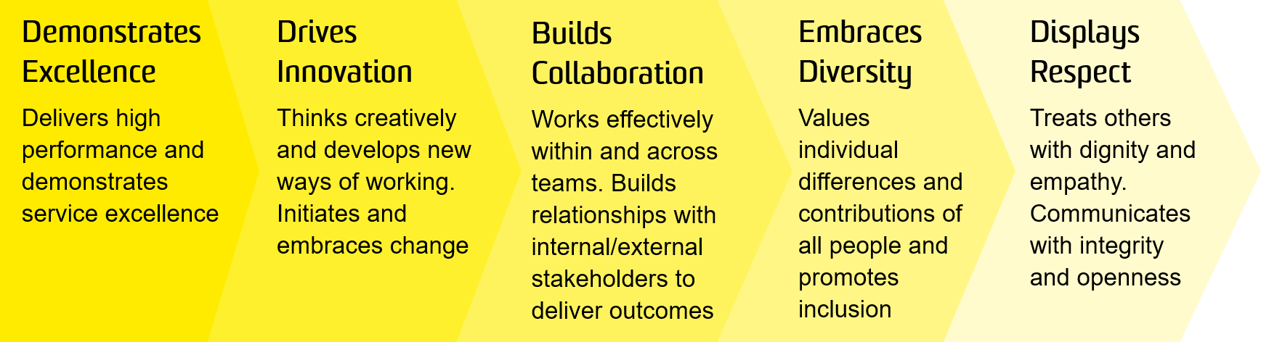

OVERVIEW OF RELEVANT AREA AND POSITION SUMMARY
Ranked 16th in the world, UNSW Law is Australia’s leader in progressive and rigorous legal education and research. Inspired by principles of justice, UNSW Law through its teaching, research and community outreach, promotes a holistic understanding of law and its role in society.
UNSW Law includes more than 100 academics, many of whom are leaders in their areas of research interest. Our research is organised around a range of centres and disciplinary clusters. The Faculty’s research ranges from traditional doctrinal study to interdisciplinary, empirical and theoretical work. A common theme is the engagement with law outside the University, through policy and law reform and collaboration with practitioners of all kinds. UNSW Law is supported by 60 professional and technical staff who provide management and support in teaching, research, finance and student administration.
The Faculty Research Manager plays a key role supporting the Associate Dean (Research), the Associate Dean (International and External Engagement), the Director of Research, the Director of Postgraduate Research, and the Director of Research (Impact and Engagement) to develop and implement research strategy in the Faculty through the management of Faculty research operations, including project management, reporting and analytical support, strategic research communications, managing key research relationships, providing high level advice on policy and strategy and relevant administrative support.
The Research Manager is the Faculty interface with relevant University work areas including Office of the Deputy Vice Chancellor Research, Research Strategy and Partnerships Office, Grants Management Office, Division of Enterprise and other Faculties as well as research bodies internal and external to the University.
The position reports to the Faculty Executive Director with a dotted line to the Associate Dean (Research), and has 2 direct reports.

RESPONSIBILITIES
- Manage the operations of the Faculty Research Support team and actively develop and implement practices and procedures to support the research activities (including HDR Support) of the Faculty
- Provide advice and support to the Associate Deans and Directors of Research on the development of the Faculty strategic plan in research and the alignment of research resources with the strategic goals of the Faculty
- Manage Faculty research databases and pro-actively analyse and report on the Faculty’s research performance, external funding success and other relevant metrics and recommend initiatives to improve research performance
- With the Associate Dean (Research), develop and implement Faculty guidelines, processes and procedures that align the Faculty with the external policy environment to support the research activities of the Faculty
- With the Associate Dean (Research), develop and implement Faculty training and support initiatives to enhance the research performance of the Faculty
- With the Associate Dean (Research), the Director of Research, and the Faculty Executive Director, develop and ensure effective management of the Faculty research budget
- Lead, motivate and develop the Research Support team, and foster a culture of collaboration and customer service
- Partner with the Division of Enterprise to develop strategies for securing major contracts and business
- Leverage strong relationships and networks with external industry sectors to facilitate outcomes for the Faculty
- Foster and maintain strong strategic and value adding relationships and networks across the University and industry
- Develop and manage effective communications to researchers and prospective and current research students relating to funding opportunities, Faculty initiatives and research policy and process, including through internal and external newsletters and events
- Support the Associate Deans in preparing Research Team reports to Faculty Board and other reporting as may be required
- Effectively manage major Faculty research projects, internal grant schemes, and other initiatives and programs on behalf of the Associate Deans
- Manage Faculty relationships with other University departments (such as the Office of the Deputy Vice Chancellor Research; Research Strategy and Partnerships Office; Research Analysis, Performance and Profile Office; Grants Management Office; Graduate Research School; ERA team; and University Planning & Performance) and external to the University ensuring that collaborative working relationships are maintained
- Manage Faculty relationships with the Division of External Relations to help ensure effective promotion of the Faculty’s researchers, research outputs and research environment and support research student recruitment
- Contribute to the Faculty Research Committee (and other relevant Committees, working groups or meetings) by providing information, advice and assistance as required
- Liaise with key university stakeholders on policy implementation and reporting, and with senior University staff on action which the Associate Deans considers necessary or desirable to facilitate the research planning for the Faculty
- Undertake high level market research and analysis of data relating to the education sector, competitor analysis, enrolment and student statistics and research performance, and present reports to the Faculty Executive highlighting trends and implications for the Faculty and by School
- Provide reporting and analysis support on key indicators relating to student load, enrolment planning and space management, and participate in Faculty planning processes as required
- Contribute ideas and recommendations regarding the ongoing management and continuous improvement of the Faculty research function

SELECTION CRITERIA
- A relevant degree with subsequent experience in research management and research administration or a similar role, or equivalent competence gained through another combination of education, training and experience
- Experience in a research environment with an excellent understanding of the broader research context, funding sources, research grants requirements, research policies and regulations and managing internal funding schemes
- Experience in successfully managing people with proven ability to lead and motivate teams in order to achieve quality outcomes
- Demonstrated ability in strategic, financial and resource planning, and effective implementation of plans, policies and procedures
- Advanced conceptual, analytical and problem-solving skills with a demonstrated ability to manage large data collection and analysis projects within set timeframes
- Strong interpersonal skills and the demonstrated ability to establish and build relationships with staff at all levels including senior management and external organisations
- Demonstrated experience in project management methodologies and strong organisational management skills
- Outstanding communication skills, ability to develop and deliver effective communications as well as the ability to write effective documents and present complex statistical data to a broad audience
- High level computer literacy in Microsoft Office applications, database management, data analysis software
- Proven ability to use tact and discretion in dealing with sensitive and confidential matters
- Ability and capacity to direct and monitor the implementation and effectiveness of the safety management system.
It is not the intention of the position description to limit the scope or accountabilities of the position but to highlight the most important aspects of the position. The aspects mentioned above may be altered in accordance with the changing requirements of the role.

