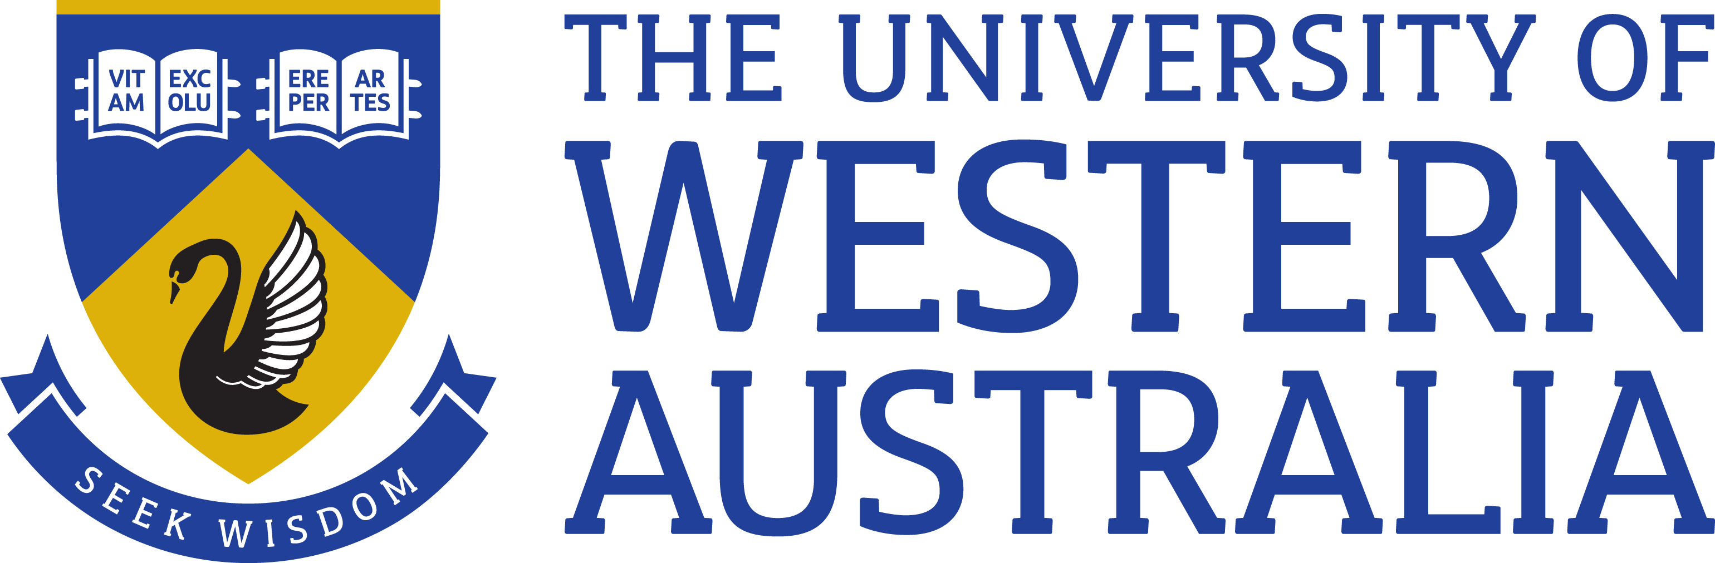

Position Title: ASTRO 3D Research Scientist in HI Galaxy Evolution Surveys
Position Classification: Level A
Position Number: NEW
Faculty/Office: Faculty of Engineering and Mathematical Sciences
School/Division: Physics, Mathematics and Computing
Centre/Section: ICRAR (International Centre for Radio Astronomy Research)
Supervisor Title: Senior Research Fellow
Supervisor Position Number: 313714

About the work area

ICRAR is a WA State funded high profile equal joint venture established in 2009 between Curtin University and The University of Western Australia (UWA). The Centre’s headquarters are located at UWA, with research nodes at both UWA and the Curtin. ICRAR is one of the lead Australian organisations participating in the international Square Kilometre Array (SKA) Project. ICRAR has been further funded from 2014 to 2019 with $26 Million by the WA State Government and equal contribution from the Joint Venture Universities. ICRAR is one of the largest astronomy organisations in Australia.

ASTRO 3D is a $40m Research Centre of Excellence led by Prof. Lisa Kewley. ASTRO 3D is funded over seven years by the Australian Research Council and supported by six collaborating Australian universities - ANU, University of Melbourne, University of Sydney, Swinburne University of Technology, University of Western Australia and Curtin University. Other Australian partners in the Centre include CSIRO, the Australian Astronomical Observatory and National Computational Infrastructure. ASTRO 3D includes collaborations with world leading international institutions.

The ASTRO 3D mission is to produce a comprehensive picture of the evolution of matter, the chemical elements, and ionizing radiation in the Universe from shortly after the Big Bang to the present day. ASTRO 3D trains the next generation of scientific leaders and conducts nationwide education and public outreach programs.

ASTRO 3D supports the activities of around 200 researchers, administrative staff and students, provides a collaborative working environment and supports a flexible, family friendly working environment. Subject to visa restrictions, this opportunity is available as either a full-time or part-time position.

Organisation chart

Role statement

This ASTRO 3D research position will be based at ICRAR/UWA and will focus on the DINGO HI survey (www.dingo-survey.org). As a member of the DINGO team, the researcher will assist with deep spectral line integrations using the ASKAP telescope to understand the role HI has played in galaxy evolution over the past 4 billion years. This project is closely aligned with the GAMA survey (and in future WAVES), enabling a wide range of spectroscopic and multiwavelength analyses. The researcher will work with DINGO principal investigator, Dr Martin Meyer, and other members of the DINGO, ICRAR, and ASTRO 3D teams, to create the core survey data products for the survey and carry out early science analyses from this ground-breaking survey.

Key responsibilities

In their role as UWA academic level A in the International Centre for Radio Astronomy Research, the appointee will be expected to:

- Undertake internationally competitive research in DINGO HI science, with a view to publishing original and innovative results in refereed journals, present research at academic seminars and at national and international conferences, and collaborate with other researchers at a national and/or international level.
- Assist in the development of DINGO science pipelines, with the acquisition of data, and with the production of survey cubes and catalogues.
- Actively collaborate with researchers within ICRAR/UWA, CSIRO, and other ASTRO 3D nodes and partner institutes.
- Participate, as appropriate, in the supervision of research students, both at the undergraduate and post-graduate level.
- Undertake administrative functions primarily connected to the area of research, including preparation of research proposals and pursuing appropriate funding applications.
- Assist in outreach activities including to prospective students, research institutes, industry, government, the media and the general public.
- Comply with, maintain an awareness of and help promote all UWA policies and procedures and in particular those relating to work health and safety and equal opportunity.
Perform other duties as requested, consistent with the classification level of the position.

Specific work capabilities (selection criteria)

- PhD in radio astronomy or related discipline
- Experience in an area of astrophysics relevant to the ASKAP DINGO survey
- Experience in radio astronomy techniques and/or data intensive astronomy methods to assist in the processing and analysis of DINGO data
- Good publication record as evidenced by international refereed publications
- Proficiency in verbal and written communication
- Demonstrated ability to work effectively in distributed scientific collaborations
- An understanding of equal opportunity principles and policies and a commitment to their application in a university context

Special Requirements

Undertake interstate and international travel

Compliance

Workplace Health and Safety
All supervising staff are required to undertake effective measures to ensure compliance with the Occupational Safety and Health Act 1984 and related University requirements (including Safety, Health and Wellbeing Objectives and Targets).
All staff must comply with requirements of the Occupational Safety and Health Act and all reasonable directives given in relation to health and safety at work, to ensure compliance with University and Legislative health and safety requirements.
Details of the safety obligations can be accessed at http://www.safety.uwa.edu.au

Equity and Diversity
All staff members are required to comply with the University’s Code of Ethics and Code of Conduct and Equity and Diversity principles. Details of the University policies on these can be accessed at http://www.hr.uwa.edu.au/publications/code_of_ethics, http://www.equity.uwa.edu.au

