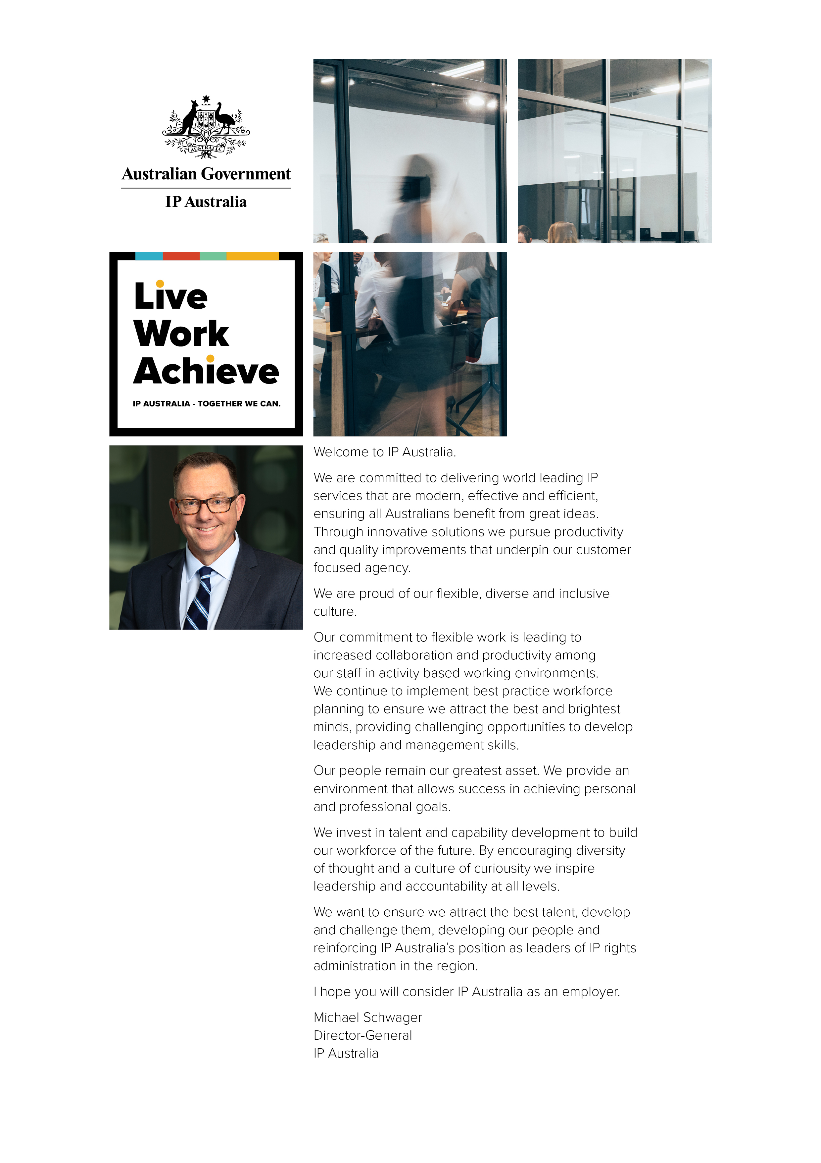
Position Profile

Position Title: | IT Subject Matter Expert Specialisation Infiniti/SmartIQ Developer
Classification: | APS 6
Position Number: | 5804
Tenure: | Ongoing
Duration: | Permanent
Section: | Business Delivery and Assurance
Group: | Innovation and Technology
Division: | Policy and Corporate
Location: | Canberra
Immediate Supervisor: | Executive Level 1
Security Classification: | ENTRY ONLY

About IP Australia
IP Australia is an Australian Government agency responsible for administering Australia’s intellectual property (IP) rights system, specifically patents, trademarks, designs, and plant breeder’s rights. IP Australia also undertakes programs to educate and promote an awareness of IP, provides IP policy input to Government, develops legislation to support the IP system and contributes to bilateral and multilateral negotiations to improve IP protection internationally.
Australia’s IP rights system supports innovation, investment, and international competitiveness. IP investment in Australia is valued at about 40 billion dollars. We are an Australian Government agency with a passion for bright ideas, offering a great work-life balance, flexible working arrangements and rewarding career paths in the intellectual property (IP) industry.
Group Responsibilities
IP Australia has embarked on a transformation journey to create a world-leading IP system that builds prosperity for Australia and ensuring Australians benefit from great ideas.
The Innovation Technology Group is an enabler to the Agency and is responsible for supporting the IT Strategy 2022; establishing the key technology platforms and supporting capabilities to increase business alignment; uplift technology and service delivery maturity and position IT for scalability.
The IT Strategy is our focal point and sets direction on how our technology capability will support the achievement of IP Australia’s business objectives and outlines the overall vision for IT within IP Australia. The strategy guides the continued digital transformation of IP Australia across all internal levels of the agency and external interactions. It supports a ‘citizen-centric’ approach to our services, in line with whole-of-government, positioning them to meet evolving customer expectations.
ITG will support IP Australia’s vision by embracing contemporary and innovative technologies to deliver smart solutions and new approaches that cement IP Australia as a visionary in the Intellectual Property ecosystem.

Section Responsibilities
Business Delivery and Assurance – comprises of cross-functional teams who are aligned to supporting business facing platforms. Our teams deliver change, maintenance, continuous delivery, and self-service capabilities used by internal and external customers.
We deliver aligned products that have clear and logical boundaries and provide services to deliver agreed business outcomes. BD&A are responsible for the delivery of development, maintenance and support capabilities and technical components (software) required to deliver the agreed business outcomes.
BD&A oversees enabling capabilities such as the Patents Modernization Initiative (PMI) and DevOps foundations delivering important capabilities and tools required by business platforms to enhance delivery efficiencies.

Job Description / Context of the Role
This position is responsible for the creation, maintenance, enhancement and support of IP Australia’s electronic forms and correspondence, built on the Intelledox Infiniti and SmartCommunications SmartIQ platforms.
Infiniti and SmartIQ are a key component of the organisations document generation solution and are integrated with a number of business systems to enable external deliver of IP Rights correspondence to our customers. They are used internally to provide electronic workflows and form generation in support of corporate processes.
The successful applicant will perform BAU activities such as application support and continuous improvement, and will contribute to system improvement initiatives including, but not limited to, the Patents Modernisation Initiative and Security Uplift Program. This includes build and development of forms/correspondence in both Infiniti and SmartIQ, and migration of on-premise Infiniti solutions to SmartIQ Software as a Service. The position requires you to work collaboratively with other developers, SME’s, Business Analysts and stakeholders to complete varied and complex tasks while adhering to agreed delivery dates/timeframes.

Job Specific Duties
The specific duties of the IT Subject Matter Expert specialising as an Infiniti/SmartIQ Developer - include, but are not limited to:
- Use of Infiniti/SmartIQ to create, maintain and enhance forms and correspondence projects/templates for the Customer Services and Policy & Corporate Divisions, whilst adhering to best-practice guidelines and established development processes.
- Perform support functions, such as; troubleshooting issues, finding and redirecting/deleting forms, creating reports and providing advice in response to correspondence and/or forms related issues and enquiries.
- Utilise a combination of Jira and Confluence software to manage tasks and priorities, record user requirements, decisions, issue resolutions, lessons learned, and establish/maintain team procedures and knowledgebase material.
- Work autonomously and collaboratively to provide smart/logical solutions to complex issues and problems and participate in testing and quality assurance activities to ensure that requirements/specifications are met, and quality outcomes are delivered to stakeholders.
- Demonstrates attitudes and behaviours responsive to workplace change (including participates in and encourages others to participate in change and contribute to successful outcomes).
- Improves organisational performance through effective engagement with and management of risk within relevant sphere of influence.
- Establishes clear expectations and creates an environment to achieve stated goals and objectives, takes ownership and honours commitments.
- Maintains an understanding of their/worker responsibilities under the Work Health & Safety Act 2011 (WHS Act) and a commitment to promoting a healthy and safe workplace.

Job Specific Capabilities
Successful candidates should possess the following:
- Highly efficient communication and negotiation skills – both written and oral with the ability to effectively negotiate outcomes.
- Demonstrated ability to think critically, assess issues, provide resolutions, and deliver outcomes within agreed timeframes.
- Demonstrated ability to work with a diverse group of people to achieve organisational goals, valuing individual differences and working styles/patterns.
- Respond proactively to feedback and be willing to develop and apply new skills.
- A high level of personal resilience and a proactive approach to learning.
- Highly developed organisational skills including the ability to prioritise and collaborate with others to achieve deadlines.
- Value individual differences and diversity.
- Demonstrate professionalism and adherence to the APS Code of Conduct.
- Understand the importance of building networks and seek to do so.
- Respond proactively to feedback and willing to develop and apply new skills.
- Display and live by the capabilities outlined in the IP Australia’s capability framework.
Please note: Applicants are encouraged to refer to the attached Capability Framework documentation which outlines agency wide behavioural descriptors for the five core capabilities at this classification.

Eligibility Qualifications / Knowledge Required
Essential skills:
- Demonstrated experience using Intelledox Infiniti or SmartCommunications SmartIQ to create/maintain forms or correspondence templates and/or workflows.
- Moderate skill level and experience using Microsoft Office software.
Highly desirable:
- Knowledge and understanding of IP Rights related business processes/legislation (or the ability to quickly acquire knowledge and understand of business processes and their supporting systems/legislation/regulations).
- Ability to analyse and interpret XML data for the purpose of troubleshooting issues and for consumption in forms and correspondence templates.
Desirable:
- Experience using Atlassian Jira/Confluence applications.
- Basic understanding of HTML and/or CSS.

Job documentation updated and endorsed for use: | Date: 18 November 2021

Working at IP Australia
IP Australia recognises the importance of employees balancing their work and personal lives by offering staff access to an ongoing series of health and wellbeing programs, flexible work-life policies and a range of professional development programs. IP Australia is a breastfeeding friendly workplace and has an onsite childcare facility with priority enrolment for IP Australia employees.
The IP Australia office in Canberra provides high quality accommodation and facilities. These include: an on-site café, conference, meeting and training rooms; limited on-site parking for cars and motor cycles available on a rotational basis; the provision of undercover bicycle racks; excellent shower/change facilities for staff choosing to walk or ride to work; and the advantage of all staff being co-located in the one building.

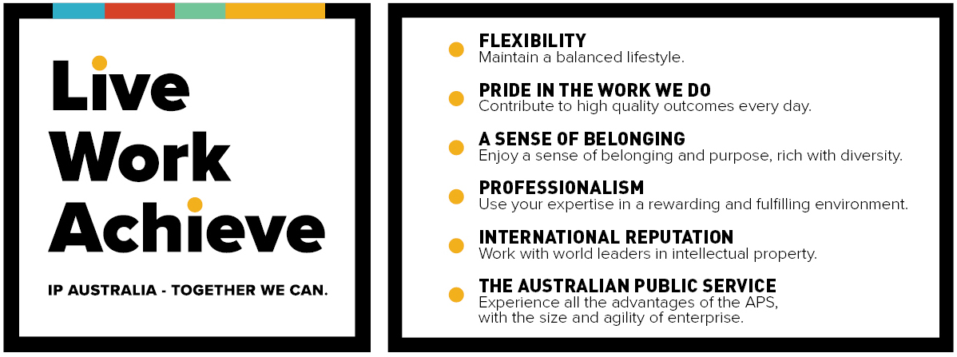

Working in the APS
Australian Public Service (APS) Values guide us through our working lives, setting expectations for shared behavior that keep our workplace harmonious and productive. The values are also a promise to the people of Australia that we can be trusted to act with integrity, in their service and in accordance with the Public Service Code of Conduct.

