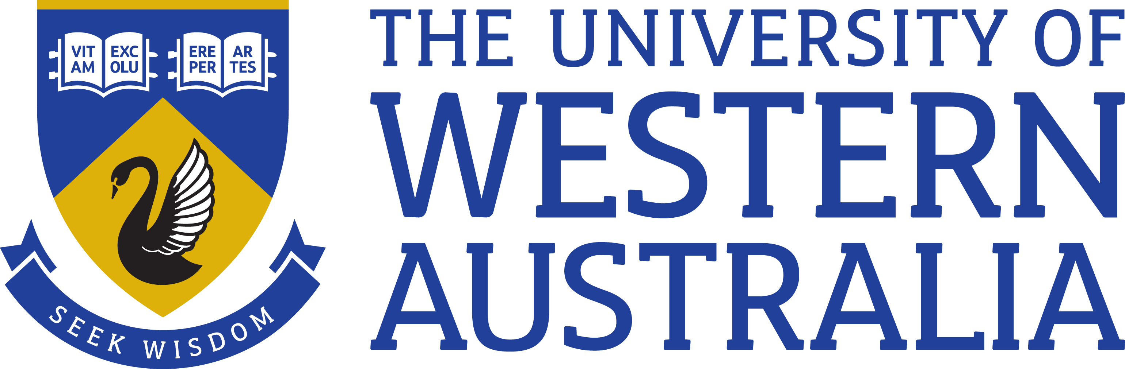

Position Title: Social Media Officer
Position Classification: Level 6
Position Number: 310450, 312884
Faculty/Office: Community and Engagement
School/Division: Brand, Marketing and Recruitment
Centre/Section: Digital and Creative Services
Supervisor Title: Senior Social Media Officer
Supervisor Position Number: 315240
Your work area
The Brand, Marketing and Recruitment (BMR) division provides organisational-wide brand strategy and ongoing brand management; strategic marketing and planning; marketing communications activities; and digital communication, research and segmentation. The team provides sales, marketing planning and campaign assistance to help attract and recruit students. Marketing and recruitment activities planned and implemented by BMR are designed to help achieve the University’s strategic goals of brand and reputation building and attracting domestic and international students to study at The University of Western Australia (UWA).
Digital and Creative Services within BMR division provides creative services across the University. This team develops creative outputs aligned to and focused on building the UWA brand through the delivery of high-quality communication and marketing material across a variety of engagement and media channels.

Reporting structure

Reports to: Senior Social Media Officer

Your role
The Social Media Officer, under limited direction, will develop and implement digital communications strategies to support the University’s position and reputation through a consistent and creative online presence.
Key responsibilities
Coordinate an integrated approach using knowledge of broader digital communications, campaigns and social media use in collaboration with other experts across the University
Apply SEO knowledge and copywriting skills to generate and share content daily that builds meaningful connections and enhances the University's reputation
Provide advice and contribute to the development of policies and procedures in relation to the UWA Digital Strategy, as required
Monitor, evaluate and review performance of digital media using analytics to identify trends and growth strategies
Develop highly effective social media campaign initiatives in conjunction with University staff/clients
Assist in the education and training of University staff in regard to social media principles, customer service and other best practice models
Support UWA’s Critical Incident Management Team with social media skills when required in a critical situation
Other duties as required
Your specific work capabilities (selection criteria)
Relevant tertiary qualification or demonstrated equivalent competency
Highly-developed written and verbal communication skills, including the ability to adapt to different audiences

Substantial experience managing social media accounts and campaigns; using social media management tools and the ability to source and curate content

Proficiency in a range of computing skills including word processing, spreadsheets, databases and image editing software
Advanced customer service skills and the ability to recognise potential risks to brand reputation and to respond accordingly
Demonstrated ability to plan, organise, set priorities and meet deadlines
Ability to work productively as part of a team, as well as independently, and contribute to a high-performing, positive team culture
Special requirements (selection criteria)

Provision of support for University needs will require availability out of ordinary working hours. Social Media Team members are expected to assist with out-of-business-hours monitoring on a rostered basis supported by an additional allowance. Flexibility to accommodate annual leave, family or study commitments will be considered as part of this roster process.

Compliance
Workplace Health and Safety
All supervising staff are required to undertake effective measures to ensure compliance with the Occupational Safety and Health Act 1984 and related University requirements (including Safety, Health and Wellbeing Objectives and Targets).
All staff must comply with requirements of the Occupational Safety and Health Act and all reasonable directives given in relation to health and safety at work, to ensure compliance with University and Legislative health and safety requirements. Details of the safety obligations can be accessed at http://www.safety.uwa.edu.au
Equity and Diversity
All staff members are required to comply with the University’s Code of Ethics and Code of Conduct and Equity and Diversity principles. Details of the University policies can be accessed at http://www.hr.uwa.edu.au/publications/code_of_ethics, http://www.equity.uwa.edu.au

