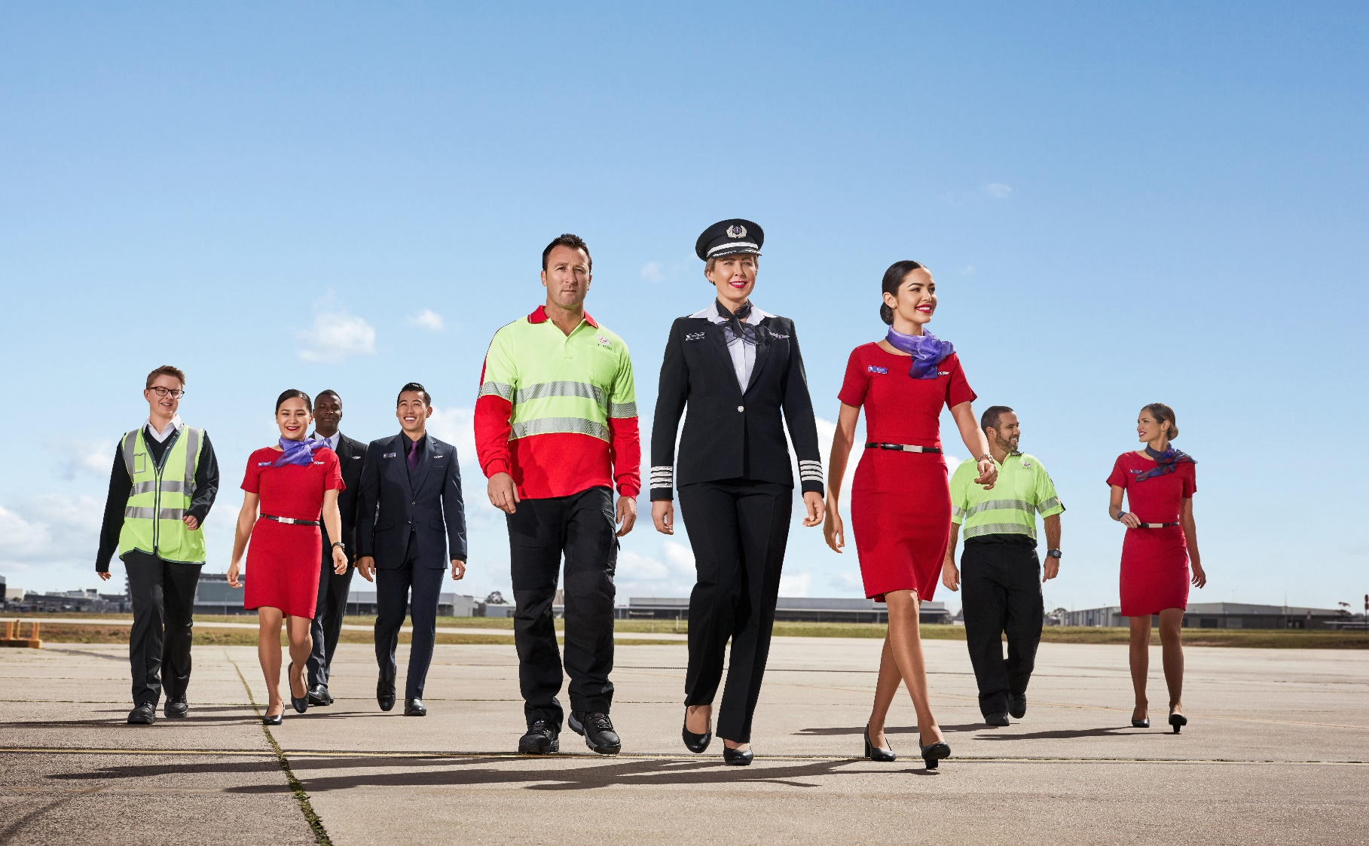
position description

Position Snapshot
Position Title: | Network Controller
Division / Department: | Aircraft Operations / Network Integrity
Location: | BNE
Reports to: | Leader, Network Integrity Team Performance
Direct reports: | 0
Level: | 1C
Award: | Airline Operations Ground Staff Award 2020
Classification: | Clerical administrative and support / Level 4
Date: | June 2021

Overall Impact Statement
Our vision is to build the airline people love, and we’ll do that by having happy people, happy customers, happy owners, by doing what matters, and by ensuring everyone is safe, always. We also believe that how you show up is as important as what you do.

The objective of the Network Controller role is to Reporting directly to the Manager, Network Integrity the Network Controller is accountable for achieving key operational and planning objectives that support Virgin Australia's network schedule delivery strategies. Responsible for actively sourcing and disseminating all relevant operational information in relation to aircraft movement, network disruption, engineering and crew related considerations. The Network Controller will support the Duty Manager, Integrated Operations Centre in conjunction with other IOC teams, E&AS, CSD and Flight Operations in achieving completion rates and daily OTP targets through the delivery of strong and effective communication, safe and compliant operational planning and delivery, execution of disruption management strategies and maintaining the integrity of the full commercial and charter schedule to the extent that is within their control. This includes engaging with internal and external stakeholders and ensuring operational compliance in all decisions and outcomes. The Network Controller will be proactive in implementing mitigation strategies to stay ahead of the day’s operational challenges and will work hand in hand with all teams in the IOC.

Organisational Context
Virgin Australia Group is a major Australian airline headquartered in Brisbane, Australia. The company operates scheduled domestic and short-haul international flights, charter and cargo services, and the award-winning loyalty program Velocity Frequent Flyer. The Group has been a competitor in the Australian aviation landscape for more than 20 years.

The company is now embarking on an exciting new chapter in the next stage of our journey. In September 2020, US private equity firm Bain Capital acquired Virgin Australia in a $3.5 billion deal. The airline has now re-launched as a mid-market carrier with a renewed focus on small and medium sized businesses, price-sensitive corporates, premium leisure travellers and holiday makers.

Since November, Virgin Australia has been working on a plan to set itself up for future success. The Group has worked to ramp up flying, simplified its organisational structure, confirmed plans for 25 new 737 aircraft to renew and grow the fleet, and signalled deeper investment in technology and customer experience.

The Group recently appointed several new faces to its Executive Leadership Team, all with a proven track record and deep experience in aviation or consumer-focussed businesses.

Virgin Australia Group prides itself on recruiting the right people to meet the challenges ahead. No matter their role – our employees share an enormous amount of passion for our guests and ambition to be the most loved airline in Australia.

Network Integrity will be at the forefront of our operation, working collaboratively with key teams across the business to be market leaders in operational excellence, schedule integrity and disruption recovery through safety conscious strategic planning, disruption management and Guest experience.

Key Accountabilities
Accountability | Major Activities
Safety, Security & Business Resilience | - Complete mandatory training applicable to the role (including Safety, Security, Resilience and, Health and Wellbeing)  - Participate in the SMS and SeMS by identifying and reporting hazards to the operation  - Be aware of personal safety matters including the emergency procedures relevant to role location  - Adhere to all documented operating procedures  - Actively participate in Safety Shares  - Actively participate in Better Me initiatives  - Actively participate in the Groups emergency response program  - Participate in consultation of WHS matters as related to your working environment  - Challenge unsafe behaviours in others  - Abide by the lawful directions of security personnel and law enforcement officers.  - Actively participate in the Group’s Resilience program.
Safety and Compliance | Adhere to all documented operating policy and procedures  Monitor compliance with applicable industry, company and regulatory requirements.  Adhere to all CASA, NZ CAA and International air/ transport safety regulations  Ensure slot compliance at controlled airports  Participate in the Safety Management System by identifying and reporting hazards to the operation  Be aware of personal safety matters including emergency procedures relevant to role location  Complete mandatory safety training, OJT and CBT applicable to role
Schedule Management | Proactive assessment and implementation of all disruption management plans  Consideration and collaboration with all impacted areas of the business and any external parties  Work effectively in a high pressure, high intensity environment with conflicting priorities  Timely implementation of plans that considers best guest and operational outcome while balancing cost and OTP  Accurate and appropriate allocation of aircraft tails to flight schedule based on operational, engineering and regulatory considerations  Strong organisational and decision making ability in high pressure situations  Ensure all stakeholders are advised of irregular operations and schedule management strategies in a timely and succinct manner  Identify opportunities to improve on-time performance, completion rates and disruption management outcomes  Understanding of and ability to apply ACDM/ ATFM process and policy in an operational capacity
Team work and communication | A positive approach to work with passion and desire to achieve best outcomes  A positive approach to colleagues, team mates and department leaders.  Ensure regular communication of operational information within the team and to operational leaders.  Work calmly, collaboratively and respectfully in high pressure situations.  Use great communication, negotiation and sound reason to make safe and informed operational and commercially sensible decisions.  Identify opportunities to improve efficiency and quality of processes in the department.  Input to and support for departmental strategy.  Completion of all shift specific duties in an accurate and timely manner  Professional, concise and objective communication with stakeholders  Written correspondence is succinct and factual  Participate in projects as required and manage agreed portfolios of additional responsibility that enhance and improve the overall departmental objectives
Customer Service | Identify opportunities to improve OTP, completion rates and maintain network and schedule integrity.  Identify your customers (internal and external). Engage and ensure consistent, respectful, quality service to those customers  Actively work to support a service-focused, customer centric organisational culture within the team and IOC  Timely liaison with all departments regarding operational matters  Oral communication is professional, concise and respectful  Written correspondence is succinct and factual

Key Requirements
Requirement | Essential | Desirable
Education / Qualifications | Secondary school | Tertiary qualification in a business discipline or airline operations management  Industry related qualifications  Operational leadership  Trade qualification
Experience | Exposure to a multi-disciplinary team environment  Experience working in a high-pressure operational environment  Previous experience in a highly regulated operational or logistics role | Experience in the training & mentoring of operational team members  Experience working for full service carrier or logistics operation
Skills | Exceptional communication skills  Ability to multi task and work in a high pressure environment  Ability to work independently and as part of a team  Excellent problem solving and and analytical ability  Ability to apply reason, compromise and negotiation to achieve an outcome  Ability to use a number of software packages relevant to the role  Proficient in the Microsoft Office suite of applications  Proven ability to develop relationships with a range of internal and external stakeholders | Ability to understand complex and dynamic operational problems
Knowledge | Demonstrated understanding of airline or similar logistical operations  Knowledge of tactical scheduling, contingency planning and business continuity strategies  Thorough understanding of airport operations  Knowledge of operational constraints affecting aircraft operations, limitations (TOW, EZFW) etc.  Awareness of Aircrew duty limits | Knowledge of applicable Civil Aviation Orders and Regulations  Working Knowledge of ACDM/ ATFM

Virgin Australia Leadership Standards
Standard | Level 1 Behavioural Descriptors
Passionately VA | - Displays a passion for delighting both internal and external customers  - Seeks to understand customer needs by actively listening to their thoughts and concerns  - Embraces diversity and is responsive to different experiences, perspectives, values and beliefs  - Is curious and continuously looks for ways to learn and improve  - Knows, understands and follows standard operating procedures  - Is authentic and honest, can admit to making mistakes
Desire to be Better | - Strives to improve experiences for internal and external customers  - Has a curious mind towards identifying opportunities and finding ways to be better  - Demonstrates a high level of personal motivation to learn and develop  - Resourceful and creative with coming up with solutions  - Identifies and contributes ideas for improvement  - Identifies, addresses and reports safety hazards
Collaborates | - Displays passion for sharing knowledge and ideas  - Voices opinions and new ideas freely  - Respects differences and seeks to understand diverse perspectives  - Works constructively in and across teams, viewing every interaction as an opportunity to collaborate  - Is curious and open-minded to new ideas, perspectives and approaches  - Clarifies own understanding and embraces alternate view  - Challenges behaviours that compromise safety
Inspires Team | - Participates in 2-way conversations, listening and discussing issues thoughtfully and openly  - Understands and value the skills, knowledge and experiences that others bring  - Engages with others, clearly conveying information and facts  - Actively seeks to provide suggestions on how to be a better team  - Informs team about work and progress  - Understands personal obligations with respect to following standard operating procedures
Creates Future | - Welcomes change and remains positive in the face of ambiguity  - Seeks information to understand change and impacts  - Demonstrates a change mindset, flexibility and openness  - Understands the need for VA Group to be innovative and drive business improvement  - Seeks to understand Virgin Australia’s strategy and how they can contribute  - Demonstrates forward-thinking and awareness of immediate consequences of actions ensuring safe outcomes
Drives Results | - Plans work to deliver within expected timeframes  - Shows energy, enthusiasm and initiative for achieving own goals  - Follows through on commitments to both internal and external customers  - Seeks guidance and support to address obstacles and achieve set goals  - Integrates feedback and takes responsibility for achieving own goals  - Delivers outcomes within standards operating procedures.

