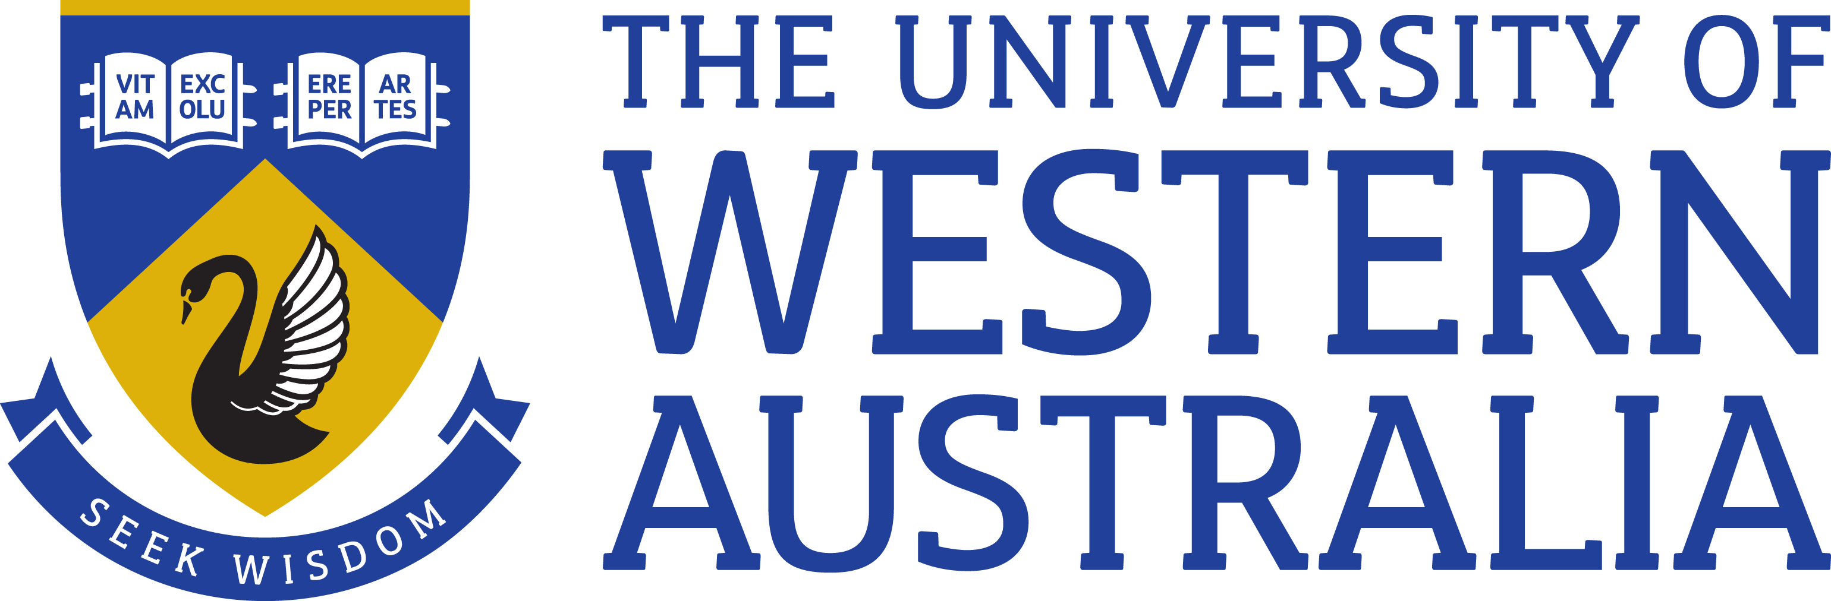

Position Title: Research Associate
Position Classification: Level A
Position Number: NEW
Faculty/Office: Faculty of Engineering and Mathematical Sciences
School/Division: Physics, Maths and Computing
Supervisor Title: Professor
Supervisor Position Number: 311317

Your work area
The Faculty of Engineering and Mathematical Sciences encompasses three schools – School of Physics, Mathematics and Computing, School of Engineering and the Oceans Graduate School. Past graduates include Rhodes Scholars, Fulbright Scholars, Eureka prize winners, CEOs and seven of the most influential engineers in Engineering Australia’s Top 100 list. The faculty is home to a former Scientist of the Year and award-winning inventors and is part of the state of the art Indian Ocean Marine Research Centre. The Faculty prides itself on its track-record for producing graduates who not only perform well in their chosen profession, but are equipped with the skills and social capital they need to be the very best.

The Faculty has an international reputation for excellence in research and its research teams benefit from global partnerships with industry, attracting research income of more than $27 million a year – well above the national average.

The Department of Physics is a research-focused school with a strong commitment to quality teaching at both undergraduate and postgraduate levels. While our core business is fundamental research, we have also successfully translated the results of research into the development of new technologies for the benefit of humankind.

UWA offers vibrant research environment for gravitational wave astronomy. The UWA Gravitational Wave Astronomy group is currently an active member of the LIGO Scientific Collaboration (http://www.ligo.org/) that aims to detect gravitational waves in the audio band and is a member of the 2017 ARC Center of Excellence for Gravitational Wave Discovery (OzGrav, https://www.ozgrav.org). The group participated directly in the discoveries of gravitational wave signals since 2015. The SPIIR gravitational wave pipeline developed at the group has made several online detections of gravitational wave events shortly after the LIGO-Virgo collaboration restarted science run in April 2019.

Reporting Structure
Reports to: Professor

Your role
As the appointee you will, under limited direction of the Professor undertake research duties in the area of gravitational wave search pipeline development and testing, high-performance computing by smart algorithm design and hardware acceleration using Graphics Processing Units. You will also help develop strategies to enable prompt electromagnetic follow up observations and extract astrophysical information using data from detected gravitational wave events.
Key responsibilities
Provide high-level research at the forefront of gravitational wave physics with emphasis on the interface between gravitational wave signal processing and multi-messenger astronomy.

Prepare research papers for publication in high impact refereed journals. Present research results at seminars and conferences

Seek additional research funding by grant applications

Contribute to software installations and testing related to GW signal search pipeline development

Contribute to the supervision of Honours, Masters and PhD research projects

Other duties as directed

Your specific work capabilities (selection criteria)
A Ph.D. in astrophysics, computer science, or engineering
Experience and demonstrated excellence in signal processing.
Strong track record of research publication relative to opportunity.
Highly developed written and verbal communication skills in the preparation of high-quality reports, presentations and publications.
An ability and willingness to direct and supervise students.
Demonstrated ability to set priorities, meet deadlines and conduct research.

Special Requirements
Nil

Compliance

Workplace Health and Safety
All supervising staff are required to undertake effective measures to ensure compliance with the Occupational Safety and Health Act 1984 and related University requirements (including Safety, Health and Wellbeing Objectives and Targets).
All staff must comply with requirements of the Occupational Safety and Health Act and all reasonable directives given in relation to health and safety at work, to ensure compliance with University and Legislative health and safety requirements.
Details of the safety obligations can be accessed at http://www.safety.uwa.edu.au

Equity and Diversity
All staff members are required to comply with the University’s Code of Ethics and Code of Conduct and Equity and Diversity principles. Details of the University policies on these can be accessed at http://www.hr.uwa.edu.au/publications/code_of_ethics, http://www.equity.uwa.edu.au

