Position Description

Manager, La Trobe University Community Children’s Centre
Position No: | 50002946
School: | Children’s Centre
Campus/Location: | Bundoora
Classification  Employment Type: | Higher Education Officer Level 10 (HEO10)  Continuing Full-Time
Position Supervisor:  Other Benefits:  Further information about La Trobe University: | Executive Director, Human Resources  http://www.latrobe.edu.au/jobs/working/benefits  http://www.latrobe.edu.au/about

For enquiries only contact:

Position Description

Manager, La Trobe University Community Children’s Centre

Position Context

This role includes the role of Responsible Person (the person who acts on behalf of The University – the Licensee) and Nominated Supervisor as outlined under the Education and Care Services National Law Act (2010) and Regulations (2011).

The La Trobe University Community Children’s Centre is a not-for-profit early education and care centre located on the Bundoora campus of La Trobe University. The Centre is licensed for 187 places and provides multiple programs, including 3- and 4-year-old Kindergarten, long daycare, sessional care, and early autism supports programs through the Autism Specific Early Learning and Care Centre (ASELCC). The Centre is committed to best practice early education and care, inclusive practice, and continuous growth.

Reporting to the Executive Director of Human Resources, working in collaboration with multiple departments across the University and working closely with the Assistant and Clinical Managers, this position is responsible for the overall operation and management of the Centre. This includes managing the day-to-day operations for optimal service delivery, compliance with relevant frameworks and legislation, supporting staff performance and development, budget management, developing and maintaining strong stakeholder relationships, and fostering an inclusive, collaborative, and high performing workplace culture. In addition, this position is responsible for leading and executing strategic objectives aligned with the Quality Improvement Plan, community needs and opportunities in the early education and early autism sectors.

Duties:

- Manage the day-to-day operations of the Centre, to ensure optimal service delivery.
- Develop and maintain strong stakeholder relationships, including with families, La Trobe University departments, community organisations, early education and care and early autism peak bodies and advocacy groups, government departments, and so on.
- Oversee the financial sustainability of the Centre, including through contributing to the development of the annual budget and ensuring resources and expenditure are managed within budget.
- Facilitate a workplace culture and team that is committed, inclusive, collaborative, reflective, innovative, accountable, and empowered.
- Ensure that the Centre is consistently compliant with relevant legislation and frameworks.
- Ensure that the early learning program is best practice and evidence based, including that it is compliant with relevant frameworks and responsive to individual children, families and the Centre community and that it is collaboratively and regularly reviewed.
- In collaboration with the Assistant and Clinical Managers, develop and enable the capability of staff within the work area by monitoring and continuously managing their performance and mentor them to better meet current and future role requirements. In doing this, provide staff with constructive feedback and support for high quality performance contributions.
- Maintain a strong understanding of any developments in the early education, disability, and NDIS sectors likely to impact service delivery, to ensure that the Centre is consistently compliant and prepared for change.
- Represent the University externally in sector groups and in negotiations.
- Lead major projects and initiatives which have significant resources and/or strategic impact.
- Develop and review major policies, objectives, programs or strategies involving high level liaison with internal and external stakeholders, including framing relevant internal consultation and negotiation strategies.
- Develop, grow and maximise the Centres student numbers, student programs and infrastructure requirements for sustained future growth and development for the University
- Perform complex, significant and high-level creative planning, program and managerial functions with clear accountability for program performance.
- Be accountable for the achievement of significant organisational objectives and programs.
- Identify risks and issues impacting on key areas of responsibility and manage appropriate interventions to mitigate risk and ensure compliance with legislative, regulatory and University requirements

Essential Criteria
Skills and knowledge required for the position

- A Bachelor of Education in Early Childhood qualification or equivalent as recognised by Australian Children’s Education & Care Quality Authority (ACECQA).
- Strong understanding of best practice early education and care, including inclusive practice, child development, family centred practice and strategies for supporting the participation and inclusion of children with disability and developmental delays.
- Proven experience and success in managing staff performance and development in an early childhood setting.
- Excellent interpersonal skills and demonstrated experience in liaising with families/caregivers, external agencies and with staff at all levels of an organisation, negotiating effective outcomes, consultation and facilitation of group discussions.
- Proven ability to deal with concepts, decisions and complex information or situations in an efficient and effective manner. Capable, agile, flexible and patient with process, and the ideas of others.
- Proven record of developing innovative solutions and practical implementations for strategic change.
- Strong leadership skills including the ability to negotiate, motivate, influence and build relationships.
- Proven ability to deal with concepts, decisions and complex information or situations in an efficient and effective manner. Capable, agile, flexible and patient with process, and the ideas of others.
- Strong understanding and experience with overseeing compliance with the Victorian Early Years Learning and Development Framework (VEYLDF), Early Years Learning Framework (EYLF) and National Quality Framework.
- Awareness of key factors influencing the early education sector, including policy, funding, social, and governmental.

Desirable:

- Demonstrated understanding and experience with the National Disability Insurance Scheme (NDIS).
- Demonstrated understanding of Autism in the early years, including some understanding of evidence based strategies to support the inclusion and participation of Autistic children in early education settings and of the challenges experienced by families.

Capabilities required to be successful in the position

- Ability to work collaboratively across functions, tailor communication in a way that is meaningful to the audience and contribute to a safe, inclusive, high-performing culture – consistently modelling accountability, connectedness, innovation and care.
- Ability to inspire and motivate others towards shared objectives, actively facilitate communication and two-way feedback across the University and create a safe, inclusive, high-performing team culture – consistently modelling and enabling accountability, connection, innovation and care.
- Ability to operationalise strategy, adapt quickly to disruption and actively contribute to a healthy team culture to successfully navigate change – implementing improvements to local and organisational practice.

Essential Compliance Requirements

To hold this La Trobe University position the occupant must:

- hold, or be willing to undertake and pass, a Victorian Working With Children Check; AND
- take personal accountability to comply with all University policies, procedures and legislative or regulatory obligations; including but not limited to TEQSA and the Higher Education Threshold Standards.
- Current ‘First Aid in an Education and Care Setting’, inclusive of Anaphylaxis, Asthma and CPR.
Other Information

The position description is indicative of the initial expectation of the role and subject to changes to University goals and priorities, activities or focus of the job.

Position Flexibility

We offer flexible work arrangements that can assist you in balancing your work and other responsibilities.

Why La Trobe:

- Develop your career at an innovative, global university where you’ll collaborate with community and industry to create impact.
- Enjoy working on our inspiring and stunning campuses – the perfect hub for industry, students and academics
- Help transform the lives of students, partners and communities now and in the future

This is more than just a job. Working at La Trobe offers opportunities to demonstrate excellence and transform lives.

Here, you’ll join exceptional people, partners and communities, who power our operations with ambition and purpose.

Our success can be attributed to its strong sense of community. We have a long-standing commitment to diversity, inclusion and social justice; we are committed to providing a workplace where all staff feel valued, respected and supported to achieve their full potential. We strive to build a workplace where all employees of diverse backgrounds, abilities, experiences, sexuality, gender, religion and age are welcome, valued, respected and one that is representative of our community. We demonstrate our cultural qualities by holding ourselves accountable and creating a culture of trust and innovation while genuinely caring for one another.

La Trobe’s Cultural Qualities:

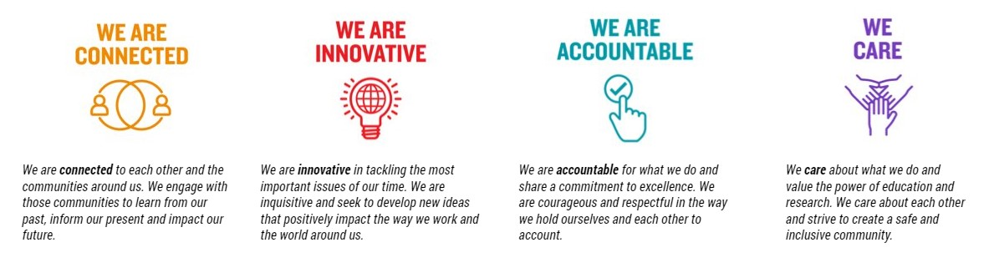

For Human Resource Use Only
Initials: Date:

