Statement of duties
Position Title | Senior Policy Officer
Position Number | 526531 and 526532
Division/Branch/Section | Program and Service Design - Housing Policy and Programs
Award/Agreement | Health and Human Services (Tasmanian State Service)
Classification | General Stream Band 6
Position Status* | Permanent
Position Type* | Full-time
Location | South/North/North West
Reports to | Manager Program and Service Design
Check Type | Annulled
Check Frequency | Pre-employment
* The above details in relation to Position Status and Position Type may be different when this position is advertised – please refer to the advertisement for vacancy details.

About Us
Homes Tasmania is established under the Homes Tasmania Act 2022 and commenced on 1 December 2022.
Homes Tasmania is building homes and creating opportunities for Tasmanians by delivering the Government’s 10-year, $1.5 billion plan to provide 10 000 new social and affordable homes by 2032.
We work with government, industry, the private sector, and the social housing and homelessness sector to improve the housing market and provide more housing opportunities for people in need.
Through the work of Homes Tasmania, Tasmanians will benefit from a resilient and diverse housing market that allows them to continue to improve their housing situation and the opportunities that better housing makes possible.

Our Purpose
The purpose of Homes Tasmania is to provide housing and housing assistance to eligible Tasmanians and to strategically manage and develop housing across Tasmania, giving consideration to the requirements of the complete housing continuum and to best meet the needs of all Tasmanians, both now and into the future.
Our Board
Homes Tasmania is governed by a skills-based Board, appointed by the Minister for Housing. The Board is established under the Homes Tasmania Act 2022.
The Board oversees how Homes Tasmania exercises its functions and powers, to ensure it meets the requirements of the Homes Tasmania Act 2022 including the Ministerial Statement of Expectations.
Our Organisation
Housing Policy and Programs
Housing Policy and Programs Unit performs the core system management functions of strategy and planning, purchasing, performance management, monitoring, reporting and analysis for housing and homelessness services in Tasmania. The branch is responsible for partnerships with housing support providers, community housing providers, and community support services to achieve positive outcomes for people accessing housing assistance in Tasmania.

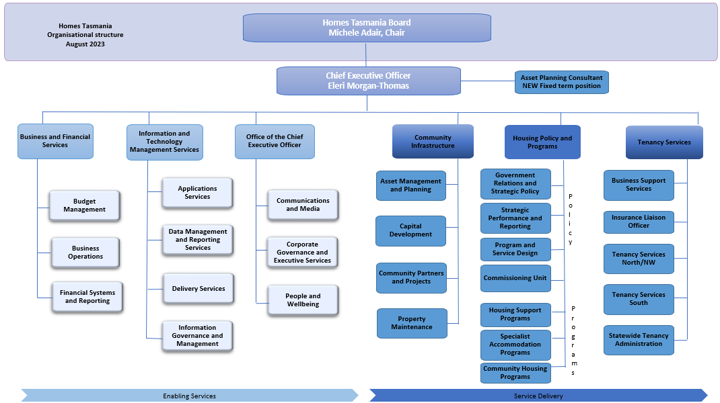

Primary Purpose
- Housing Advisors provide advice on Homes Tasmania’s strategic direction including research, consideration and collaboration across government and key stakeholders, identifying risks, and evaluating outcomes while maintaining a high-level awareness of key strategic, government and ministerial priorities.
This is a senior officer role within the Housing Policy and Programs branch, requiring experience in developing program guidelines and requirements for social services and performance measures to monitor and evaluate the operational success of programs delivered or funded by Homes Tasmania.
The Senior Policy Officer, as part of the Program and Service Design unit, will contribute to the design and development of initiatives to reform service delivery, as necessary, by working collegially with key stakeholders to deliver change and embed new practices.
Primary Duties
- Work collaboratively as part of a team that develops program guidelines and performance measures, to design, monitor and evaluate housing and homelessness services in Tasmania, which are delivered mostly by non-government organisations.
- Prepare or contribute, to a high standard, clear and concise documents including high level program policies and documents for a range of stakeholders in accordance with strategic policy direction, relevant legislation, and best practice and quality guidelines.
- Undertake research activities and consult with experts to provide high-level advice and policy analysis to senior managers and colleagues about the design of new services and embedding new practices.
- Undertake projects that contribute to the successful implementation of strategic reform initiatives and approved service priorities.
- Establish and maintain effective working relationships with internal and external colleagues and stakeholders to ensure high levels of satisfaction with the responsiveness, professionalism, and effectiveness of Homes Tasmania on managing the reform of housing programs and policy development.
- Work collaboratively with stakeholders to support the planning, coordination, development, monitoring and delivery of specific initiatives.
- Actively participate in and contribute to Homes Tasmania’s commitment to being a healthy, safe, inclusive and wellbeing focused organisation.
- The incumbent can expect to be allocated duties, not specifically mentioned in this document, that are within the capacity, qualifications and experience normally expected from persons occupying positions at this classification level.
Level of Responsibility, Direction and Supervision
Supervision
The incumbent is not responsible for direct supervision of staff.
The incumbent is expected to work as part of an inclusive and dynamic team in a manner that reflects the values of Homes Tasmania, where staff are respected in their workplace and have equal access to opportunities and resources.
Direction
The incumbent reports to and receives management direction from the Manager of the unit.
The incumbent is required to operate with a high degree of autonomy and is expected to exercise a high level of initiative and professional judgement across the spectrum of their responsibilities.
Overall determination of work standards and the allocation of work will be set by the Manager of the unit. Priorities and task-specific instructions will be agreed in consultation with the Manager.
Level of Responsibility
The incumbent is responsible for providing timely, accurate and authoritative advice, analysis, recommendations and solutions to the Manager of the unit across the spectrum of their responsibilities.
Responsible for representing Homes Tasmania with the authority to negotiate and conclude outcomes within their delegation that meet the specified requirements and objectives of Housing Policies and Programs.
Essential Requirements
Registration/licences that are essential requirements of this role must remain current and valid at all times whilst employed in this role and the status of these may be checked at any time during employment. It is the employee’s responsibility to ensure that registration/licences remain current and to advise the Employer if their circumstances change. This includes notifying the Employer of any new criminal convictions and/or if a registration/licence is revoked, cancelled or has its conditions altered.
- The Head of the State Service has determined that the person nominated for this job is to satisfy a pre-employment check before taking up the appointment, on promotion or transfer. The following checks are to be conducted:
  - Conviction checks in the following areas:
    - crimes of violence
    - sex related offences
    - serious drug offences
    - crimes involving dishonesty
    - serious traffic offences (if Driver’s Licence is an essential requirement)
  - Identification check
  - Disciplinary action in previous employment check.
Desirable Requirements
- Current Driver’s Licence.
- Satisfactory completion of an appropriate course of study from a recognised tertiary institution.
Selection Criteria
- Highly developed conceptual and analytical skills and demonstrated ability to develop policy and performance measures, to design, monitor and evaluate social services.
- Demonstrated ability to conduct research and consult with experts to provide timely and accurate advice, recommendations and solutions to senior managers and colleagues on relevant issues across the spectrum of their responsibilities.
- Highly developed written communication skills, including attention to detail, and ability to prepare concise and correct written documents that identify relevant issues.
- Well-developed interpersonal skills, including verbal communication skills, and demonstrated ability to represent Homes Tasmania externally, and ability to build trust and work collaboratively with colleagues and Homes Tasmania’s partners to maintain productive relationships.
- Highly developed time management skills and the demonstrated ability, both individually and as a member of a team, to plan, organise, set priorities to complete tasks to meet deadlines and achieve established benchmarks and standards.
- Demonstrated high level knowledge and understanding of the provision of housing and homelessness services in Tasmania.
Values and Behaviours
We are a values-based organisation. Our aim is to attract, recruit and retain people who uphold our values and are committed to building a strong values-based culture. Our values and behaviours reflect what we consider to be important.
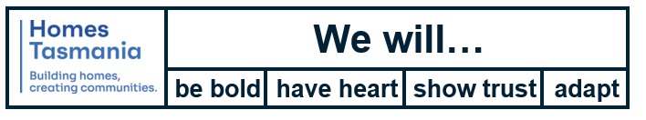
State Service Principles and Code of Conduct: The minimum responsibilities required of officers and employees of the State Service are contained in the State Service Act 2000. The State Service Principles at Sections 7 and 8 outline both the way that employment is managed in the State Service and the standards expected of those who work in the State Service. The Code of Conduct at Section 9 reinforces and upholds the Principles by establishing standards of behaviour and conduct that apply to all employees and officers, including Heads of Agencies. Officers and employees who are found to have breached the Code of Conduct may have sanctions imposed.
The State Service Act 2000 and the Employment Directions can be found on the State Service Management Office’s website at http://www.dpac.tas.gov.au/divisions/ssmo
Delegations: This position may exercise delegations in accordance with a range of Acts, Regulations, Awards, administrative authorities and functional arrangements mandated by Statutory office holders including the Secretary. The relevant manager can provide details to the occupant of delegations applicable to this position. Homes Tasmania has a zero tolerance in relation to fraud and in exercising any delegations attached to this role the occupant is responsible for the detection and prevention of fraud, misappropriation and other irregularities.
Records and Confidentiality: Officers and employees of Homes Tasmania are responsible and accountable for making proper records. Confidentiality must be maintained at all times and information must not be accessed or destroyed without proper authority.
Smoke-free: Homes Tasmania is a smoke-free work environment. Smoking is prohibited in all State Government workplaces, including vehicles and vessels.

