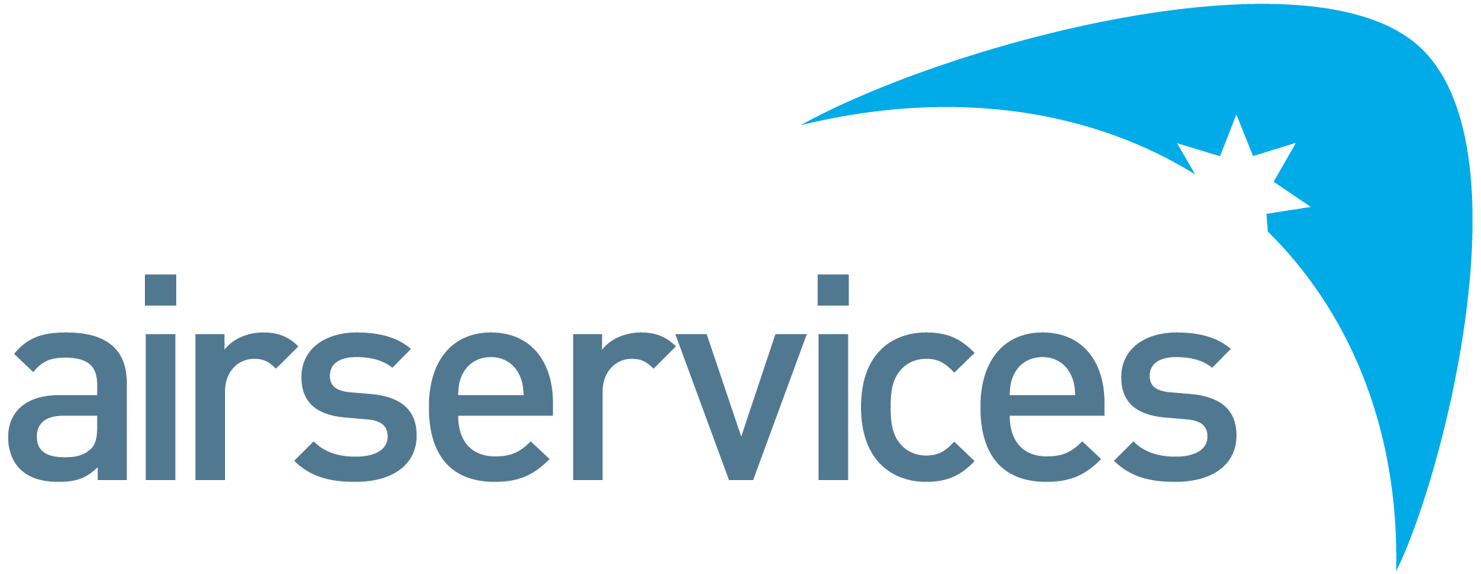

SSEA Assurance Senior Specialist
Position Detail
Reports To | Head of Learning & Assurance | Group | SSEA
Classification | ASA7A | Location | Melbourne, Brisbane, or Sydney
Reports – Direct  Total | 0

Organisational Environment
Airservices is a government owned organisation providing safe, secure, efficient, and environmentally responsible services to the aviation industry.
Each year we manage over four million aircraft movements carrying more than 156 million passengers and provide air navigation services across 11 per cent of the world’s airspace.
Airservices has two major operating centres in Melbourne and Brisbane and a corporate office in Canberra. We operate 29 air traffic towers at international and regional airports and provide aviation rescue fire fighting services at 26 Australian airports.
We are committed to continuing to improve our business by providing our customers with services they value and embedding new ways of working and technology investments to further innovate and optimise.
Primary Purpose of Position
As SSEA Assurance Senior Specialist, you will own the program management of the Line 2 Safety, Environment and Security & Resilience Assurance Program. Activities will include aligning each Framework’s Assurance Plan to one standard plan, monitor and track its progress and provide routine reports to key leaders to achieve visibility. You will also play a leading role in facilitating the SSEA Assurance Working Group to champion continuous improvement and capability development.
Accountabilities and Responsibilities
Position Specific
- Establish common SSEA Assurance ways of working, stakeholder engagement and documentation.
- Working with each Framework, confirm and collate the SSEA line 2 assurance program.
- Facilitation of the Assurance Working Group to enable cross-SSEA and organisational collaboration on how we identify and manage our assurance activities.
- Continuous improvement / thought leadership on assurance activities and capability across the frameworks.
People
- Maintain an effective working relationship across the SSEA Frameworks and those carrying out assurance activities.
- As needed, manage external agencies for independent system oversight of our Frameworks
Compliance, Systems and Reporting
- Reporting monthly and quarterly to key stakeholders across the business, regarding both the planned and outcomes of line 2 assurance activities
- Champion and support line 2 assurance processes via corporate repositories (CIRRIS and Integrated Risk Management)
- Maintain compliance with enterprise governance systems and policies, including Safety, Environment, WHS and Enterprise Risk
Safety
- Demonstrate safety behaviours consistent with our SSEA Strategy and organisational values.
Key Performance Indicators
Efficient, Effective and Accountable
- Proactively lead the SSEA Frameworks community to align and standardise how line 2 assurance is facilitated.
- Quality and timeliness of reporting on the Program’s status and plan
- Lead a purposeful and committed Assurance Working Group
Commercial
- Deliver efficiencies through a fit for purpose program of our line 2 activities.
- Lead and manage external agencies, where required, for independent framework oversight.
Safety
- Compliance with safety, risk, environmental and any other standards
Key Relationships
- Framework owners, facilitating both system level and risk-based line 2 assurance.
- Heads of SSEA
- Service Delivery stakeholders.
- Governance, Risk & Compliance (GRC)
Skills, Competencies and Qualifications
Skills
- Demonstrable experience leading or managing assurance programs.
- Experience in understanding risk and trends.
- Demonstrated ability to liaise with diverse stakeholders to meet customer needs.
- Facilitation skills
- Proficiency in reporting, to achieve simple and compelling insights.
- Highly developed skills of coordination, organisation and records management to plan and manage activities.
Competencies
- Working with People
- Adhering to Principles & Values
- Delivering Results & Meeting Customer Expectations
- Deciding & Initiating Action
- Relating & Networking
- Planning & Organising
- Adapting & Responding to Change
Qualifications / accreditation
- A degree in aviation, safety or a related field is highly desirable.
- Further education in Risk Management is advantageous.
Performance Standards and Behaviours
As a member of Airservices, you will consistently demonstrate performance standards and behaviours that meet our Code of Conduct. This includes:
- Treating everyone with dignity, respect, and courtesy
- Acting with honesty and integrity
- Acting ethically and with care and diligence
- Complying with all Airservices’ policies and procedures, and applicable Australian laws
- Disclosing and taking reasonable steps to avoid any actual, potential, or perceived conflict of interest.
- Behaving in a way that upholds our vision, mission, and values, and promotes the good reputation of Airservices.

