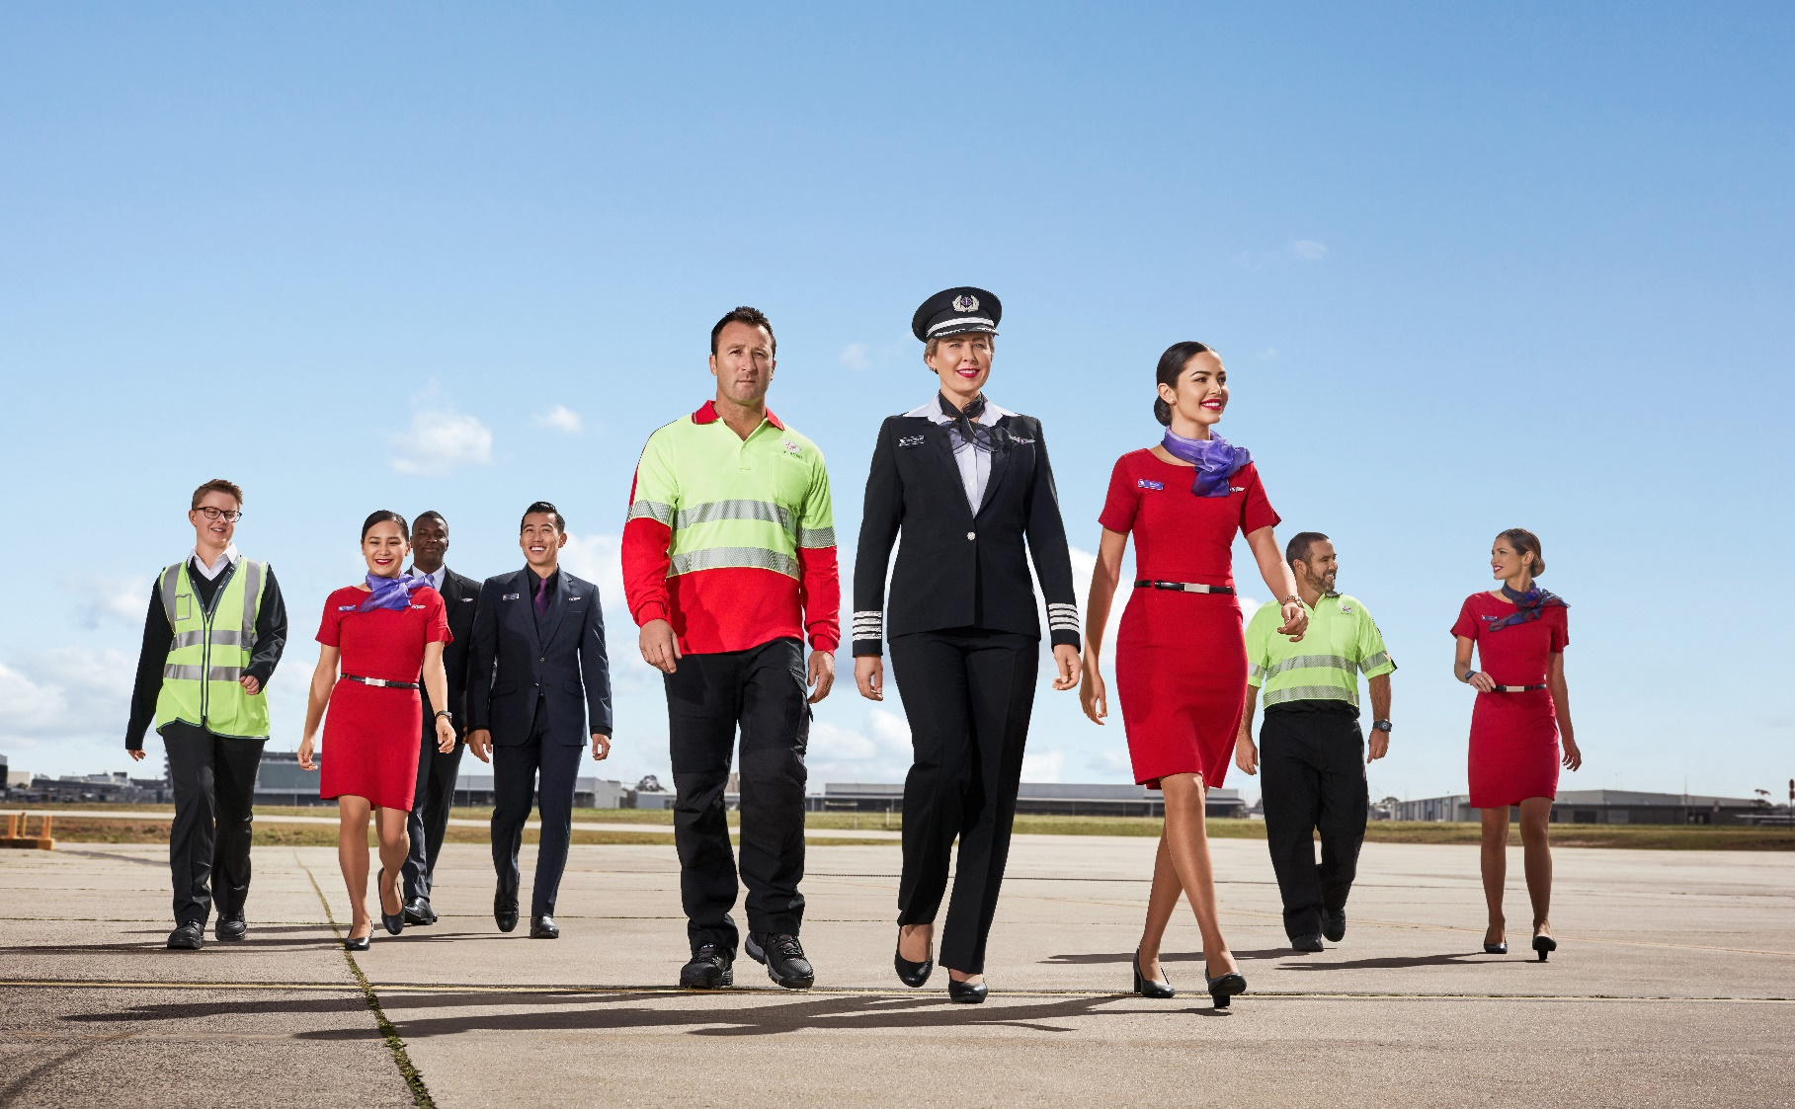
position description

Position Snapshot
Position Title: | Duty Manager, Integrated Operations Centre
Business / Division / Department: | COO / Integrated Operations Centre
Location: | Brisbane Headquarters
Reports to: | General Manager, Integrated Operations Centre
Direct Reports: | NA (30+ Indirect)
Date: | June 2021

Overall Impact Statement
Integrated Operations and the Integrated Operations Centre (IOC) is a multi-functional/multi-divisional team created to coordinate, monitor, support and enable our internal customer and their resources to deliver a market leading, safe, on time, customer centric and efficient operational network.

The objective of the Duty Manager, Integrated Operations Centre is to be the senior leadership role within the Virgin Australia Airlines Integrated Operations Centre, ensuring the delivery of the daily operational schedule in line with Virgin Australia’s strategy. A priority is enabling our guests to travel as expected (safely and on time) and where disruption to our guests’ travel plans occur, this role is responsible for the end-to-end recovery to ensure the best possible guest experience is achieved, while balancing operational costs and our corporate key performance indicators (On Time and Completion).
This role has delegated authority from the Chief Operations Officer and General Manager, Integrated Operations Centre to drive the best outcomes for our guests’, our business and our people within the Integrated Operations Centre.

Key Accountabilities
Accountability | Major Activities
Financial | - Manage Virgin Australia’s daily operational budget to minimise increasing costs on behalf of the Chief Operations Officer.  - Support VARAs operational budget to minimise increasing costs on behalf of the EGM, VARA.  - Manage Virgin Australia’s Customer Reprotection budget to minimise cost leakage, on behalf of the GM, Integrated Operations Centre.  - Support VARA Customer Reprotection budget to minimise cost leakage, on behalf of the EGM, VARA.
Operations | - For all known and probable Disruption events, a proactive plan formulated and published, ready to implement as required. Plans are to be published by; 20:00 for next day head starts operation and AM disruptions, 10:00 for PM storm activity and as appropriate for events under CMT, VAMT and/or SEAT coordination.  - Identify key performance levers for the next 12-24 hours as a proactive opportunity that will significantly improve OTP, Completion, Cost and/or Guest Experience.  - Management of network schedule, resources, cost and disruption events to achieve divisional performance metrics in line with the strategy.  - Minimise diversions on high frequency markets.  - Ensure any port that is nominated an alternate is advised to support recovery.  - Consider accommodation and transport for guests prior to departing to high-risk diversion ports.  - Ensure our guest accommodation and transport provider is aware of any probable diversions.  - Be aware of accommodation requirements and restrictions. Include this information in disruption recovery plans.  - Continued network assessment to identify risks, plan actions and minimise adverse effects on the network.  - Own the end-to-end disruption management plan for all guests and hence will veto unacceptable disruption solutions from a Customer Experience perspective.  - Proactive in assessment and implementation of all disruption management plans.  - Consideration of all impacted parts of our business and external parties.  - With safety a given, implementation of plans that considers customer satisfaction, cost and OTP.  - Work with alliance partners to seek a better solution to a disruption.  - Ensure resources are readied at ports that may be affected by disrupt events.  - Drive recovery solutions with ports to ensure all aspects of business performance is achieved.  - Ensure compliance with all Commercial and Tactical Slot requirements.  - Ensure compliance with applicable industrial, company and regulatory requirements.
Continuous Improvement | - Collaborate with Commercial and Engineering leadership team to understand and mitigate schedule limitations prior to the network schedule being finalised.  - Identify opportunities to improve efficiency and quality of processes in the Integrated Operations Centre  - Identify possible barriers preventing the implementation of processes and key initiatives, as well as providing actions to mitigate barriers.  - Lead any post event review of guest disruption recovery across the various IOC divisions  - Analysis of key stakeholder feedback, audit information, reports and the Integrated Operations Centre team member feedback to identify areas of opportunity – ability to make recommendations based on these findings.  - Manage agreed portfolios of additional responsibility that are designed to enhance and improve the overall department’s effectiveness.  - Support the company’s and Integrated Operations Centre’ change management policies and processes.  - Engage, as required, regarding commercial policy changes to aid disruption recovery and Customer Experience.
Customer | - Proactive resolution of potential guest connection related disruptions. Instruct proactive action and communication to guests.  - Ensure you have a complete understanding and you have approved the Guest recovery for all disruptions within your control.  - Reassess, amend and re-approve Guest recovery plans if situation deteriorates or causes a negative experience.  - Continued engagement with operational teams (IOC, GCC, CSD and E&AS) to identify, plan actions for potential system stresses which could adversely affect the network.  - Other airline contact to share/gather operational information pertaining to aligned operations.  - Ensure guests have been communicated with in the event of a disruption – delay, cancellation or diversion through automated messaging and/or verbal from frontline teams.  - Ensure prompt timely communications to Senior Management and Corporate Communications.  - Ensure senior management are communicated in a timely manner on activation of IAT, VAMT and SEAT.  - Ensure alliance partners are aware of any disruptions that may include their Guests.  - As required update internal customers on Customers’ recovery during disruptions.  - Ensure all pertinent communications are sent to key client (mining / IOT).
People | - Create a safe on-time performance culture within the Operations Control Centre and between departments / divisions.  - Lead all IOC work units to ensure they are functioning as one with communication, lines of authority maintained particularly during difficult disruptions.  - All teams aware of daily expectations to deliver operational excellence.  - Welfare of IOC team members is forefront of mind throughout difficult times.  - Performance Manage IOC team members as required when direct report leadership is not available.  - Lead, motivate and inspire team members.  - Actively demonstrate a fair, honest, open and consistent approach to leadership.  - Recognise and reward positive performances (both team and  individual).  - Ensure adherence to all required policies including EEO and disputes resolution.  - Actively promote an inclusive, consultative workplace.
Safety, Security & Business Resilience | - Ensure all team members complete mandatory training applicable to their roles (including Safety, Security, Resilience and, Health and Wellbeing).  - Ensure adherence to Virgin Australia Risk Management Framework (RMF) and adopt a proactive approach to the timely identification of operational and corporate risk and work to mitigate, resolve and escalate as required.  - Actively participate in relevant forums to improve Safety, Security, Resilience and Health and Wellbeing throughout the Group.  - Lead and participate in Safety Shares in all meetings.  - Champion Better Me throughout the Group.  - Lead consultation of WHS matters as related to your working environment  - Lead the IOC evacuation process in the event of an infrastructure threat.  - Adhere to all documented operating procedures.  - Chair IATs, VAMTs, SEATs, Bomb Threat Assessments and IRM conference calls.  - Be a thrusted partner to the Group Crisis Chairs on threat assessments.  - Perform and delegation of duties as required under limited response or red alert.  - Lead the IOC in response to any and all threats.

Virgin Australia Leadership Standards
Standard | Behavioural Descriptors
Passionately VA | - Identifies and addresses the underlying needs of internal and external customers  - Identifies service trends and contributes to providing creative solutions  - Looks for ways to leverage digital transformation initiatives to improve ways of working and customer experience  - Taps into individual differences and working styles to improve business processes and outcomes  - Simplifies complex concepts and arguments  - Instils confidence in self and others to embrace challenges and opportunities  - Recognises and celebrates success and achievement  - Uses data to measure and monitor safety performance and ensures team members are accountable for their individual contribution to safety outcomes
Desire to be Better | - Uses digital platforms to generate insights on business performance, customer experience and risks  - Monitors trends and ideas, sharing insights to add value and address emerging risks  - Seeks ways to continuously improve and empowers others to challenge the status quo  - Explores and leverages new ways to communicate for maximum impact  - Pushes barriers and displays persistence, even in the face of failure  - Role models and coaches safety behaviours to support compliance and safety outcomes
Collaborates | - Understands the VA Group’s objectives and the links between teams, functions, businesses and sector  - Identifies and facilitates connections that add value  - Communicates convincingly, anticipating varied audience needs and adapting style  - Empowers others to build trusting and cooperative partnerships and facilitates relationships across the business and with external partners  - Enables connections, identifying and removing obstacles  - Shares learnings and drives collaboration and joint problem solving
Inspires Team | - Assembles high performing teams through complimentary skill sets and ways of working  - Coaches and mentors others, facilitating their development and encouraging initiative and action  - Sets goals for self and others that contribute to the achievement of VA’s strategy  - Proactively seeks and reflects on feedback to identify development opportunities  - Empowers others to take action without direct control  - Leads by example through influencing others with own actions  - Actively monitors teams for adherence to standard operating procedures and drive a ‘safety first’ culture
Creates Future | - Adopts an open-minded approach, anticipating the immediate impacts of change and enabling an agile response  - Engages with others and demonstrates empathy and caring in the face of change  - Prepares for change, seeking opportunities to contribute to change initiatives  - Demonstrates hunger for innovation, is comfortable with being uncomfortable when it comes to change  - Evaluates progress and re-prioritises work regularly based on changing needs and risk considerations
Drives Results | - Understands the interdependence of the Group’s goals, taking into account wider operational context  - Plans own work and that of others to demonstrate accountability towards the achievement of extraordinary outcomes  - Removes barriers and overcomes obstacles to ensure delivery of results  - Applied knowledge and analysis of issues and trends to formulate and achieve plans  - Establishes systems and procedures to guide work and track progress  - Thinks laterally and finds ways to achieve outcomes  - Reviews safety and risk performance within own area and searches for ways for continuous improvement.

