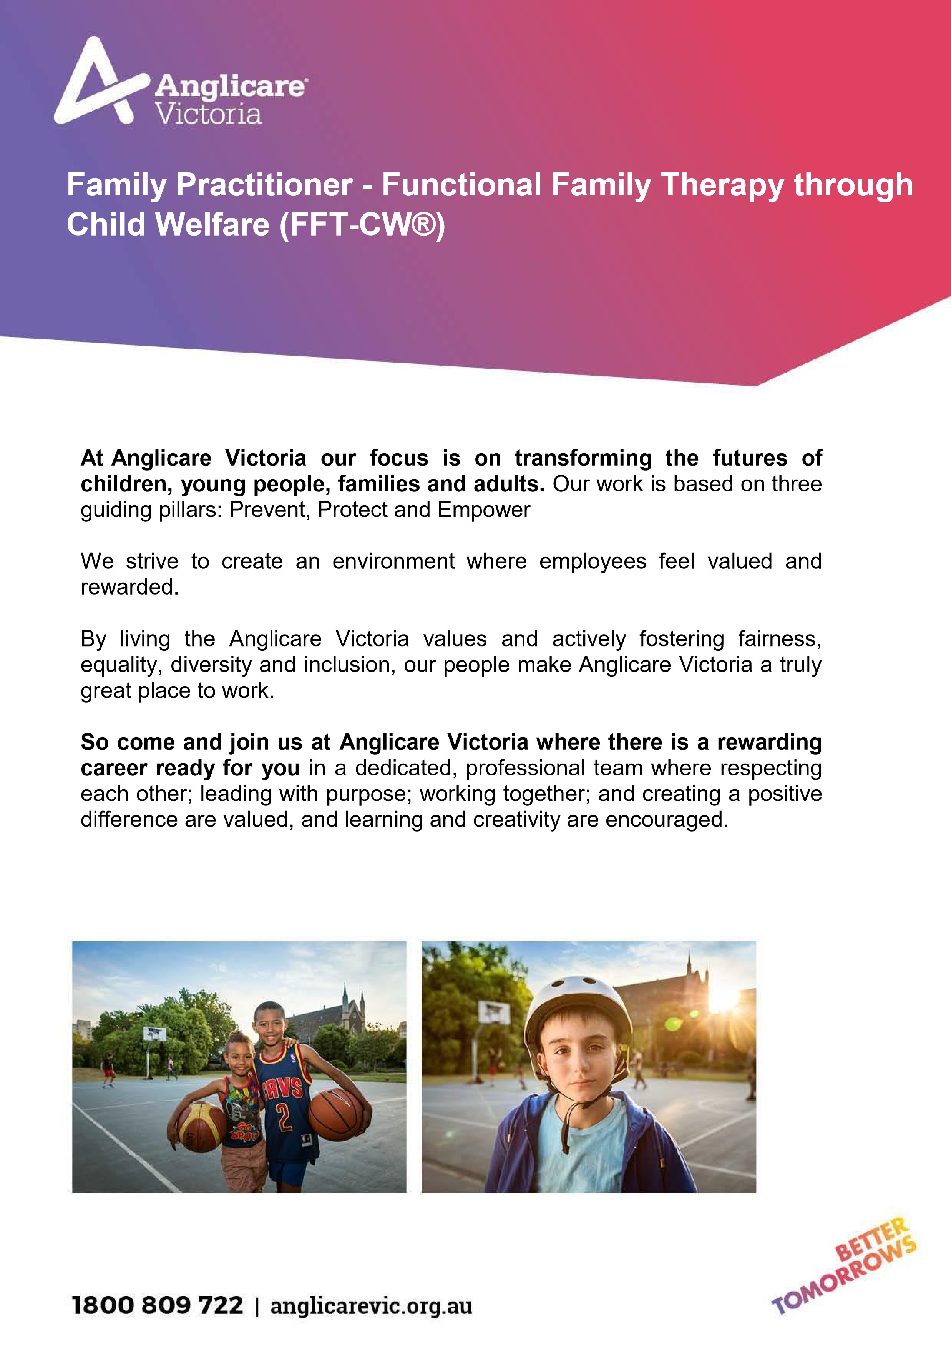

Position details

Position | Functional Family Therapy through Child Welfare (FFT-CW®) – Practitioner
Program | Family Services
Classification | SCHADS Award Level 6
Hours | Full Time (38 hours per week, 7.6 hours per day, Monday to Friday between 8:00am – 8:00pm).  Part time (0.8EFT or 0.9EFT) applications may be considered  This position requires flexibility in working hours to ensure family’s needs are met.  The start and finish time of working hours may vary each week.
Duration | Permanent
Location | Preston
Reporting  Relationship | This position reports directly to the FFT-CW Lead Practitioner.
Effective date | December 2020

Service Information
Functional Family Therapy through Child Welfare (FFT-CW) is an adaptation of Functional Family Therapy (FFT) which provides services to children, youth and families in child welfare settings. Functional Family Therapy through Child Welfare (FFT-CW) aims to keep families together and where possible prevent children from entering out of home care. Services in FFT-CW are based on the standard FFT model.

FFT-CW is a short term, assertive outreach, evidence based intervention program with an average of 12 to 20 sessions over three to five months. FFT-CW is a strengths-based model built on a foundation of acceptance and respect. The program has supported many adolescents and their families in various multi-ethnic and Indigenous cultural contexts globally.

There are five major elements of FFT-CW, which are:

- Building a trusting relationship between the family and practitioner
- Working to reduce conflict and to increase hope and a positive family environment.
- Identifying how family interactions can affect behaviour.
- Working to improve communication and conflict management skills.
- Extending changes into other areas, such as when other people in the family’s support network are brought in, e.g. extended family, teachers, youth justice workers.

Position Purpose
The Practitioner FFT-CW is required to:

- Participate in all model program training, including group supervision and group consultation activities on a weekly basis.
- Provide assertive outreach service delivery with families in their homes, community or other appropriate settings.
- Provide services that are culturally inclusive and respectful to Aboriginal Families and to families from culturally and linguistically diverse background.
- Assess and respond to reducing risk for families using evidenced-based interventions compatible with the principles and practices of the model.
- Demonstrate compliance with agency requirements and model fidelity through clear and concise documentation and data entry.
- Contribute positively to the development of collaborative partnerships both internally and externally.

Key responsibilities

The key responsibilities are as follows but are not limited to:

1. | Provide assertive outreach service for young people and families which identifies and overcomes barriers to engagement and motivation through the planning and delivering of evidence-based interventions who have been referred to the service.
2. | Complete systemic assessments to identify and engage key participants, risks and protective factors and to develop an analysis of the problem behaviours within the context of the FFT-CW model.
3. | Develop interventions tailored to young people and families, using excellent written and oral communication skills, which address referral behaviours and safety risks.
4. | Participate in FFTCW group supervision led by Lead Practitioner or FFT Consultant and be open to consistent peer supervision and feedback.
5. | Record and update data management systems to meet Anglicare Victoria & DHHS guidelines and statutory requirements.
6. | Work with relevant stakeholders to enable continual improvement to the implementation of our service delivery model to further extend our commitment to improving the lives of children, young people and their families
7. | Develop positive working relationships with Aboriginal agencies to ensure cultural safety in our practice and good outcomes for aboriginal children and young people.
8. | Maintain positive key internal and external stakeholder relationships. Coordinate services within Anglicare Victoria and with other community providers.
9. | Work with the FFT-CW Lead Practitioner to identify personal and team  performance trends, best practices, and opportunities for improvement.

What we look for - the key selection criteria

The Key Selection Criteria are based on role specific requirements and the Anglicare Victoria Capability Framework.

Applicants are required to provide a written response to:

- The role specific requirements. The five criteria are to be addressed individually (no more than 2 pages in total).

- Anglicare Victoria Capability Framework. Applicants are to describe how they demonstrate the characteristics in each of the two capability groups; Personal Qualities and Relationship and Outcomes. (No more than 1 page in total).

Key Selection Criteria

a) Role specific requirements.

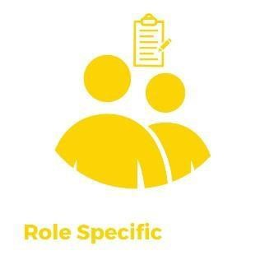 | - Tertiary qualifications, preferably in social work, psychology or behavioural sciences or equivalent.  - Experience of working with marginalised, minority and hard to reach young people and/or their families in their homes and communities.  - Excellent understanding of the child and family service system, including legislative and policy frameworks.  - Knowledge and understanding of culturally sensitive practice and demonstrated ability to engage and effectively work with Aboriginal and culturally diverse groups.  - Demonstrated experience in, or knowledge of, family/care giver systems theory, behavioural and cognitive therapies and the application of these in working with young people and families experiencing multiple and complex challenges.  - Proven ability to effectively time manage caseload and documentation requirements whilst demonstrating the ability to flexibly manage competing priorities and stressful situations

a) Anglicare Victoria Capability Framework

The Anglicare Victoria Capability Framework describes the capabilities required to meet the expectations of clients, colleagues and communities in today’s changing environment.

These capabilities work together to provide an understanding of the knowledge, skills and abilities required of all employees.

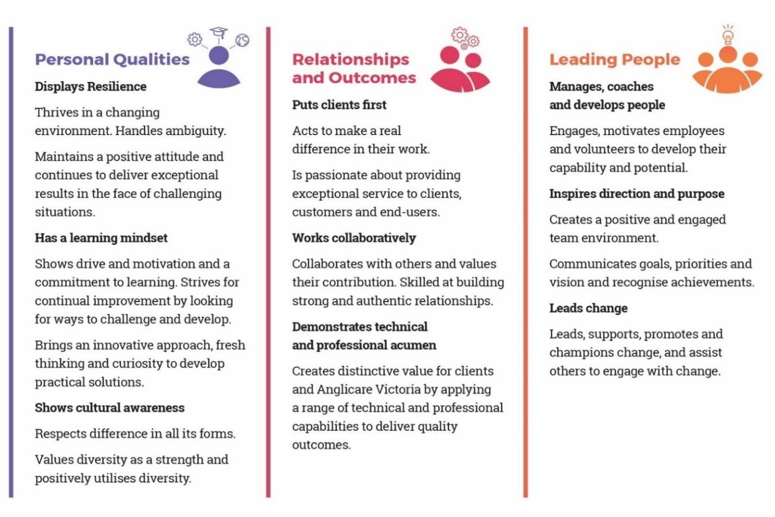

Occupational Health & Safety (OHS)
Anglicare Victoria is committed to ensuring the health and safety of its employees and any other individuals present in our workplaces.
In achieving and maintaining workplace health and safety, Anglicare Victoria will apply best practice in OHS in accordance with statutory obligations at all times.
All Anglicare Victoria employees, contractors and volunteers are required to:
- take reasonable care for their own health and safety and for that of others in the workplace by working in accordance with legislative requirements and the company’s OHS policies and procedures
- take reasonable care their actions or omissions do not adversely affect the health and safety of themselves and others
- cooperate with any reasonable directions, policies and procedures relating to health and safety in the workplace
- report all injuries, illness or ‘near misses’ to their Supervisor or Manager
- participate in relevant health and safety training based on roles and responsibilities
- as required, participate in the development and implementation of specific OHS hazard and risk management strategies.
In addition to the above, positions with supervision or management responsibility are required to ensure a safe and healthy work environment for all employees, clients, contractors and visitors. This can be achieved by ensuring all people are aware of and have access to OHS policies, procedures, training and reporting systems

Cultural Safety in the Workplace
Anglicare Victoria recognises the important and unique contribution Aboriginal and Torres Strait Islander employees make by bringing their unique skills, knowledge and experience to the workplace. They also contribute important insight into how Anglicare Victoria can provide for and engage with Indigenous clients and communities more effectively.
Our Reconciliation Action Plan (RAP) and Workforce Strategy outlines Anglicare Victoria’s commitment to leading and facilitating sustainable employment, training, retention and career development opportunities for Aboriginal and Torres Strait Islanders people.

Conditions of employment
- Salary and conditions are in accordance with the Social, Community, Home Care and Disability Services Industry Award 2010. Salary packaging is offered with the position
- All offers of employment are subject to a satisfactory Criminal History Check and must provide a Working with Children Check prior to commencement.
- A current Victorian Driver’s license is essential

- All offers of employment at Anglicare Victoria are subject to a six month probationary period. The staff member will be asked to participate in an annual performance review linked to objectives set out for the position.

