Position Number(s) | 005009 | Manager’s Role Title | Manager Maintenance Planning
Business Group | Asset Operation & Delivery | Manager Once Removed | Senior Manager Asset Maintenance & Operational Control
Level of Work | V SA Water Hierarchy Level | Direct Report’s Role Title(s) | Not applicable

Purpose (Unique value add)
Providing a comprehensive, efficient and effective business support service to the Asset Maintenance & Operational Control (AM&OC) Group and assisting with specific projects as required.

Objectives
The objectives (maximum 6) of this role are to:
- Provide an effective and efficient business support service to the AM&OC Group, actioning all work requests within set KPIs.
- Ensure all local office needs are met in relation to business support, WHS, facilities management and any corporate initiatives as required.
- Ensure all relevant AM&OC reports are generated and maintained according to agreed timeframes and team requirements
- Ensure continual improvement and streamlining of AM&OC administrative services and processes.

Shared Organisational Goals
As a member of the Asset Operation & Delivery Group you are collectively accountable for delivering our goals and objectives.

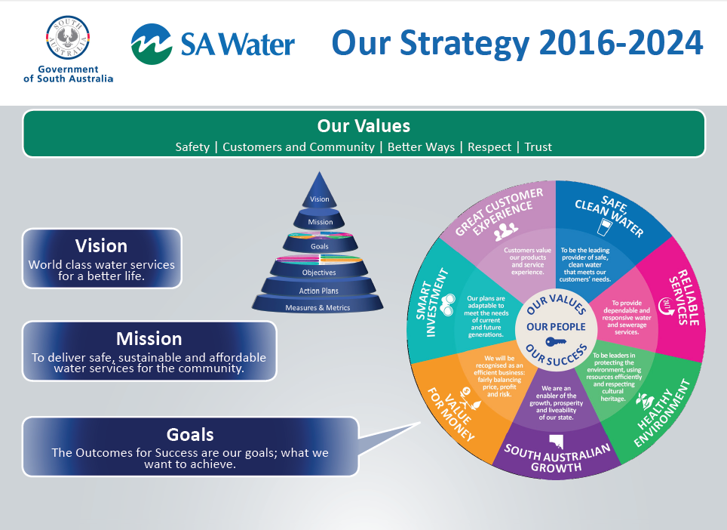
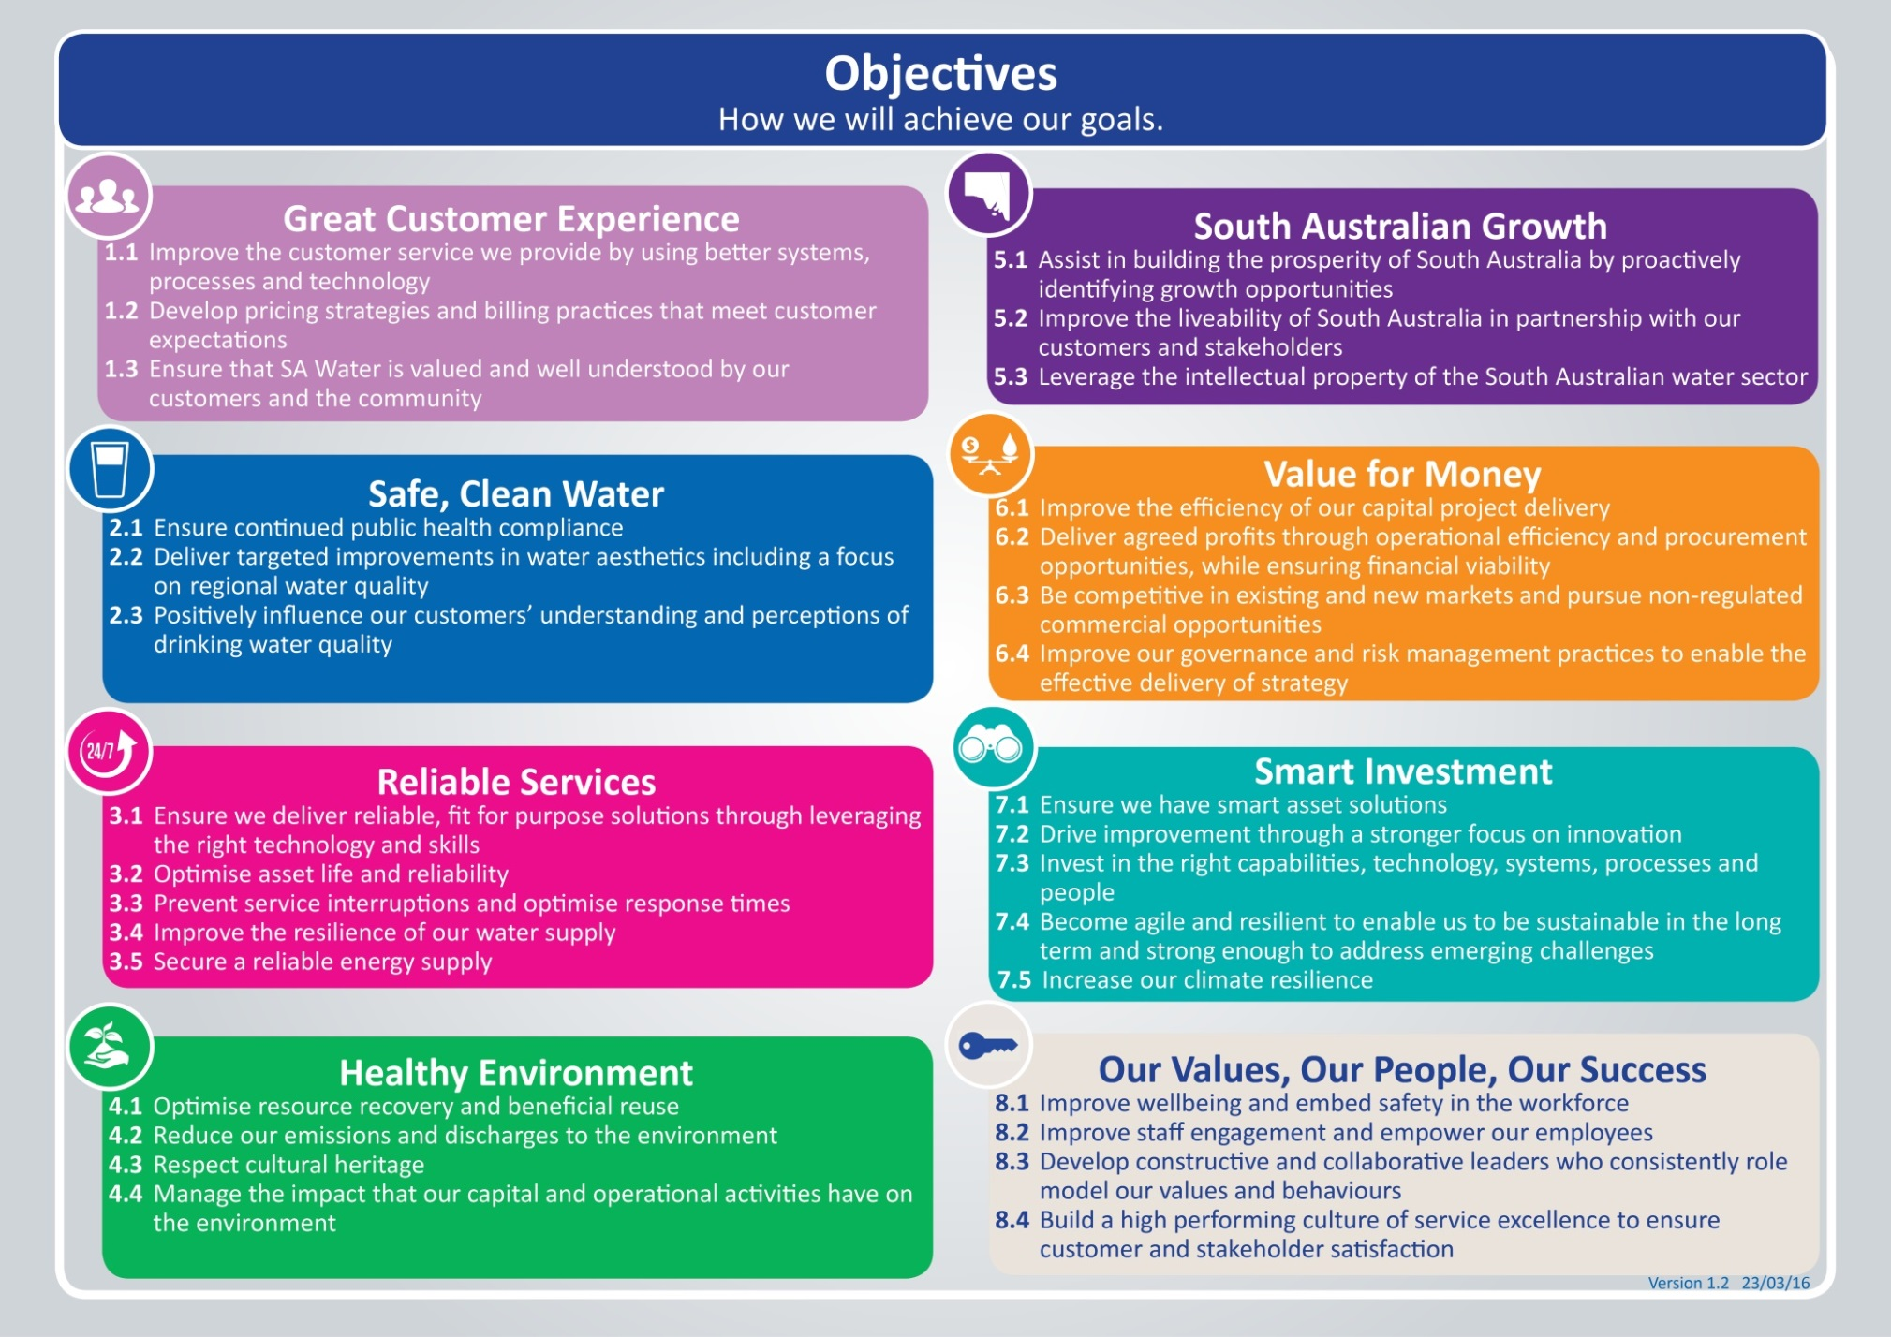

Key Accountabilities
Select relevant objectives from section 1.3 of this PD: Our Strategy 2016-2024 (also available on the AquaNet) and add them to the table as key accountabilities.
The key accountabilities (minimum 4 and maximum 6 including the mandatory ones), of this role are:
Key Accountabilities | Output/Measures
Mandatory accountability:  Contribute effectively to the team ensuring efforts are aligned toward achieving team goals | - Implement the direction set by your people leader.  - Complete specific tasks allocated.  - Collaborate effectively to ensure team goals are achieved by providing input into decision making and problem solving.  - Actively contribute to creating a culture of service excellence.
Mandatory accountability:  Put safety above all else | - Be aware of and apply roles and responsibilities in accordance with WHS Roles and Responsibilities Procedure.  - Take responsibility for the safety and wellbeing of yourself and others including your own fitness for work (e.g. under the influence of drugs, alcohol and/or fatigue).
Administration | - Provide an effective and efficient administrative service to the AM&OC Group, including mail duties, stationery ordering, travel and accommodation bookings, uniform orders, organising meetings and taking minutes.  - Provide on-site administrative support at regional workshops and reservoir sites as required.  - Assist with AM&OC programs and undertake project work as required.
Customer services | - Maintain an agreed high level of service that meets internal customers’ expectations.  - Ensure local office needs are responded to and met in a timely manner.  - Ensure that AM&OC work requests are completed in accordance with processes, set timeframes and delivered in a highly professional manner.
Work processes | - Ensure Credit Card Reconciliations are completed accurately and in line with the Corporate Purchasing Card Policy.  - Track, update and accurately complete all work requests as required.  - Ensure all business processes and work instructions are documented, relevant and kept up-to-date.
Team effectiveness | - Participate in all 1 on 1s and performance appraisals.  - Ensure own Position Description and PADP is up to date.  - Participate actively in all team meetings.  - Ensure active involvement in all team/corporate initiatives that need to be driven from our business support team to AM&OC Group.

Lead Behaviours
Uphold SA Water’s Values:
- Put safety above all else
- Act in the best interests of customer and the community
- Seek and apply better ways
- Respect our people
- Be trustworthy

LEAD Behaviours |  | Behavioural Description
L ead our Future | Leads Change and Improvement | Brings people along to embrace sustainable change to deliver desired change outcomes. Identifies and takes ownership of opportunities presented through ambiguous situations, generating creative ideas/solutions. Carries out systematic analysis to identify the root cause of problems and makes informed judgments. Challenges the status quo to simplify, rationalise or develop products, processes or services to meet the needs of our internal/external customers.
E mpower our People | Communicates with Influence | Two-way - Communicates openly and confidently. Motivates and influences others in a way that results in acceptance and agreement. Shapes conversations to ensure focus and understanding, debates at the table, not afterwards. Is a supportive listener.
A dd Value for our Customers | Customer Service Excellence | Make it easy for our customer/community by proactively anticipating internal and external needs - collaborating to build valued and trusted relationships through the delivery of high quality service.
 | Collaborates for Success | Coordinates efforts/resources within and across teams to deliver Outcomes for Success. Recognises the importance of teamwork to achieve outcomes; brings in ideas, information, suggestions and expertise from others outside the immediate team. Builds strong team relationships within and across teams to positively impact business performance.
D eliver on the Promise | Empowers Self | Acts with integrity. Pursues self-awareness; understands own strengths and limitations and is focused on self-development. Shows energy and resilience. Maintains commitment and a positive outlook in the face of setbacks and obstacles. Is authentic, approachable open and honest.
 | Achieves Results | Achievement focused. Takes personal accountability for achieving individual and shared outcomes. Sets robust plans well in advance and initiates action to move work forward. Adjusts actions to respond and capitalise on changing circumstances. Manages time effectively, monitoring performance against deadlines and milestones.

Knowledge, Skills and Experience

Foundation knowledge, skills, experience and qualifications | Essential or Desirable
Administrative qualifications (Certificate III Administration) | Desirable
Drivers licence (C Class) | Essential
Demonstrated experience in providing administrative services with the ability to work as a member of a multi-disciplinary group under limited supervision | Desirable
Demonstrated experience in prioritising workloads to meet required timeframes | Essential
Excellent data entry skills | Desirable
Knowledge of SA Water Credit Card and Purchasing procedures and policies | Desirable
Demonstrated capacity to record and manage data electronically | Essential
Effective written and verbal communication skills | Essential
A good understanding of Corporate and Operations policies, procedures and practices (HR and WHS) | Desirable
Demonstrated proficiency with computer applications | Essential

Key Stakeholder Relationships
- Maintenance Planning team
- AM&OC all staff
- Network Operations, Production & Treatment
- SA Water Learning & Development Group
- WHS
- Various internal and external stakeholders and service providers

Special Conditions
- Flexible hours and some after hours as required, some intra and interstate travel.

Template: Position Description - Level 5 Employee Version 3.01 22/11/16 -Document ID: SAWT-HR-0021

