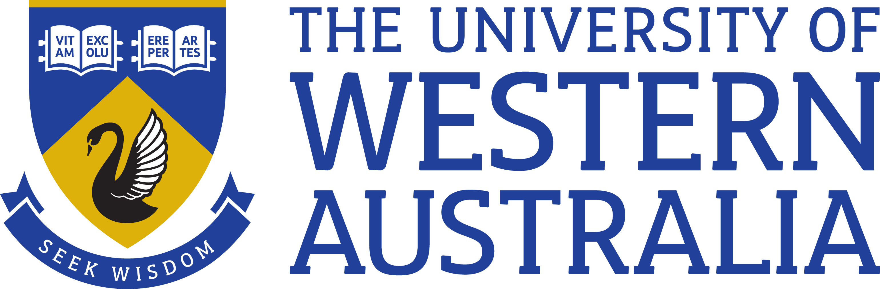

Position Title: Senior Research Fellow
Position Classification: Level C
Position Number: NEW
Faculty/Office: Faculty of Engineering and Mathematical Sciences
School: Engineering
Department: Chemical Engineering
Supervisor Title: Professor
Supervisor Position Number: 307682

Your work area
The School of Engineering is renowned for its award-winning researchers, teachers and facilities. It is a multidisciplinary school offering education and research in a number of engineering disciplines. This includes civil, environmental, mining, chemical, mechanical, electrical and electronic engineering. Successful applicants will work in the large Fluid Science and Resources (FSR) Research Group (https://www.fsr.ecm.uwa.edu.au/), which works extensively with the energy and natural gas industries prominent in Western Australia. This position will help conduct, high impact and industrially-relevant research across the themes of Fluid Properties and Flow Assurance.

Reporting Structure

Reports to: Professor Eric May

Your role

As the appointee you will, with guidance from Prof. Eric May, collaborate with researchers in the existing research group to conduct and coordinate the experimental, analytical and other research work related to the project “Unlocking Australia’s Offshore Gas Endowment”. In particular, you will take a leading role in the day-to-day conduct of research programs that investigate the nucleation and growth of natural gas hydrates, the impact of wax on gas condensate fluids, and the deposition of solids formed in cryogenic gas processing. You will guide junior post-doctoral and PhD researchers working on these and similar projects and help with the management of partnerships with industrial collaborators.

The position is for an initial period of two years.

Key responsibilities

- Undertake nationally significant, high-quality independent and collaborative research in the areas of Flow Assurance and Fluid Properties.

- Supervise and attract high-quality research students at both the undergraduate and postgraduate levels and post-doctoral research fellows.

- With advice from senior academics, contribute to a strong, internationally recognized research programme synergistic with existing research groups

- Attract research funding from nationally competitive funding agencies, industry, and local and federal governments.

- Promote research projects via publication of research papers and presentations at international conferences and workshops.

- Contribute to UWA teaching activities when appropriate opportunities arise.
- Play a major role and provide a significant degree of leadership in scholarly, research and/or professional activities relevant to the discipline and/or community
- Work in accordance with the University’s values, policies, delegations, financial regulations and other procedures; demonstrating tolerance and open mindedness, with understanding of the diverse nature of the University’s community

- Other duties as required.
Your specific work capabilities (selection criteria)

- A PhD in a relevant field.

- Extensive knowledge and experience in executing industry-driven research and contributing to the management of research projects in the area of Flow Assurance and Fluid Properties.

- Demonstrated ability to produce nationally significant, influential research with high quality publication outputs, relative to opportunity

- Established ability to attract competitive research funding from industry and government.
- Highly developed ability to work with industry and deliver business outcomes.
- Have a proven track record in the successful supervision of the research of honours and postgraduate students.

- Excellent interpersonal, verbal and written communication skills with the ability to both lead a team and to work effectively as part of a team

- Demonstrated ability to work independently and show initiative.

Special Requirements

Undertake Interstate & International Travel representing FSR and UWA to engage with industry sponsors.
Occasional weekend work.

Compliance

Workplace Health and Safety
All supervising staff are required to undertake effective measures to ensure compliance with the Occupational Safety and Health Act 1984 and related University requirements (including Safety, Health and Wellbeing Objectives and Targets).
All staff must comply with requirements of the Occupational Safety and Health Act and all reasonable directives given in relation to health and safety at work, to ensure compliance with University and Legislative health and safety requirements.
Details of the safety obligations can be accessed at http://www.safety.uwa.edu.au

Equity and Diversity
All staff members are required to comply with the University’s Code of Ethics and Code of Conduct and Equity and Diversity principles. Details of the University policies on these can be accessed at http://www.hr.uwa.edu.au/publications/code_of_ethics, http://www.equity.uwa.edu.au

