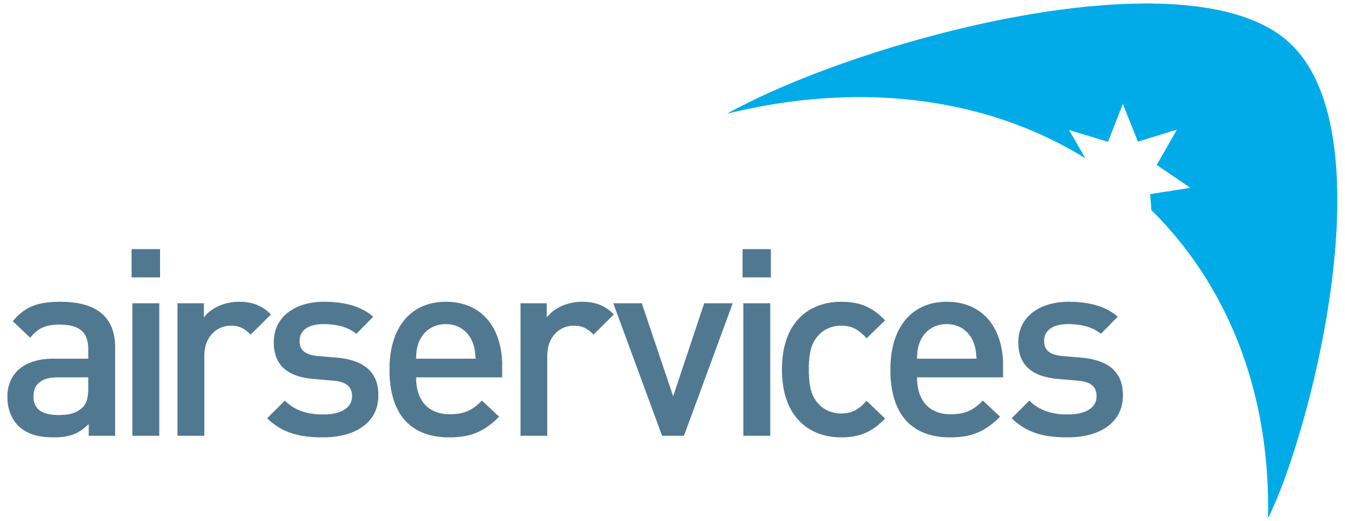

Regulatory Specialist
Position Detail
Reports To | Head of Government, International and Regulatory Engagement | Group | Chief Customer Experience and Strategy Officer
Classification | ASA7A | Location | Canberra
Reports – Direct  Total | 0

Organisational Environment
Airservices is a government owned organisation providing safe, secure, efficient and environmentally responsible services to the aviation industry.
Each year we manage over four million aircraft movements carrying more than 156 million passengers, and provide air navigation services across 11 per cent of the world’s airspace.
Airservices has two major operating centres in Melbourne and Brisbane and a corporate office in Canberra. We operate 29 air traffic towers at international and regional airports, and provide aviation rescue fire fighting services at 26 Australian airports.
We are committed to continuing to improve our business by providing our customers with services they value and embedding new ways of working and technology investments to further innovate and optimise.
Primary Purpose of Position
The aviation environment is transforming rapidly, driven largely by emerging technologies including advanced air mobility aircraft and remotely piloted aircraft, and unmanned air systems traffic management (UTM) that are interfacing with traditional airspace systems and users. In addition Airservices is investing in an integrated civil/military air traffic control system which will modernise Australia’s air traffic management and surveillance capabilities. As the Regulatory Specialist, you will provide advice on existing and strategic aviation regulatory matters to ensure Airservices is able to meet its responsibilities and achieve its objectives and strategy. You will draw on your regulatory knowledge and experience in aviation to analyse the regulatory environment and identify existing and future regulatory requirements, risks and issues Airservices needs to engage on to achieve its purpose.
Accountabilities and Responsibilities
Position Specific
- Demonstrate a sophisticated understanding of Australia’s aviation regulatory environment.
- Lead regulatory advice and reform, including on emerging aviation technology, consistent with Airservices strategy and legislative obligations.
- Provide insights that can inform Airservices strategic engagement on regulatory risks and opportunities.
- Communicate strategic advice to senior executives in order to manage issues and risks, and generate support for Airservices’ regulatory goals.
- High level presentation and communication skills in order to influence senior stakeholders by expressing opinions, information and key points of an argument clearly
- Provide technical support to internal and external stakeholders on aviation safety regulatory matters.
People
- Build and maintain constructive and effective relationships with the Civil Aviation Safety Authority (CASA), the Department of Infrastructure, Transport, Regional Development and Communications (the Department) and other government agencies with which Airservices interacts.
- Maintain an effective working relationship with other Airservices staff to ensure that there is effective coordination of all activities in support of organisational objectives
Compliance, Systems and Reporting
- Maintain compliance with enterprise governance systems and policies, including Safety, Environment, WHS and Enterprise Risk
Safety
- Demonstrate safety behaviours consistent with enterprise strategies
Key Performance Indicators
Efficient, Effective and Accountable
- Quality of advice and support provided across the value chain, as well as to customers and stakeholders
- Development and maintenance of a constructive working relationship with CASA and across the value chain
Commercial
- Effective contribution to regulatory engagement to deliver efficiencies and safety improvements
Safety
- Compliance with safety, risk, environmental and any other standards
Key Relationships
- Safety and Risk
- Service Delivery
- Department of Infrastructure, Transport, Regional Development and Communications
- CASA
Skills, Competencies and Qualifications
Skills
- Extensive knowledge and understanding of Australia’s aviation regulatory environment with a demonstrated history of success providing regulatory advice.
- Ability to analyse key technical information and develop regulatory proposals or policy positions which further the interests of Airservices Australia.
- Well-developed skills in influencing and managing senior stakeholders and expectations to deliver enhanced regulatory outcomes.
- Effective verbal and written communication, presentation and analytical skills.
- Proven ability to make astute decisions with incomplete information in dynamic situations based on insights.
Competencies
- Working with People
- Adhering to Principles & Values
- Delivering Results & Meeting Customer Expectations
- Relating & Networking
- Persuading & Influencing
- Presenting & Communicating Information
- Planning & Organising
- Adapting & Responding to Change
Qualifications
- 5-10 years’ experience working in policy, regulatory or legal positions in government
- Tertiary qualifications in aviation, safety, law or a related discipline are desirable
Performance Standards and Behaviours
As a member of Airservices, you will consistently demonstrate performance standards and behaviours that meet our Code of Conduct. This includes:
- Treating everyone with dignity, respect and courtesy
- Acting with honesty and integrity
- Acting ethically and with care and diligence
- Complying with all Airservices’ policies and procedures, and applicable Australian laws
- Disclosing and taking reasonable steps to avoid any actual, potential or perceived conflict of interest
- Behaving in a way that upholds our vision, mission and values, and promotes the good reputation of Airservices.

