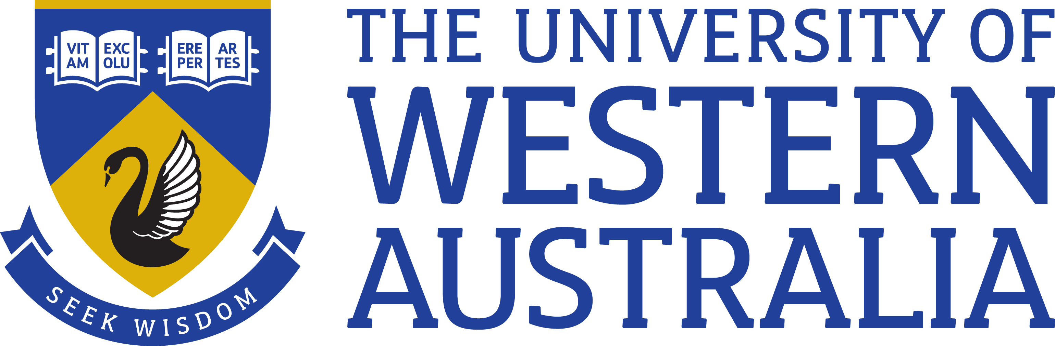

Position Title: Research Associate
Position Classification: Level A
Position Number: NEW
Faculty/Office: Faculty of Engineering and Mathematical Sciences
School/Division: School of Engineering
Department: Department of Chemical Engineering
Supervisor Title: Professor
Supervisor Position Number: 308999
Your work area
The UWA School of Engineering is renowned for its award-winning researchers, teachers and facilities. It is a multidisciplinary school offering education and research in a number of engineering disciplines. This includes civil, environmental, mining, chemical, mechanical, electrical and electronic engineering. Successful applicants will work in the large Fluid Science and Resources Research (FSRR) Group (https://www.fsr.ecm.uwa.edu.au/) which primarily conducts research across the oil and gas industry. The relevant theme to these positions focusses on the use of NMR techniques for the characterisation of porous media.

Reporting Structure

Reports to: Prof. Mike Johns
Your role

As the appointee you will, under the direction of Prof. Mike Johns, conduct experimental and analytical research regards the use of various NMR techniques (in particular multi-dimensional relaxometry and diffusion measurements, including the use of solid and magic echoes) to characterise various fluids in porous media. Specifically you will consider their use to characterise natural gas adsorption and absorption in clays and immobile organic matter in model porous media, before progressing to shale rock core samples. The ultimate objective of the research is to improve prediction of producible hydrocarbons from complex shale samples based on special core analysis using benchtop NMR spectrometers. It will feature a collaboration with Chevron Energy Technology.

The position is for an initial period of two years.

Key responsibilities

Conduct high quality research on the project.

Publication of research papers and presentations at international conferences and workshops.

Work collaboratively with other researchers and students engaged in the FSRR research group.

Assist in the supervision of undergraduate, Masters and PhD students.
Participate in the research group’s activities and contribute to/organize group projects, meetings and workshops.

Contribute to UWA teaching activities where possible.

Other duties as directed.

Your specific work capabilities (selection criteria)
A PhD in a relevant field.
Strong track record of research publication relative to opportunity.
Extensive research experience regards the application of NMR techniques for the characterisation of porous media.
Research experience with either adsorption/absorption and/or rock core characterisation is highly desirable.
Highly developed written and verbal communication skills in the preparation of high-quality reports, presentations and publications.
An ability and willingness to direct and supervise students.
Highly developed organisational skills and demonstrated ability to set priorities, meet deadlines and conduct research.

Special Requirements

Undertake Interstate Travel
Occasional weekend work

Compliance

Workplace Health and Safety
All supervising staff are required to undertake effective measures to ensure compliance with the Occupational Safety and Health Act 1984 and related University requirements (including Safety, Health and Wellbeing Objectives and Targets).
All staff must comply with requirements of the Occupational Safety and Health Act and all reasonable directives given in relation to health and safety at work, to ensure compliance with University and Legislative health and safety requirements.
Details of the safety obligations can be accessed at http://www.safety.uwa.edu.au

Equity and Diversity
All staff members are required to comply with the University’s Code of Ethics and Code of Conduct and Equity and Diversity principles. Details of the University policies on these can be accessed at http://www.hr.uwa.edu.au/publications/code_of_ethics, http://www.equity.uwa.edu.au

