Position Description
Position title: Platform Support Analyst
Mission Australia
About us: | Mission Australia is a non-denominational Christian organisation that has been helping people re gain their independence for over 155 years.  We’ve learnt the paths to getting back independence are different for everyone. This informs how we help people, through early learning and youth services, family support and homelessness initiatives, employment and skills development, and affordable housing. Our nationwide team delivers different approaches, alongside our partners and everyday Australians who provide generous support.  Together we stand with Australians in need, until they can stand for themselves.
Purpose: | Inspired by Jesus Christ, Mission Australia exists to meet human need and to spread the knowledge of the love of God.  “Dear children, let us not love with words or speech but with actions and in truth.”  (1 John 3:18)
Values: | Compassion Integrity Respect Perseverance Celebration
Goal: | To reduce homelessness and strengthen communities.

Position Details:
Position Title: | Platform Support Analyst
Division: | IT Services, Solutions and Architecture, Applications Support
Reports to: | Applications Support Manager
Duration | Full Time Equivalent
Position Purpose | The Platform Support Analyst provides technical support and advice to users across multiple platforms and technologies including Dynamics 365 CRM, Salesforce, HRIS Platforms (iChris/HR21v5), Kronos Dimensions, Salesforce, Operations 365, Power Platform, SQL server stack and associated integrations.

Position Requirements (What are the key activities for the role?)
Key accountabilities
- Field incoming Support requests (ServiceNow based Incident and Request Tickets)
- Provide advice, support, and documentation on operating services, including monitoring, and alerting platforms
- Directly resolving technical issues, exploring root causes and implementing Requests for Change to implement permanent corrective actions
- Maintain detailed records of end-user issues and resolutions in tickets and knowledge base articles
- Provide support to Service Desk, Field Engineers and to Operations peers on a wide range of systems and platforms.
- In consultation with the team and managers, Plan, Design, Develop and Develop platform upgrades within their prescribed upgrade cycle, keeping platform currency to within n-1

Key challenges
- Develop and maintain detailed knowledge of multiple, complex platforms and technologies to enable effective integration and utilisation of enterprise applications and services
- Develop and maintain an active culture of technology awareness within the organisation
- Identify system, infrastructure and project interdependencies and balance competing demands to ensure support deliverables are achieved
- Manage conflicting and concurrent ICT infrastructure installation/upgrade/refresh projects and programs
- Building a knowledge base of systems to provide sufficient support and guidance to peers and users.
- Keeping pace with new emerging technologies and trends, an open mindset that is flexible and adaptable.

Key Activities
- Provide 2nd and 3rd level support for incidents and problems
- Maintain and extend documentation
- Improve and optimise processes and procedures
- Analysis and design in alignment with third level support issues
- Change management
- Deployment management

Experience guide
- Technical skills – excellent technical and computer skills are vital in this role, since support analysts work directly with users to resolve software and hardware issues
- Team collaboration – support analysts tend to work within larger teams of IT professionals to resolve user issues, so effective collaboration within the department is essential
- Problem-solving skills – this role requires excellent technical and creative problem-solving skills, since support analysts develop and deploy solutions to user issues and conduct troubleshooting
- Time management – support analysts typically handle multiple user issues at once, so they should be able to effectively manage their time, set priorities, and resolve problems in a timely manner
- Communication skills – effective communication is vital in this role, since support analysts prepare and maintain reports about problems and frequently talk users through steps, they can take to resolve software and hardware issues

Purpose and Values
- Actively support Mission Australia’s purpose and values.
- Positively and constructively represent our organisation to external contacts at all opportunities.
- Behave in a way that contributes to a workplace that is free of discrimination, harassment, and bullying behaviour at all times.
- Operate in line with Mission Australia policies and practices (e.g. IT, financial, HR, etc.)
- Follow reasonable directions given by the company in relation to Work Health and Safety.
- Promote and work within Mission Australia's client service delivery principles, ethics, policies and practice standards.
- Actively support Mission Australia’s Reconciliation Action Plan.

Organisational Hierarchy
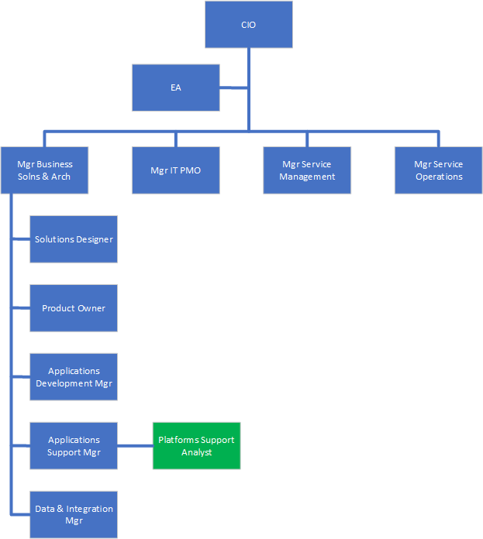

Recruitment information
Traits
- “Hands on” – whilst documentation and design is important, the successful candidate will demonstrate good design in practice, willingly rolling their sleeves up, building and administering solutions and services on behalf of Mission Australia and ITS
- Team orientated – consultative and open, the successful candidate will ensure collaborative design is married with current industry practices, at times possibly realigning “the way we do things” with “the way industry current practice does things”.
- Cross industry aware – bringing an understanding of how other industry sectors solve business problems and, where applicable, implementing solutions based on that knowledge
- Flexible and responsive – Mission Australia practices “just-in-time” Architecture, and fit-for-purpose EA, the successful candidate must be able to work within an ambiguous Enterprise and Solution Architecture landscape.
- Creative, Inquisitive, Curious and Eager – Our team relies on staff who Take Ownership and Follow Up, while ensuring they follow required protocols and processes.

Qualification, knowledge, skills and experience required to do the role
- Relevant academic qualifications (technical and/or business related)
- At least two years’ experience in an applications support role
- Solid understanding of T-SQL (MSSQL 2012-2019)
- Aware of all traditional architectural domains: Business, Application, Integration, Data, Information and Infrastructure & Technical
- Strength in Infrastructure & Technical domain preferred
- Strong knowledge of cloud, PaaS (Microsoft’s 365 suite essential) as well as platforms like Salesforce, ServiceNow, iChris/HRESS and KRONOS Dimensions
- Demonstrated design, build and run skills in Office 365, Power platform, Azure IaaS (incl. Azure AD), SaaS, platform integration, data classification and categorisation, and automation where applicable
- Knowledge of ETL Processes
- Knowledge in Dynamics CRM and other CRM platforms is desirable

Competencies
- Action oriented and takes accountability to achieve results in line with set timeframes.
- Builds and maintains sustainable internal and external relationships.
- Effective communication and active listening skills, demonstrating the ability to present information, decision and reasons confidently, clearly and concisely selecting the appropriate medium.
- Demonstrated experience working and collaborating effectively with others, ensuring key stakeholders are involved, sharing information and ensuring people are kept informed of progress, changes and issues.
- Ability to deal with ambiguity and complexity.

Compliance checks required
Working with Children ☐
National Police Check ☐
Vulnerable People Check ☐
Drivers Licence ☐
Other (prescribe) ☐ ____________________

Approval
Manager name | Ian Wilkins | Approval date

