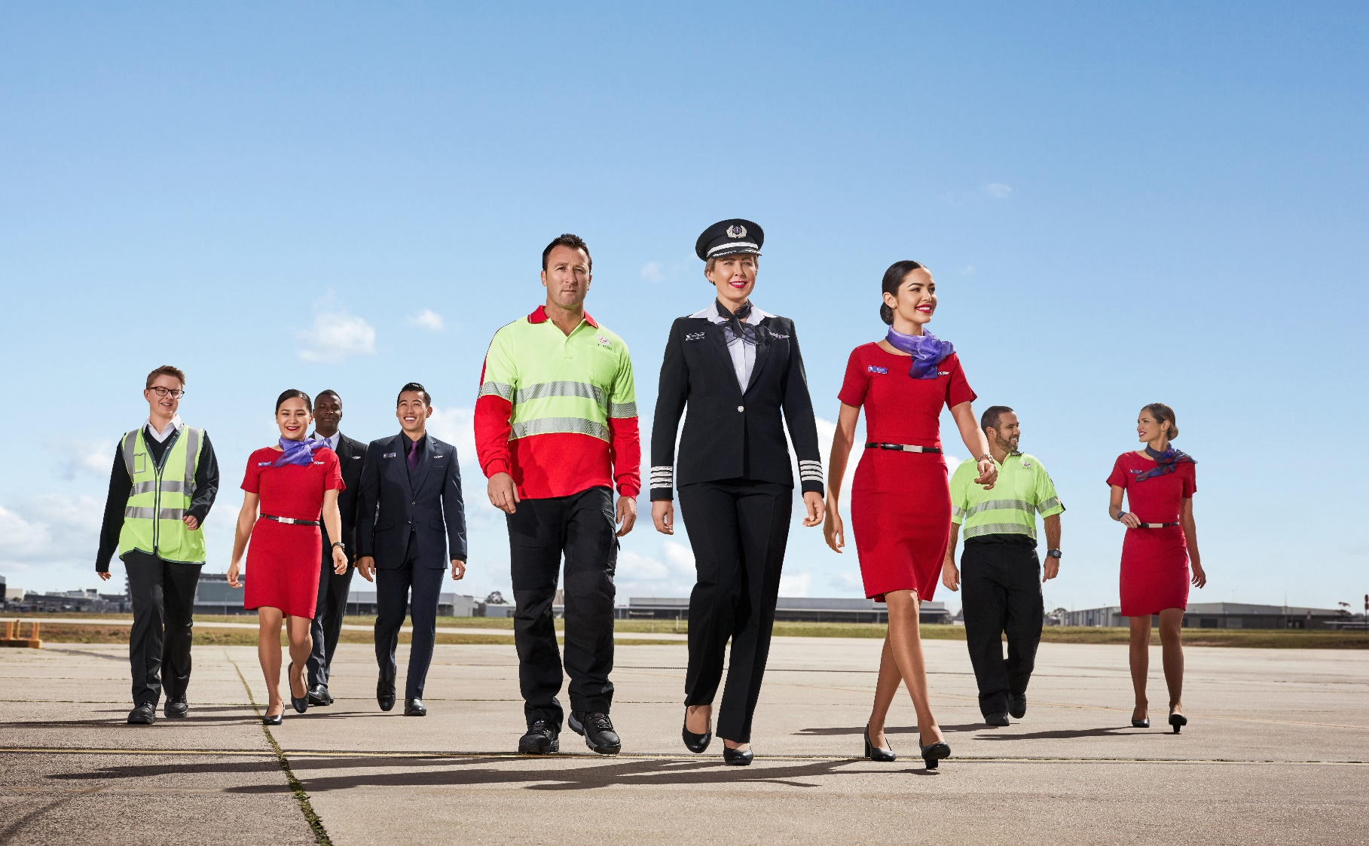
position description

Position Snapshot
Position Title: | Crew Roster Planner (Flight or Cabin Crew)
Business / Division / Department: | COO / Workforce planning
Location: | Brisbane – South Bank
Reports to: | Head of Workforce Planning
Direct Reports: | NA
Classification: | TBA
Date: | April 2021
Overall Impact Statement
Our vision is to build the airline people love, and we’ll do that by having happy people, happy customers, happy owners, by doing what matters, and by ensuring everyone is safe, always. We also believe that how you show up is as important as what you do.

Work Force Planning is a multi-functional team created to plan & deliver resource plans that enable stakeholders and their people to deliver a market leading, safe, on time, customer centric and efficient operation.
Our purpose is to deliver business needs and enabling others is not only what we stand for as a team, but the ethos we use when leading our people.

Objective of the Crew Roster Planner
As a Crew Roster Planner, your role will encompass the coordination of all aspects of flight crew and/or cabin crew roster production whilst balancing crew satisfaction, fairness, productivity targets and operational robustness. Most importantly, you will ensure that rosters are compliant with all industrial, regulatory and company policies and are published on time. Post publish the roster is handed over to our day of operations team to manage any 'on the day' changes however their feedback will be an important consideration for future rosters, as will your feedback to the
training and manpower planning teams on resource availability and training placement.

Organisational Context
Virgin Australia Group is a major Australian airline group which launched in 2000 bringing real competition to the skies. The Group consists of Virgin Australia Airlines and Velocity Frequent Flyer – our awesome loyalty program.

We operate regional & domestic flights and each year we carry more than 25 million passengers here, there, and everywhere! We’re known for our exceptional customer service, award-winning cabin crew and fantastic product offerings. We’re also passionate about the environment and reducing our carbon footprint both on the ground and in the air.

We pride ourselves on recruiting the right people into the right roles and we’re always looking for team members in all specialities to join our crew.

Virgin Australia Group team members are pretty unique, and we all have the same DNA inside us which makes us want to go one step further for our customers and each other. When we live our shared values, we can do things that most people would think impossible, and we think that’s pretty cool.

As a result, every person we come into contact with – be it our guests, customers, colleagues or the community, will feel and experience better outcomes, based on the interactions we have with them.

Key Accountabilities needs to be updated, extract below
Accountability | Major Activities
Financial | - Preparation of operational budgets  - forecasting and forward planning  - Modelling of cost savings on business initiatives  - Strategically drive improvements to budget modelling  - Initiate, analyse and present work rules change proposals  - Stakeholders and Unions representatives to support EBA negotiations  - Prepare detailed analysis to support annual and quarterly reforecast budget cycle
Analysis | - Conduct detailed analysis that support improvement and change initiatives and drive down costs, increase utilisation, improve lifestyle issues and fatigue management  - Utilise a variety of statistical and analytic methods to generate data models to help predict and explain business and operational trends to senior leadership and other division stakeholders  - Review and streamline reports and processes on a regular basis including increased automation  - Produce in-depth reports on trends, change and improvement initiatives, and operational initiatives and make recommendations based on detailed analysis to aid evaluation against desired outcomes  - Short notice modelling requests to support strategy and decision making using highly developed excel skills
Operations | - Review the departments high level operational key performance indicators and key drivers to gain insight in opportunities for improvement.  - Actively participate in regular meetings in an advisory capacity to Key Stakeholders
Continuous Improvement | - Drive improvement initiatives across multiple business units where relevant, to ensure a well-timed and well-executed, consistent approach to business change and improvement.  - Development and maintenance improvement initiatives governance structures, to enable consistent processes across all current and future initiatives.  - Maintain a focus on improvement and advocate better ways of working at every opportunity to ensure that we are constantly evolving into a better business. Be brilliant at the basics.  - Identify and implement strategies to simplify process.  .
Customer | - Act as trusted advisor to key stakeholders within Workforce Planning and other relevant stakeholder groups.  - Collaboration with all relevant Divisions in the development of improvement initiatives.  - Effectively communicate changes to all relevant stakeholders.  - Regular meetings with key stakeholders to identify support requirements.  - Actively work to support a service-focussed, customer centric organisational culture.  - Build and promote relationship with divisions for the betterment of delivering against department strategy.
Safety, Security & Business Resilience | - Ensure adherence to Virgin Australia Risk Management Framework (RMF) and adopt a proactive approach to the timely identification of operational and corporate risk and work to mitigate, resolve and escalate as required  - Actively participate in relevant forums to improve Safety, Security, Resilience and Health and Wellbeing throughout the Group  - Champion Better Me throughout the Group

Key Accountabilities
Aircrew Rostering
• Prepare and plan roster pre-assignments including, but not limited to, training, leave, non-operational duties
and other requests
• Liaise with internal Stakeholders on requirements for the roster period (e.g. discuss impacts of requests)
• Prepare standby blocks in accordance with planned levels and operational coverage requirements
• Regular communication with tactical operations on reserve timing and placement
• Establish roster requirements (e.g. target productivity, peak demand periods)
• Resolve all data import/export file issues prior to commencement of the roster process
• Optimise rosters to ensure a balance of bid satisfaction, fairness, productivity targets, cost control, fatigue
management and operational robustness
• Manually manipulate rosters and training to ensure full roster coverage, as required
• Conduct regular analysis of resource allocation levels to ensure an even disbursement of crew resources to
cover operational commitments
• Update systems with changes to crew status and details (e.g. new, full time/part time, promotions, transfers,
resignations, terminations, name change, address etc.)
• Liaise with Flight Operations, Cabin Crew management and Airline Operations prior to publish to ensure
reserve is best placed to meet demand
• Ensure all industrial and regulatory requirements have been adhered to by way of batch legality check
• All checklists and procedures are carried out and adhered to at all times
• Update checklists and procedures with any changes required and conduct regular reviews of procedures to
ensure they are relevant and accurate
• Publication of rosters within assigned timeframes

Aircrew Leave Planning
• Allocate crew leave requests within specified timeframes
• Generate and manage the leave process to ensure all eligible crew are able to submit leave requests
• Manually enter leave requests following the closure of the ballot process to capture outstanding requests
• Process all ad-hoc leave requests with the view of maintaining adequate resource levels across the network
• Review all ad-hoc leave requests and process as required
• Assign left over leave based on leave preferences
• Perform all tasks within the boundaries outlined in the departmental checklists and procedures

Quality Control and Continuous Improvement
• All checklists and procedures are carried out and adhered to at all times
• Update checklists and procedures with any changes required and conduct regular reviews of procedures to
ensure they are relevant and accurate
• Perform all tasks within the boundaries outlined in the departmental checklists and procedures
• Provide feedback to the training planners on training placement and the analyst team on reserve, pairings and
resource coverage for input into the forward plan
• Ensure maintenance of directory structure and files on network and within applications
• Identify potential process improvements and make recommendations for their implementation
• Contribute concepts for consideration in Industrial and company policy

Key Requirements
Requirement | Essential | Desirable
Education / Qualifications |  | • Relevant Tertiary Qualifications
Experience | • Experience in understanding of rostering and resource planning processes, theories and methodologies  • Previous experience in a crew rostering or crewing environment  • Experience in working as part of a team  • Experience in applying Industrial, regulatory rules or enterprise agreements within a business  • Minimum 2 years experience rostering of finite resources in the aviation sector to achieve specific outcomes (or similar sector)  • Exposure to delivering results within restrictive timeframes in a fast paced and dynamic environment  • Ability to multi task and work to concurrent deadlines | • Experience in aircrew planning or rostering role  • Experience using a workforce planning (rostering) application in an airline environment  • Airline industry operations and/or planning experience
Skills | • Application of industrial work rules  • Intermediate Computer skills including Microsoft Office skills (Word, Excel, PowerPoint, Outlook) | • Experience in SharePoint
Knowledge | • Conversant working with CASA, IOSA and company regulations | • Knowledge of aircrew industrial agreements  • Knowledge of aircrew resource management systems (Sabre AirCrews, Mint training, Geneva)  and optimisation systems (Kronos Altitude Pairing & PBS)

Virgin Australia Leadership Standards
Standard | Level 1 Behavioural Descriptors
Passionately VA | - Displays a passion for delighting both internal and external customers  - Seeks to understand customer needs by actively listening to their thoughts and concerns  - Embraces diversity and is responsive to different experiences, perspectives, values and beliefs  - Is curious and continuously looks for ways to learn and improve  - Knows, understands and follows standard operating procedures  - Is authentic and honest, can admit to making mistakes
Desire to be Better | - Strives to improve experiences for internal and external customers  - Has a curious mind towards identifying opportunities and finding ways to be better  - Demonstrates a high level of personal motivation to learn and develop  - Resourceful and creative with coming up with solutions  - Identifies and contributes ideas for improvement  - Identifies, addresses and reports safety hazards
Collaborates | - Displays passion for sharing knowledge and ideas  - Voices opinions and new ideas freely  - Respects differences and seeks to understand diverse perspectives  - Works constructively in and across teams, viewing every interaction as an opportunity to collaborate  - Is curious and open-minded to new ideas, perspectives and approaches  - Clarifies own understanding and embraces alternate view  - Challenges behaviours that compromise safety
Inspires Team | - Participates in 2-way conversations, listening and discussing issues thoughtfully and openly  - Understands and values the skills, knowledge and experiences that others bring  - Engages with others, clearly conveying information and facts  - Actively seeks to provide suggestions on how to be a better team  - Informs team about work and progress  - Understands personal obligations with respect to following standard operating procedures
Creates Future | - Welcomes change and remains positive in the face of ambiguity  - Seeks information to understand change and impacts  - Demonstrates a change mindset, flexibility and openness  - Understands the need for VA Group to be innovative and drive business improvement  - Seeks to understand Virgin Australia’s strategy and how they can contribute  - Demonstrates forward-thinking and awareness of immediate consequences of actions ensuring safe outcomes
Drives Results | Plans work to deliver within expected timeframes  Shows energy, enthusiasm and initiative for achieving own goals  Follows through on commitments to both internal and external customers  Seeks guidance and support to address obstacles and achieve set goals  Integrates feedback and takes responsibility for achieving own goals  Delivers outcomes within standard operating procedures

