As an applicant for a role in the Tasmanian State Service these guidelines are provided to assist you to provide a strong application. With each selection being a potentially a million dollar plus purchase over the employment life time, we are looking for people who will strengthen the service we provide for the state of Tasmania.

Defining the Short Form Application
A Short Form Application is a document no more than two A4 pages that is asked for in some Tasmanian State Service job selections, as an initial application for a vacant position.

Panels use your Short Form Application, along with your résumé, to make an initial assessment of your suitability for a position and determine if you will be invited to participate in further forms of assessment for the role, for example an interview.

The Short Form Application is not the only way a selection panel might call for initial applications and another method that is popular, and you may be familiar with, is to ask applicants to address selection criteria in a longer form of application.

If you have been asked to submit a Short Form Application these guidelines will support you to understand what the Short Form Application is, and how you can write one that gives the selection panel a good opportunity to initially assess your suitability as a candidate.

Note: The information contained in these guidelines is of a generic nature. If it in any way contradicts advice you receive from the panel please defer to the panel instructions rather than these guidelines.

What to include in your Short Form Application
In asking for a Short Form Application the selection panel is aware that it is impossible to include details of all your skills, knowledge, and capabilities in such a short amount of writing. The panel will not be expecting too much from you, so do not try to include more in the two pages than the panel asks for.

To supplement the information asked for in the Short Form Application the panel will also ask you to submit your résumé. The WHAT section below gives pointers that may be useful as you put your résumé together.

Your Short Form Application does not need to be in the format of a letter and should not be accompanied by a separate cover letter. Only provide additional documents when they are requested by the selection panel.

Use your Short Form Application to give the selection panel an insight into how well you would be able to perform in the role now and into the future. The following WHAT:HOW:WHY model is one way you can do this.

WHAT:HOW:WHY Model
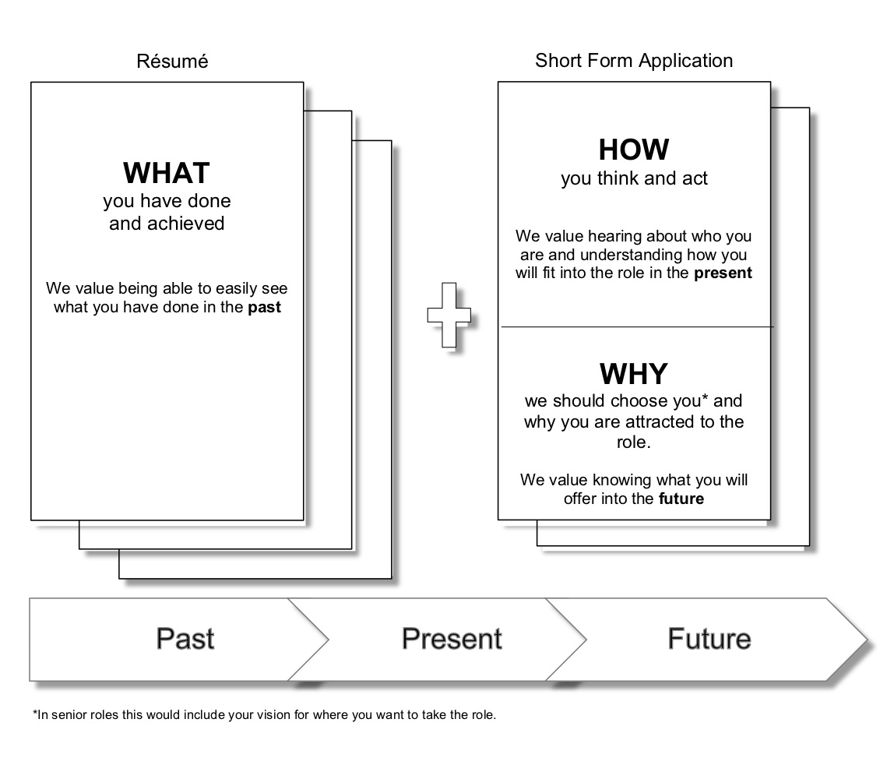
The notes on the next page give you further information on how you can use this model when writing your Short Form Application.

WHAT (Résumé)
The panel want to know what you have done in the past that is relevant to the role. The suggested document for presenting this information is your résumé.

Please include in your résumé what you feel is relevant for the panel to know. As a minimum include the following:
- Succinctly list the skills you have that will support you to do the role
- Give a history of your relevant work experience (both paid and unpaid)
- List your relevant education, qualifications and/or training history
- Include the names and full contact details of 2 referees who are willing to be interviewed about your capacity to perform the role
- For senior roles (e.g. Senior Executive) it would be valuable to include significant achievements
Keep your résumé succinct with clear headings and dot points so it is easy for the selection panel to see and find information.

HOW (Short Form Application)
The panel want to know how you currently think and act. The suggested document for presenting this information is the Short Form Application.

Think about the role and what will be required of someone to do it well now and into the future. Think about what you will be doing and what you will need to accomplish. In essence, put yourself into the role.

Then write about how you think and act in relation to what the panel have asked you to focus upon. One way to present how you think and act is to give an example of a real life situation focusing on how you handled it. For example:

Example 1:
“Performing [insert] tasks in my role at [insert] I had the opportunity to do [insert]. I approached this by thinking about [insert] then took the following action [insert] in the following way [insert]. This resulted in [insert].”

Example 2:
“My experience in doing [insert] has given me capabilities in [insert]. As such when I approach [insert] type of tasks I consider [insert] then act in the following ways [insert].”

Sometimes the panel may have given you one or two specific questions to answer, alternatively they may have asked you to focus on a limited number of selection criteria, or possibly on all of the selection criteria. The key thing they will be looking for is an insight into HOW you go about achieving the types of things that need to be achieved in the role.

WHY (Short Form Application)
The panel want your take on why they should choose you. The core document for presenting this information is the Short Form Application. As a guide this would be roughly a quarter of your Short Form Application.
Finish your Short Form Application by telling the panel why you are attracted to the role and why you would be a good fit for it. This is about giving the panel an insight into what you will bring to the future of the role. For senior roles an indication of your vision for where you want to take the role would also be appropriate here.
The purpose of the Statement of Duties (including the Selection Criteria)
The Statement of Duties (including the Selection Criteria) are included in the information package the selection panel will put together for the role. The information provided in the package will help you make an informed decision about how suitable a match there is between you and the role. They are also the core information the panel will use to guide their decision making to ensure their selection is based on merit.
Unlike the longer form of written application, in which applicants are asked to submit a piece of writing against each selection criterion, the Short Form Application does not ask for writing specifically organised against the selection criterion. Instead use the Statement of Duties and Selection Criteria as background information and context to inform your writing.
Talk to the Selection Contact Officer
In the information package provided for the role the name of a contact person will be provided. The role of this person is to answer any questions you have about the role and ensure you know how the panel want you to present information. You are encouraged to give the contact person a call to ensure you have a good understanding of the role and to know if it is a right fit for you.
Common Questions
- Can I write more than two pages?
For fairness and equity this is not encouraged and some panels may impose a strict adherence to the two page limit and not read additional information. Within the two page limitation, please use a clear readable font size and adopt conventional page margins. Allow time after completing your first draft to review and edit your submission. Often good editing will allow you to reach the two page limit if your first draft is over length.

- How important is my résumé?
It is very important that your résumé compliment, and work with, the information you provide in your Short Form Application. The selection panel will read both documents together so it is not necessary to repeat information in your Short Form Application that can easily be seen in your résumé. Use the WHAT information in the model above to guide what you include in the résumé.

- How long should my résumé be?
No length restriction is placed on the résumé although most are no longer than 4 pages.

- How important are my referees?
When the Short Form Application is used selection panels place a large degree of importance on the information they gather from your referees. Ask people to be a referee knowing the panel is likely to question them deeply about your capabilities. Make sure your referees understand the importance of the role they are taking on.

- Should I include a cover letter?
No. It is not necessary to include an additional cover letter as all the information needed to identify the role you are applying for and your personal details will be captured through the electronic process of submitting your application.
- I am applying for a Senior Executive role and wonder how to incorporate the Senior Executive Leadership Capability Framework into my Short Form Application.
The selection panel will have taken the Senior Executive Leadership Capability Framework into consideration when they determined the information they want you to focus on in your Short Form Application. If you use the WHAT:HOW:WHY framework to write your application you will particularly be able to display your capabilities across the five areas of the Leadership Capability Framework when you write about HOW you think and act.

