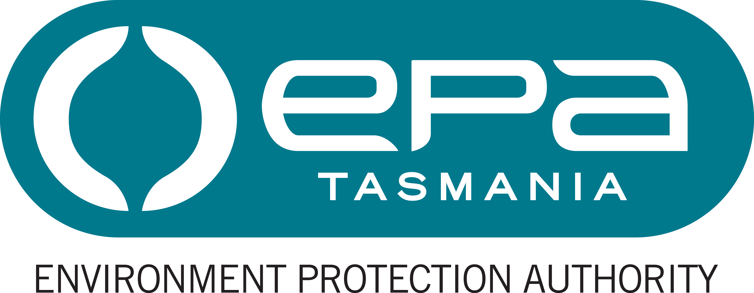
Environment Protection Authority
Statement of Duties

Position title Senior Environmental Officer (Assessments)
Position number 709797
Division/Business Unit/Branch Environmental Assessment Division/ Assessments Branch
Award/Agreement: Tasmanian State Service Award
Classification General Stream, Band 6
Position Status Fixed term.
Full Time Equivalent (FTE): 1.0 FTE (minimum 0.80 FTE, by negotiation)
Ordinary hours per week: 36.75 hours (minimum 29.40 hours, by negotiation)
Location Hobart
Report to Principal Assessment Officer
Position Purpose
The purpose of the role is to work within the statutory framework of the Environmental Management and Pollution Control Act 1994 and the Resource Management and Planning System of Tasmania, to co-ordinate and undertake environmental assessment of environmentally relevant activities, to undertake policy research, analysis, development and review, and to contribute to the maintenance of an effective environmental policy and legislative framework.

Major Duties
- Undertake and co-ordinate the environmental impact assessment of environmentally relevant activities, including level 2 activities, by researching, analysing and evaluating information provided by proponents and consultants, and seeking specialist advice from other staff and Government Agencies as necessary. Lead the development of guidelines and assessment reports, including the drafting of legal instruments, and provide recommendations to senior management.
- Administer the assessment process under the Bilateral Agreement between the Commonwealth and the State of Tasmania and assist with implementation of strategies for assessment and/or approval of developments under the Major Infrastructure Development Approvals Act 1999, Projects of State Significance and Major Projects under the Land Use Planning and Approvals Act 1993 as necessary. Provide accurate and timely advice to senior management and Government representatives in relation to the assessment of major development projects.
- Manage and monitor environmental impact assessment timing and progress, and identify and mitigate risks, and provide status updates as required.
- Prepare a wide range of material, including Environmental Assessment Reports, Ministerial correspondence, Parliamentary Briefs, and Media releases.
- On behalf of the EPA lead or participate, as required, on committees and working groups associated with the assessment and/or approval of developments within the State.
- Represent the EPA with interest groups and stakeholders, other agencies and community groups, and as required before the Tasmanian Civil and Administrative Tribunal.
- Undertake emergency management activities including training and, commensurate with that training and relevant experience, participate in responses to incidents, particularly for matters for which the EPA is the lead agency or otherwise responsible for contributing relevant staff resources.

Responsibility, Decision Making and Direction
The occupant of the position is responsible for:
- implementing policies, regulations and plans to provide efficient and effective program or service delivery outcomes;
- management and/or quality control of outcomes, processes, systems, resources, assets and infrastructure. This includes managing the performance of subordinate staff;
- providing advice on the application of policy to systems and processes in meeting specified program objectives; and
- a safe working environment by complying with relevant Work Health and Safety (WHS) legislation, codes of practice and policies, procedures and guidelines issued under the EPA’s WHS Management System.
The decision making and direction in relation to the role are that:
- guidance and instruction may on occasion be received on the implementation of modifications consistent with policy, regulatory and/or technological requirements and developments;
- the occupant operates with considerable independence in determining priorities, procedures and approach in implementing policies, plans, systems and procedures in a complex specialised environment; and
- work of a highly technically complex nature or with a varied range of activities may receive instruction and/or provide innovative solutions to meet program or service delivery outcomes.

Knowledge, Skills and Experience (Selection Criteria)
- Demonstrated scientific and technical knowledge and experience in the best practice environmental management field with an emphasis on impact assessment. Contemporary understanding of and experience with, or the ability to acquire, the implementation of environmental management systems including the Tasmanian Environmental Management and Pollution Control System (EMPCS) and the Resource Management and Planning System (RMPS).
- Significant knowledge of environmental management and/or resource management legislation and policies or the proven ability to acquire such knowledge. Practical experience in policy review, development and implementation.
- High level communication and interpersonal skills including consultation, negotiation, liaison and conflict resolution skills and the ability to effectively represent the Agency and clearly, concisely and accurately convey complex technical information in a manner understandable to non-specialists. High level written communication skills.
- Highly developed conceptual and reasoning skills and ability to research, investigate, analyse, evaluate and integrate relevant solutions from diverse disciplines or fields into the area of activity. Initiative, flexibility and creativity in developing options and recommendations to resolve problems and improve service delivery.
- High level organisational skills which enable the coordination, facilitation and conduct of a variety of activities, and the planning and completion of work activities within tight time frames.

Position Requirements

Desirable Qualifications and Requirements
- A degree in Science, Engineering, Environmental Studies or related field, or an equivalent qualification from a recognised tertiary institution.
- Detailed understanding of environmental management as related to one or more of the following industry categories would be considered advantageous: mining, wood processing, extractive industries, heavy industry, food & textiles processing, wastewater treatment, solid waste management, or renewable energy.
- An understanding of relevant Commonwealth environmental legislation is desirable.
- A current motor vehicle driver’s licence.

The EPA’s Role
The Environment Protection Authority is Tasmania’s principal environmental regulator. The EPA administers the Environmental Management and Pollution Control Act 1994 and is an integral part of Tasmania's Resource Management and Planning System.​
The EPA’s purpose is to regulate developments and activities that may impact on environmental quality and to promote best practice, sustainable environmental management. Its goals are clean air, clean water, clean land, acceptable noise levels and sustainable use of resources.
The EPA comprises a Board and Director, supported by staff. Both the Board and the Director exercise powers at arm's length from State Government and have independent statutory powers under the Act.
Under Tasmania’s emergency management arrangements, the EPA is the management authority (lead agency) for various aspects of emergencies including marine pollution spills. Emergency prevention, preparedness and response activities are core business of this agency and potentially may involve all staff in some way.
The EPA website at epa.tas.gov.au provides more information.

Working Environment

Employees work within an environment that supports safe work practices, diversity and equity with employment opportunities and ongoing learning and development. We are committed to valuing and respecting each other as colleagues and peers. We value the diverse backgrounds, skills and contributions of all employees and treat each other and our customers with respect. We do not tolerate discrimination, harassment or bullying in the workplace.

The Environment Protection Authority has a culture of zero tolerance towards violence, including any form of family violence. We will take an active role to support employees and their families by providing a workplace environment that promotes their safety and provides the flexibility to support employees to live free from violence.

There is a strong emphasis on building leadership capacity throughout the EPA.

The expected behaviours and performance of the EPA’s employees and managers are enshrined in the State Service Act 2000 through the State Service Principles and Code of Conduct. These can be located at www.dpac.tas.gov.au/divisions/ssmo.

