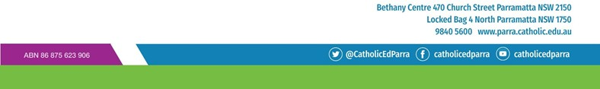
Page 1 of 1

Parish Priest Reference from Parish of Worship for
SCHOOL LEADERSHIP POSITION
Name of Applicant:
Name of Catholic Priest:
Parish:

Catholic Priest to tick the appropriate boxes
The applicant is someone who worships regularly in my parish
Yes
No
Unsure

PLEASE CHOOSE ONE OF THE FOLLOWING
I have no reservation recommending this applicant for a leadership position within the Parramatta Diocese

OR
I have some reservations recommending this applicant for a leadership position within the Parramatta Diocese

OR
I do not recommend this applicant for a leadership position within the Parramatta Diocese

Comment (if desired):

Signature of Catholic Priest:
Address:
Phone number:
Date of completion:

