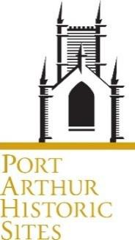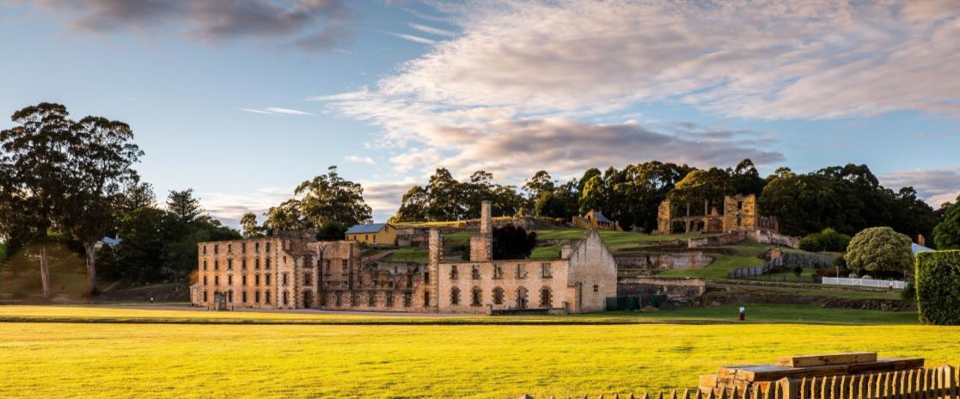

Position Description

Award | Port Arthur Historic Site Management Authority Award
Classification | General Stream Band 5 Rostered Day Worker
Position Title | Cascades Female Factory Site Manager
Employment  Status | Permanent Full Time
Hours of work
per week
Division | Tourism Operations
Position Reports  to | Director Tourism Operations
Location | Cascades Female Factory

It is strongly recommended when applying for positions with the Port Arthur Historic Site Management Authority (PAHSMA) that the Position Description is read in conjunction with the Information for Applicants document.

Position Overview
As an important part of our fast paced and dynamic front facing tourism team oversee the efficient and effective operation of staff and other resources at Cascades Female Factory Historic Site to ensure we deliver a memorable, quality, customer-focused visitor experience at a level consistent with that expected of an Australian World Heritage Site.
Lead and develop the team to excel in the delivery of outstanding visitor services, experiences and outcomes.

Key Deliverables (Statement of Duties)
Work is performed under general direction. Within the scope of the role, flexibility, innovation and initiative are expected in providing alternative solutions to operational issues and challenges. The work requires detailed planning, organising, directing, controlling and co-ordinating of resources.

- Co-ordinate the day-to-day operations of the CFFHS to deliver sound operational, financial & budget outcomes for the Port Arthur Historic Site Management Authority (PAHSMA).
- Ensure all visitor facing interactions and infrastructure are presented to the highest standard and that all aspects of security of monies, risk management, and staff and visitors health and safety are considered and maintained.
- Lead, manage and drive the successful performance of the CFF team to:
  - Build a strong connected team focussed environment that supports cooperation and collaboration
  - Deliver high level customer service
  - Ensure a positive visitor experience at all touchpoints
  - Share our visions, strengthen accountability and support us to meet our overall business objectives and targets.
- Coordinate all staff direction and supervision, including roster, leave and absentee management to ensure sufficient staff are in place to meet visitor needs, and the ongoing delivery of effective coaching and training of staff to ensure efficiency and productivity.
- Oversee daily functions of the Point-of-Sale booking & ticketing system, prepare reports and ensure accurate analysis, recording and reporting of all bookings.
- Work closely with other PAHSMA business units on visitor engagement, commercial, conservation & interpretation projects and operations.
- Provide current relevant and accurate information to visitors regarding activities, features and facilities offered at the Port Arthur Historic Sites.
- Taking a solutions based approach and showing initiative, investigate and appropriately resolve complex operational issues, concerns or complaints.
- Contribute to building and maintaining a positive, collaborative, professional, respectful, supportive and high performance workplace culture across PAHSMA that encourages people to connect and thrive in the workplace.
- Build good working relationships with stakeholders and represent the business unit at internal and external forums.
- Participate on a rotational roster to undertake the wide ranging role of Weekend Manager.
- Other duties as required and directed from time to time.
Duties should be reviewed and updated periodically to reflect changes in the role and to align with priorities.

Capabilities & Attributes (Selection Criteria)

- Demonstrated staff management skills with the ability to foster strong teamwork and high quality customer service, be adaptable and maintain clear performance expectations and deliver outcomes in a challenging tourism environment.
- Highly regarded organisational, coordination and problem solving skills with the ability to prioritise, work independently, make decisions on operational performance and activities and simultaneously manage visitor experiences and operational tasks.
- Competent with computer systems and programs including computerised staff rostering, point of sale and bookings and ticketing systems or the ability to quickly acquire these skills.
- Well-developed communication and interpersonal skills including proven capacity to work well in a team, demonstrate sound written skills and to interact and liaise effectively with people at all levels.
- High level developed administrative and financial skills including budgeting, report writing, statistical analysis and implementation of measures to ensure security and safety is maintained.
Essential Requirements
- Nil
Desirable Requirements
- Diploma in Business
- Experience in similar role
- Workplace 2 First Aid Certificate

Working in our team
The World Heritage-listed Cascades Female Factory tells the story of the displacement, mistreatment and forced migration of convict women and girls, and their contribution to colonisation throughout the history of colonial Australia to the present day. Open seven days a week, our aim is to provide the highest level of customer service ensuring a positive visitor experience. Working at this ste means you’ll be a person our visitors
remember so you’ll always need to be – friendly, courteous, helpful, kind, listening, punctual, well presented and make everyone feel welcome. We are agile and bring a positive, can do attitude and our best selves to work every day. We know that how we treat and respect our own team members is just as important as how we treat visitors. We support each other by stepping up and sharing the load. We appreciate that every job and team member is important and connected. We value diversity and inclusion and the different perspectives people bring to our team.

Assessing candidates

The position overview and deliverables, capabilities and attributes outline the key skills, knowledge, experience, behaviours and attitudes required to successfully fulfil the responsibilities, duties and expectations of the position. They also provide a measure against which candidates will be evaluated throughout the selection and appointment process and enable PAHSMA to assess the overall and comparative suitability of candidates.

Working at PAHSMA About Us
Port Arthur Historic Site Management Authority (PAHSMA) is responsible for the conservation and development of visitor experiences at three of the eleven sites which make up the UNESCO Australian Convict Sites World Heritage Property inscribed in 2010.
The Port Arthur Historic Sites are important places of outstanding heritage value at local, state national and international level. They form part of the Australian Convict Sites World Heritage Property and are major Tasmanian tourist attractions, which receive visitors from all walks of life and all parts of the world.
Our three sites are located in southern Tasmania
- Port Arthur Historic Site
- Coal Mines Historic Site, Saltwater River
- Cascades Female Factory, Hobart
The sites tell unique aspects of the global story of forced migration of convicts by the British Empire. They help Australians and international visitors to understand the history of Australia – from the ongoing custodianship of the Palawa people before, during and after invasion, through the colonial period and convictism to the terrible events of 1996 that occurred at Port Arthur.
Our sites are important places for our communities to talk about and understand our complex history and build a better understanding for the future. They are places of history, learning and conversation – and they belong to the people of lutruwita/Tasmania, Australia and the world.
We are known as experts in conserving our heritage and convict history – and we share this deep knowledge with visitors and the world.
Read our 2023-28 Strategic Plan to find out more.

Our Expectations
PAHSMA People must meet high standards of behaviour and conduct and align with the organisation’s requirements and expectations, including but not limited to those outlined in this PD.

PAHSMA does not tolerate discrimination, harassment, sexual harassment, bullying or victimisation in the workplace or toward colleagues anywhere at any time. We have a culture of zero tolerance towards violence, including any form of family violence. We will take an active role to support employees and their families by providing a workplace environment that promotes their safety and provides the flexibility to support employees to live free from violence.
PAHSMA expects everyone to:
- understand and comply with all policies, procedures, standards and reasonable directions including in relation to the Port Arthur Historic Site Management Authority Award, the Port Arthur Historic Site Management Authority Act 1987, and our Emergency Management Plan;
- take reasonable care to protect the safety, health and welfare of self and others in the workplace including by adhering to occupational health and safety legislation and requirements including but not limited to: exercise reasonable care in the performance of duties; comply with all Work Health & Safety (WHS) policies, procedures and requirements; report and document all accidents/incidents; and, be aware of procedures in the Emergency Management Plan;
- model a high standard of ethical and respectful behaviours and attitudes consistent with PAHSMA Values and Tasmanian State Services Principles and Code of Conduct, PAHSMA policies and expected professional standards; and contribute towards a positive and result focussed workplace culture and visitor experience;
- support diversity and inclusion and uphold the principles of fair and equitable access to employment, promotion, personal development, and training;
- participate actively and constructively in performance management and professional development activities; and be agile, resilient and willing to take on new activities as needs, jobs and workplaces evolve.
- ensure the Sites are presented to the highest standard, to support the protection of the heritage fabric of the sites against vandalism or damage.
Our Values

Unity
We work as one to achieve PAHSMA’s Vision and Purpose
People Matter
We acknowledge and show respect to our people – past, present and future
Accountability
We hold ourselves, and each other, accountable for our actions
and behaviours

Passion & Pride
We are committed to being world class
Port Arthur Historic Site Management Authority recognises the deep history and culture of lutruwita/Tasmania.
We acknowledge the Palawa people, the traditional owners of the Land upon which we work. We acknowledge and pay our respects to all Aboriginal Communities – all of whom have survived invasion and dispossession and continue to maintain their identity and culture.

Endorsed by Head of People & Culture |  | Approval by CEO
Date: |  | Date

Version Control
Position Number/s | Date of original  version | Version Number | Date of this version

General inquiries | Email recruitment@portarthur.org.au or visit portarthur.org.au

