Department of State Growth

Advice to applicants

Short form applications
Thank you for your interest in working with us. This information has been developed to assist you to understand State Growth’s recruitment and selection processes and make the most of your opportunity to apply.
Working at State Growth
State Growth is a diverse organisation. We work to grow our economy and provide opportunities for all Tasmanians.
Our people are the heart of our organisation, where collaboration is key and our people are supported by a strong constructive culture and agency values of courage to make a difference through teamwork, excellence, integrity and respect.
We are committed to providing a diverse and inclusive workplace that enables our people to contribute to their full potential, by recognising and supporting their strengths and needs. We recognise the importance of diversity and encourage applications from everyone with the right skills and experiences.
State Growth undertakes employment decisions in line with the merit principle. A merit selection process aims to select the best candidate for a position based on an assessment of the candidates’ work-related qualities and their capacity to achieve outcomes related to the duties of the role.
Want to know more about working at State Growth? Further information is available in the ‘Careers’ section of our website.
About the role
Please read this information in conjunction with the statement of duties and get in touch with the contact person to ensure you have a good understanding of the role and how it fits within State Growth. This will also help you decide if the role is the right fit for you.
Are you eligible to apply for the role?
To be eligible for appointment on a permanent or fixed term basis with the Tasmanian State Service, you must be an Australian citizen, a permanent resident, or be eligible to hold and meet any visa requirements as determined by the Australian Government’s Department of Home Affairs and the Migration Act 1958. For more information on visa requirements please refer to www.immi.gov.au.
Where a position is subject to essential requirements you must be able to demonstrate that you meet all of and be able to continue to meet the listed requirements. However, we do not require evidence of any essential requirements, e.g. certification, qualifications etc at this stage of the application process.
If a position is subject to pre-employment checks and you have been successful in the application process, you will be asked to undertake these checks prior to being appointed to the role.
The statement of duties document will specify any essential requirements for the role.

Your application
Your application is the first step towards working for State Growth. This is your opportunity to provide useful information about yourself to the selection panel (the panel) to help in assessing your suitability for the role.
To apply, you will need the following:
- A short form application (recommended one to two pages).
Your short form application should outline how your experience, skills and knowledge relate to the advertised role as outlined in the statement of duties which will help us know why we should choose you.
- An up-to-date resume (usually up to four pages).
Your resume should tell us what you done and achieved including a brief summary of your relevant qualifications and/or training history.
- Details of two referees, usually your last two managers.
Your referees may be contacted at any stage of the selection process, including as part of shortlisting. You should advise your referees before submitting your application, as the panel may wish to contact referees during shortlisting and will assume they are aware. Please speak with the contact person if you have a concern about this.
Information on short form applications
In asking for a short form application the panel is aware that it may not be possible to include details of all your skills, knowledge, and capabilities in such a short amount of writing.
What, how and why model
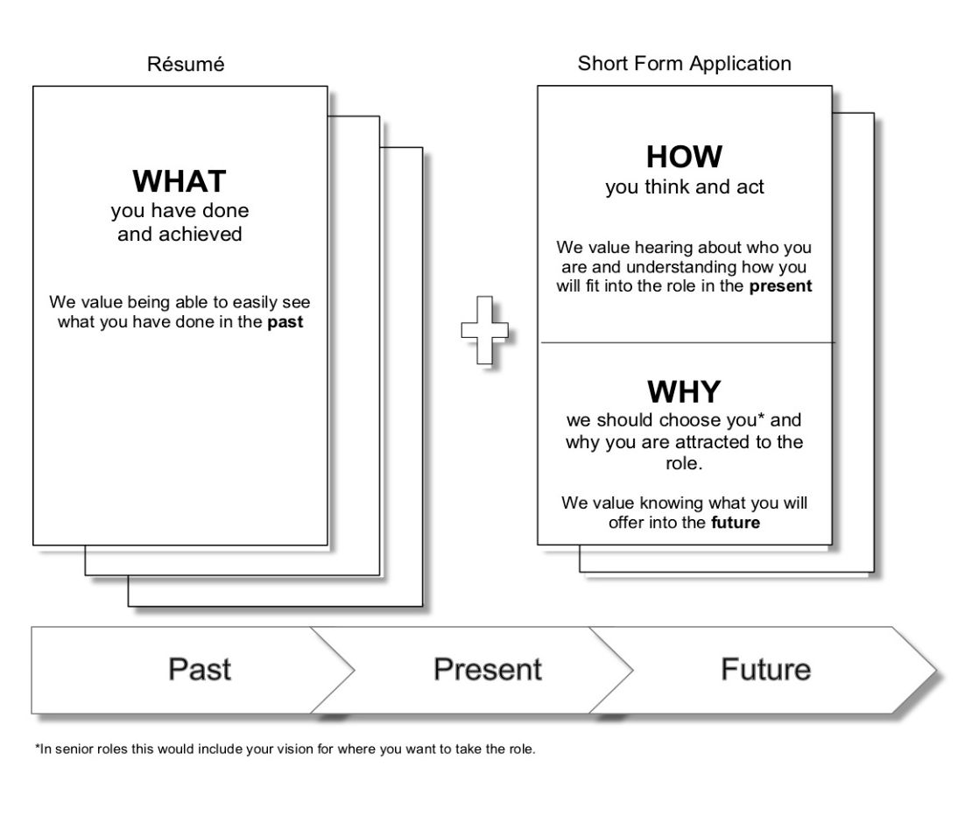
What? (resume)
The panel want to know what you have done previously that is relevant to the role. As a minimum your resume should include:
- The skills you have that will support you to do the role.
- A history of your relevant work experience (paid and unpaid).
- Relevant education, qualifications and/or training history.
- The contact details of two referees who can attest to your capacity to perform the role.
Keep your resume succinct with clear headings and dot points so it is easy to read.
How? (short form application)
The panel want to know how you think and act, so think about the role and what will be required of someone to do it well now and into the future. Put yourself in the role and think about what you will need to accomplish and what the panel have asked you to focus on. One way to present this is to use a real life situation focusing on how you handled it. For example:
Example 1:
“Performing [insert] tasks in my role at [insert] I had the opportunity to do [insert]. I approached this by thinking about [insert] then took the following action [insert] in the following way [insert]. This resulted in [insert].”
Example 2:
“My experience in doing [insert] has given me capabilities in [insert]. As such when I approach [insert] type of tasks I consider [insert] then act in the following ways [insert].”
The key thing the panel will be looking for is an insight into how you deliver the type of things that need to be achieved in the role.
Why? (short form application)
The panel want to know why they should choose you. As a guide this would be roughly a quarter of your short form application. Finish your application by telling the panel why you are attracted to the role and why you would be a good fit for it. This is about giving the panel an insight into what you will bring to the future of the role. For senior roles an indication of your vision for where you want to take the role would also be appropriate here.
How to submit my application?
Applications must be submitted by the advertised closing date and time, via the www.jobs.tas.gov.au website.
Find the relevant vacancy on this website, click the Apply Now button where you will need to complete an online application and provide your personal information (name, address, etc.). Attach your resume, short form application, details of two referees, and any other documents requested.
Ensure all your documentation is correct and has uploaded properly before you submit it. Once it has been submitted you are unable to make any further changes. You will get an email acknowledging your application has been received.
If you can’t submit your application online or wish to amend uploaded documents, please email our HR Operations Team before the closing date.

What happens next?
The panel will discuss the applications and assess which applicants have best demonstrated merit for the role. If you are shortlisted, a panel member will contact you to arrange further assessments of your skills and ability, and the assessment methods will be clearly communicated to you if you are shortlisted.
Assessment methods may include:
- Interview - face to face, telephone or virtual eg. Microsoft Teams.
- Written or numeracy work-related exercise.
- Presentation exercise at interview.
- Other assessment methods such as skills or ability testing.
- Referee checks.
Shortlisted applicants will also be advised who is on the selection panel. Should you have any concerns regarding any of the panel members, please discuss with the contact person in the first instance or our HR Operations Team.
If an interview is conducted, the panel will explore your suitability for the role through a series of questions relating to the role in the context of the selection criteria. You also have the opportunity to ask questions of the panel members, provide relevant information and may be asked bring along work samples to support your claims.
The contact person will keep you informed if there are any delays in the recruitment process.
We can provide reasonable adjustments
We seek to cater for the diverse needs of applicants and will aim to provide reasonable adjustments for you during the recruitment process. We seek to give all applicants the opportunity to demonstrate they are the best applicant for the role and can readily make reasonable adjustments in the workplace. Please call the contact person to discuss any specific requirements that you may need if shortlisted.
How will I know about the selection outcome?
The selection process usually takes six to eight weeks from the date applications close.
Once the panel have made a recommendation for appointment, all applicants will be advised of the outcome in writing. However, you are also welcome to phone or email the contact person at any point in the process to discuss progress.
If you are the successful applicant, you will be notified of the outcome by phone and receive an offer of employment email. Where applicable offers are conditional, subject to the satisfactory completion of any pre-employment checks, verification that you meet any essential requirements and, a review period.
Once the pre-employment checks have occurred, you will receive formal employment documentation, along with orientation and payroll related information.
If you are unsuccessful, we encourage you to seek feedback from the panel which can help you understand their decision and how you may improve your future applications or interview performance.
How can I express my interest in other roles at State Growth?
If you were unsuccessful on this occasion, we encourage you to create a “job alert” on www.jobs.tas.gov.au website together with other job websites such as www.seek.com.au for any future vacancies.
You can also join LinkedIn and view our profile and opportunities.
We look forward to receiving your application and you taking the first steps towards a new career with State Growth and all we can offer.

