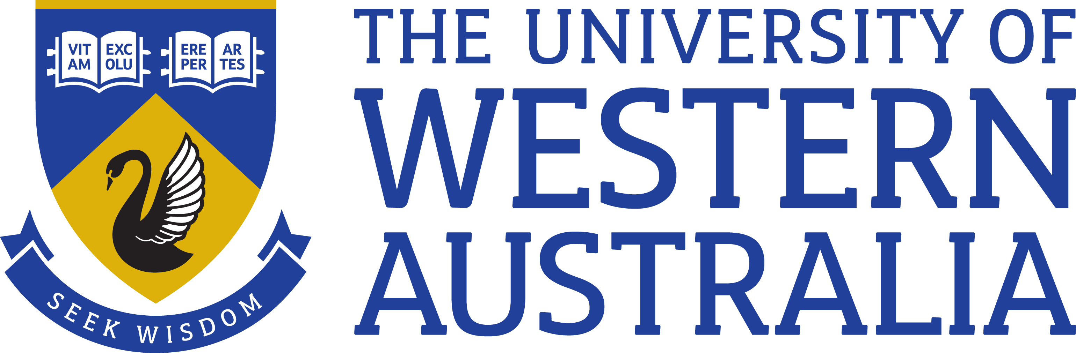

Position Title: Program Coordinator
Position Classification: Level 6
Position Number: 309119
Faculty/Office: Faculty of Arts, Business, Law and Education
School/Division: Confucius Institute
Centre/Section:
Supervisor Title: Business Manager
Supervisor Position Number: 314734

Your work area
The Confucius Institute (CI) at The University of Western Australia (UWA) is a non-profit organisation dedicated to strengthening ties and increasing mutual understanding between China and Western Australia. CI connects Western Australians with Chinese language and culture through Chinese language tuition, presentation of public performances, seminars and workshops, and delivery of cultural awareness training. CI supports Chinese language programs in more than 30 schools in metropolitan and regional WA. The first CI to be established in Australia, CI at UWA now forms part of a network of 500 sister institutes across 138 nations. For more information about CI visit the website at www.confuciusinstitute.com.au.

Reporting Structure

Reports to: Business Manager

Direct Reports: Nil

Your role

As the appointee you will, under limited supervision, provide support to the Director and Business Manager to implement the strategic plan of the Confucius Institute. You will liaise with the University and partner organisations in Australia and China and provide senior administrative support to staff to deliver the Institute’s educational and cultural programs. You will also provide translation/interpreting support and be actively involved in delivering cultural awareness training to the university and corporate sector.

Key responsibilities

- Coordinate the administrative aspects of public events, cultural activities and educational programs as directed.
- Develop and deliver Chinese cultural awareness training to meet clients’ needs.
- Translation and interpreting tasks from English to Chinese, and Chinese to English, as required.
- Establish and maintain procedures and office systems for the efficient operation of programs and activities.
- Liaise with staff to develop web based and hard copy resources and promotional materials.
- Liaise with WA schools to deliver supporting programs.
- General administrative duties as required.

Your specific work capabilities (selection criteria)

- Relevant tertiary qualifications in Translation or equivalent competency.
- Highly developed written and verbal communication and interpersonal skills including experience in delivering training and/or presentations.
- Highly developed organisational skills with an ability to set priorities and to meet deadlines.
- Substantial administrative experience at an appropriate level, including experience in event management and development of promotional material.
- Ability to work independently, show initiative and to work as part of a team.
- Native or near-native fluency in Chinese Mandarin and English (spoken and written).

Special Requirements

Occasional after hours work will be required on evenings and weekends.

Compliance

Workplace Health and Safety
All supervising staff are required to undertake effective measures to ensure compliance with the Occupational Safety and Health Act 1984 and related University requirements (including Safety, Health and Wellbeing Objectives and Targets).
All staff must comply with requirements of the Occupational Safety and Health Act and all reasonable directives given in relation to health and safety at work, to ensure compliance with University and Legislative health and safety requirements.
Details of the safety obligations can be accessed at http://www.safety.uwa.edu.au

Equity and Diversity
All staff members are required to comply with the University’s Code of Ethics and Code of Conduct and Equity and Diversity principles. Details of the University policies on these can be accessed at http://www.hr.uwa.edu.au/publications/code_of_ethics, http://www.equity.uwa.edu.au

