Position Number: 00060359
Position Title: Administrator – Operations and Systems
Date Written: May 2018
Faculty / Division: AGSM
School / Unit: Career Development Centre
Position Level: Level 5

ORGANISATIONAL ENVIRONMENT
UNSW is currently implementing a ten year strategy to 2025 and our ambition for the next decade is nothing less than to establish UNSW as Australia’s global university. We aspire to this in the belief that a great university, which is a global leader in discovery, innovation, impact, education and thought leadership, can make an enormous difference to the lives of people in Australia and around the world.
Following extensive consultation in 2015, we identified three strategic priority areas. Firstly, a drive for academic excellence in research and education. Universities are often classified as ‘research intensive’ or ‘teaching intensive’. UNSW is proud to be an exemplar of both. We are amongst a limited group of universities worldwide capable of delivering research excellence alongside the highest quality education on a large scale. Secondly, a passion for social engagement, which improves lives through advancing equality, diversity, open debate and economic progress. Thirdly, a commitment to achieving global impact through sharing our capability in research and education in the highest quality partnerships with institutions in both developed and emerging societies. We regard the interplay of academic excellence, social engagement and global impact as the hallmarks of a great forward-looking 21st century university.
To achieve this ambition we are attracting the very best academic and professional staff to play leadership roles in our organisation.

UNSW BEHAVIOURS
UNSW recognises the role of employees in driving a high performance culture. The behavioural expectations for UNSW are below.

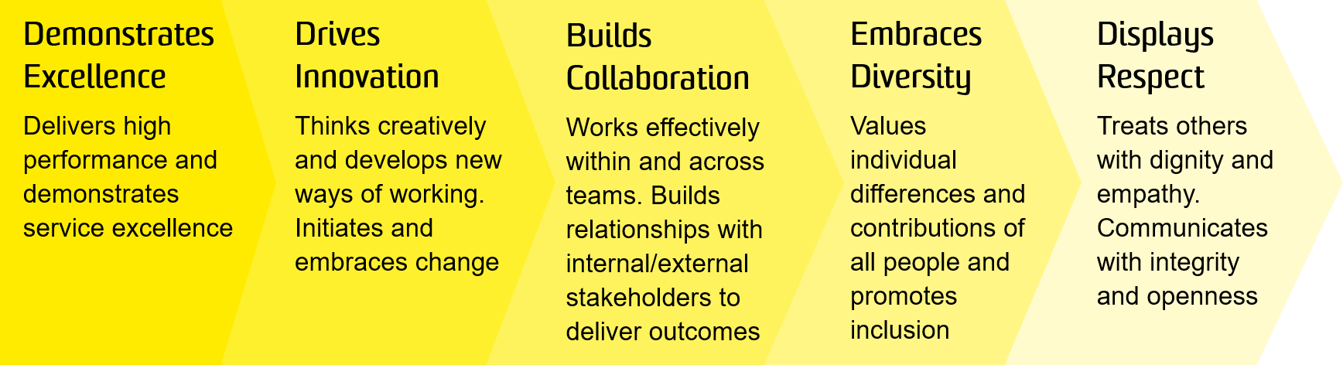

OVERVIEW OF RELEVANT AREA

UNSW Business School is a leader in business education and research in the Asian region and one of the largest Business Schools in Australia with more than 15,000 students, 500 academic and professional staff and more than 80,000 alumni and partners. The Business School offers a full suite of business degree programs at undergraduate, postgraduate, coursework and research levels, including the AGSM MBA programs and a range of Executive Programs. Its direction is guided by a business advisory council of leading CEOs, chairpersons and other business leaders.

The Business School’s reputation is built on its outstanding staff, students and alumni and a cultural diversity which ensures an international focus. It also has a long history of deep industry engagement, and takes pride in the impact it has through its educational and research activities. The School is frequently ranked among the top 50 in the world, and in some areas among the top 20, according to global indicators. For further information, see: https://www.business.unsw.edu.au/.

The AGSM Career Development Centre (CDC) exists to deliver global best practice career transition services to students enrolled across the full-time MBA, MBA Executive and MBAX (online) programs to optimise their post-MBA career success.

This position is responsible for the administration and maintenance of the digital ecosystem (systems, technology and platforms) that support the operations of the AGSM Career Development Centre (CDC). As first point of contact for students, alumni and potential employers, this position delivers a customer focused service that provides access and connection to the full range of AGSM career services including online and in person.
The role reports to the Director, Career Development Centre, and has no direct reports.

RESPONSIBILITIES
Specific responsibilities for this role include:
- Provide advice and support to students, alumni and employers to access the full range of AGSM career services available to them, both online and in person. This may include assistance with scheduling appointments, providing guidance on accessing materials via AGSM systems and providing general support as a first point of contact.
- Coordinate and maintain operational efficiency for CDC systems and platforms in support of education and career service delivery. Work with UNSW partners to support this end.
- Liaise with AGSM Students, external clients and other stakeholders to update and maintain data in a timely and accurate manner across multiple systems (including Symplicity, VMock, Career Leader and others).
- Coordinate and provide administrative support to CDC events by; including but not limited to: collaboration/communication with internal and external stakeholders, sourcing of venues, communication of appropriate marketing correspondence, budget overview and adherence, management of event registrations, and on the day assistance.
- Produce regular reports on CDC activities and other performance metrics
- Develop and implement appropriate procedures and processes that document and support the delivery of Career services and systems supporting this.
- Monitor shared email account, ensure timely responses to all parties and excellent customer service
- Liaise with suppliers and coordinate logistics. Undertake procurement activities consistent with UNSW policy and procedure
- Keep up to date with relevant education and career services practices and offerings, particularly in the area of education and career technology support platforms
- Work collaboratively with the AGSM Brand and Communications team and UNSW partners to contribute to the production and design of careers publications, brochures and other collateral that is supported with appropriate technology. Where required, liaise with external providers to fulfil these needs.
- Coordinate and deliver accurate and timely administration of activities related to the CDC Finance function
- Monitor inventory and equipment and coordinate repairs or updates as required
- Participate in and support other ad hoc careers projects
- Cooperate with all health and safety policies and procedures of the university and take all reasonable care to ensure that your actions or omissions do not impact on the health and safety of yourself or others

SELECTION CRITERIA
- Relevant qualifications with relevant administrative experience in an academic or similarly large and complex environment and/or equivalent level of knowledge gained through a combination of education, training and/or experience in a tertiary organisation
- Experience in the maintenance of digital systems and platforms which support programs, courses and other education related content.
- Demonstrated ability to engage with a diverse range of stakeholders, with excellent interpersonal and communications skills and capacity to establish and develop productive work relationships
- Experience in creating corporate promotional material with intermediate skills in the Office 365 suite, InDesign/Adobe Creative Suite (or equivalent software), database management and website maintenance
- High-level organisational skills and proven ability to multi-task, establish priorities and meet deadlines
- Excellent attention to detail with the ability to work accurately and independently
- Experience with or knowledge of career related technology and/or design software beneficial but not required
- Knowledge of health and safety responsibilities and commitment to attending relevant health and safety training.
It is not the intention of the position description to limit the scope or accountabilities of the position but to highlight the most important aspects of the position. The aspects mentioned above may be altered in accordance with the changing requirements of the role.

