Faculty / Division: UNSW Law
School / Unit: UNSW Law
Position Level: Level 8
Position Number: XXXXXX
Position Title: Legal Profession Manager
Date Written: August 2018

ORGANISATIONAL ENVIRONMENT
UNSW is currently implementing a ten year strategy to 2025 and our ambition for the next decade is nothing less than to establish UNSW as Australia’s global university. We aspire to this in the belief that a great university, which is a global leader in discovery, innovation, impact, education and thought leadership, can make an enormous difference to the lives of people in Australia and around the world.
Following extensive consultation in 2015, we identified three strategic priority areas. Firstly, a drive for academic excellence in research and education. Universities are often classified as ‘research intensive’ or ‘teaching intensive’. UNSW is proud to be an exemplar of both. We are amongst a limited group of universities worldwide capable of delivering research excellence alongside the highest quality education on a large scale. Secondly, a passion for social engagement, which improves lives through advancing equality, diversity, open debate and economic progress. Thirdly, a commitment to achieving global impact through sharing our capability in research and education in the highest quality partnerships with institutions in both developed and emerging societies. We regard the interplay of academic excellence, social engagement and global impact as the hallmarks of a great forward-looking 21st century university.
To achieve this ambition we are attracting the very best academic and professional staff to play leadership roles in our organisation.

UNSW BEHAVIOURS
UNSW recognises the role of employees in driving a high performance culture. The behavioural expectations for UNSW are below.
Please refer to the UNSW Behavioural Indicators for the expectations of your career.

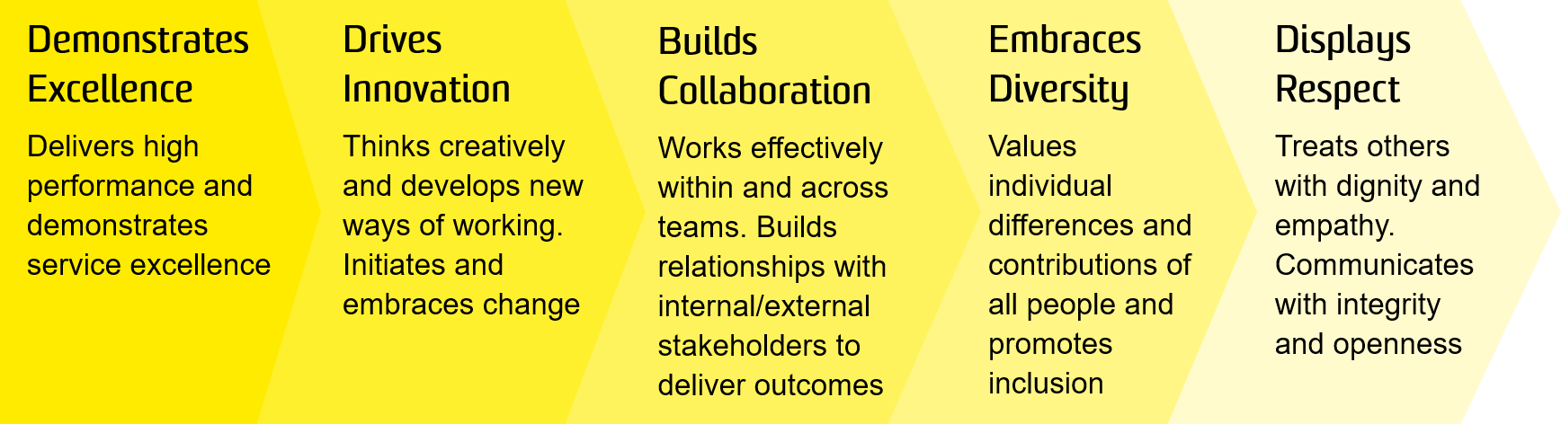

OVERVIEW OF RELEVANT AREA AND POSITION SUMMARY
Ranked 16th in the world, UNSW Law is Australia’s leader in progressive and rigorous legal education and research. Inspired by principles of justice, UNSW Law through its teaching, research and community outreach, promotes a holistic understanding of law and its role in society. UNSW Law includes more than 100 academics, many of whom are leaders in their areas of research interest. The Faculty’s research is organised around a range of centres and disciplinary clusters.
The Legal Profession Manager is primarily responsible for achieving placement success and the provision of best practice career services for Law Undergraduate (UG), Juris Doctor (JD) and Postgraduate (PG) students to ensure that UNSW Law is the preferred choice for employers seeking those with law qualifications. Key to this, is developing and managing relationships with industry and alumni on behalf of the Law School.
This position requires a proactive approach to ensure delivery of key objectives and goals and sound advice in accordance with relevant legislations, policies and procedures of the University.
The role of Legal Profession Manager reports to the Faculty Executive Director, UNSW Law, and has one direct report.

RESPONSIBILITIES
Specific responsibilities for this role include:
- Identify and promote careers for UNSW law students in a range of sectors including commercial law firms, public interest careers in law and non-law options as well as international employment opportunities
- Develop external relationships including with commercial law firms, government bodies, NGO’s and other public interest organisations and recruitment firms that add value to student learning and provide networking opportunities
- Identify a range of employment options with the aim of facilitating workshops and presentations by potential employers for the students to enhance career opportunity
- Develop skill-based workshops that enhance student market readiness for employment, consider employment trends that align with UNSW Law objectives and strategies
- Plan and promote the UNSW Law Summer Clerkship program and the Graduate Employment program and engage with relevant stakeholders to ensure a seamless process for the students.
- Organise and plan on-campus career events ensuing optimal representation of major recruiting organisations
- Conduct one-on-one sessions with students progressed in their UG, JD or PG studies to help develop their individual profiles and assist in employment searches
- Manage and analyse feedback and surveys from students, Alumni and Advisory Board on employment related topics for reporting purposes
- Engage with Alumni to identify national, regional and global employment opportunities for UNSW law students and work closely with the Director of Senior Studies and academic staff to assist with student careers
- Ensure hazards and risks are identified and controlled for tasks, projects and activities that pose a health and safety risk within your area of responsibility

SELECTION CRITERIA
- Relevant degree with extensive relevant experience, or equivalent competency gained through any other combination of education, training and/or experience
- Minimum 5 years’ demonstrated experience in successfully delivering career development programs and services
- Well developed knowledge of developments in the current law employment market, both domestic and international
- Ability to build and maintain relationships with established organisations in sectors employing law graduates
- Excellent organisational skills and ability to coordinate and deliver workshops to enhance successful employment options for students
- Excellent written and verbal communication skills and proven ability to interact effectively with a diverse range of people including industry clients, alumni and current students
- Ability and capacity to implement required UNSW health and safety policies and procedures

It is not the intention of the position description to limit the scope or accountabilities of the position but to highlight the most important aspects of the position. The aspects mentioned above may be altered in accordance with the changing requirements of the role.

