Information for Applicants applying for positions at DPAC

CONSIDER A JOB WITH US
Thank you for your interest in working for the Department of Premier and Cabinet (DPAC). This information sheet has been developed to give you an overview of the Department and its values, structure and position as an Employer of Choice. You are encouraged to read this information carefully in conjunction with the Statement of Duties.

ABOUT THE DEPARTMENT OF PREMIER AND CABINET
DPAC is the central agency of the Tasmanian State Government. The Department provides a broad range of services to Cabinet, other members of Parliament, Government agencies and the community.
The Department works closely with the public sector, the community, local government, the Australian Government and other state and territory governments. The Department also provides administrative support to the Tasmanian Community Fund which is separately accountable and reports directly to Parliament.
For further information about DPAC please refer to www.dpac.tas.gov.au.

DPAC VALUES
DPAC values underpin our culture and guide our decision making and behaviour. Our values are:
Excellence: We strive for excellence at all times.
Customer-focused: Our customers are at the centre of what we do and how we do it.
Working together: We support and respect one another and work with others to achieve results.
Being professional: We act with integrity and are accountable and transparent
For more information about DPAC visit www.dpac.tas.gov.au

DPAC ORGANISATIONAL STRUCTURE (AS AT JULY 2015)
The DPAC organisational chart shows the structure of the Department's divisions and business units, as well as the reporting structure to the Secretary and Deputy Secretaries.
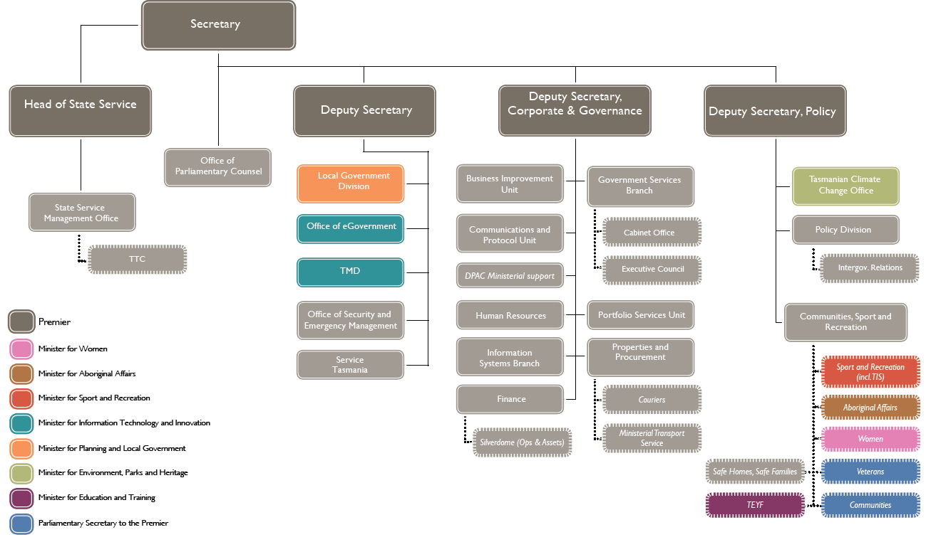

DPAC AS AN "EMPLOYER OF CHOICE"
DPAC is an innovative, dynamic and progressive agency that provides a diverse, flexible and rewarding working environment.

DPAC offers many challenging and rewarding opportunities to many different people; from someone who is starting work as a trainee or a graduate, to someone who wants a career change or to return to work. DPAC rewards performance with competitive salary structures that ensure real career prospects and development.

DPAC is the central agency of the Tasmanian State Service. It offers numerous unique opportunities to gain a broad understanding of the Tasmanian Government and the wider community. The Department’s role in providing advice to the Premier and members of Cabinet gives employees the opportunity to be included in the strategic and salient issues impacting on Tasmania across the economic, social and environmental spheres.

Working for DPAC gives people the chance to play a key role in the future advancement of this island state. DPAC offers a diverse range of project work, policy development, working parties, taskforces and multi-disciplinary teams to assist in the development of highly transferable skills and career experiences.

DPAC values creativity, team work and equal opportunities, recognising that employee diversity encourages a dynamic range of ideas, perspectives and experiences.

In addition, DPAC offers a range of programs and activities to help employees to stay healthy and achieve a better work and home life balance; from flexible working arrangements and family friendly incentives through to health and wellbeing activities run throughout the agency.

DPAC recognises the growing importance of climate change and being environmentally responsible. The Tasmanian Climate Change Office is based within DPAC and coordinates whole-of-government reports and policies made by agencies on identifying and implementing emission reduction measures. DPAC is actively involved in developing initiatives around the workplace to improve sustainability and be environmentally friendly.

VACANCY INFORMATION
All Tasmanian State Service positions are filled on the basis of merit. A merit selection process aims to select the best candidate for a position, by addressing the relative claims of applicants against a selection criterion. The selection criteria are contained in the Statement of Duties. If you require further information about the position after reading the Statement of Duties you should get in touch with the contact officer nominated in the advertisement. The contact officer works in the area of the vacancy and will be able to advise you on the technical aspects of the position and the work area.

APPLYING FOR JOBS WITH US

BEFORE YOU APPLY
Following the steps below will help you research whether this is a job you are interested in and whether you have the right skill set for the work:

- Review the Statement of Duties
- Download the Statement of Duties from the jobs.tas.gov.au site. The Statement of Duties outlines the title of the position, salary level, duties/functions, specific work section, location, the required skills and knowledge (selection criteria) and information about the work environment.
- Review the Statement of Duties carefully, taking particular note of the selection criteria, the duties/functions and any essential requirements, and consider if you think you have the right skills and experience to do the job.
- Learn about DPAC!
The jobs.tas.gov.au site provides additional information about DPAC. You can also download a copy of the most recent annual report and take note of the Agency's goals and strategic direction here.

- Speak to the contact officer
Each vacancy notice will include details for a contact officer for enquiries. You should call this person to ask questions about the position, the Agency or any aspects of the selection criteria you are unsure of.
  - Note the closing date for applications, late applications are usually not accepted

WRITING YOUR APPLICATION
Your written application is your first opportunity to promote yourself as the best candidate for the job. The selection panel will use your application to determine if your qualities (skills and knowledge) match those needed in the role and decide whether you progress to the next stage, a selection interview.

Everything you need to complete your application is available on the vacancy notice page of jobs.tas.gov.au.

What to include in your application
- A cover letter of no more than a page that includes:
- a brief introduction about yourself
- the reasons you are applying for the job
- a brief summary of your experience
- the attachments you have included with your application (ie, resume, statement addressing the selection criteria and copies of qualifications if required).
- Your up-to-date resume or CV, which includes your:
- Full name and contact details
This does not need to include your date of birth, but should include your home address, contact phone number/s and an email address.
- Education and training
This is a list of your education and training activities that are relevant to the vacancy, with the most recent listed first.
- Employment history
This can include information such as job title, employment dates, employer name and description (the primary business of the employer), your main duties and achievements. Keep this information to a brief paragraph, or a few dot points outlining the main duties and/or achievements. The most recent should be listed first.
- Volunteer/community involvement
If you are, or have been involved in any volunteer or community organisations be sure to mention this on your resume, use the same format as listing employment history.
- Current referees
At least two are normally required. List their name, position, and contact details. Make sure you get their consent to be listed as a referee and let them know that the selection panel may contact them. It may also be useful to send them a copy of the Statement of Duties as the selection panel may ask them to report on how they think you meet the selection criteria.
Work-related referees are preferred such as your current supervisor, manager or other senior personnel. If you do not have any relevant work-related referees consider using a teacher, principal or lecturer; a supervisor where you have completed volunteer or community work; or a sporting team captain, president or coach.
- A statement addressing each of the selection criteria (please see Addressing the selection criteria below for more information).
- A copy of any qualifications which are listed as essential to the job.

Addressing the selection criteria
Selection criteria describe the key competencies and capabilities required for a job. They provide information on the skills, knowledge, experience, values and personal attributes required for the vacancy. These will be assessed by the selection panel.

Your written application should explain how you meet each of the specific selection criteria, and include examples from your personal work history, courses and/or study experiences.

The most important aspect of addressing selection criteria is to provide evidence through relevant examples. Support your claims with actual, specific examples of what you have done and how well you did it. One way to do this is to use the STAR model:

- Situation – Outline a specific circumstance where you demonstrated the particular skills or qualities required. Set the context of the situation.
- Task – What was your role? What did you have to do?
- Action – What did you do and how did you do it?
- Result – What did you achieve? What were the results of what you did?

Most applicants write half to a full page for each criterion, and some use dot points. Alternatively, some Expression of Interest (EOI) advertisements might say to provide around 2 pages only addressing the selection criteria

Example: Demonstrated capacity to communicate effectively
Situation: I demonstrated my ability to communicate effectively with a range of people in my job as receptionist with the XYZ community organisation.

Task: I dealt with members of the general public, officers from the local council and government departments, and representatives from private businesses on a daily basis.

Action: I communicated with these people face-to-face, over the phone and through use of email. As I was the first point of contact for the organisation it was very important that I was professional, courteous and helpful in my interactions.

Result: In recognition of my positive interpersonal skills my temporary position was extended for nine months beyond my initial contract.

While you may not have direct or substantial experience that is relevant to each of the selection criteria, preparing a statement allows you to highlight your level of understanding and interest, and your academic background as it relates to the criterion.

Include references to activities undertaken while studying at University, and activities undertaken during voluntary or community work, social, sporting or cultural groups.

Essential and Desirable Requirements
Essential requirements are additional elements which the successful applicant must hold in order to successfully undertake the duties and responsibilities of the position.

Some examples of the most common essential requirements are:
- Academic or Professional qualifications
- Driver’s license
- Professional registration/licensing
- Pre-employment checks (such as conviction)
Evidence of your ability to satisfy any applicable essential requirements should be submitted with your application. Alternatively you may be asked to provide copies of any required documentation during selection methods.

Desirable requirements are not an essential part of a position’s requirements but may be beneficial to the position. You do not have to hold the desirable requirement in order to be the successful applicant.

THE SELECTION PROCESS
The selection process begins once applications for the vacancy have closed. Each vacancy will have a selection panel convened to assess the applications, undertake any interviews and make a recommendation on who is the best candidate for the job.
Each selection process may vary slightly, using different methods to determine who is most suited to the vacancy. Most commonly, the selection process will include the following steps.

Short-listing
- The selection panel will meet to discuss the applications and decide which (if any) applicants warrant further investigation through an interview.
- Once a short-list is created applicants are advised if they have been successful in progressing.
- Short-listing should be completed within two weeks of the application closing date.

Interview
- If you are short-listed for an interview you will be contacted by the panel and advised on the date, time and location of the interview. If you need any assistance such as wheelchair access, let the chair of the panel know so that this can be arranged.
- Interviews can include practical elements as well as the usual question and answer – this may be a practical demonstration of your skills to assess your suitability.
- If an interview is conducted you will have an opportunity to explain or clarify information provided in your application. A series of questions relating to the role is generally used to enable the panel to assess each applicant.
- Sometimes other selection techniques will be used in the selection process. You may be asked to provide examples of previous work, undertake appropriate tests, or individual exercises
  - Take a copy of your application with you to your interview; it will help jog your memory in those 'blank' moments

Referee checks
- After the interview, the panel may contact the referees you nominated in your application. They will ask your referees about your skills and knowledge based on the requirements of the position as well as your experience and general work behaviour and performance.

Selection
- The selection panel will make a recommendation to the Head of Agency (or delegate) as to who (if anyone) should be appointed to the vacancy.
- If the Head of Agency (or delegate) accepts the recommendation then an offer of employment will be made to the preferred candidate.
- All applicants will be advised of the outcome of the selection process.
- If your application is unsuccessful you can request post-selection feedback to discuss how you can improve your prospects in future selection processes.
  - The selection process for a vacancy may be used to fill subsequent or similar vacancies for up to six months from the date a position was advertised.

APPLICATION CHECKLIST
Before you lodge your application, please check that:
- you have contacted the vacancy Contact Officer to ask any questions you have, or let them know of any adjustments or support you may need if selected for interview.
- you have provided a brief cover letter
- you have made a written statement against each of the selection criteria
- your resume or CV is included and up to date
- your contact details are current
- all documents have your name clearly identified on them.

  - End-to-end selection timeframes may vary dependent on a number of factors, from several weeks to several months.

SUBMITTING YOUR APPLICATION
Please submit one copy of your application by 11:55pm on the date that applications close via the jobs.tas.gov.au website.
If you are unable to submit your application electronically, please contact us at hr@dpac.tas.gov.au.

