Position Number: 00061594
Position Title: Lecturer/ Senior Lecturer
Date Written: August 2017
Faculty / Division: UNSW Business School
School / Unit: School of Information Systems &
Technology Management
Position Level: B/ C

ORGANISATIONAL ENVIRONMENT

UNSW is currently implementing a ten year strategy to 2025 and our ambition for the next decade is nothing less than to establish UNSW as Australia’s global university. We aspire to this in the belief that a great university, which is a global leader in discovery, innovation, impact, education and thought leadership, can make an enormous difference to the lives of people in Australia and around the world.

Following extensive consultation in 2015, we identified three strategic priority areas. Firstly, a drive for academic excellence in research and education. Universities are often classified as ‘research intensive’ or ‘teaching intensive’. UNSW is proud to be an exemplar of both. We are amongst a limited group of universities worldwide capable of delivering research excellence alongside the highest quality education on a large scale. Secondly, a passion for social engagement, which improves lives through advancing equality, diversity, open debate and economic progress. Thirdly, a commitment to achieving global impact through sharing our capability in research and education in the highest quality partnerships with institutions in both developed and emerging societies. We regard the interplay of academic excellence, social engagement and global impact as the hallmarks of a great forward-looking 21st century university.

To achieve this ambition, we are attracting the very best academic and professional staff to play leadership roles in our organisation.

UNSW BEHAVIOURS
UNSW recognises the role of employees in driving a high-performance culture. The behavioural expectations for UNSW are below.
Please refer to the UNSW Behavioural Indicators for the expectations of your career level.
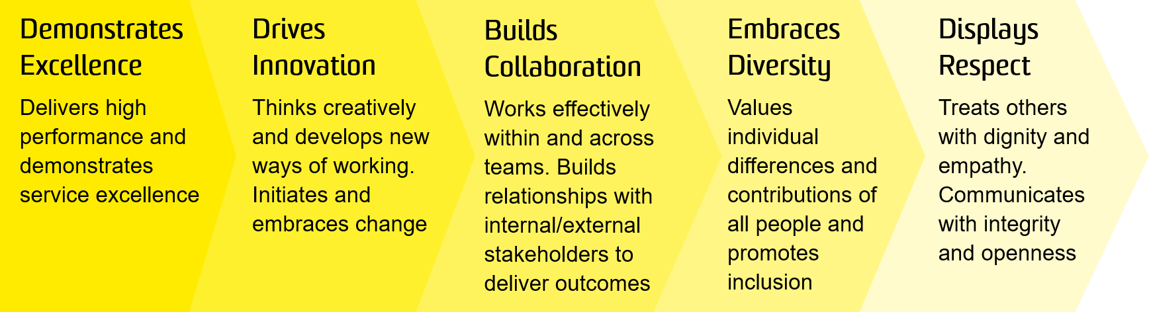

OVERVIEW OF RELEVANT AREA AND POSITION SUMMARY
UNSW Business School is a leader in business education and research in the Asian region and one of the largest Business Schools in Australia with more than 15,000 students, 500 academic and professional staff and more than 80,000 alumni and partners. The Business School offers a full suite of business degree programs at undergraduate, postgraduate, coursework and research levels, including the AGSM MBA programs and a range of Executive Programs. Its direction is guided by a business advisory council of leading CEOs, chairpersons and other business leaders.

The Business School’s reputation is built on its outstanding staff, students and alumni and a cultural diversity which ensures an international focus. It also has a long history of deep industry engagement, and takes pride in the impact it has through its educational and research activities. The School is frequently ranked among the top 50 in the world, and in some areas among the top 20, according to global indicators. For further information, see: https://www.business.unsw.edu.au/

The School of Information Systems & Technology Management at the UNSW Business School comprises over 20 FT academics who are actively engaged in teaching and research. Our research is positioned at the forefront of the discipline and has well developed local and international linkages.

Applications are invited for the appointment of a Lecturer/ Senior Lecturer (Level B/C academic) with an outstanding record of research and scholarship, and demonstrated leadership and research expertise in Information Systems.

A Level B academic is expected to make contributions to the teaching effort of the institution and to carry out activities to maintain and develop their scholarly, research and/or professional activities relevant to the profession or discipline.

A Level C academic is expected to make significant contributions to the teaching effort of a department, school, faculty or other organisational unit or an interdisciplinary area. An academic at this level is also expected to play a major role in scholarship, research and/or professional activities.

The role of Lecturer/ Senior Lecturer reports to the Head of School. Positions reporting to this position include Research Assistants and casual staff as required.

RESPONSIBILITIES
Level B
Specific responsibilities for this role include:
- Pursue and develop an active research program (research grant applications, research student supervision, publications in top-tier refereed Information Systems journals, presentations at international conferences);
- Develop, teach, and coordinate undergraduate and postgraduate courses in Information Systems (IS);
- Assist with the development of new teaching programs, adopting a flexible approach to teaching and learning;
- Supervise and monitor postgraduate research and honours students;
- Maintain and develop links with the IS profession and industry including offering professional development programs;
- Engage with the media (both traditional and new media) on matters of interest to business and society;
- Actively participate in seminars, meetings and Committees in the School, Faculty and University;
- Cooperate with all health and safety policies and procedures of the university and take all reasonable care to ensure that your actions or omissions do not impact on the health and safety of yourself or others.
- Cooperate with all health and safety policies and procedures of the university and take all reasonable care to ensure that your actions or omissions do not impact on the health and safety of yourself or others

Level C
In addition to the duties described above:
- Undertake major administrative responsibilities associated with the delivery of the Teaching Unit’s programs and other broad administrative functions, as required;
- Attract and maintain external funding through successful applications for research grants;
- Play a significant role in research projects in the School, including, where appropriate, leadership of a research team;
- Represent the School or participate in School activities and UNSW Business School committees.
- Ensure hazards and risks are identified and controlled for tasks, projects and activities that pose a health and safety risk within your area of responsibility.

SELECTION CRITERIA
Level B
- A PhD degree in Information Systems or a closely-related business field;
- Experience of teaching technology (programming, database, security, networking) or business analytics courses would be a distinct advantage;
- Expected or demonstrated excellence in publishing in leading Information Systems conferences (e.g. ECIS, ICIS, AMCIS, PACIS) and journals (e.g. AIS Basket of 8 and/or Australian Business Deans Council A/A* under FOR code 0806);
- Expected or demonstrated ability for lecturing, teaching innovation and curriculum development in Information Systems at both undergraduate and/or postgraduate level is essential;
- Highly developed interpersonal skills with the ability to work with staff and students from diverse backgrounds. Experience of student management (e.g. Program co-ordination) would be an advantage;
- Potential to supervise honours and postgraduate research students;
- Excellent verbal and written communication skills. Experience of engaging with traditional and new media would be a distinct advantage;
- Ability to obtain research funding and participate in collaborative research and educational projects. Experience of collaboration with international networks of researchers would be a distinct advantage;
- Willingness to be involved with, and contribute to, the academic discipline and the profession. Experience of involvement in conference / journal reviewing would be a distinct advantage;
- Knowledge of health and safety responsibilities and commitment to attending relevant health and safety training.

Level C
In addition to selection criteria detailed above:
- A strong track record of publications in international disciplinary journals in Information Systems and related areas;
- Demonstrated ability to effectively supervise honours and postgraduate research students;
- Evidence of ability to develop a research team. Leadership skills and experience would be an advantage;
- Demonstrated track record of effective teaching, curriculum development and course management. Experience of MBA teaching would be an advantage.
- Ability and capacity to implement required UNSW health and safety policies and procedures.

It is not the intention of the position description to limit the scope or accountabilities of the position but to highlight the most important aspects of the position. The aspects mentioned above may be altered in accordance with the changing requirements of the role.

