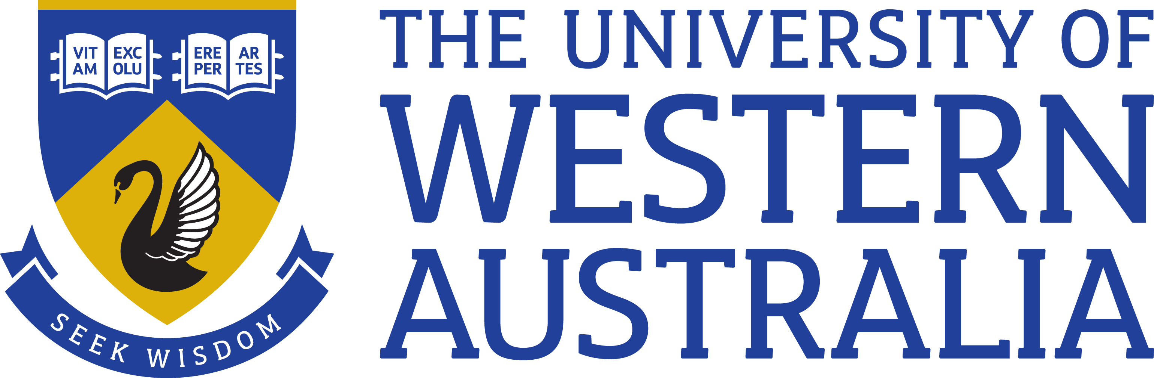

Position Title: | Deputy Director, Human Resources
Position Classification: | Level 10 Grade 3
Position Number: | 105135
Faculty/Office:  School/Division:  Centre/Section: | Human Resources
Supervisor Title: | Director, Human Resources
Supervisor Position Number: | 100588
About the work area
Human Resources supports the mission of the University by providing a high quality, responsive people management and advisory service. The University’s professional service delivery model was created to deliver effective and efficient end to end services across the whole University. The model includes all core services of the University and creates functionally aligned services via Service Delivery Centres.

Reporting Structure
Reports to: Director, Human Resources
Direct Reports: HR Managers, Employee Relations Manager
The Role
This key position reports to the Director, HR and is responsible for leading and managing the HR Managers and Employee Relations team at UWA, as such the role is expected to change over time as the newly introduced Service Delivery Centre Model matures.

The role will work in partnership with the business to define, lead and facilitate ongoing improvements to drive business and service delivery. It will have responsibility for driving a quality HR service culture into the business and helping to shape the broader short term and long term HR and Employee Relations strategy.
Key responsibilities
Strategy and Culture
- Develop, co-ordinate and implement the University’s SDC HR and Employee Relations strategy aligned with the broader UWA and HR strategy
- Manage the relationships between HR and other central service functions
- Lead a team of HR Managers and Advisory and transactional teams to provide localised delivery of HR services, policies and frameworks and provide employee lifecycle management and HR transactional services to Faculties and units.
- Deliver a high profile, best practice HR Business Partnering service.
- Act as key adviser on strategic and operational HR issues to the Senior Leadership Team
- In collaboration with the Employee Relations Manager, lead the enterprise bargaining process, manage the industrial relations case workload and develop capability to enable appropriate responses to emerging challenges

Policy, Procedures and Performance
- Provide strategic input for and Implement whole of University people initiatives such as talent and capability frameworks, culture, change, staff development, workforce and succession planning. Lead HR projects and transformation activities as required.
- Provide leadership to embed best practice Employee Relations and HR service delivery across the broader HR team and UWA - delivering agreed KPI’s and Service Partner Agreements and managing within resources allocated.
- Report and manage all operational programs, policies and initiatives within are of responsibility

Team
- Operate as an integral member of the HR Leadership Team
- Manage selection and development of team members to ensure the necessary capability.
- Proactively undertake and encourage team members to undertake broader HR projects to ensure continued professional development and improvement
- Deputise for members of the HR Leadership Team in their absence
- Work collaboratively with senior leaders across the university to coach and provide specialised advice and strategic support

Undertake other duties within field of expertise and knowledge as required.
Specific work capabilities (selection criteria)
- Tertiary qualification in a relevant field, preferably at a postgraduate level and extensive relevant experience, or an equivalent combination of relevant experience and education
- Proven HR and Employee Relations leadership skills; experience and success at a senior level in complex organisation including the leadership and management of finances, people, and projects (an understanding of current issues in higher education would be advantageous)
- Excellent interpersonal and written skills with proven ability to effectively negotiate persuade and influence stakeholders to achieve strategic outcomes
- Proven experience in effective management of a large team and the ability to provide leadership and direction to achieve high level service delivery
- Excellent conceptual, analytical and problem-solving skills with the ability to develop creative solutions to complex problems and business requirements
- Demonstrated ability to drive results and culture change across multiple stakeholders
- Experience of delivery in a transformational workplace

Leadership capabilities
- Champions the organisation's vision and goals and promotes a shared commitment to the strategic direction. (Shapes strategic thinking)
- Helps create organisational strategies that are aligned with UWA objectives and likely future requirements. (Shapes strategic thinking)
- Oversees the implementation of multiple change initiatives with a focus on the desired outcomes. (Achieves results)
- Ensures ideas and intended actions become reality and that planned projects result in expected outputs (Achieves results)
- Consults broadly to obtain buy in. Draws on the knowledge of key stakeholders within and outside the organisation and facilitates cooperation by sharing information. (Cultivates productive working relationships)
- Commits to achieving key outcomes for the organisation and uses personal drive, focus and energy to enthuse others. (Exemplifies personal drive and integrity)
- Communicates clearly, confidently presenting messages in a clear, concise and articulate manner. (Communicates with influence)

Special Requirements
NA
Compliance

Workplace Health and Safety
All supervising staff are required to undertake effective measures to ensure compliance with the Occupational Safety and Health Act 1984 and related University requirements (including Safety, Health and Wellbeing Objectives and Targets).
All staff must comply with requirements of the Occupational Safety and Health Act and all reasonable directives given in relation to health and safety at work, to ensure compliance with University and Legislative health and safety requirements.
Details of the safety obligations can be accessed at http://www.safety.uwa.edu.au

Equity and Diversity
All staff members are required to comply with the University’s Code of Ethics and Code of Conduct and Equity and Diversity principles. Details of the University policies on these can be accessed at http://www.hr.uwa.edu.au/publications/code_of_ethics, http://www.equity.uwa.edu.au

