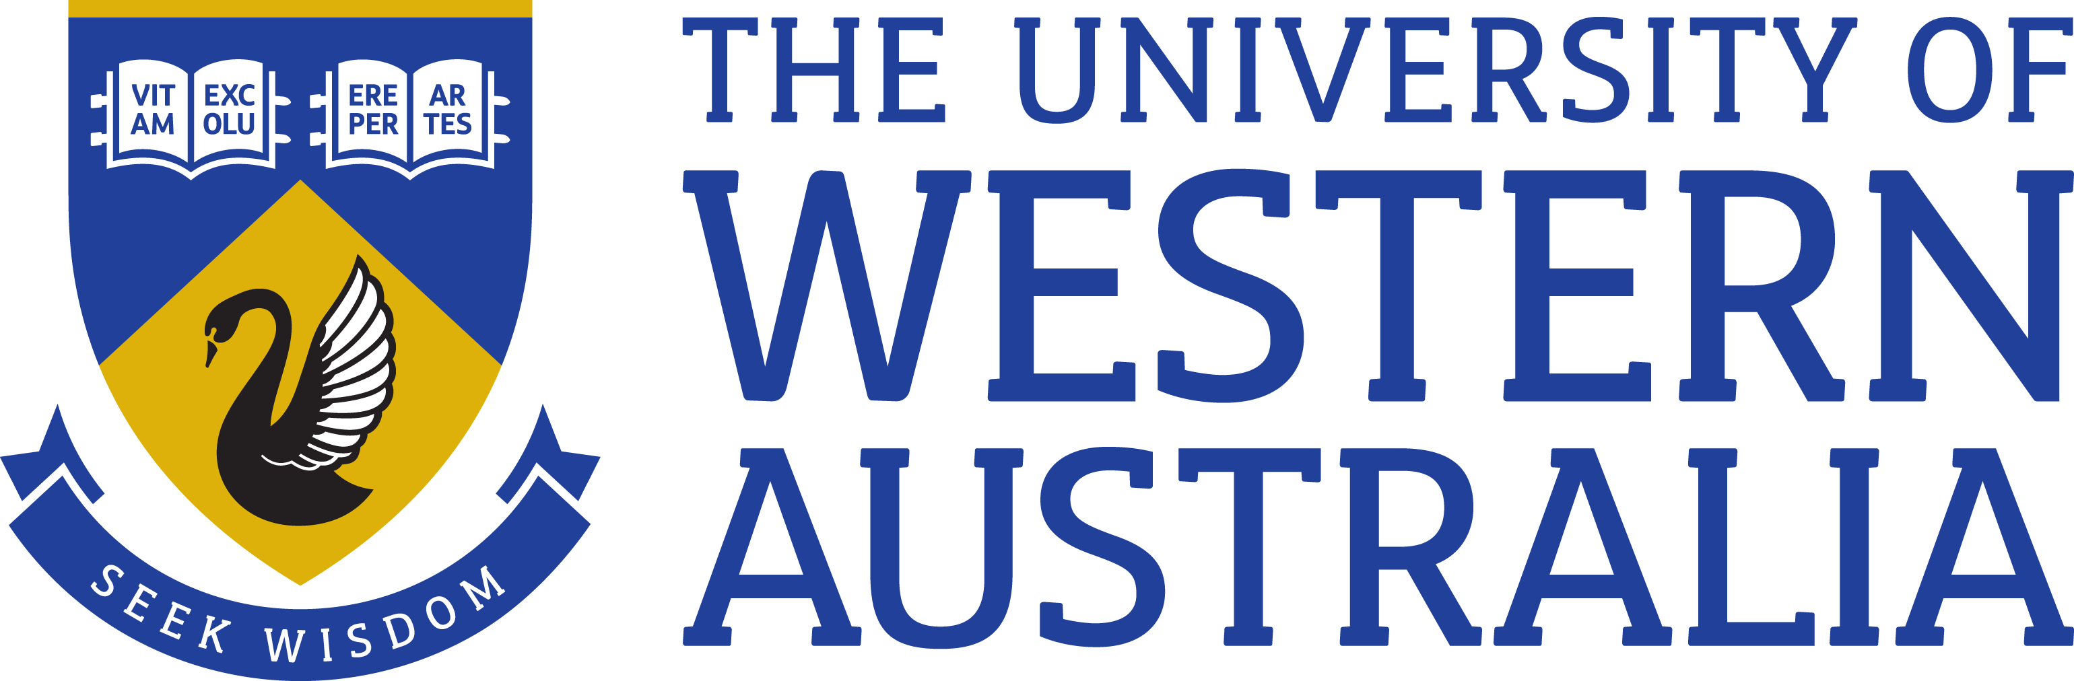

Position Title: Senior Lecturer/Associate Professor (Joint Appointment)
Position Classification: Level C or D
Position Number: 102275
Faculty/Office: Central DVC-R 50%/Faculty of Science 50%
School/Division: Centre for Microscopy, Characterisation & Analysis 50% and School of Molecular Sciences 50%
Centre/Section:
Supervisor Title: Director
Supervisor Position Number: 307221
Your work area
The Centre for Microscopy, Characterisation & Analysis (CMCA) comprises 35 academic, research, technical and administrative staff supporting more than 45 instrument platforms including secondary ion mass spectrometry (SIMS), electron microscopy and microanalysis, optical, confocal, confocal Raman, and multiphoton microscopy, cytometry & cell sorting, nuclear magnetic resonance spectroscopy (NMR), powder, thin-film and single-crystal X-ray diffraction, bio-organic mass spectrometry, small animal imaging, scanning probe microscopy, and micro-CT.
The CMCA’s mission is to enable research excellence by providing world-class science infrastructure and expertise in Characterisation to researchers and industry. Its strategy is to provide such excellence through a focus on world-class facilities matched with expertise and through a concept-to-publication User Pathway designed to meet the Characterisation requirements of researchers and industry through excellence in training, measurement and analysis.
Amongst many affiliations, the CMCA forms a part of the NCRIS capabilities as nodes of the Australian Microscopy & Microanalysis Research Facility and the (Australian) national Imaging Facility, part node of Metabolomics Australia and is supported by several other capabilities.
The CMCA’s NMR facilities, supporting mainly chemistry and structural biology, comprise four instruments ranging from 400 to 600 MHz. The 600 MHz spectrometer was upgraded to a Bruker Avance III HD system in December 2014 and a Bruker Avance III HD 500 MHz spectrometer was installed in early 2015. The facility houses a Varian/Agilent 400MHz spectrometer equipped with solid state capabilities. In 2017, a second 600 MHz spectrometer will be installed for metabolomics as part of the soon-to-be-established Western Australian Phenome Centre involving Murdoch University and Edith Cowan University. The NMR facility is located in a specially designed laboratory within Bayliss building.
The School of Molecular Sciences is a comprehensive research-intensive school that spans the broad disciplines of chemistry, biochemistry and molecular biology, and genetics, and is responsible for the BSc majors that fit within its broad discipline base. The iconic Bayliss Building on the Crawley campus houses the School numerous research groups, as well as the CMCA's NMR, X-ray diffraction, and mass spectrometry facilities.
Reporting Structure
Direct Reports: Director, CMCA and Head, School of Molecular Sciences
Teams: NMR Technique Group (CMCA), Biological Sciences Application Group (CMCA)
Your role
The position will be a joint appointment (50:50) between the Centre for Microscopy, Characterisation and Analysis (CMCA), and the School of Molecular Sciences. In addition to pursuing an internationally recognised program of independent research, and managing the Nuclear Magnetic Resonance Facility, the successful applicant will be responsible for high-quality undergraduate and postgraduate teaching. Appointment will be made at the level appropriate to the experience and track record of the successful applicant.
Key responsibilities
- Research and Teaching Specialist in Nuclear Magnetic Resonance Spectroscopy
- Provide expertise to academic staff and research students in all areas of NMR spectroscopy including spectrometer operation, data acquisition and analysis;
- Initiate and undertake an independent, externally funded research program utilising NMR spectroscopy and engage in collaborative research projects across the School, Faculty, and wider University research community;
- Direct and supervise major undergraduate and postgraduate research projects;
- Engage in the teaching and demonstration of the principles of NMR spectroscopy to HDR, Honours, and undergraduate students – from first principles to advanced concepts;
- Provide high quality teaching in NMR spectroscopy and chemistry/biochemistry areas, incorporating research, scholarship and/or professional practice into teaching activities; and
- Other duties as directed.

- Management of the CMCA NMR Facilities
- Take responsibility for the maintenance, care, and security of the NMR spectrometers including cryogen maintenance, fault location and rectification;
- Supervise a Senior Research Officer involved in day-to-day operation of the Facility.
- Train academic, research, technical staff and research students in the use of high-field spectrometers and supervise the operation of these spectrometers;
- Support Chemical, Biological and Metabolomic NMR spectroscopy;
- Maintain current knowledge of developments in NMR spectroscopy, and engage in strategic planning regarding future upgrades;
- Support new experimental development and implementation, pulse programming and automation programming;
- Monitor the scientific output and usage of the NMR facility; and
- Other duties as directed.
Your specific work capabilities (selection criteria)
ESSENTIAL:

- PhD in chemistry or allied science;
- Demonstrated knowledge and experience in Nuclear Magnetic Resonance spectroscopy, including pulse sequence and automation programming
- Demonstrated knowledge of NMR spectroscopy applied toward one or more of the following: Chemistry, Structural Biology, Metabolomics;
- Demonstrated ability to carry out independent research, and willingness to participate in collaborative research;
- Ability and willingness to direct and maintain a multi-user NMR facility;
- Ability to work in an interdisciplinary environment; and
- Good communication and interpersonal skills.

DESIRABLE:

- Experience across a wide range of multinuclear and multidimensional NMR experiments;
- Experience with NMR-based structural investigations of chemicals and/or biological molecules;
- Experience in metabolomics approaches for biological or clinical studies including an understanding of data processing and analysis;
- Experience in the development and delivery of high quality teaching;
- Experience in computer programming and data management; and
- Experience working with teams of researchers from different fields (e.g., biology, chemistry, materials).
Special Requirements
There are no special requirements.
Compliance
Workplace Health and Safety
All supervising staff are required to undertake effective measures to ensure compliance with the Occupational Safety and Health Act 1984 and related University requirements (including Safety, Health and Wellbeing Objectives and Targets).
All staff must comply with requirements of the Occupational Safety and Health Act and all reasonable directives given in relation to health and safety at work, to ensure compliance with University and Legislative health and safety requirements.
Details of the safety obligations can be accessed at http://www.safety.uwa.edu.au

Equity and Diversity
All staff members are required to comply with the University’s Code of Ethics and Code of Conduct and Equity and Diversity principles. Details of the University policies on these can be accessed at http://www.hr.uwa.edu.au/publications/code_of_ethics, http://www.equity.uwa.edu.au

