Faculty / Division: Division of Philanthropy
School / Unit:
Position Level: 6
Position Number: XXXXXX
Position Title: Executive Assistant
Date Written: February 2018

ORGANISATIONAL ENVIRONMENT
UNSW is currently implementing a ten year strategy to 2025 and our ambition for the next decade is nothing less than to establish UNSW as Australia’s global university. We aspire to this in the belief that a great university, which is a global leader in discovery, innovation, impact, education and thought leadership, can make an enormous difference to the lives of people in Australia and around the world.
Following extensive consultation in 2015, we identified three strategic priority areas. Firstly, a drive for academic excellence in research and education. Universities are often classified as ‘research intensive’ or ‘teaching intensive’. UNSW is proud to be an exemplar of both. We are amongst a limited group of universities worldwide capable of delivering research excellence alongside the highest quality education on a large scale. Secondly, a passion for social engagement, which improves lives through advancing equality, diversity, open debate and economic progress. Thirdly, a commitment to achieving global impact through sharing our capability in research and education in the highest quality partnerships with institutions in both developed and emerging societies. We regard the interplay of academic excellence, social engagement and global impact as the hallmarks of a great forward-looking 21st century university.
To achieve this ambition we are attracting the very best academic and professional staff to play leadership roles in our organisation.

UNSW BEHAVIOURS
UNSW recognises the role of employees in driving a high performance culture. The behavioural expectations for UNSW are below.
Please refer to the UNSW Behavioural Indicators for the expectations of your career level (level 6).

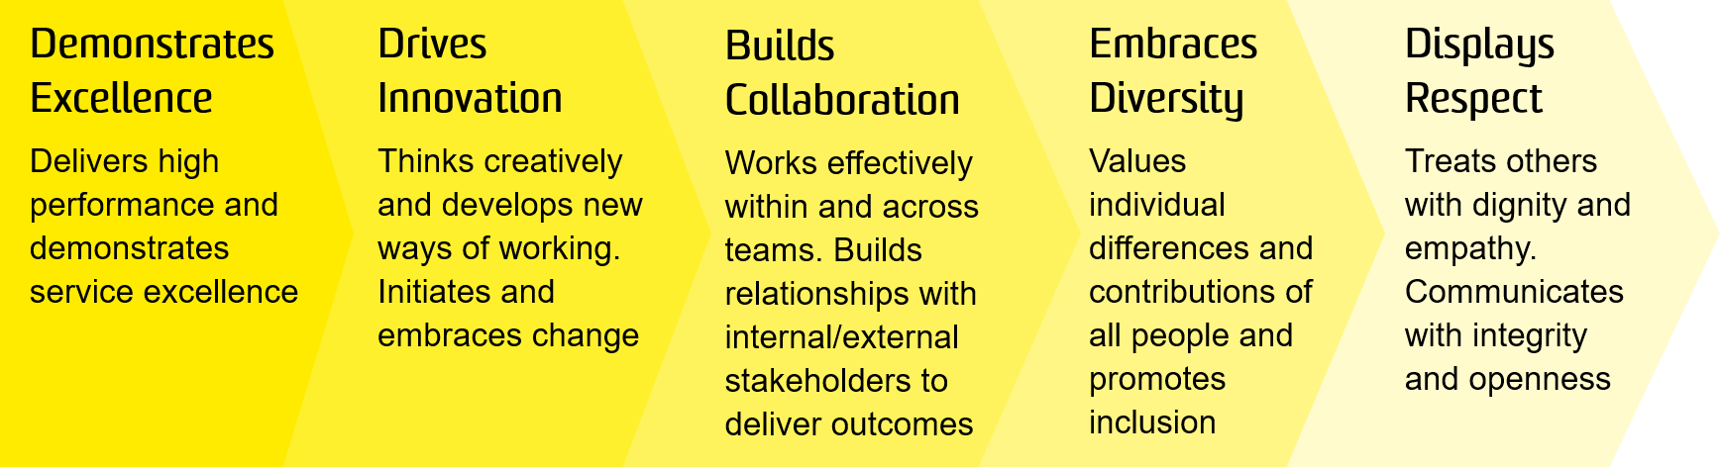

OVERVIEW OF RELEVANT AREA AND POSITION SUMMARY

Philanthropy is critical to the success of the 2025 Strategy. Beginning with the appointment of a new Vice- President, Philanthropy in February 2016, UNSW is committed to building a world-class development and engagement team that will help advance UNSW’s ambitious goals. Our Development and International Development teams work closely with individuals, corporations, and foundations to raise philanthropic support for the university’s highest priorities. Our Alumni and Engagement team encourages alumni, parents, and friends to give time, money and expertise in support of these priorities, while providing ongoing value to graduates, and strengthening the University’s reputation. Our Operations Team ensures that all UNSW alumni, parents, and friends receive a consistent and high standard of service and stewardship and our Office of the Vice-President team The VPP Office team look after the strategic priorities of the Division, has oversight of the Principal Gifts program, manage our Boards and Volunteer Committees both in Australia and overseas and have oversight for the inaugural fundraising campaign for the University.

The Executive Assistant is responsible for ensuring all administrative matters, including diary and meeting arrangements, travel arrangements and correspondence, are prioritised and handled efficiently and effectively. This position is the first point of contact for enquires, requiring prompt, courteous and effective communication with internal and external stakeholders and will be required to effectively manage all projects/initiatives, as assigned.

The role of Executive Assistant reports to the Executive Directors and will have no direct reports.

RESPONSIBILITIES
Specific responsibilities for this role include:
- Provide superior executive support, while exercising discretion, initiative and confidentiality.
- Deliver a highly customer-focused service, and demonstrate commitment to excellence and continuous improvement.
- Act as the first point of contact for internal and external stakeholders, maintaining effective channels of communication, analysing requests and correspondence to prioritise priorities as well as urgent and often sensitive matters.
- Undertake diary, email and document management, including the monitoring and prioritising of emails, assisting with the preparation of responses, and ensuring the timely review of papers and pre-reading is actioned in a timely manner.
- Coordinate and plan meetings, including compiling agendas and other documents, preparing minutes and following up on allocated or outstanding meeting tasks and arranging catering as required.
- Build and maintain effective working relationships between the Division of Philanthropy and other Divisions and Faculties.
- Undertake ad-hoc projects aligned with the Division of Philanthropy goals and strategy.
- Coordinate payments, accounts, travel and associated requirements in accordance with the University's policies and procedures
- Provide supplemental and back-up administrative support to the Vice-President, Philanthropy and other Executive Directors as required.
- Cooperate with all health and safety policies and procedures of the university and take all reasonable care to ensure that your actions or omissions do not impact on the health and safety of yourself or others.

SELECTION CRITERIA
- A relevant tertiary qualification and relevant experience as an executive assistant or an equivalent level of knowledge gained through any combination of education, training and experience.
- High-level organisational skills and proven ability to deal with multiple tasks, undertake complex diary management, establish priorities and meet deadlines.
- Excellent oral and written communications skills and the ability to liaise effectively with all levels of staff, students, management, and external stakeholder.
- Demonstrated experience working with a high degree of confidentiality and integrity, and the ability to work flexible hours, as required.
- Demonstrated ability to work flexibly and productively as an effective team member to ensure deadlines are met.
- Advanced level of computer literacy with excellent skills in Microsoft Office applications and databases (e.g. Raisers Edge).
- Knowledge of health and safety responsibilities and commitment to attending relevant health and safety training.
It is not the intention of the position description to limit the scope or accountabilities of the position but to highlight the most important aspects of the position. The aspects mentioned above may be altered in accordance with the changing requirements of the role.

