Selection of Assistant Principal

Dear Referee

Assessment of Applicant

You have been nominated as a referee for this applicant’s application for Assistant Principal. You are kindly asked to complete the attached reference forms and return to the Recruitment Officer via email esd@parra.catholic.edu.au by the closing date as advised by the applicant.

This reference will assist us in the shortlisting process for the position of Assistant Principal.

I thank you for your assistance in this regard. Yours sincerely

Talent Acquisition Team

Catholic Education Diocese of Parramatta
Page 2 of 6

Name of Applicant:
Referee’s Name:
Contact Number:
Referee’s Position:
Working Relationship to
Applicant:
Date:
Free from any impediment to full acceptance by the Church in lifestyle, witness and modelling
Demonstrated record of leading processes to improve student performance in Catholic schools
Capacity to challenge and lead a school community that gives witness to the Catholic faith and its teaching and is aligned with the system strategic intent.
Demonstrated knowledge and use of current and emerging technologies as enablers for contemporary learning and teaching.
Minimum of four years professional qualification in education
Substantial currency in Religious Education pedagogy and knowledge of Religious Education curriculum

Attainment of a relevant Masters qualification or commitment to complete within four years of appointment
Demonstrated experience in leading contemporary learning theory and practice within the school
Demonstrated commitment to ongoing professional learning and formation.
Commitment to team and to building positive relationships
What are the major strengths this person brings to the application?
What are their areas of development?
Overall how would you rate the applicant’s performance? Please tick Highly competent
Competent
Effective in most areas Improvement needed

Are there any additional comments you would like to make?

Have you discussed this referee report with the applicant? Yes
No

Signed: Date:

Child Protection REFEREE questions for child-related employment

Name of Applicant:
Referee’s Name:
Contact Number:
Referee’s Position:
Working Relationship to Applicant:
Date:

- To your knowledge has the applicant been barred from working with Children no
yes (If yes, please provide brief details)

- Are you aware of any conviction of an offence that would bar the applicant from child-related work?
no
yes (If yes, please provide brief details – disqualifying offences are specified in Schedule 2 of the Child Protection (Working with Children) Act 2012) General details of the disqualifying offences can be viewed at – Automatic barring records

- Do you know of any criminal proceedings that if proven would bar the applicant from child-related work?
no
yes (If yes, please provide brief details)

Child Protection Referee questions Staff Services Version 1 November 2014

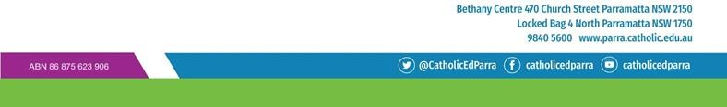

5. Are you aware that if applicant has ever been the subject of an Apprehended Violence Order (AVO) that was made for the purpose of protecting a child or young person from harm?
no
yes (If yes, please provide brief details)

6 Are you aware of any reason or concern which may make the applicant unsuitable to work in child-related employment?
no
yes (If yes, please provide brief details)

REFEREE

print name signature

