Position Number(s) | 006269 | Manager’s Role Title | Manager River Operations and Maintenance
Business Group | Operations & Maintenance | Manager Once Removed | Senior Manager River Murray Operation
Level of Work | V SA Water Hierarchy Level | Direct Report’s Role Title(s) | Not applicable

Purpose (Unique value add)
Contribute to the achievement of RMO performance targets by carrying out the operation and maintenance of Environmental Management Structures primarily and also River Murray Locks and Weirs and associated structures, in a safe and efficient manner as required.

Objectives
The objectives (maximum 6) of this role are to:
- Under direction, regulate pool levels by removal and reinstatement of environmental regulation structure components in a safe and timely manner.
- Provide safe and efficient passage of river traffic though the locks as required from time to time.
- Assist with operation and maintenance of lock and weir structures, associated environmental structures, buildings, public facilities, surrounds, plant and equipment.
- Provide good customer service, with provision of river information in a professional manner.
- Assist with ensuring all WHS (Work, Health, Safety) key performance indicators are achieved by adherence to safe working and operating procedures and compliance with WHS, environmental and property policies and guidelines.
- Undertake the operation, maintenance and reporting of key environmental watering sites and undertake key reporting requirements to stakeholders

Shared Organisational Goals
As a member of the Operations & Maintenance Group you are collectively accountable for delivering our goals and objectives.
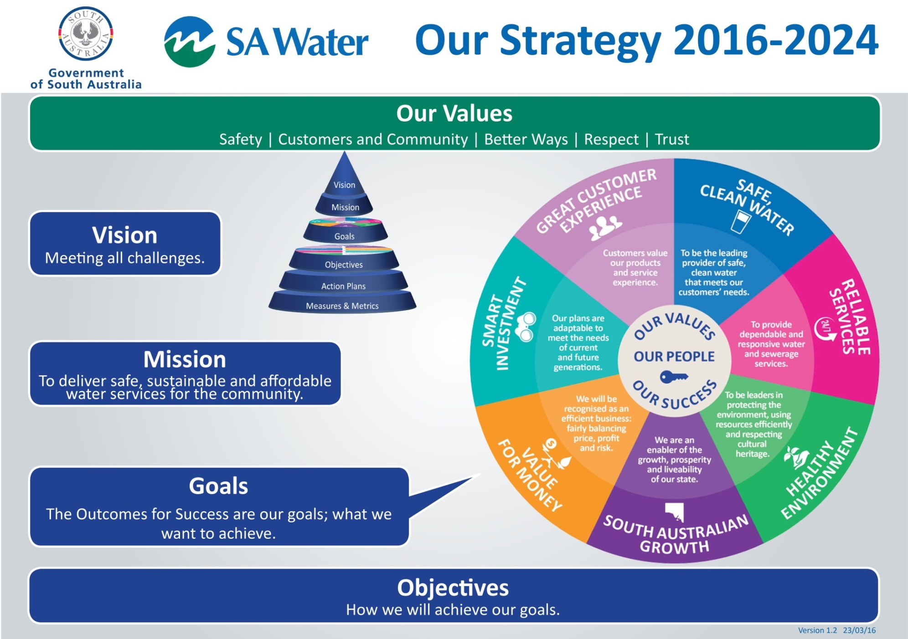
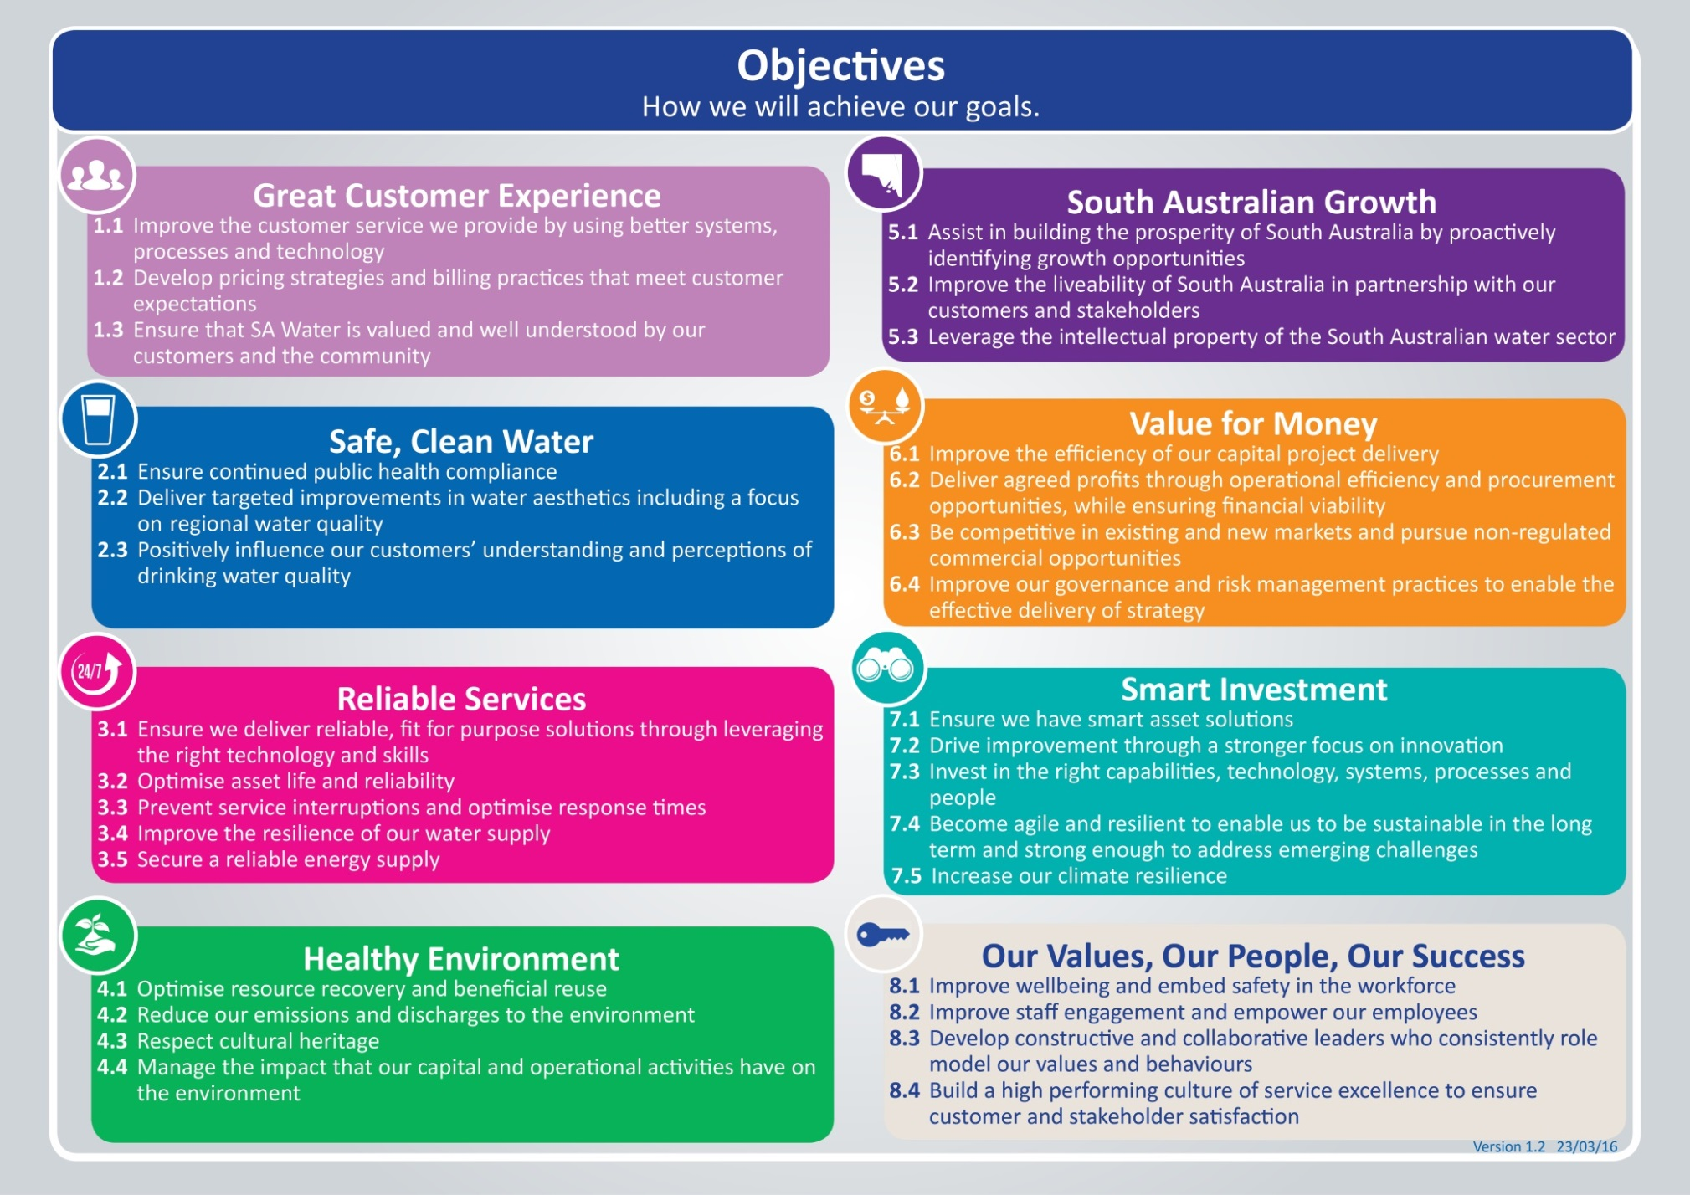

Key Accountabilities
Select relevant objectives from section 1.3 of this PD: Our Strategy 2016-2024 (also available on the AquaNet) and add them to the table as key accountabilities.
The key accountabilities (minimum 4 and maximum 6 including the mandatory ones), of this role are:
Key Accountabilities | Output/Measures
Mandatory accountability:  Contribute effectively to the team ensuring efforts are aligned toward achieving team goals | - Implement the direction set by your people leader.  - Complete specific tasks allocated.  - Collaborate effectively to ensure team goals are achieved by providing input into decision making and problem solving.  - Actively contribute to creating a culture of service excellence.
Mandatory accountability:  Put safety above all else. | - Be aware of and apply roles and responsibilities in accordance with WHS Roles and Responsibilities Procedure.  - Take responsibility for the safety and wellbeing of yourself and others including your own fitness for work (e.g. under the influence of drugs, alcohol and/or fatigue).
Customer Service | - Provide safe public access to the Locks and public facilities.  - Customers are to be provided with appropriate information relating to the river and its structures  - Communication occurs between customers and colleagues to ensure the best outcome  - Maintain a high level of service that meets customers’ expectations  - Customer issues are resolved in a timely manner  - Develop and maintain good working relations with other agencies, landholder and customers
Compliance | - Compliance with WHS policies, regulations and work procedures ensuring all key performance indicators are achieved  - Effectively participate in team meetings, work planning, training and development programs as required  - Compliance with Asset management system  - Utilise and comply with all relevant electronic / paper systems, processes and procedures in a timely manner
Environment | - Comply with SA Water’s environmental policy.  - Comply with other agencies environmental requirements.  - Assist with fish movement monitoring and provide data according to requested schedule.  - Operate and maintain environmental assets to a high standard.
Operations and Maintenance | - Assist with operation and maintenance of the Lock and Weir structures and associated infrastructure and surrounds to a high standard  - Operation of lock chambers to allow the boating public safe navigation passage along the river  - Operation of the Navigable Pass during periods of high flow  - Assist with the management of the river flow in conjunction with other structures to achieve flows as directed by Murray Darling Basin Authority (MDBA) to meet South Australia’s water supply entitlement, environmental watering and distribution of any additional flow  - Collect and provide accurate data and conduct regular infrastructure inspections and reporting  - Assist with fishway operation and maintenance, fish tagging, monitoring fish movement and record statistical data daily  - Use and maintain all relevant tools, materials, equipment and vehicles appropriately  - Contribute to your work team achieving outcomes effectively  - Carry out other duties as required

Lead Behaviours
Uphold SA Water’s Values:
- Put safety above all else
- Act in the best interests of customer and the community
- Seek and apply better ways
- Respect our people
- Be trustworthy

LEAD Behaviours |  | Behavioural Description
L ead our Future | Leads Change and Improvement | Brings people along to embrace sustainable change to deliver desired change outcomes. Identifies and takes ownership of opportunities presented through ambiguous situations, generating creative ideas/solutions. Carries out systematic analysis to identify the root cause of problems and makes informed judgments. Challenges the status quo to simplify, rationalise or develop products, processes or services to meet the needs of our internal/external customers.
E mpower our People | Communicates with Influence | Two-way - Communicates openly and confidently. Motivates and influences others in a way that results in acceptance and agreement. Shapes conversations to ensure focus and understanding, debates at the table, not afterwards. Is a supportive listener.
A dd Value for our Customers | Customer Service Excellence | Make it easy for our customer/community by proactively anticipating internal and external needs - collaborating to build valued and trusted relationships through the delivery of high quality service.
 | Collaborates for Success | Coordinates efforts/resources within and across teams to deliver Outcomes for Success. Recognises the importance of teamwork to achieve outcomes; brings in ideas, information, suggestions and expertise from others outside the immediate team. Builds strong team relationships within and across teams to positively impact business performance.
D eliver on the Promise | Empowers Self | Acts with integrity. Pursues self-awareness; understands own strengths and limitations and is focused on self-development. Shows energy and resilience. Maintains commitment and a positive outlook in the face of setbacks and obstacles. Is authentic, approachable open and honest.
 | Achieves Results | Achievement focused. Takes personal accountability for achieving individual and shared outcomes. Sets robust plans well in advance and initiates action to move work forward. Adjusts actions to respond and capitalise on changing circumstances. Manages time effectively, monitoring performance against deadlines and milestones.

Knowledge, Skills and Experience

Foundation knowledge, skills, experience and qualifications | Essential or Desirable
Certificate III in Water Operations | Desirable
Drivers Licence Class C | Essential
Heavy Combination License | Desirable
Boat Licence | Desirable
Restricted Coxswain Certificate | Desirable
Machine Operator Licences | Desirable
First Aid Certificate | Desirable
White card | Desirable
Dogging | Desirable
Use of hand tools | Essential
Use of basic water quality measuring equipment | Desirable
Machine operation | Essential
Ability to identify problems and report to Coordinator | Essential
Basic computer skills in common applications such as Microsoft Office | Essential
Ability to communicate effectively both written and verbal | Essential
Understanding of general operation of lock and weir structure. | Essential
Ability to do basic calculations | Essential

Key Stakeholder Relationships
- SA Water management and staff
- MDBA, RMW, Landholders, other agencies, authorities and community groups
- SA Water customers (general public)
- Contractors
- Consultants
- External service providers

Special Conditions
- Flexible hours and some after hours as required, some intra and interstate travel.
- Be available to be rostered to work at least every second weekend as required.
- Some work in remote and isolated locations

Template: Position Description - Level 5 Employee Version 3.00 17/06/16 -Document ID: SAWT-HR-0021

