Statement of duties
Position Title | Team Leader
Position Number | Generic
Division/Branch/Section | Homes Tasmania, Tenancy Services
Award/Agreement | Health and Human Services (Tasmanian State Service)
Classification | General Stream Band 5
Position Status* | Permanent
Position Type* | Full-time
Location | South/North/North West
Reports to | Lead Tenancy Manager
Check Type | Annulled
Check Frequency | Pre-employment
* The above details in relation to Position Status and Position Type may be different when this position is advertised – please refer to the advertisement for vacancy details.
About Us
Homes Tasmania is established under the Homes Tasmania Act 2022 and commenced on 1 December 2022
Homes Tasmania is building homes and creating opportunities for Tasmanians by delivering the Government’s 10-year, $1.5 billion plan to provide 10 000 new social and affordable homes by 2032.
We work with government, industry, the private sector, and the social housing and homelessness sector to improve the housing market and provide more housing opportunities for people in need.
Through the work of Homes Tasmania, Tasmanians will benefit from a resilient and diverse housing market that allows them to continue to improve their housing situation and the opportunities that better housing makes possible.

Our Purpose
The purpose of Homes Tasmania is to provide housing and housing assistance to eligible Tasmanians and to strategically manage and develop housing across Tasmania, giving consideration to the requirements of the complete housing continuum and to best meet the needs of all Tasmanians, both now and into the future.

Our Board
Homes Tasmania is governed by a skills-based Board, appointed by the Minister for Housing. The Board is established under the Homes Tasmania Act 2022.
The Board oversees how Homes Tasmania exercises its functions and powers, to ensure it meets the requirements of the Homes Tasmania Act 2022 including the Ministerial Statement of Expectations.

Our Organisation
Tenancy Services
Tenancy Services provides tenancy management services for Tasmania’s public housing which is around half of all social housing stock in the state. This includes:
- allocations
- lease sign ups and renewals
- rent management
- property inspections
- tenancy issues including tenancy interview to help sustain tenancies.
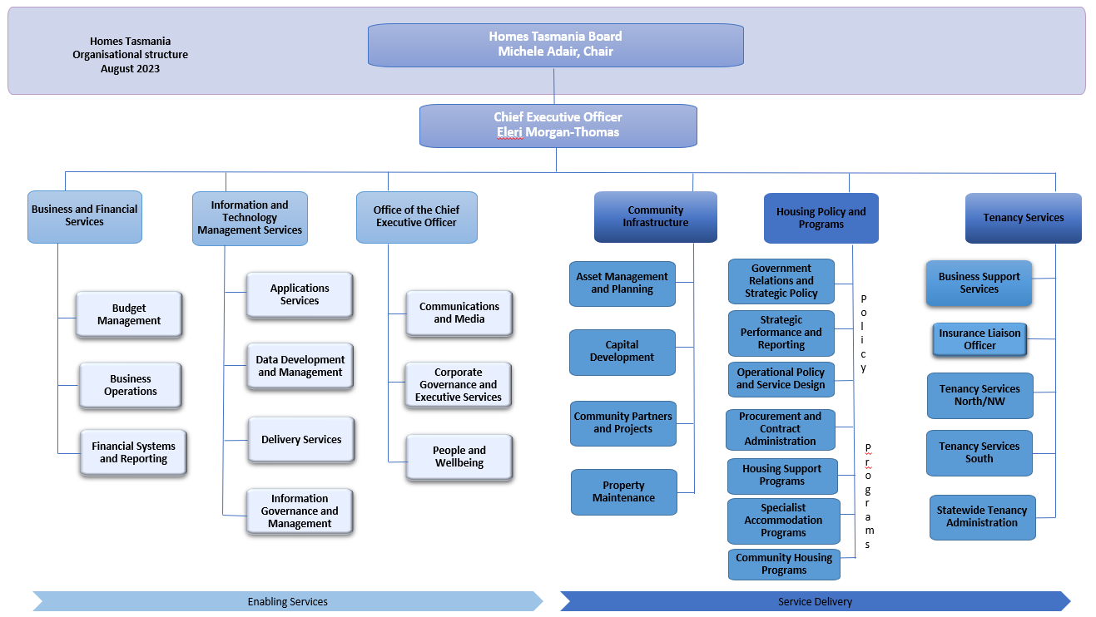

Primary Purpose
In accordance with Tenancy Service’s policies, principles and standards the Team Leader will:
- Support the Lead Tenancy Manager in the delivery of services.
- Be accountable for all property and tenancy coordination activities for a zone of properties and the relevant tenancies.
- Effectively coordinate a team to ensure the achievement of quality, financial and performance targets.
Primary Duties
- Coordinate the human, financial and physical resources of the nominated zone to established standards and benchmarks.
- Provide effective coordination, advice and leadership for staff working within the zone and ensure access to a range of training and development activities for staff designed to achieve best practice in client service.
- Assist the Lead Tenancy Manager in research, data collection and analysis regarding property coordination, tenancy coordination, client service and staff performance.
- Support complex client tenancies whilst they are at risk, including participation in a range of case coordination activities to facilitate early intervention and support planning for clients with housing and support needs.
- Provide high level policy and program advice to the area in relation to the development of property and service plans.
- Provide timely and accurate advice and information regarding the services provided by Tenancy Services and other services for clients with support needs.
- Prepare high level correspondence, project documents, business case proposals, reports and submissions for senior management, the Minister and Cabinet.
- Represent Tenancy Services in the Magistrates Court and at other fora as appropriate.
- Effectively maintain Tenancy Services data and records to facilitate planning, quality management and reporting.
- Actively participate in and contribute to Homes Tasmania’s commitment to being a healthy, safe, inclusive and wellbeing focused organisation.
- The incumbent can expect to be allocated duties, not specifically mentioned in this document, that are within the capacity, qualifications and experience normally expected from persons occupying positions at this classification level.

Level of Responsibility, Direction and Supervision
The Team Leader is responsible for providing leadership and supervision to the nominated zone and will work under the limited supervision and direction of the Lead Tenancy Manager. The occupant will:
- Coordinate a nominated zone’s resources with respect to day-to-day client service including contributing to the development of specific projects and programs and reporting on performance.
- Provide authoritative advice and recommendations regarding Tenancy Service’s property and tenancy management, the broader service and support system and the operations of the nominated zone.
- Support efficient and effective asset and client service programs, including assisting with the development and implementation of service delivery models.
The incumbent will ensure that all work undertaken is aligned with and upholds Homes Tasmania’s values including a commitment to participate in building an inclusive workplace and workforce for the Community Services, Infrastructure and Housing Services Division.
Essential Requirements
Registration/licences that are essential requirements of this role must remain current and valid at all times whilst employed in this role and the status of these may be checked at any time during employment. It is the employee’s responsibility to ensure that registration/licences remain current and to advise the Employer if their circumstances change. This includes notifying the Employer of any new criminal convictions and/or if a registration/licence is revoked, cancelled or has its conditions altered.
The Head of the State Service has determined that the person nominated for this job is to satisfy a pre-employment check before taking up the appointment, on promotion or transfer. The following checks are to be conducted:
  - Conviction checks in the following areas:
    - crimes of violence
    - sex related offences
    - serious drug offences
    - crimes involving dishonesty
    - serious traffic offences (if Driver’s Licence is an essential requirement)
  - Identification check
  - Disciplinary action in previous employment check.

Desirable Requirements
- Current Driver’s Licence.
- Relevant tertiary qualifications.
Selection Criteria
- Demonstrated ability to coordinate human, financial and physical resources, to monitor effectiveness and efficiency, and to lead and coordinate a team in an environment subject to work pressure and competing priorities.
- Well-developed knowledge and understanding of property and tenancy services and the political, social and organisational environment coupled with a capacity to identify relevant issues and make sound judgments.
- High level communication, negotiation, and conflict resolution skills with a demonstrated ability to liaise and negotiate effectively with a wide range of stakeholders.
- Demonstrated experience in developing and maintaining collaborative working relationships with a wide range of stakeholders to facilitate early intervention and support planning for clients.
- Well-developed analytical and conceptual skills including the ability to solve problems and contribute to the development and implementation of service improvements.
- Working knowledge of the Community Services, Infrastructure and Housing division, including products and services provided by Tenancy Services and an understanding, or the ability to acquire knowledge of the social housing system.
Values and Behaviours
We are a values-based organisation. Our aim is to attract, recruit and retain people who uphold our values and are committed to building a strong values-based culture. Our values and behaviours reflect what we consider to be important.
State Service Principles and Code of Conduct: The minimum responsibilities required of officers and employees of the State Service are contained in the State Service Act 2000. The State Service Principles at Sections 7 and 8 outline both the way that employment is managed in the State Service and the standards expected of those who work in the State Service. The Code of Conduct at Section 9 reinforces and upholds the Principles by establishing standards of behaviour and conduct that apply to all employees and officers, including Heads of Agencies. Officers and employees who are found to have breached the Code of Conduct may have sanctions imposed.
The State Service Act 2000 and the Employment Directions can be found on the State Service Management Office’s website at http://www.dpac.tas.gov.au/divisions/ssmo
Delegations: This position may exercise delegations in accordance with a range of Acts, Regulations, Awards, administrative authorities and functional arrangements mandated by Statutory office holders including the Chief Executive Officer. The relevant manager can provide details to the occupant of delegations applicable to this position. Homes Tasmania has a zero tolerance in relation to fraud and in exercising any delegations attached to this role, the occupant is responsible for the detection and prevention of fraud, misappropriation and other irregularities.
Records and Confidentiality: Officers and employees of Homes Tasmania are responsible and accountable for making and maintaining proper records, including using relevant information management systems. Confidentiality must be always maintained and information must not be accessed or destroyed without proper authority.
Smoke-free: Homes Tasmania is a smoke-free work environment. Smoking is prohibited in all State Government workplaces, including vehicles and vessels.

