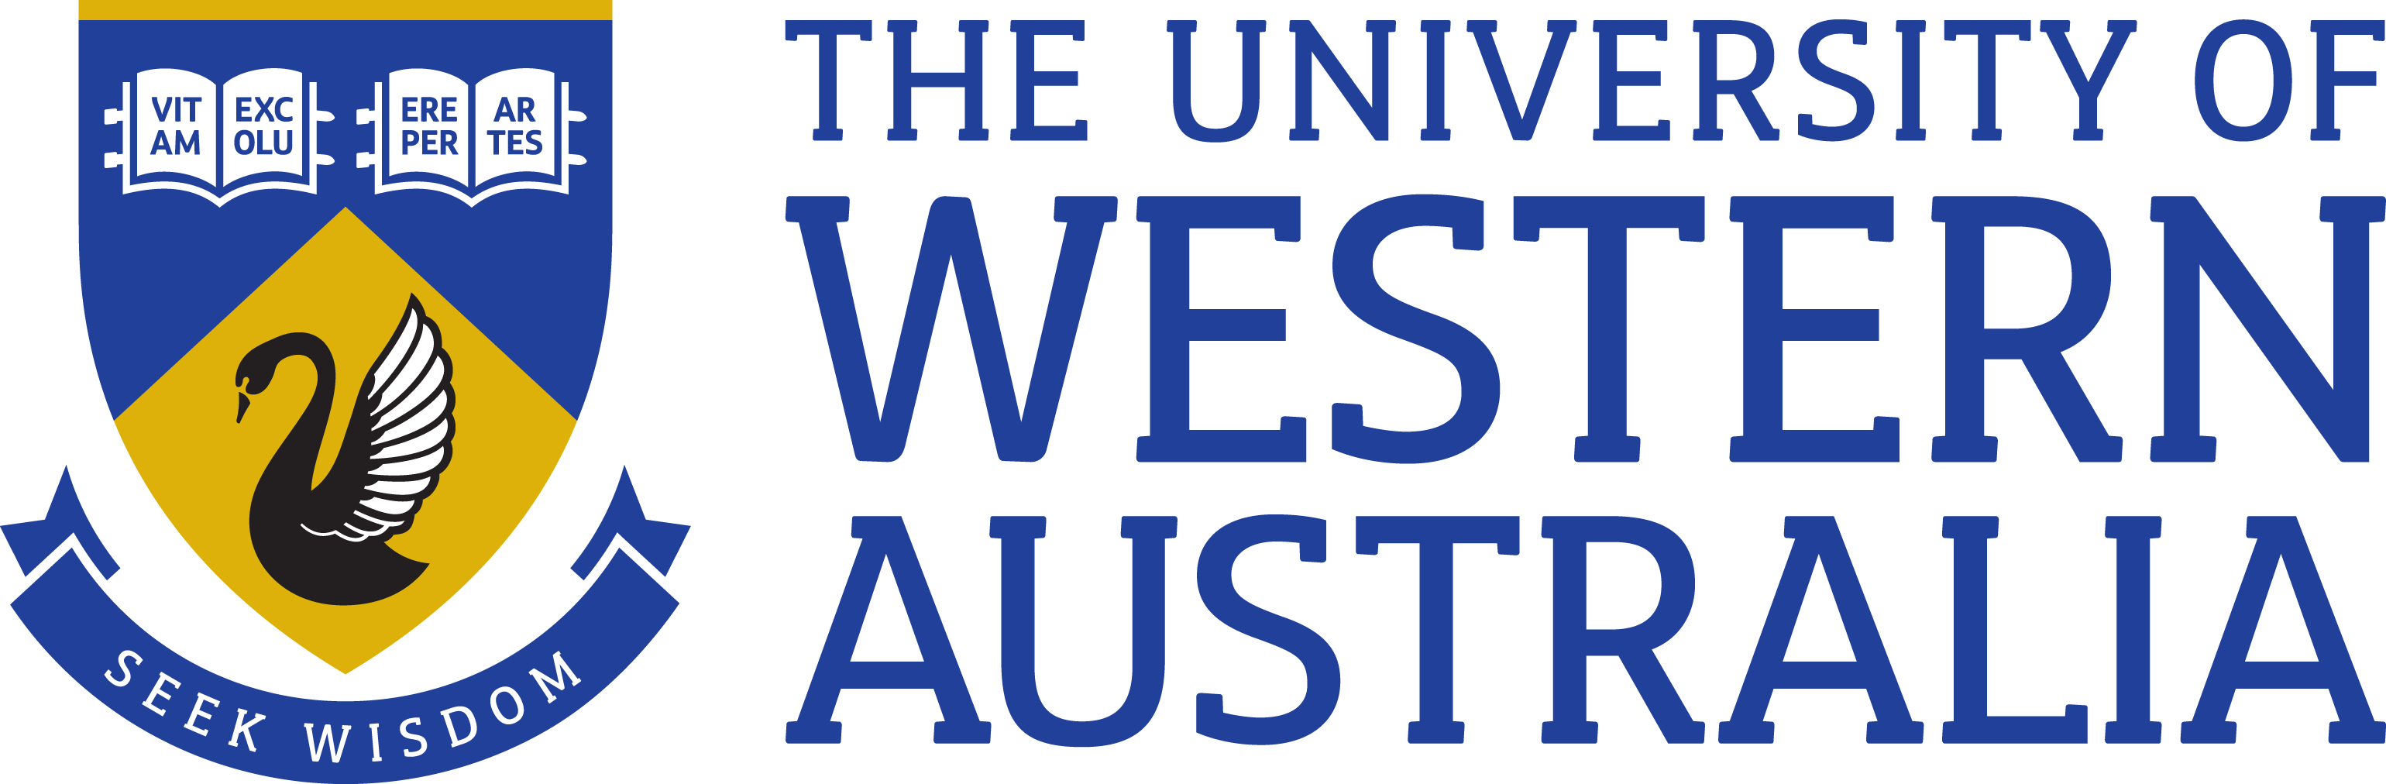

Position Title: Research Associate
Position Classification: Level A
Position Number: NEW
Faculty/Office: Engineering and Mathematical Sciences
School/Division: Department of Civil, Environmental and Mining Engineering
Centre/Section: Mining
Supervisor Title: Professor
Supervisor Position Number:
Your work area
The Department of Civil, Environmental and Mining Engineering is renowned for its award-winning researchers, teachers and facilities. The broad-based undergraduate and postgraduate programs are complemented by a wide range of research activities and the School is a leader in developing graduates in the critical industries of mining, energy, oil and gas. In the resource rich state of Western Australia the opportunities for partnership and collaborative research are extensive and the School has well established links with industry.
The Faculty of Engineering, Computing and Mathematics, including the Department of Civil, Environmental and Mining Engineering, is a world leader in Engineering for Remote Operations (ERO) providing an integrated approach and solutions to the challenges of mining development and production in remote locations, offshore engineering, agriculture, health, transport, energy, water supply and community development.

Reporting Structure

Reports to: Professor

Your role
The appointee is expected to work with Chief Investigators and other partners to undertake research associated with the investigation of the stability of filtered tailings stacks. The work programme will include laboratory element, geotechnical centrifuge and transportation moisture limit tests, complemented by numerical modelling and in-situ field tests.
Key responsibilities

Work on recently awarded MRIWA grant on filtered tailings

Publishing high quality peer-reviewed journal papers related to the research

Producing project reports as required

Presentation of research results and conclusions in workshops and conferences

Supervision of honours students

Other Duties as directed

riteria)
Your specific work capabilities (selection criteria)

A PhD in Geotechnical Engineering or related field, preferably related to mine tailings.

High level proficiency in specialised laboratory testing, a range of computer skills including scientific programming, word processing, spreadsheets, and use of specialised software such as finite elements, or computational fluid dynamics

Excellent communication skills, including writing and oral presentation

Experience in working with the relevant industry

Ability to supervise honours students

Ability to work both independently and in a team

Special Requirements

Nil

Compliance

Workplace Health and Safety
All supervising staff are required to undertake effective measures to ensure compliance with the Occupational Safety and Health Act 1984 and related University requirements (including Safety, Health and Wellbeing Objectives and Targets).
All staff must comply with requirements of the Occupational Safety and Health Act and all reasonable directives given in relation to health and safety at work, to ensure compliance with University and Legislative health and safety requirements.
Details of the safety obligations can be accessed at http://www.safety.uwa.edu.au

Equity and Diversity
All staff members are required to comply with the University’s Code of Ethics and Code of Conduct and Equity and Diversity principles. Details of the University policies on these can be accessed at http://www.hr.uwa.edu.au/publications/code_of_ethics, http://www.equity.uwa.edu.au

