Faculty / Division: Faculty of Engineering
School / Unit: Mechanical and Manufacturing Engineering
Position Level: Level A
Position Number: 00080260
Position Title: Research Associate
Date Written: December 2019

ORGANISATIONAL ENVIRONMENT
UNSW is currently implementing a ten year strategy to 2025 and our ambition for the next decade is nothing less than to establish UNSW as Australia’s global university. We aspire to this in the belief that a great university, which is a global leader in discovery, innovation, impact, education and thought leadership, can make an enormous difference to the lives of people in Australia and around the world.
Following extensive consultation in 2015, we identified three strategic priority areas. Firstly, a drive for academic excellence in research and education. Universities are often classified as ‘research intensive’ or ‘teaching intensive’. UNSW is proud to be an exemplar of both. We are amongst a limited group of universities worldwide capable of delivering research excellence alongside the highest quality education on a large scale. Secondly, a passion for social engagement, which improves lives through advancing equality, diversity, open debate and economic progress. Thirdly, a commitment to achieving global impact through sharing our capability in research and education in the highest quality partnerships with institutions in both developed and emerging societies. We regard the interplay of academic excellence, social engagement and global impact as the hallmarks of a great forward-looking 21st century university.
To achieve this ambition we are attracting the very best academic and professional staff to play leadership roles in our organisation.

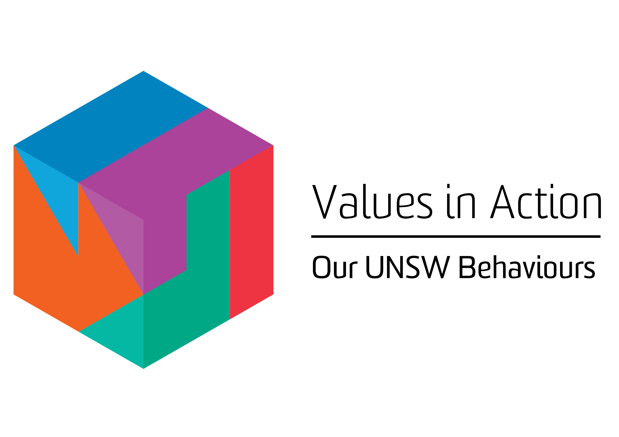
VALUES IN ACTION: OUR UNSW BEHAVIOURS

UNSW recognises the role of employees in driving a high-performance culture. The behavioural expectations for UNSW are below.

Delivers high performance and demonstrates service excellence.
Thinks creatively and develops new ways of working. Initiates and embraces change.
Works effectively within and across teams. Builds relationships with internal and external stakeholders to deliver on outcomes.
Values individual differences and contributions of all people and promotes inclusion.
Treats others with dignity and empathy. Communicates with integrity and openness.

OVERVIEW OF RELEVANT AREA AND POSITION SUMMARY
The School of Mechanical and Manufacturing Engineering is one of the largest and most prestigious in Australia, with 2500 student enrolments, 80 academic staff, 25 professional staff, and total annual budget of over $22 million including external research grants. Our mission is to prepare students for careers of leadership and innovation, create new scientific advances, and translate research outcomes to positively impact national and global industry and society. We are seeking to attract high-calibre researchers and educators to expand our thriving research programs and contribute to our education excellence in Aerospace, Mechanical Engineering, Advanced Manufacturing Engineering, Robotics and Mechatronics. For further information about the School, please visit http://www.engineering.unsw.edu.au/mechanical-engineering/.

The ARC Training Centre for Automated Manufacture of Advanced Composites (AMAC) http://advanced-composites.unsw.edu.au was established in 2017 under the Industrial Transformation Research Program (ITRP). With UNSW as the administrating node, AMAC is a collaboration between UNSW, ANU, Technical University of Munich (TUM) and nine industry partners. It combines world-class composites manufacturing capabilities with a high-value, industry focused research training experience to nurture and develop future innovators. Composites research in Australia has been identified as an area of national research strength and a key component of Federal Government’s Advanced Manufacturing innovation agenda. The research organisations (UNSW Sydney, ANU & TU Munich) provide the knowledge and cutting edge capability that, through the Centre programs, will transform advanced composites manufacturing for Australian Industries.

The role of the Research Associate will contribute to the research activities of AMAC specifically those activities funded by the CRC Projects Grant “Dentistry without mercury: Glass-fibre reinforced flowable dental composite restorative materials”. This is a collaborative project between Industries, University of Sydney and University of Wollongong. The Research Associate will be expected to contribute to the production of research output as per the project guidelines, liaise with the industry and university partners and co-supervise PhD and undergraduate students involved in the project.
The role of Research Associate reports to Prof. Gangadhara Prusty, and has no direct reports.

RESPONSIBILITIES
Specific responsibilities for this role include:
- Conducts research in the area of dental/bio/materials independently and as part of a team.
- Develop numerical models/simulation of composite materials systems, design and conduct experiments, and analyse and interpret data.
- Contribute to the writing of scientific papers and reports for international journals and progress reporting to other researchers and industry partners.
- Assist with the coordination of research activities and actively contribute to research outputs to meet project milestones.
- Contribute to the preparation of research proposal submissions to funding bodies and actively seek collaboration with industry partners as appropriate.
- Participate in and/or present at conferences and/or workshops relevant to the project as required.
- Assist with the supervision of research students in the research area where required.
- Liaise with industry and other university partners and coordinate activities where required.
- Cooperate with all health and safety policies and procedures of the university and take all reasonable care to ensure that your actions or omissions do not impact on the health and safety of yourself or others.

SELECTION CRITERIA
- PhD in Mechanical/Materials Engineering with specialisation in composite/bio/dental materials.
- Demonstrated experience and expertise in numerical simulation in dental/bio composites/materials area.
- Demonstrated experimental skills in composite materials fabrication and testing in dental/bio composites/materials area.
- Demonstrated ability to conduct independent research with limited supervision.
- Demonstrated track record of publications and conference presentations relative to opportunity.
- Demonstrated ability to work in a team, collaborate across disciplines and build effective relationships.
- Strong interpersonal skills with demonstrated ability to communicate and interact with a diverse range of stakeholders and students.
- Knowledge of health and safety responsibilities and commitment to attending relevant health and safety training.
It is not the intention of the position description to limit the scope or accountabilities of the position but to highlight the most important aspects of the position. The aspects mentioned above may be altered in accordance with the changing requirements of the role.

