Position Number: 00060358
Position Title: Career Development Program Officer
Date Written: May 2018
Faculty / Division: AGSM
School / Unit: Career Development Centre
Position Level: Level 6

ORGANISATIONAL ENVIRONMENT
UNSW is currently implementing a ten year strategy to 2025 and our ambition for the next decade is nothing less than to establish UNSW as Australia’s global university. We aspire to this in the belief that a great university, which is a global leader in discovery, innovation, impact, education and thought leadership, can make an enormous difference to the lives of people in Australia and around the world.
Following extensive consultation in 2015, we identified three strategic priority areas. Firstly, a drive for academic excellence in research and education. Universities are often classified as ‘research intensive’ or ‘teaching intensive’. UNSW is proud to be an exemplar of both. We are amongst a limited group of universities worldwide capable of delivering research excellence alongside the highest quality education on a large scale. Secondly, a passion for social engagement, which improves lives through advancing equality, diversity, open debate and economic progress. Thirdly, a commitment to achieving global impact through sharing our capability in research and education in the highest quality partnerships with institutions in both developed and emerging societies. We regard the interplay of academic excellence, social engagement and global impact as the hallmarks of a great forward-looking 21st century university.
To achieve this ambition we are attracting the very best academic and professional staff to play leadership roles in our organisation.

UNSW BEHAVIOURS
UNSW recognises the role of employees in driving a high performance culture. The behavioural expectations for UNSW are below.
Please refer to the UNSW Behavioural Indicators for the expectations of your career level.

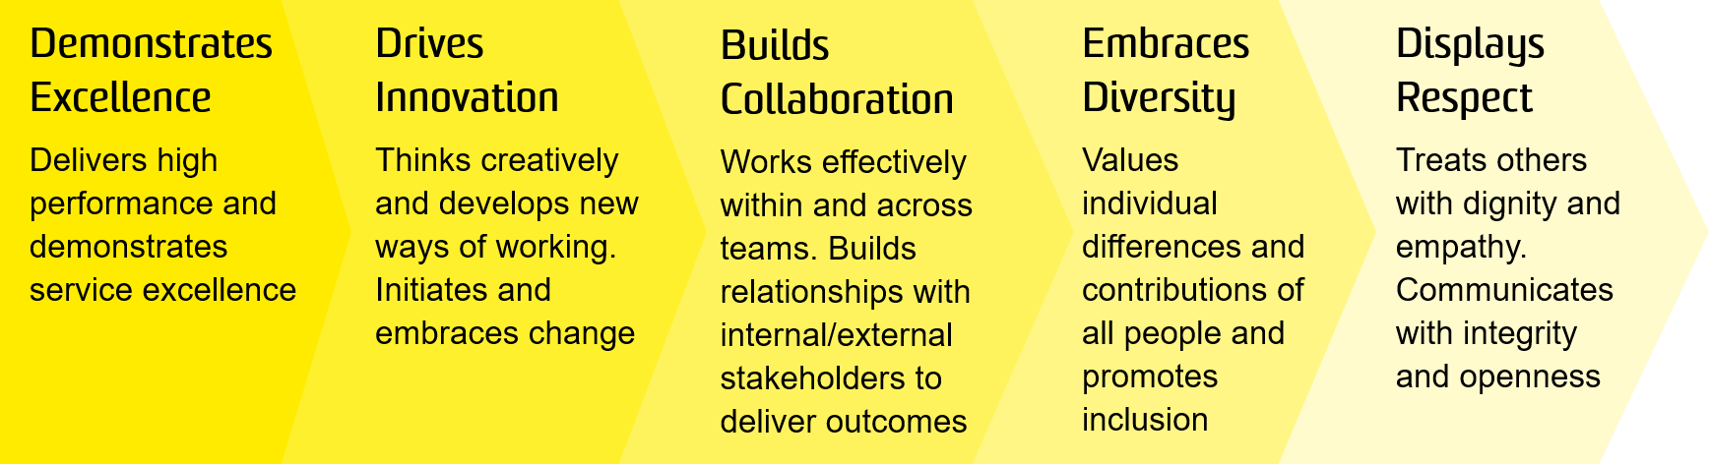

OVERVIEW OF RELEVANT AREA AND POSITION SUMMARY
UNSW Business School is a leader in business education and research in the Asian region and one of the largest Business Schools in Australia with more than 15,000 students, 500 academic and professional staff and more than 80,000 alumni and partners. The Business School offers a full suite of business degree programs at undergraduate, postgraduate, coursework and research levels, including the AGSM MBA programs and a range of Executive Programs. Its direction is guided by a business advisory council of leading CEOs, chairpersons and other business leaders.
The Faculty reputation is built on its outstanding staff, students and alumni and a cultural diversity which ensures an international focus. The School is frequently ranked among the top 50 in the world, and in some areas among the top 20, according to global indicators. For further information, see: https://www.business.unsw.edu.au/

The AGSM Career Development Centre (CDC) exists to deliver global best practice career transition services to students enrolled across the full-time MBA, MBA Executive and MBAX (online) programs to optimise their post-MBA career success.
This position works closely with the Career Relationship Manager and Career Development Manager providing high level support to ensure the creation and delivery of quality, engaging workshops and events while maintaining strong relationships with industry and ensuring appropriate involvement in careers activities.
The role reports to the Director, Career Development Centre and has no direct reports.

RESPONSIBILITIES
- Support the team in design and delivery of high quality workshops, both face to face and online
- Assist the team in planning and delivery of events, including employer presentations, speaker panels, networking events and other special events involving students, alumni and industry representatives
- In collaboration with the Career Relationship Manager to source relevant MBA internships and full-time opportunities, and maintain AGSM’s relationships with industry
- Proactively contribute to student clubs and societies, offer advice and information relating to their specific sector and help facilitate networking activities
- Manage online communities and oversee communications to students to increase engagement with and participation in career services and related events and activities
- Compile data and produce reports on team activities, student engagement and outcomes
- Represent CDC at relevant events, meetings and forums, including occasional evening and weekend activities
- Participate in other ad hoc careers projects as determined by your supervisor from time to time
- Cooperate with all health and safety policies and procedures of the university and take all reasonable care to ensure that your actions or omissions do not impact on the health and safety of yourself or others

SELECTION CRITERIA
- Tertiary qualification with subsequent relevant experience in a similar institutional setting or work environment
- Demonstrated skills in coordinating and supporting career development and placement programs
- Strong interpersonal and communication skills, including the ability to communicate openly and regularly with a range of stakeholders/client groups, and to effectively facilitate workshops
- Intermediate to advanced skills in word processing, PowerPoint and other Microsoft Office tools. Experience with social media and mass email platforms.
- Excellent time management and organisational skills with a proven ability to establish priorities, meet deadlines and to work under pressure, with minimum supervision and on multiple tasks.
- Understanding of key sectors employing AGSM graduates
- Knowledge of health and safety responsibilities and commitment to attending relevant health and safety training

It is not the intention of the position description to limit the scope or accountabilities of the position but to highlight the most important aspects of the position. The aspects mentioned above may be altered in accordance with the changing requirements of the role.

