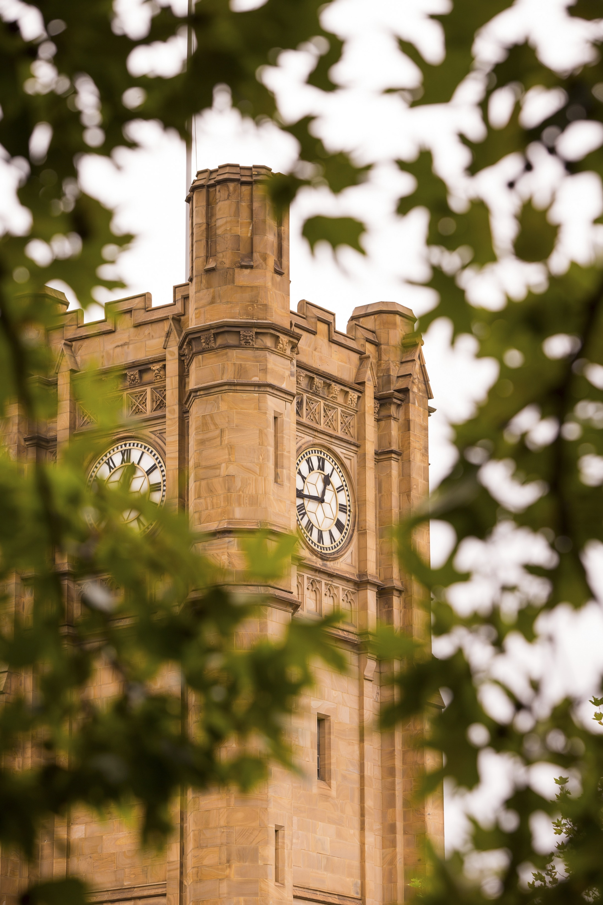
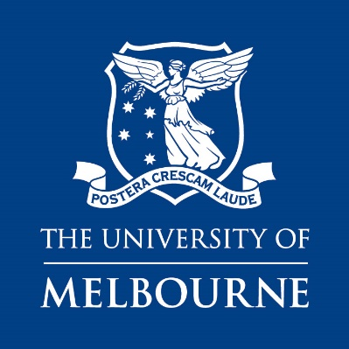
Appointment of
Senior Lecturer /
Associate Professor
Department of Economics
Faculty of Business and Economics
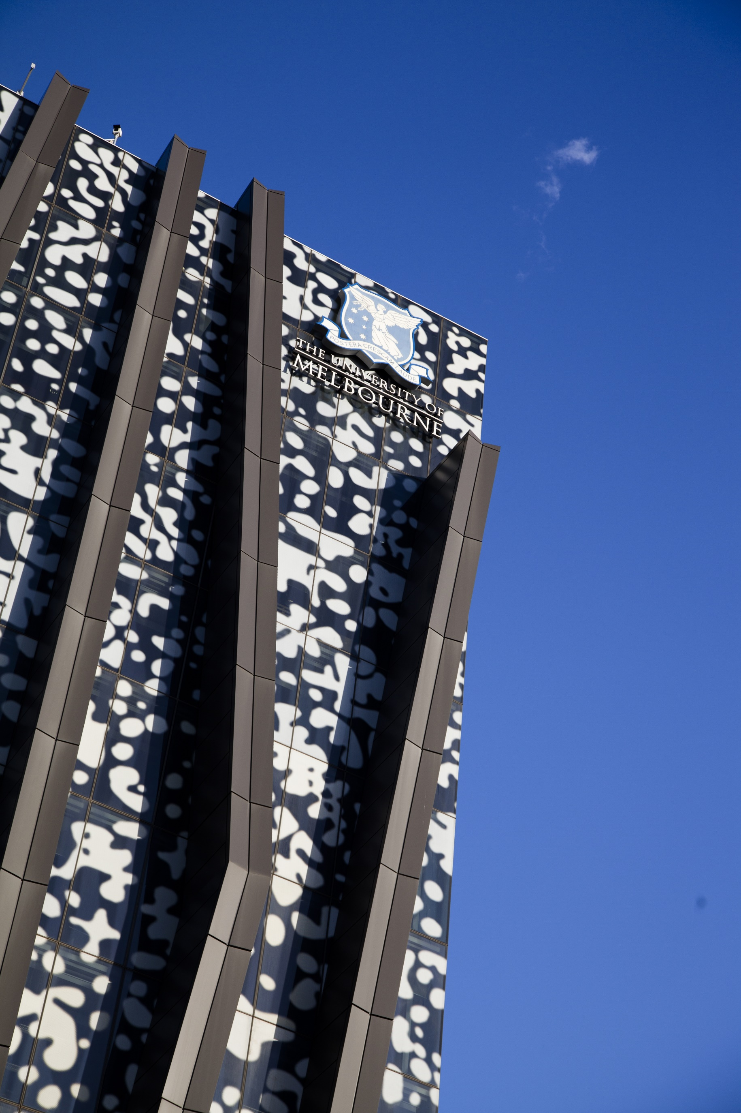
Contents
- Acknowledgement of Country
- Position Description & Selection Criteria
- Department of Economics
- Faculty of Business and Economics
- Our Culture
- The University of Melbourne
- University of Melbourne’s Strategic Plan 2020 – 2030
- Living & Working in Melbourne
- Further Information
- How to Apply

Acknowledgment of Country
The Faculty of Business and Economics acknowledges the unique place held by Aboriginal and Torres Strait Islander peoples as the original custodians of the lands and waterways across the Australian continent with histories of continuous connection dating back more than 60,000 years.
We acknowledge and pay respect to the Traditional Owners of the lands upon which our campuses are situated:
- the Wurundjeri and Boon Wurrung peoples (Parkville, Southbank, Werribee, and Burnley campuses)
- the Yorta Yorta Nation (Shepparton and Dookie campuses)
- the Dja Dja Wurrung people (Creswick campus).
We also acknowledge and are grateful to the Traditional Owners and Elders who have been instrumental in our reconciliation journey.
We also acknowledge and respect our Aboriginal and Torres Strait Islander students, staff, Elders and collaborators, and all Aboriginal and Torres Strait Islander people who visit our campuses from across Australia.

Position Description & Selection Criteria
__
POSITION NO. 0038905
CLASSIFICATION Senior Lecturer (Level C)
Associate Professor (Level D)
SALARY From:
$140,433 - $161,926 p.a. (Lvl C)
$169,094 - $186,288 p.a. (Lvl D)
Salary loadings may be considered subject to qualifications and experience.
SUPERANNUATION Employer Contribution 17%
WORKING HOURS Full time (1.0 FTE)
BASIS OF EMPLOYMENT Continuing position

Position Summary
The Department of Economics at the University of Melbourne is a leading economics department in Australia with strong undergraduate and postgraduate programs and an outstanding group of researchers in economics and econometrics. The Department offers internationally competitive salaries and benefits and a stimulating work environment.
The Department invites applications for continuing Senior Lecturer (equivalent of tenure track Assistant Professor in North America) and Associate Professor positions. Candidates specialising in Environmental Economics and Econometrics will be highly regarded.
Key Responsibilities
Research and Research Training
- To produce high quality research in economics and/or econometrics that is published in leading international refereed journals.
- To participate in academic conferences, seminars and workshops.
- To supervise PhD students.
- To attract research grants.

Teaching and Learning
- To teach to required standards in specialist subjects at third year, Honours or graduate level in Economics or Econometrics, and
a core first or second year subject in Economics or Quantitative Methods/Econometrics if required.
- To advise Honours and Masters students.
- To foster a high level of achievement in undergraduate and graduate students.

Leadership and Service
- To work effectively and collaboratively within a large department.

Responsibility and Compliance
- Maintain a sound knowledge of current University Policy and Procedures, and reliably follow these and provide compliant advice to others.
- Reliably follow communications protocols and/or policies as appropriate.
- Follow all Occupational Health and Safety (OH&S) and Environmental Health and Safety (EH&S) responsibilities.
- Behavioural Expectations - All staff are expected to maintain the following behaviours:
- Treat everyone equitably; act fairly with staff and demonstrate respect for diversity
- Be an effective team player who is cooperative and gains the trust and support of staff, peers and clients through collaboration.
- Create ethics applications and report to the ethics committees

Selection Criteria – Level C
Essential
- Have completed or be in the final stages of completing a PhD (or an appropriate equivalent) in Economics or a related discipline.
- Research interests and an ongoing research program in Economics or Econometrics as demonstrated by submissions to leading refereed journals and working papers.
- Ability to teach in at least one specialist subject at the third year, Honours year or graduate level in Economics or Econometrics and a core first or second year subject in Economics, Econometrics or Quantitative Methods if required.
- A record of participation in academic conferences, seminars and workshops.
- Personal qualities which will foster a high level of achievement in students.
- An ability to work effectively within a large department.
Desirable
- Teaching experience at tertiary level with evidence of excellent results as indicated, for example, by student evaluations.
- An ability to attract research grants.

Selection Criteria – Level D
Essential
- Have completed a PhD (or an appropriate equivalent) in Economics or related discipline.
- A well-established, internationally-recognized research record that includes publication in top-ranked economics or econometrics journals and presentations at international conferences.
- The ability to attract and generate research funds from competitive grants and other sources to support research.
- The capacity to provide high quality mentoring and supervision for graduate students.
- The capacity to make a significant contribution to the research, teaching and engagement objectives of the Department of Economics.
- A record of high quality teaching and leadership in course and curriculum development.
- An ability to work effectively within a large department.
Desirable
- A record of effective engagement with the wider community.
- Leadership in and/or membership of relevant professional bodies, advisory boards and other relevant organisations.

Department of Economics
The Department of Economics at the University of Melbourne is a leading economics department in Australia. The US News and World Report’s Best Global Universities rankings place the University of Melbourne 56th in the world in the disciplines of Economics and Business. In the widely used Tilburg ranking of economics departments, the University of Melbourne is ranked 32nd.
The Department of Economics has 65 academic staff and is part of a larger community of economists at the university. This includes the Melbourne Business School with 11 academic economists and econometricians and the Melbourne Institute of Applied Economic and Social Research with 43 researchers undertaking research and consultancy projects for government and private sector clients.
RESEARCH
Objectives
The Department’s objective is to produce high-quality impactful research that contributes to international knowledge and is publishable in leading general and field journals. There is a strong emphasis within the Department on encouraging a good research culture and promoting collaboration, developing the careers of young faculty members, and providing a friendly and supportive atmosphere.
The culture of the department emphasizes research contributions at the highest level of the economics profession. Our faculty have published 12 articles in the “top 5” journals of the economics profession since 2017, along with numerous papers in leading field and general interest outlets over this period. Our faculty members serve on the editorial boards of leading journals in the profession, including Econometrica, the Journal of Economic Theory and the American Economic Journal: Microeconomics among others. Three department members have been recognized as Fellows of the Econometric Society. We encourage potential applicants to review our personnel on our departmental website.
Seminars
Seminar series are active in the fields of economic theory, applied microeconomics, econometrics, experimental economics, macroeconomics, and trade and development, as well as an internal workshop. The Melbourne Institute also runs a regular seminar series for external speakers, and a labour economics workshop series.
Study leave
After every three years of eligible service, travel grants and six months paid sabbatical leave (known as Special Studies Leave) are available.
Research Funding
A new academic in the Department of Economics should have no trouble accessing research funds for their first several years. Faculty and University research grant schemes provide funding for Early Career researchers. Additional research funds can be sought from the Australian Research Council. The Department has a strong record in attracting grants and research fellowships.
Travel and visitors
Staff are encouraged to travel domestically and internationally to develop their research and to participate in the international research community. Funding for travel can be sourced from the annual allocation from the Department. In addition, internal or external research grants can fund further travel.
The Faculty of Business and Economics has a Visiting Research Scholar Scheme to fund visitors to the University for up to 3 months.
TEACHING
Undergraduate and graduate programs
The primary teaching of the Department is in the Bachelor of Commerce Degree, the graduate Masters Programs and PhD programs.
The department provides core subjects and electives in economics and econometrics across the three years of the Bachelor of Commerce. A feature of the teaching program at Melbourne is the quality of students who undertake the Honours year in Economics. The Honours year teaching program comprises Micro, Macro, Econometrics and a research essay. Some of the honours essays are subsequently published in refereed journals, and top honours students gain admission to elite PhD programs in the United States.
The PhD program consists of two years of coursework followed by 3 years of dissertation research. Students who complete the PhD obtain academic placements or jobs as professional economists in government or business. Recent placements include the University of Pittsburgh, Oxford, University of Colorado – Boulder, and the World Bank.
The normal teaching load includes two subjects per year. There is generally also a requirement to act as an advisor to several Honours and Masters students writing research essays and as a PhD supervisor.
In the initial years after hiring, teaching responsibilities would generally be in the third or Honours years of the undergraduate program, or in the graduate program (where class sizes would be smaller than in the first two years of the undergraduate program), and an attempt is made to match teaching with the main research interests of each member of staff.

PUBLICATIONS IN THE TOP FIVE JOURNALS IN THE LAST FIVE YEARS
(department-affiliated authors in bold)

American Economic Review
- Fehr, Ernst, Michael Powell, and Tom Wilkening. 2021. "Behavioral Constraints on the Design of Subgame-Perfect Implementation Mechanisms." American Economic Review, 111 (4): 1055-91.
- Baranov, Victoria, Sonia Bhalotra, Pietro Biroli, and Joanna Maselko. 2020. "Maternal Depression, Women's Empowerment, and Parental Investment: Evidence from a Randomized Controlled Trial." American Economic Review, 110 (3): 824-59.
- Byrne, David P., and Nicolas de Roos. 2019. "Learning to Coordinate: A Study in Retail Gasoline." American Economic Review, 109 (2): 591-619.
- Eusepi, Stefano, and Bruce Preston. 2018. "Fiscal Foundations of Inflation: Imperfect Knowledge." American Economic Review, 108 (9): 2551-89.
- Loertscher, Simon, and Leslie M. Marx. 2022. "Incomplete Information Bargaining with Applications to Mergers, Investment, and Vertical Integration." American Economic Review, 112 (2): 616-49.
- Martin, Leslie, S. Nataraj, and A. Harrison (2017): “In with the Big, Out with the Small: Removing Small-Scale Reservations in India,” American Economic Review, 107(2): 354-386.
- Recalde, Maria, L. Vesterlund and L. Weingart (2017): “Gender Differences in Accepting and Receiving Requests for Tasks with Low Promotability,” American Economic Review, 107(3): 714-47.
Econometrica
- Gene M. Grossman, Phillip McCalman, Robert W. Staiger. The “New” Economics of Trade Agreements: From Trade Liberalization to Regulatory Convergence? Econometrica, JAN 2021, VOLUME 89, ISSUE 1, p. 215-249.
- Ivan Balbuzanov, Maciej H. Kotowski. Endowments, Exclusion, and Exchange. ECONOMETRICA: SEP 2019, VOLUME 87, ISSUE 5 p. 1663-1692
- Joshua B. Miller, Adam Sanjurjo. Surprised by the Hot Hand Fallacy? A Truth in the Law of Small Numbers. ECONOMETRICA: NOV 2018, VOLUME 86, ISSUE 6 p. 2019-2047
Journal of Political Economy
- Simon Loertscher and Leslie M. Marx (2019), Merger Review for Markets with Buyer Power, Journal of Political Economy, Volume 127, Number 6, pp. 2967–3017.
- Simon Loertscher and Ellen Muir (2022): “Monopoly Pricing, Optimal Randomization and Resale” Journal of Political Economy, 130(3), 566-635.
- Chen, Yi-Chun, Richard Holden, Takashi Kunimoto, Yifei Sun, and Tom Wilkening (2022): “Getting Dynamic Implementation to Work,” Journal of Political Economy, forthcoming.
Quarterly Journal of Economics
- David Byrne, Leslie Martin, Jia Sheen Nah (2022): “Price Discrimination by Negotiation: A Field Experiment in Retail Electricity”, Quarterly Journal of Economics, forthcoming
Review of Economic Studies
- Marc Chan (2017): “Welfare Dependence and Self-Control: An Empirical Analysis,” Review of Economic Studies, 84(4), 1379-1423.

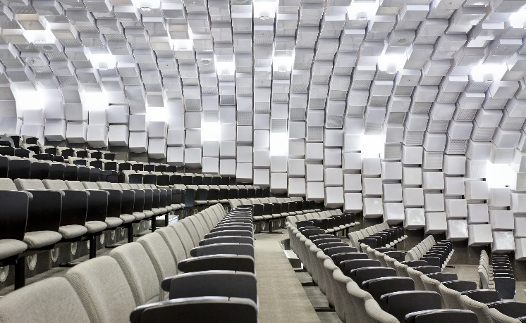
The Faculty of Business and Economics
Through its leading research and teaching, the Faculty of Business and Economics at the University of Melbourne influences policy design, corporate governance, and business practices globally.
__
The Faculty of Business and Economics offers extensive undergraduate, graduate, and research higher degree study options through the Bachelor of Commerce, Melbourne Business School suite of programs, as well as the Melbourne Business School MBA. There are more than 10,000 students enrolled in undergraduate and graduate degrees within the Faculty. The Bachelor of Commerce is one of the most sought-after business courses in Australia. The Faculty is also the home of leading research masters degrees and the PhD.
The Faculty of Business and Economics holds Association to Advance Collegiate Schools of Business (AACSB) accreditation and European Quality Improvement System (EQUIS) accreditation. The Faculty subscribes to the Principles for Responsible Management Education (PRME) initiative founded by the United Nations, a platform to raise the profile of sustainability in schools globally, and to equip today's business students with the understanding and ability to deliver responsible and transformative change in the future.
The Faculty hosts world class academics and professional staff, the brightest students, alumni, and other stakeholders. Since its establishment, the Faculty has produced a large number of leaders in business, government, and academia, in Australia and around the world. We are committed to enhancing our applied research outcomes, expanding our curriculum, and bolstering our connections with industry to help shape the world of business and economics in Australia and internationally.
The Faculty seeks to welcome and value the unique contributions of people from all backgrounds. We are committed to diversity and inclusion practices to achieve our vision through the policy of relative-to-opportunity performance evaluation and initiatives such as Faculty Carer’s Travel Support Scheme, Professional Development Programs, Awards for excellence in teaching and research, etc.
Further information about the Faculty is available at www.fbe.unimelb.edu.au
Further information about joining the Faculty is available at https://fbe.unimelb.edu.au/about/join-fbe
Accreditations and Rankings
The Faculty of Business and Economics at the University of Melbourne has been preparing students for exciting and challenging careers in industry since 1924. We have developed an outstanding reputation, locally and internationally, for the quality of our teaching and research.
- #2 in Australia and #34 globally for Economics and Econometrics
- #1 in Australia and #34 globally for Business and Management Studies
- #1 in Australia and #15 for Social Sciences and Management
- #2 in Australia and #21 globally for Accounting and Finance
- #8 for Graduate Employability globally
References: QS World University Subject Rankings 2022; QS Graduate Employability Rankings 2022

Our Mission
- We enable individuals and organisations to be global leaders through the creation, application and dissemination of business and economics knowledge.

Our Vision
- Our aspiration is to become one of the leading global providers of business and economics education and research.
- We aim to critically evaluate and influence policy design, corporate governance, and business practices to secure the best possible outcomes for our stakeholders and for the broader societies in which we operate.
Our Values
- We are an inclusive learning community in which there is respect for our diverse backgrounds and interests and where there is a shared joy in learning and scholarship.
- Rigour and relevance are the foundations of all that we do.
- Integrity and ethical behaviour guide all of our actions, policies and decision making.
- Openness and transparency characterise our organisational culture.
- Academic freedom is paramount.
Organisational Structure
The Faculty is home to Melbourne Business School (MBS) and to six teaching and research departments:
- Accounting
- Business Administration
- Economics
- Finance
- Management and Marketing
- Melbourne Institute of Applied Economic and Social Research

The Faculty has the following student and academic support centres:
- The Williams Centre for Learning Advancement
- Academic Support Office
- Research Professional Services Unit
- Student Experience and Experiential Learning
- Quality Office

The Faculty is supported by the following central services:
- Finance and Post Awards Research Finance (PAFS)
- Research, Innovation and Commercialisation (RIC)
- Human Resources (including OHS)
- Marketing and Communications
- Student Recruitment and Admissions
- Business Services and Facilities Management

The Faculty also hosts two University-wide initiatives:
- The Melbourne School of Professional and Continuing Education (MSPACE) which provides support to all Academic Divisions for their existing professional, continuing and executive education programs, and operates with a specific whole-of-institution mandate to significantly expand the University’s professional, continuing and executive education offerings.
- The Melbourne Entrepreneurial Centre (MEC) which brings together a number of programs to focus a range of activities aimed at developing an entrepreneurial culture at the University of Melbourne.

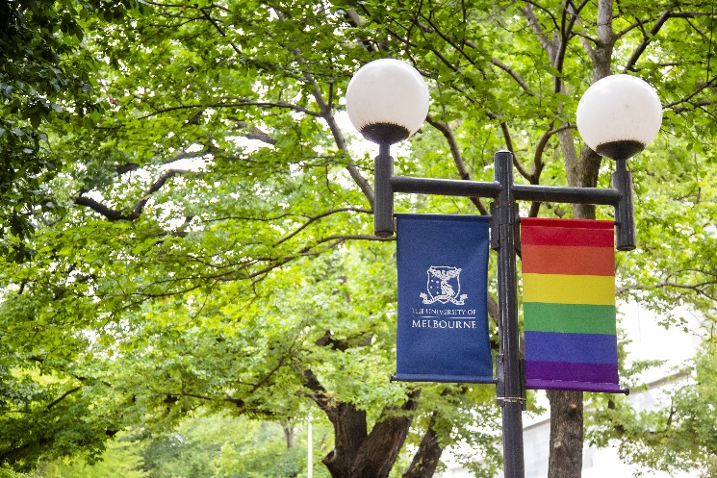
Our Culture
As a global university seeking to attract and retain the best employees and students, as well as form collaborative partnerships with global institutions and businesses, we are committed to fostering an inclusive environment where diversity is celebrated.
__
The Faculty of Business and Economics has a vision to “be among the top-ranked providers of business and economics education within our region… and esteemed globally as a leading supplier of academic and business-relevant research”. Our roles include the responsibilities to produce excellent research, pursue important questions, make great contributions to society, and lead by example to create diverse and inclusive environments.
Differences in age, race, gender, cultural heritage, sexual orientation, physical ability, and background bring valuable experiences to our campus. We embrace the diversity of our staff and students. We are committed to cultivating, providing, and supporting a safe, fair, and enriching environment for our staff and students.
We offer the opportunity to be part of a growing list of initiatives across the Faculty. As a member of our University/Faculty community, you will have access to:
- Increased flexible work possibilities including flexible hours and work from home options
- Paid parental leave and retention benefits
- Salary packaging of childcare
- Holiday programs for school age children
- Subsidised onsite sporting facilities
- Discounted car parking
- Discounted dental and eye care
- Employee Assistance Program and access to Counselling and Psychological Services
- A tailored transition plan for new hires and relocation support (where applicable)
- Professional development opportunities including a University-wide Academic Women in Leadership Program and a Faculty-wide Academic Women in Leadership Program
- Faculty Carer’s Travel Support Scheme to support staff with caring responsibilities who wish to undertake research-related travel (nationally or internationally)
- Strategic awards for excellence in teaching and research
- Our campuses with 11 libraries, 12 museums and galleries and 37 cultural collections
- Extra days leave and compensation for public holidays worked (i.e., Queen’s Birthday and Melbourne Cup Day)
- Faculty-wide schemes under development such as support for academics returning to work from parental leave, strategic awards for women of excellence, etc.
We are dedicated to integrating our values and behaviours into the way we work with a strong focus on leadership accountability. Our people’s safety and wellbeing are a top priority. The University is recognised as an employer of choice for women and is one of the 40 organisations to participate in the Science in Australia Gender Equity (SAGE) pilot program of the Athena SWAN in Australia. We have also been awarded Bronze Tier accreditation at the 2021 Australian LGBTQ Inclusion Awards.
Relative-to-opportunity performance evaluation is another important component of promoting an inclusive environment. This policy is systematically applied in Performance Development Reviews, confirmation assessments, and promotion assessments.

Gender Equity
Creating more gender equity by increasing the representation of women in academic positions, and more broadly across the Faculty in senior leadership roles, is a strategic priority for the Faculty of Business and Economics and is an important part of our diversity agenda:
We are committed to:
- Cultivating a culture and environment that is attractive to the best academic talent
- Supporting female candidates throughout their recruitment experience and beyond
- Providing support and development to female academics and creating a platform for further inclusion, fulfilment, and progression
- Enhancing our understanding of how to better support women to thrive in their current roles and progress their careers in academia
- Assess and measure our progress in realising our aims in creating diverse and inclusive environments.
Indigenous Cultural Awareness
We are committed to increasing the recruitment and retention of Aboriginal and Torres Strait Islander people across all academic and professional occupation categories in the Faculty of Business and Economics. The Indigenous Employment Framework is the key driver for advancement of Indigenous staff recruitment and retention across the University.
Our commitment is to provide:
- A culturally safe workplace for Aboriginal and Torres Strait Islander staff
- Cultural and Ceremonial Leave available
- Annual cultural events such as the Wominjeka to begin the Academic Year and the Narrm Oration
- Spaces to meet and connect with Aboriginal and Torres Strait Islander colleagues and students
- Indigenous Staff Support Network
- An Indigenous Employment Officer.
The Dilin Duwa Centre for Indigenous Business Leadership, a collaboration between the University of Melbourne’s Faculty of Business and Economics and Melbourne Business School, is committed to the pursuit of equity for Australia’s First Nations people in the economic life of our country. Further information about the Dilin Duwa Centre for Indigenous Business Leadership is available at https://fbe.unimelb.edu.au/cibl

Equal Opportunity, Diversity & Inclusion
The University is an equal opportunity employer and is committed to providing a workplace free from all forms of unlawful discrimination, harassment, bullying, vilification, and victimisation. The University makes decisions on employment, promotion, and reward on the basis of merit. This commitment is set out in the University’s Strategy and policies that address diversity and inclusion, equal employment opportunity, discrimination, sexual harassment, bullying and appropriate workplace behaviour. All staff are required to comply with all University policies.
The University values diversity because we recognise that the differences in our people’s age, race, ethnicity, culture, gender, nationality, sexual orientation, physical ability and background bring richness to our work environment. Consequently, the Diversity and Inclusion Strategy 2030 sets out the strategic aims to advance and embed the principles of diversity and inclusion across all activities at the University to create enduring and widespread cultural change.
Occupational Health & Safety (OHS)
All staff are required to take reasonable care for their own health and safety and that of other personnel who may be affected by their conduct.
OHS responsibilities applicable to positions are published here.
These include general staff responsibilities and those additional responsibilities that apply for Managers and Supervisors and other Personnel.

The University of Melbourne
Established in 1853, the University of Melbourne is a public-spirited institution with an outstanding reputation for excellence in research, learning and teaching, and engagement.
__
Ranked number 1 in Australia and number 33 globally in the latest Times Higher Education World University Rankings*, Melbourne competes on an international stage with the best institutions globally and has an international outlook and reach to match.
With a rich history stretching over 160 years, the University of Melbourne also occupies a special place in the heart of the city. Since its founding in 1853, the University has been a public-spirited institution committed to making distinctive contributions to intellectual, cultural, social, and economic life in the region and beyond. These values underpin the University’s entire academic mission and shape operating practices, preparing engaged graduates, and steering research that advances the world.
With a wide range of disciplines, the University of Melbourne currently educates over 50,000+ students from over 130 countries. The University comprises ten Academic Divisions providing learning that stimulates, challenges, and fulfils the potential of excellent students from around the world, leading to personal development, meaningful careers and profound contributions to society.
The alumni network is significant and truly international, with representation from 160 countries. This international community includes former Prime Ministers, Governors General, and Nobel Laureates, and is a testament to the world-class education the University of Melbourne delivers.
*Times Higher Education World University Rankings 2022
The Melbourne Model
Building on long-standing traditions of leadership and innovation in teaching and embracing international developments in curriculum design, the University introduced the Melbourne Model in 2008. The distinctive educational model offers degrees in three broad cycles. At Bachelor level, students select from one of six broad degrees (offering a total of 87 major fields of study) and a limited number of specialist offerings. These programs lay the intellectual foundations for future employment or further study. Most professional qualifications are subsequently offered at Masters level, where students can choose from a variety of professional or specialist graduate programs offering intensive graduate-level experiences that promote deep professional learning. At Doctoral level, students work alongside and are nurtured by international research leaders in a broad range of fields.
The Melbourne Model’s curriculum combines academic breadth with disciplinary depth to strategically reposition the University in an increasingly globalised higher education framework. The University prepares its students to enter a world marked by rapid change where graduates must possess the applicable knowledge, and flexible and adaptable skills, to succeed.
Governance
The Vice Chancellor is the Chief Executive Officer of the University and responsible to Council for the good management of the University.
Comprehensive information about the University of Melbourne and its governance structure is available at https://about.unimelb.edu.au/strategy/governance
The University of Melbourne’s Strategic Plan 2020 – 2030
__
Advancing Melbourne
The University’s strategic direction is grounded in its purpose. While its expression may change, our purpose is enduring: to benefit society through the transformative impact of education and research. Together, the vision and purpose inform the focus and scale of our aspirations for the coming decade.
Advancing Melbourne reflects the University’s commitment to its people, its place, and its partners. Our aspiration for 2030 is to be known as a world-leading and globally connected Australian university, with our students at the heart of everything we do.
- We will offer students a distinctive and outstanding education and experience, preparing them for success as leaders, change agents and global citizens.
- We will be recognised locally and globally for our leadership on matters of national and global importance, through outstanding research and scholarship and a commitment to collaboration.
- We will be empowered by our sense of place and connections with communities. We will take opportunities to advance both the University and the City of Melbourne in close collaboration and synergy.
- We will deliver this through building a brilliant, diverse, and vibrant University community, with strong connections to those we serve.
The means for achieving these goals include the development of the University of Melbourne’s academic and professional staff and the capabilities needed to support a modern, world class university. Those means require a commitment to ongoing financial sustainability and an ambitious infrastructure program which will reshape the campus and our contribution to the communities we engage with. This strategy, and the priorities proposed, is centred around five intersecting themes: place, community, education, discovery, and global.

Living and Working in Melbourne
__
Melbourne is the capital city of Victoria and the second largest city in Australia. It is set around the shores of Port Phillip Bay and sits beside the Yarra River, around five kilometres from the bay.
Melbourne is home 4.5 million people and a metropolitan area of 9990.5 km2. The Economist Intelligence Unit has rated Melbourne one of the world’s most liveable city for six consecutive years, based on its education, entertainment, health care, research and development, tourism and sport.
The City of Melbourne municipality, in which the University’s main Parkville campus is based, covers 37.7 km2 and has a population of more than 143 000 people. It includes the city centre and a number of attractive inner suburbs with thriving communities and businesses.
The City of Melbourne is home to residents from 180 countries who speak more than 233 languages and dialects and follow 116 religious faiths. The Wurundjeri, Boonwurrung, Taungurong, Dja Dja Wurrung and the Wathaurung people of the Kulin Nation are the Traditional Owners of the land now known by its European name of Melbourne.
The City of Melbourne is recognised as Australia’s cultural capital with a number of world-class galleries and museums, internationally renowned food and wine regions, and an impressive year-round calendar of events catering for all tastes.

Further Information
General Information about the University of Melbourne is available at its website www.unimelb.edu.au

About the University of Melbourne
about.unimelb.edu.au

The University of Melbourne’s Strategic Plan 2020-2030: Advancing Melbourne
https://about.unimelb.edu.au/strategy/advancing-melbourne

Annual Reports
https://about.unimelb.edu.au/strategy/annual-reports

Faculty of Business and Economics
fbe.unimelb.edu.au

Research
University of Melbourne research strategy and implementation
research.unimelb.edu.au

Teaching
Teaching and Learning at the University of Melbourne
provost.unimelb.edu.au

Careers
https://about.unimelb.edu.au/careers

How to apply
Please submit your application via:
https://econjobmarket.org/positions/9870
The Faculty of Business and Economics is committed to equity, diversity and inclusion and strongly encourages people with diverse experiences to apply. This includes First Nations people, culturally and linguistically diverse people, Deaf and hard of hearing people, people with a disability, LGBTIQ+, and neurodiverse people. If you have any accessibility requirements for the application or interview, please contact us. We are dedicated to ensuring barrier free and inclusive practices to recruit the most talented candidates. A position description is available in alternate formats if required, including USB, Large Print and Plain English.

ENQUIRIES
Contact for enquiries only, please do not send your application to this contact.
NAME David Harris
EMAIL harris.d@unimelb.edu.au

